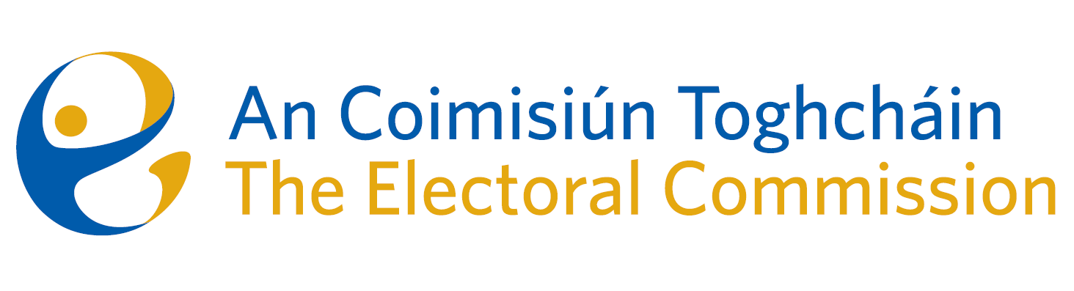
Agenda
Meeting 1, 10.30 a.m., 23rd February, 2023
Ombudsman’s Office, 6 Earlsfort Terrace, Dublin 2

- Introductions
- Chairperson’s opening remarks
- Working arrangements (to include confidentiality, conflicts of interest etc.)
- Work Programme:
- constituency review;
- possible referendums;
- online political advertising;
- misinformation/disinformation;
- education & public engagement;
- research;
- oversight of the electoral register;
- audit of electoral events;
- (registration of political parties)
5. AOB
6. Next meeting

