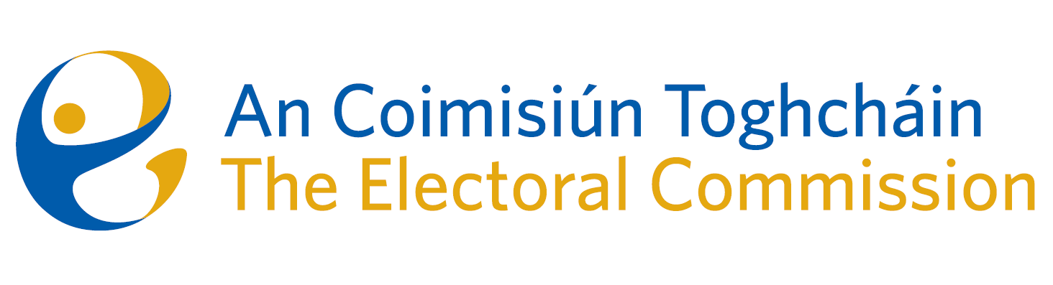
Agenda
Meeting 2, 08.00 a.m., 7th March, 2023
Ombudsman’s Office, 6 Earlsfort Terrace, Dublin 2
(Enter via 5 Earlsfort Terrace)

- Minutes of the previous meeting (incl. arrangements for publication)
- Conflicts of Interest
- Draft Code of Business Conduct/Ethics requirements
- Appeal against Decision to register a political party
- Constituency Review
- AOB
- Date of next meeting

