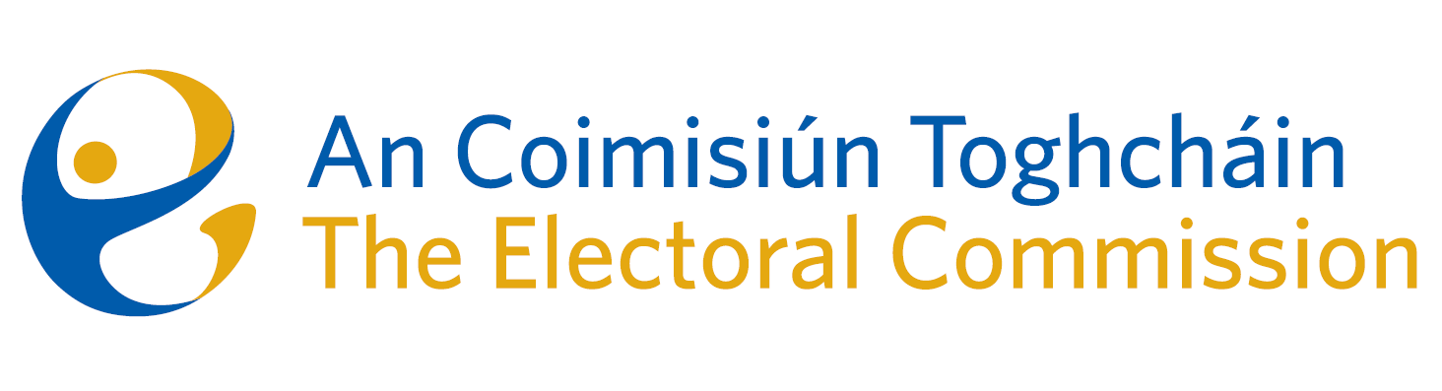
Agenda
Meeting 3, 8 a.m., 23rd March, 2023
Ombudsman’s Office, 5 Earlsfort Terrace, Dublin 2

- Minutes of the previous meeting
- Conflicts of Interest
- Briefing on Gender Equality Referendum
- Constituency Review
- Appeal against Decision to register a political party
- AOB

