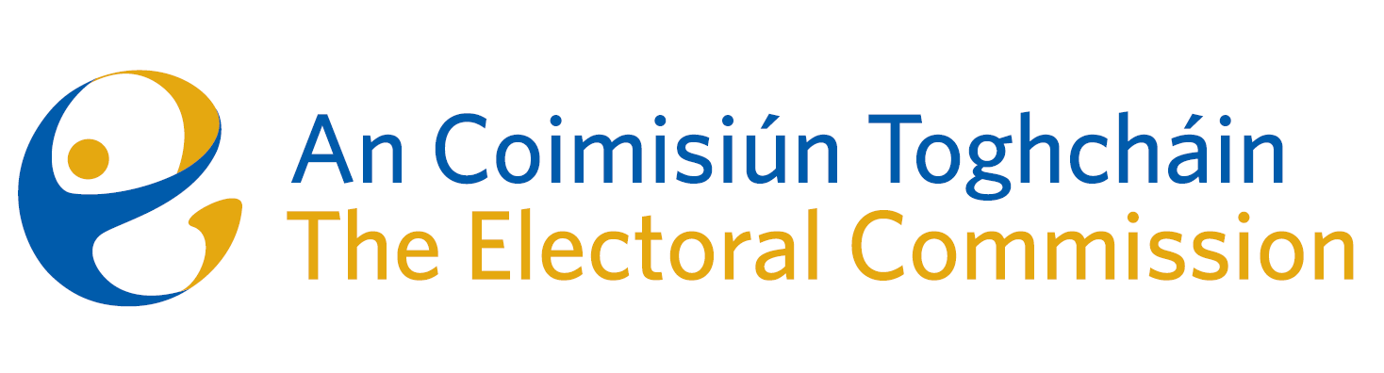
Meeting of An Coimisiún Toghcháin (ACT), The Electoral Commission.

Held in the Office of the Ombudsman, 8.00am – 23rd March 2023
In attendance:
Coimisiún Members: Justice Marie Baker (Chairperson), Alex Atwood (AA), John Curran (JC), Ger Deering (GD), Peter Finnegan (PF), Maura Quinn (MQ) and Prof. Caroline Fennell (CF)*.

An Coimisiún Executive: Art O’Leary (AOL), Karen Kehily, Mary Clare O’Sullivan, Tim Carey (TC)*, Emer Grenville, Ian Stuart–Mills (ISM) and Aodha Molloy (AM).

*Prof. Fennell and Tim Carey attended remotely on Zoom
------------------------------------
- Welcome
The Chairperson welcomed members.

The minutes from the previous meeting were approved by all.

- Conflict of Interest
None declared

- Gender Equality Referendum
The Commission were briefed on the subject matter for the forthcoming Referenda.

- Constituency Review
Commission members continued their work on the Constituency Review and will consider all submissions and options available to them prior to making any final decisions.

- Appeal against Decision to register a political party
The Commission confirmed that the appellant has not responded to the Commission’s request for further information. The Commission decided that the appeal lodged against the registration of Ireland First is inadmissible as the appellant has not established standing in accordance with the requirements of section 51(3) a (ii) of the Act.

- AOB
Commission members approved a request for a resolution for the Electoral Commission to open a bank account.

_______________________
(Signed) Ms. Justice Marie Baker
Chairperson

