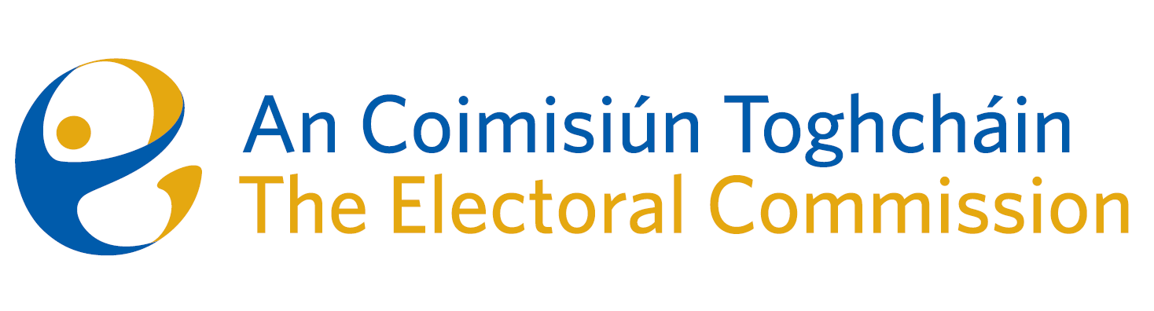
Meeting of An Coimisiún Toghcháin (ACT), The Electoral Commission.

Held in OPW, 1 Georges Quay, 8.00am – 28th March 2023
In attendance:
Coimisiún Members: Justice Marie Baker (Chairperson), Alex Atwood (AA), John Curran (JC), Ger Deering (GD), Peter Finnegan (PF), Maura Quinn (MQ) and Prof. Caroline Fennell (CF)*.

An Coimisiún Executive: Art O’Leary (AOL), Karen Kehily, Tim Carey (TC), Emer Grenville, Brian Dawson (BD), Ian Stuart–Mills (ISM) and Aodha Molloy (AM)*.

*Prof. Fennell and Aodha Molloy attended remotely on Zoom
------------------------------------
- Welcome
The Chairperson welcomed members.

The minutes from the previous meeting were approved by all.

- Conflict of Interest
None declared

- Communications Strategy Briefing
Commission members were briefed on proposals for a public awareness campaign for the constituency review currently underway.

The Commission members:
- approved the next steps for the public awareness campaign;
- agreed that the Head of Communications and Public Engagement will manage and respond to all media queries received by Commission members and that when required, the spokespeople for An Coimisiún will be the Chairperson and/or CEO; and
- agreed to return to the communications strategy as part of their consideration of the wider organisational strategy.

- Constituency Review
Commission members continued their consideration of the review of constituencies for Dáil Éireann and the European Parliament.

- AOB
None

__________________

(signed) Ms. Justice Marie Baker
Chairperson

