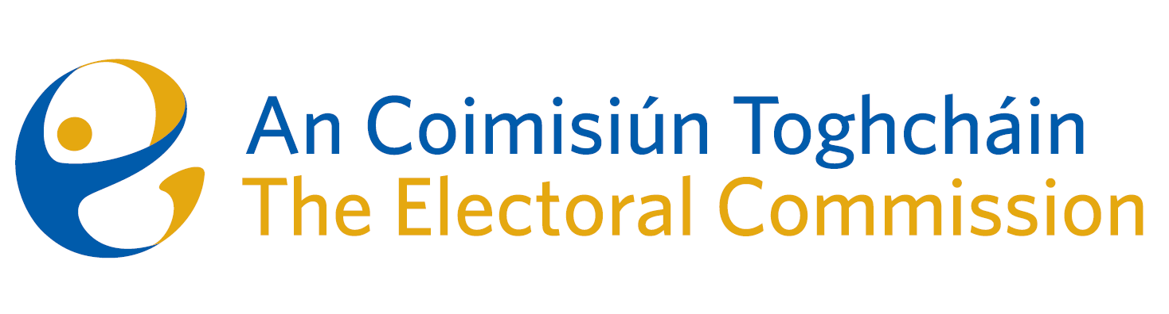
Meeting of An Coimisiún Toghcháin (ACT), The Electoral Commission.

Held in the Office of the Ombudsman, 8.00am – 30th March 2023
In attendance:
Coimisiún Members: Justice Marie Baker (Chairperson), Alex Atwood (AA), John Curran (JC), Ger Deering (GD), Peter Finnegan (PF), Maura Quinn (MQ)* and Prof. Caroline Fennell (CF)*.

An Coimisiún Executive: Art O’Leary (AOL), Karen Kehily, Tim Carey (TC), Emer Grenville, Ian Stuart–Mills (ISM) and Aodha Molloy (AM)*.

*Prof. Fennell, Maura Quinn and Aodha Molloy attended remotely on Zoom
------------------------------------
- Welcome
The Chairperson welcomed members.

The minutes from the previous meeting were approved.

- Conflict of Interest
Commission members considered the possibility of a perceived conflict of interest with regard to two members. In the absence of the two members, the Commission:
- Agreed there was no conflict of interest in either case.
- Decided that in the event of a perceived conflict of interest, a member would continue to contribute to the review of the constituencies. However, if a vote is required, then that member would recuse themselves from the vote.

- Constituency Review
Commission members continued their consideration of the review of constituencies for Dáil Éireann and the European Parliament.

- AOB
None

__________________
(signed) Ms. Justice Marie Baker
Chairperson

