Dáil Constituency Review - Submission by Cllr. Gearóid Murphy

Summary of Proposal
My submission focuses on the Dáil Constituencies in Cork County and proposes 5 constituencies returning 20 members in total. These are as follows:

Table 1.1
Name | Population | Number of TDs | Population per TD
Cork North Central | 145,688 | 5 | 29,138
Cork South Central | 145,310 | 5 | 29,062
Cork North | 87,757 | 3 | 29,252
Cork East | 87,406 | 3 | 29,135
Cork West | 115,447 | 4 | 28,861

The proposed boundaries are depicted in the map at Figure 1.1 below and detailed in Appendix A at the end of this submission.

Figure 1.1: Proposed boundaries
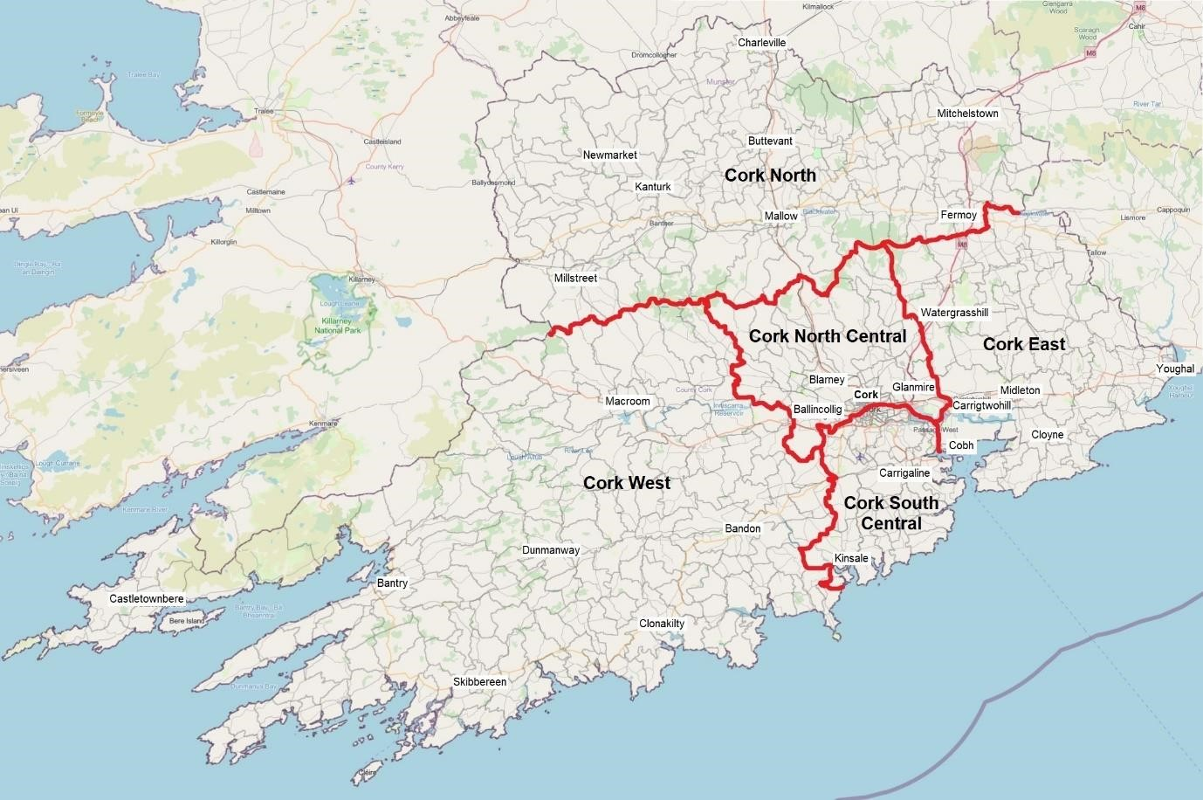
Under this proposal, Cork North Central and Cork South Central would both become 5-seat constituencies, which would require relatively minor boundary changes as compared with the current arrangement. There would be more substantial changes to the three rural-based constituencies. It is submitted that these changes are justified by reference to the Commission’s Terms of Reference. The mean population per TD in the proposed Cork constituencies is 29,080. The highest percentage variance above this is +0.6% (Cork North) and the highest percentage variance below is -0.8% (Cork West).

Terms of Reference
The Terms of Reference for the present Electoral Commission Report are set out in Section 57(2) of the Electoral Reform Act, 2022. Following is an analysis of my proposal by reference to this Section. There will also be a comparison with the existing arrangement, where appropriate.

A. Number of Members
S.52(2)(a) of the Electoral Reform Act provides for between 171 and 181 TDs in total. Using the preliminary results of the 2022 census, this would yield an average population per TD of between 28,307 (181 TDs) and 29,962 (171 TDs). Dividing the 2022 population of Cork County by these numbers gives between 19.4 and 20.53 TDs. Having regard to S.52(2)(c), it is submitted that the most appropriate number of TDs for the county would be 20.

B. Number of Members from each Constituency
As per S.52(2)(b), my proposal is for constituencies of between 3 and 5 TDs.
C. Avoiding the Breaching of County Boundaries
As per S.52(2)(c) and (d), my proposal avoids breaching the relevant County boundaries.

D. Contiguous Areas
S.52(2)(e) provides that each constituency shall be composed of contiguous areas. The constituencies I am proposing are compact and well-defined by reference to the natural hinterlands of the urban areas within them.
It is submitted that this contrasts favourably with the existing arrangement of constituencies in Cork County. Figure 1.2 below contrasts my proposal with the existing arrangement.

Figure 1.2: Proposed boundaries (above) and existing boundaries (below)
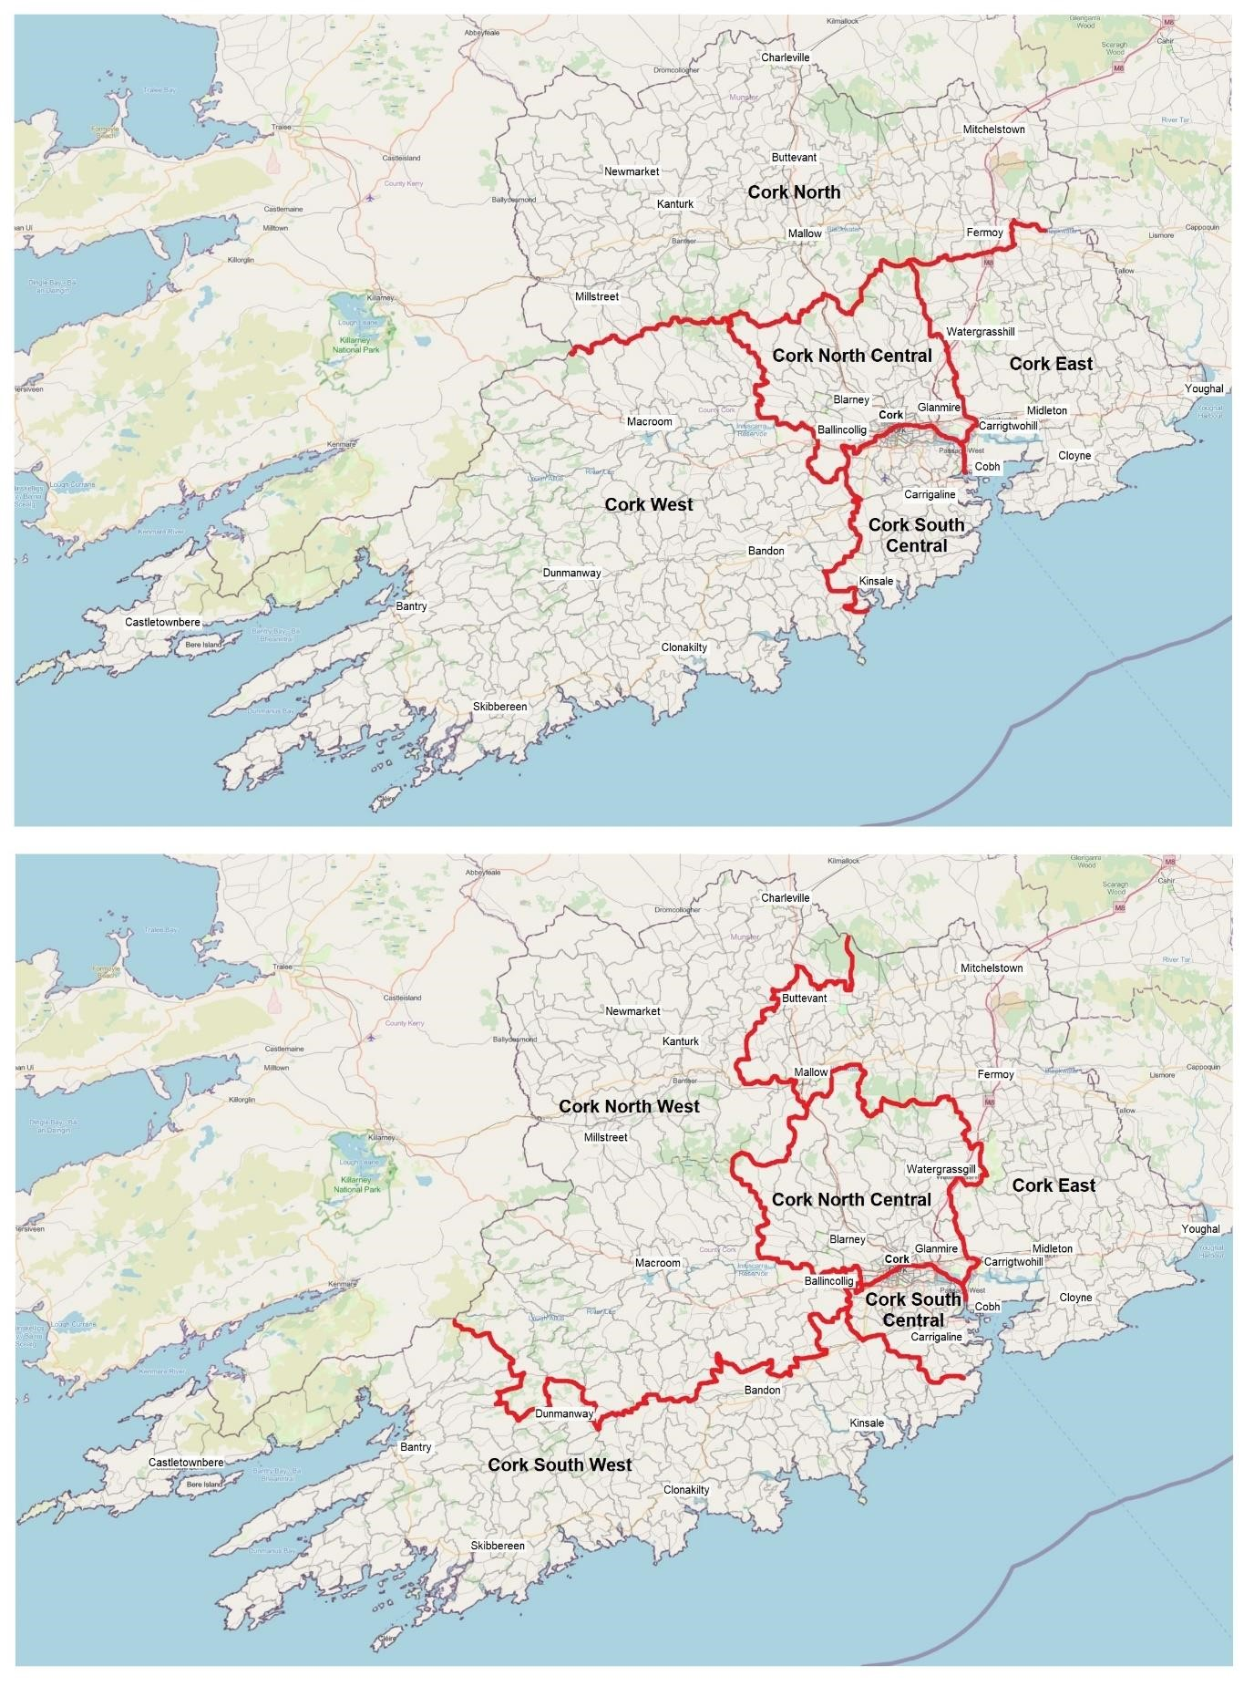
As is clear from the visual representation, the existing arrangements of Cork North West, Cork South West and Cork East are based on mostly artificial boundaries, which are long, winding and needlessly complex. The areas within the boundaries of the constituencies in my proposal are more contiguous to each other and are organised more cohesively.

E. Geographic Considerations
Section 52(2)(f) states that there “shall be regard to geographic considerations including significant physical features and the extent of and the density of population in each constituency”. I will discuss geographic considerations under physical geography and human geography.

Physical Geography
My proposal is clearly defined by reference to physical features. Figure 1.3 below shows a topographical map of Cork County. The Boggeragh Mountains and the Derrynasaggart Mountains (southeast and southwest of Millstreet) provide a clear natural barrier between the proposed Cork North and Cork West. These mountain ranges are ignored by the existing arrangement. Similarly, the Nagles Mountains (southeast of Mallow) coincide with the proposed boundaries between Cork North, Cork East and Cork North Central, with the triconstituency point located in these mountains.

Figure 1.3: Topographical map of Cork
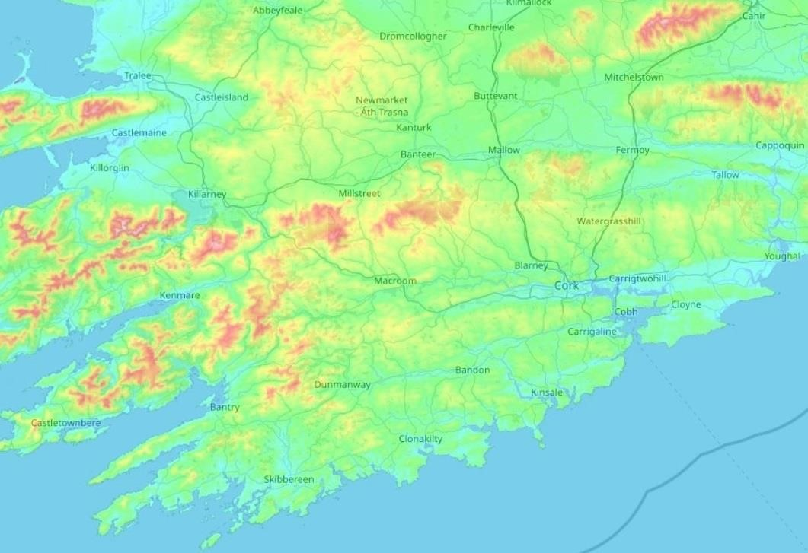
The proposed Cork North would also be defined by reference to the River Blackwater and its tributaries. The river runs the length of this proposed constituency from west to east, and provides the setting for the towns of Mallow and Fermoy. Mitchelstown, Buttevant, Kanturk and Newmarket are built on or adjacent to its tributaries. Similarly, the proposed Cork West is defined by reference to the River Lee and the River Bandon, both of which also run from west to east. Cork West is also defined as a coastal constituency.
Like Cork West, the proposed Cork East is defined strongly as a coastal constituency, with the constituency centred on large coastal towns such as Cobh and Youghal. This is in contrast to the existing Cork East, which is a far more sprawling constituency and is not defined with any consistency by reference to geographical features.

Human Geography
There are distinct intra-county regional identities in North Cork, East Cork and West Cork. West Cork has a particularly strong identity and is generally defined by reference to being to the west of Cork City. It would therefore include Macroom and the Gaeltacht area of Baile Bhuirne. The existing arrangement of Cork North West and Cork South West separates these areas from the rest of West Cork in an artificial manner. Meanwhile, North Cork has a rural identity, which is currently diluted by the inclusion of northeast Cork and Mallow with the Midleton and Cobh areas. It is submitted that the proposed boundaries vindicate these regional identities, while the existing boundaries virtually ignore them.
The proposed boundaries retain the existing constituencies of Cork North Central and Cork South Central with relatively minor alterations. The proposed Cork North Central would include Ballincollig, which is a satellite town of Cork City. Under the existing arrangement, Ballincollig is in Cork North West and is thus completely at odds with the very rural character of the rest of this constituency. Aside from the addition of Ballincollig, however, Cork North Central would otherwise be made more compact and more focused on the city, as four of its rural Electoral Divisions would be transferred to adjacent rural constituencies.
Cork South Central would be expanded to include Kinsale, a town which is adjacent to this constituency as it currently exists. The constituencies of Cork North Central and Cork South Central would therefore be much more similar in geographic size than in the existing arrangement. Finally, the Glasheen area of Cork City would once again be united in a single constituency, as this proposal would transfer Glasheen A and Glasheen B to Cork South Central.

F. Continuity
S.52(2)(g) provides that, subject to the other provisions of that section, the Commission shall endeavour to maintain continuity in relation to the arrangement of constituencies. This submission does propose substantial changes to the arrangement of the rural-based constituencies in Cork County. However, it is submitted that although these changes are substantial, they are not disproportionate, given the lack of compatibility between the existing arrangements and the other terms of reference contained in S.52(2), particularly those relating to geographic considerations. It is further submitted that existing boundaries have been preserved in this submission wherever they were compatible with the other terms of reference. For example, relatively few changes are made to Cork North Central and Cork South Central, despite now returning five TDs each rather than four.

Case study: Mallow
The following case study focuses on Mallow, the largest town and economic centre of North Cork with a population of 12,459. This will focus on how the town is currently completely divided from its natural rural hinterland, and how my proposal would remedy this. Figure 1.4 below shows the existing arrangement in relation to Mallow. Drommahane is a large village of 959 just outside Mallow and a satellite of the town. However, Drommahane is located in Cork North West, while Mallow is in Cork East. Furthermore, the Cork North Central constituency lies immediately to the south and east of Mallow, despite being focused on Cork City. Figure 1.4: Mallow
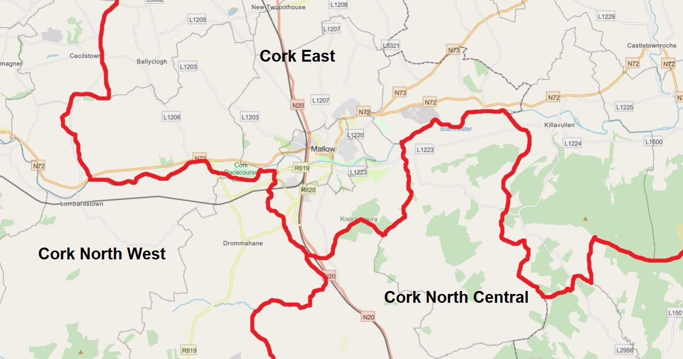
It is submitted that Mallow, situated at the geographic centre of North Cork, serves as a focal point for the region and it is difficult to justify cutting it off from its natural hinterland. This is exacerbated by the fact that Mallow and its hinterland is divided between three different Dáil constituencies. My proposal would completely remedy this by removing the artificial division between northeast and northwest Cork and also by transferring the Electoral Divisions of Ballynamona and Rahan to the south and east of Mallow from Cork North Central to the proposed Cork North.

Appendix A
Following are the compositions of the five proposed constituencies in terms of Electoral Divisions.

Cork North
In the county of Cork the electoral divisions of:
Ballyhooly, Castlecooke, Castle Hyde, Castletownroche, Fermoy Rural, Glanworth East,
Glanworth West, Gortnaskehy, Kilcummer, Killathy, Kilworth, Leitrim, in the former Rural District of Fermoy;
Allow, Ballyhoolahan, Banteer, Barleyhill, Barnacurra, Bawncross, Boherboy, Castlecor, Castlemagner, Clonfert East, Clonfert West, Clonmeen, Coolclogh, Dromina, Glenlara, Gortmore, Greenane, Kanturk, Kilbrin, Kilmeen, Knockatooan, Knocktemple, Meens, Milford, Nad, Newmarket, Newtown, Roskeen, Rosnalee, Rowls, Tincoora, Tullylease, Williamstown, in the former Rural District of Kanturk;
Ardskeagh, Ballyclogh, Ballynamona, Buttevant, Caherduggan, Carrig, Churchtown, Clenor,
Doneraile, Dromore, Imphrick, Kilmaclenine, Kilshannig, Liscarroll, Mallow Rural, Milltown, Monanimy, Rahan, Rathluirc, Shanballymore, Skahanagh, Springfort, Streamhill, Templemary, Wallstown in the former Rural District of Mallow;
Cahernarnagh, Coomlogane, Crinnaloo, Cullen, Derragh, Doonasleen, Drishane, Keale, Kilcorney, Knocknagree, Rathcool, Skagh, in the former Rural District of Millstreet;
Ballyarthur, Derryvillane, Farahy, Kildorrery, Kilgullane, Kilphelan, Marshalstown,
Mitchelstown, Templemolaga, in the former Rural District of Mitchelstown No. 1;
and Fermoy Urban, Mallow North Urban and Mallow South Urban.

Cork East
In the county of Cork the electoral divisions of:
Cobh Rural, Knockraha, in the former Rural District of Cork;
Aghern, Ballynoe, Castlelyons, Coole, Curraglass, Gortroe, Kilcor, Kildinan, Knockmourne, Rathcormack, Watergrasshill, in the former Rural District of Fermoy;
Ballintemple, Ballycottin, Ballyspillane, Carrigtohill, Castlemartyr, Clonmult, Cloyne, Corkbeg, Dangan, Dungourney, Garryvoe, Ightermurragh, Inch, Lisgoold, Midleton Rural, Mogeely, Rostellan, Templebodan, Templenacarriga, in the former Rural District of Midleton;
Ardagh, Clonpriest, Kilcronat, Killeagh, Kilmacdonagh, Youghal Rural, in the former Rural District of Youghal No. 1; and Cobh Urban, Midleton Urban and Youghal Urban.

Cork North-Central
In the city of Cork the electoral divisions of:
Ballincollig, Bishopstown A, Bishopstown B, Bishopstown C, Blackpool A, Blackpool B, Blarney, Caherlag, Carrigrohanebeg, Centre A, Centre B, Churchfield, Commons, Fair Hill A, Fair Hill B, Fair Hill C, Farranferris A, Farranferris B, Farranferris C, Gillabbey A, Gillabbey B, Gillabbey C, Gurranebraher A, Gurranebraher B, Gurranebraher C, Gurranebraher D,
Gurranebraher E, Knocknaheeny, Mardyke, Matehy, Mayfield, Montenotte A, Montenotte B,
Rathcooney, Riverstown, St. Mary’s, St. Patrick’s A, St. Patrick’s B, St. Patrick’s C, Shanakiel,
Shandon A, Shandon B, Sunday’s Well A, Sunday’s Well B, The Glen A, The Glen B, Tivoli A, Tivoli B, Whitechurch; and, in the county of Cork, the electoral divisions of:
Ballincollig, Ballynaglogh, Blackpool, Blarney, Caherlag, Carrignavar, Carrigrohane Beg, Dripsey, Firmount, Glenville, Greenfort, Killeagh, Knockantota, Matehy, Rathcooney, Riverstown, Whitechurch, in the former Rural District of Cork;
Carrig, in the former Rural District of Fermoy;
Gowlane, in the former Rural District of Macroom.

Cork South-Central
The city of Cork, except the parts thereof which are comprised in the constituencies of Cork North-Central and Cork West; and in the county of Cork, the electoral divisions of:
Ballygarvan, Carrigaline, Douglas, Iniskenny, Monkstown Rural, Monkstown Urban, in the former Rural District of Cork;
Ballyfeard, Ballyfoyle, Ballymartle, Carrigaline, Cullen, Farranbrien, Kilmonogue, Kilpatrick, Kinsale Rural, Kinure, Liscleary, Novohal, Templebreedy, in the former Rural District of Kinsale; and Kinsale Urban.

Cork West
In the city of Cork the Electoral Division of Ovens; and the County of Cork, except the parts thereof which are comprised in the constituencies of Cork North, Cork East, Cork North-Central and Cork South-Central.

