Melissa O Neil

To the Board members of the Electoral Commission in respect of the
review of boundaries to Dáil Elections.
Dear Board Members,
I wish to put forward my submission as follows, particularly as the government
has set an upper limit of 181 Dáil seats, representing an average
population per TD of 28,307.
I wish to make representation in respect of the proposed constituency
boundary review for the upcoming Dáil election in respect of the County
Waterford
The commission will note that as of the 2016 census, Waterford had a
the population of 116.176 persons and had four Dáil representatives, giving
a proportion of 29,044 persons per TD, or very close to the maximum of
30,000 / TD permitted by the Constitution.
The population of Waterford has now increased, as per the preliminary
census results for 2022, to a population of 127,085. If the number of
representatives were to remain at four this would represent a population
or TD of 31,771 persons, well outside the maximum set by the
constitution. If the number of representatives was increased to 5 TDs
this would give a proportion of 25,417 persons per TD or just over the
median point between the maximum (30,000) and the minimum (20,000)
persons per representative. The case therefore for increasing the
representation of the Waterford constituency to 5 TDs seems to be
overwhelming. Increasing representation to 5 would be likely to ensure
that it would remain at this level for at least the next two elections, as it is
unlikely that there would be a further increase of 25,000 persons, thus
triggering another revision, for the next 15 years or so.
Waterford is a very geographically distinct County bordered on the
South by the Atlantic Ocean on the east by counites by Cork, Tipperary, Kilkenny, and Wexford The only area where
there is no distinct geographical boundary is the second largest towns land of Kilkenny Ferrybank/Kilcullen as it is referred to is under the political jurisdiction of Waterford city and council and the area of administration for Waterford city on the northern bank of the river suir extends into Waterford
However, some parts of the Ferrybank extend into the county of Kilkenny and are administered by the Kilkenny council
Most Waterford people would be very much of the opinion that the
constituency should remain as a single entity and that the only matter to
be decided is the level of representation. As pointed out above, the
the argument for increasing representation for Waterford to 5 TDs for Dáil elections is
very strong. Ferrybank known to most as no man's land between two counties has a long history of proposals on this boundary for decades, now is the time to extend this artificial Dail boundary for the good practice of government and all involved to create balanced representation.
2
The result of the review ( please see Attached document)The committee members Mr. David O Connor Chair, Mr. John martin, and Mr ollie Killeen recommended that the boundary of Waterford city and county should be extended into County Kilkenny and those parts of the electoral areas of Anglish and Dunkett contained within the Area of interest that lie south of the N25 bypass. ( All maps relating to this submission are contained within the attached county boundary the terms of reference for the commission are that county
boundaries should generally be observed for constituencies. I note also
however that the government has placed an upper limit of 181 TDs for
the next Dáil. Given the current national population of 5,123,536, this
equates to a population per TD of 28,307, and for this reason, it may be
difficult for the commission to achieve the constituency revisions
required without breaching some county boundaries.
Given the limit of 181 TDs, the commission may feel that the population
of the Waterford, constituency may need to be increased if it becomes a five
seat constituency to some 140,000 persons, (ie 5x28,000) and that the
constituency may need to extend outside of the county boundary.
An extensive boundary review was sought on June 19th, 2015 under section 28 of the local government act to make recommendations with respect to that boundary and any consequential recommendations with respect to the Metropolitan District of Waterford that it considered necessary in the interest of effective and convenient local government
The result of the review ( please see attached link)The committee members Mr. David O Connor Chair, Mr. John Martin, and Mr ollie Killeen recommended that the boundary of Waterford city and county should be extended into County Kilkenny and those parts of the electoral areas of Anglish and Dunkett contained within the Area of interest that lie south of the N25 bypass.( All maps relating to this submission are contained within the link attached )
https://www.waterfordboundaryreview.ie/Report%20of%20the%20Waterford%20Boundary%20Review%20Committee.pdf

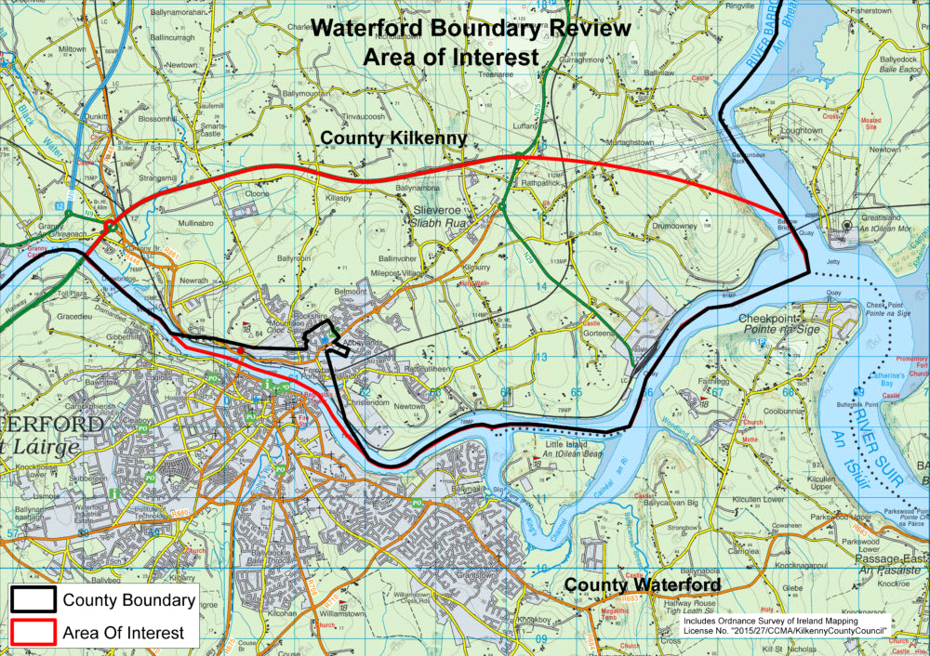

3
As stated above, if the constituency is kept to the county boundaries of
Waterford with a population of 127,085 would give a population per TD of
25,417 if a five-seat constituency. The commission may feel that the
constituency should therefore increase its population by approximately
to reach the median population figure of 28,307 to ensure that
the figure of 181 TDs is not exceeded.
Adding the following DEDs, which are at present part of south Kilkenny
constituency would increase the population of the Waterford Dail constituency.
(Belview 1.095) ,(Dunkitt1,898),( kilmacow 650),(Piltown 1,220),( mooncion1,175) , (kilculliheen 5.246) (, Kilbeacon/mullinvat 2284) this would bring population for Waterford Dail artificial boundary up by 13,567
this will bring the existing population of Waterford from 127.085 to 140,652
allowing for a 5 Td Dail constituency with a 28,130 population per TD
I have used the Waterford metropolitan transport strategy 2021 report to show the prediction of growth in these areas of interest.
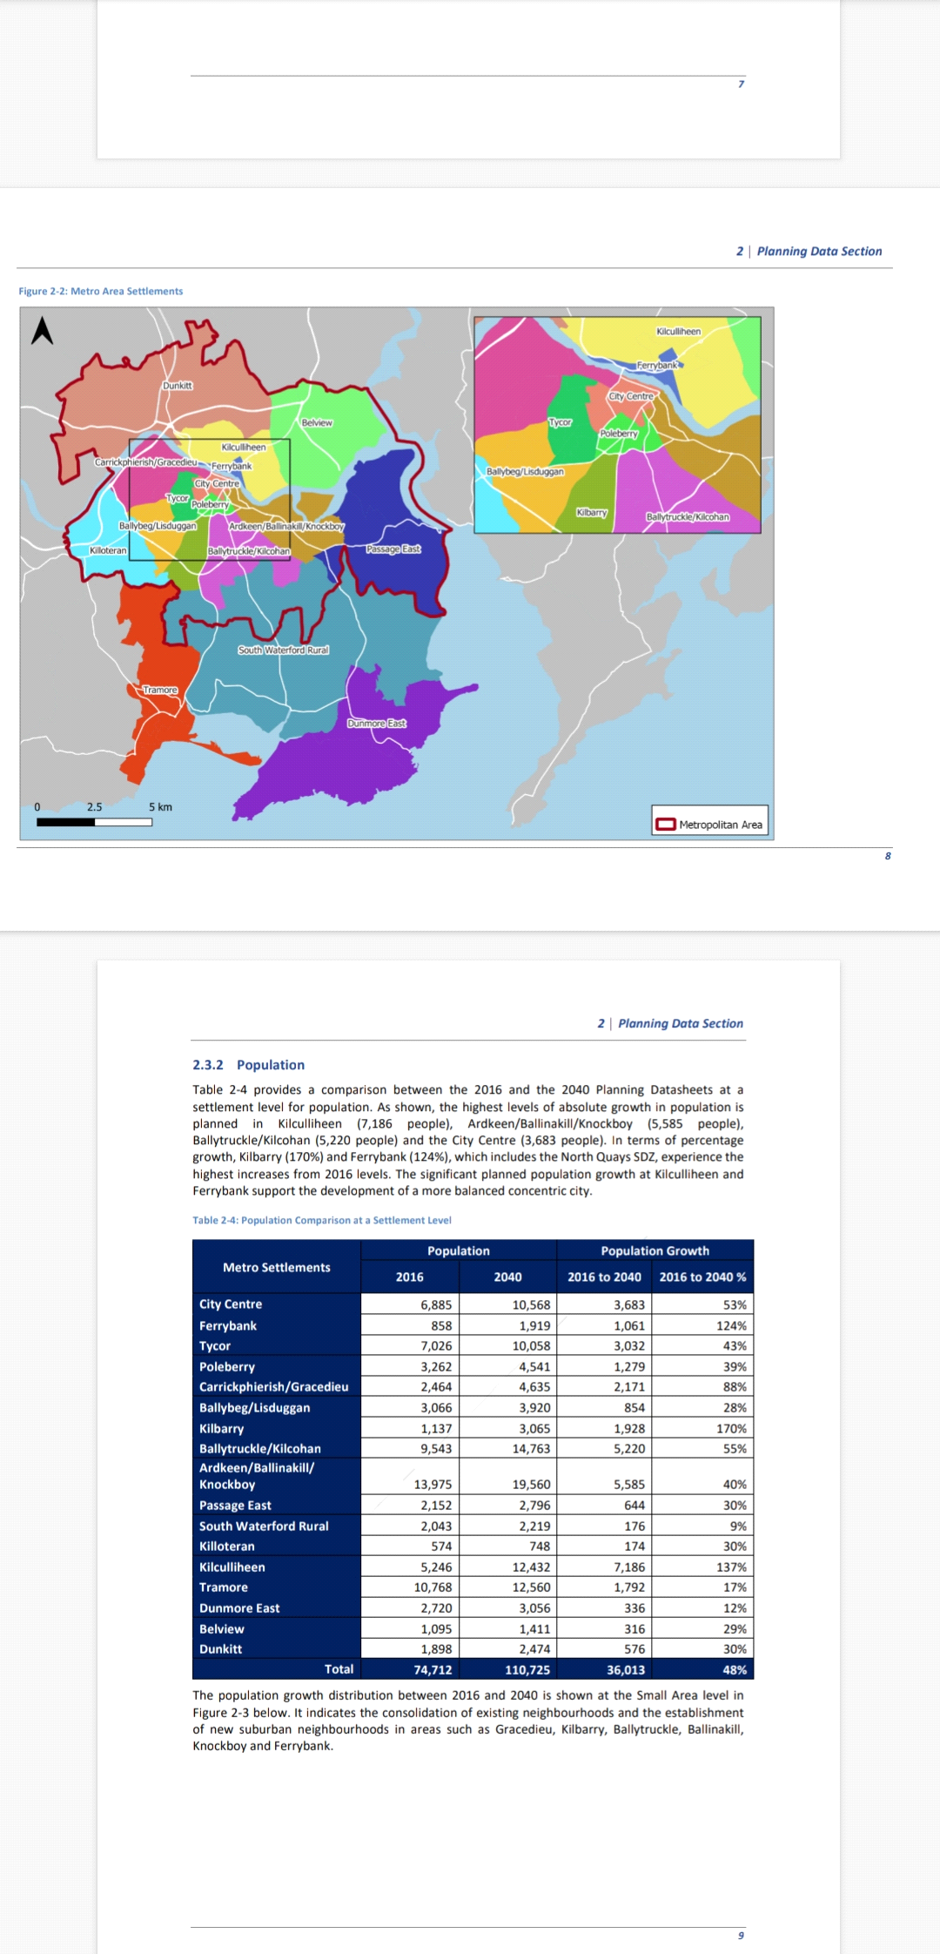

2040 growth prediction.
In Munster, Waterford has the fastest-growing county expanding by 9%
RSES predicts a 1.462 population increase in the north quay of Ferrybank by 2027 with the North quay major development green light to supply 300 + new apartments
this would certainly warrant a 5 seater for Waterford population allowing for the 9% projection growth to continue without further review into the future,

4
The population limit and retaining Carlow/Kilkenny as a 5-seater has also exceeded
the population of just under 30.000 per Td 2016 to 33.123 in 2023
with the change of Dail artificial border, I am suggesting this leaves 30,4096 per Carlow/Kilkenny TD
While my preference would be for Waterford to be a five-seat constituency as a gateway city
without going outside its boundaries, the above proposal indicates how
the issues in the Waterford/Carlow/Kilkenny constituencies could be resolved with minimum
county boundary breaches and by the addition of a 5 seater to Waterford and 5 seaters to Kilkenny /Carlow, with the reduction in population this allows in Carlow/ Kilkenny for fewer
boundary changes, Laois has the numbers for a 3 seat although Offaly falls short.
I would be obliged if you could acknowledge receipt of this submission
and also if you could indicate when the boundary changes
are likely to be decided.
Is mise le meas
Melissa O neill
13/3/2023

