Mr. Tim Carey,
Head of Electoral Operations,
An Coimisiún Toghcháin, The Electoral Commission
Dublin Castle,
Dublin 2.

Thursday 20 April 2023

Dear Mr. Carey,
I am writing to you as I understand that the Electoral Commission are again considering making changes to the Tipperary Constituency.
I live in Rathcabbin, Co. Tipperary in the northern end of electoral area of Borrisokane/Nenagh, known as Lower Ormond (see map attached). Our area was taken out of the Tipperary constituency and added to the Offaly constituency from 2016 to 2020.
As former chairperson of Rathcabbin Development Association, I felt that the normal chain of communication from councillor to TD to government did not function properly during 2016-2020, as the Offaly TDs were not heeded by Tipperary county council on several matters raised in our village such as proper street lighting and construction and repair of wheelchair accessible footpaths.
The Lower Ormond area is significant for tourism, agriculture and culture. It borders the River Shannon which will be a key source of water to the Dublin area in the future.
Rathcabbin is the site of a former illegal dump currently being decommissioned by Tipperary County Council. The completion of this project and subsequent use of this site will require close cooperation between Government representatives and Tipperary County Council. The people of Rathcabbin, in my opinion, will need to be represented by a Tipperary TD who is familiar with the history of this problem and to the Council decision makers.
For the above reasons, I urge the Commission not to remove Lower Ormond from the Tipperary Constituency again.

Yours sincerely
Darina Kelly
Darina Kelly

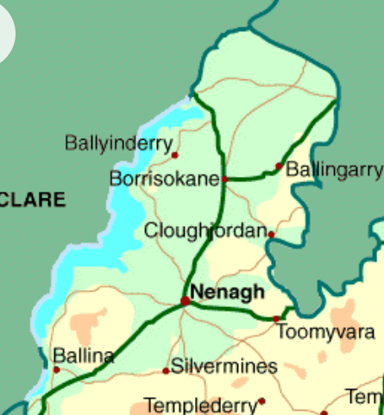
Rathcabbin

