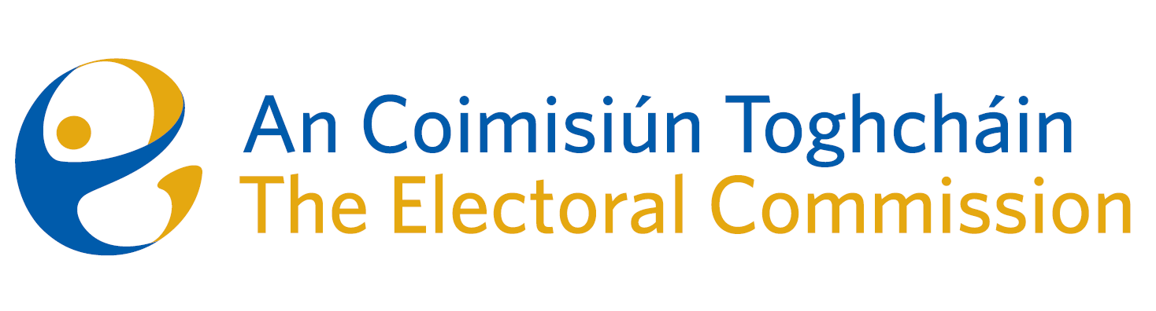
Meeting of An Coimisiún Toghcháin (ACT), The Electoral Commission.

Held in OPW, 1 Georges Quay, 8.00am – 11th May 2023

In attendance:
Coimisiún Members: Justice Marie Baker (Chairperson)*, Alex Attwood (AA), John Curran (JC), Ger Deering (GD)*, Maura Quinn (MQ), Peter Finnegan (PF), and Prof. Caroline Fennell (CF)*.

An Coimisiún Executive: Art O’Leary (AOL), Tim Carey (TC), Karen Kehily, Andrea Jones, Ian Stuart–Mills (ISM) and Aodha Molloy (AM)*.

* Justice Marie Baker, Ger Deering, Prof. Caroline Fennell and Aodha Molloy attended remotely on Zoom
------------------------------------
- Welcome
The Chairperson welcomed members.

The minutes from the previous meeting were approved.

- Conflict of Interest
No conflict of interest was declared

- Election Observation Opportunities
Commission members considered a recent circular from the Dept. Of Foreign Affairs and Trade seeking expressions of interest from those interested in applying to be a member of Ireland’s next International Election Observation Roster and a request that the Electoral Commission play a part in the recruitment process for new observers. Ireland's current International Election Observation Roster is due to expire on 31 December 2023.

- Constituency Review
Commission members continued their consideration of the review of constituencies for Dáil Éireann and the European Parliament.

- AOB
The Commission considered correspondence from the Department of Justice as part of the public consultation on the role of Sheriffs. The Commission members agreed to reflect on the matter and will return to it at the next meeting.

Dates of the next meetings are 18th May and 1st June.

__________________
Ms. Justice Marie Baker (signed)
Chairperson

