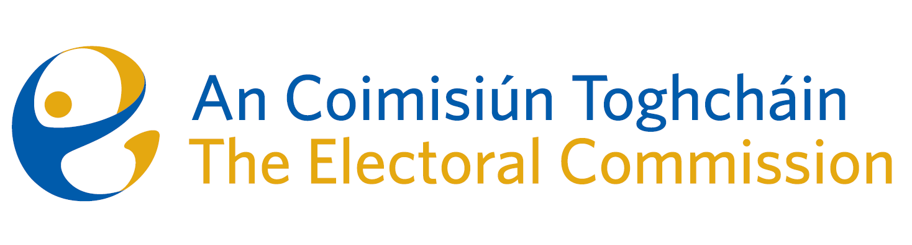
Meeting of An Coimisiún Toghcháin (ACT), The Electoral Commission.

Held in the Office of the Ombudsman, 4.30pm – 25th April 2023
In attendance:
Coimisiún Members: Justice Marie Baker (Chairperson)*, Alex Attwood (AA)*, John Curran (JC), Ger Deering (GD), Maura Quinn (MQ) and Prof. Caroline Fennell (CF)*.

An Coimisiún Executive: Art O’Leary (AOL), Tim Carey (TC), Karen Kehily, Ian Stuart–Mills (ISM) and Aodha Molloy (AM)*.

Apologies
Peter Finnegan

* Justice Marie Baker, Prof. Fennell, Alex Attwood and Aodha Molloy attended remotely on Zoom
------------------------------------
- Welcome
The Chairperson welcomed members.

The minutes from the previous meeting were approved.

- Conflict of Interest
No conflict of interest was declared

- Code of Conduct
The Commission approved the Code of Business Conduct and Ethics Requirements.

- Judgment on the Seanad Franchise
The Chair provided a briefing on the Supreme Court Judgment in the case of Heneghan v the Minister for Housing, Planning and Local Government on the matter of the constitutionality of the Seanad Franchise.

- Constituency Review
Commission members continued their consideration of the review of constituencies for Dáil Éireann and the European Parliament.

- AOB
Dates of the next meetings are 11th, 18th and 23rd May.

__________________
Ms. Justice Marie Baker (signed)
Chairperson

