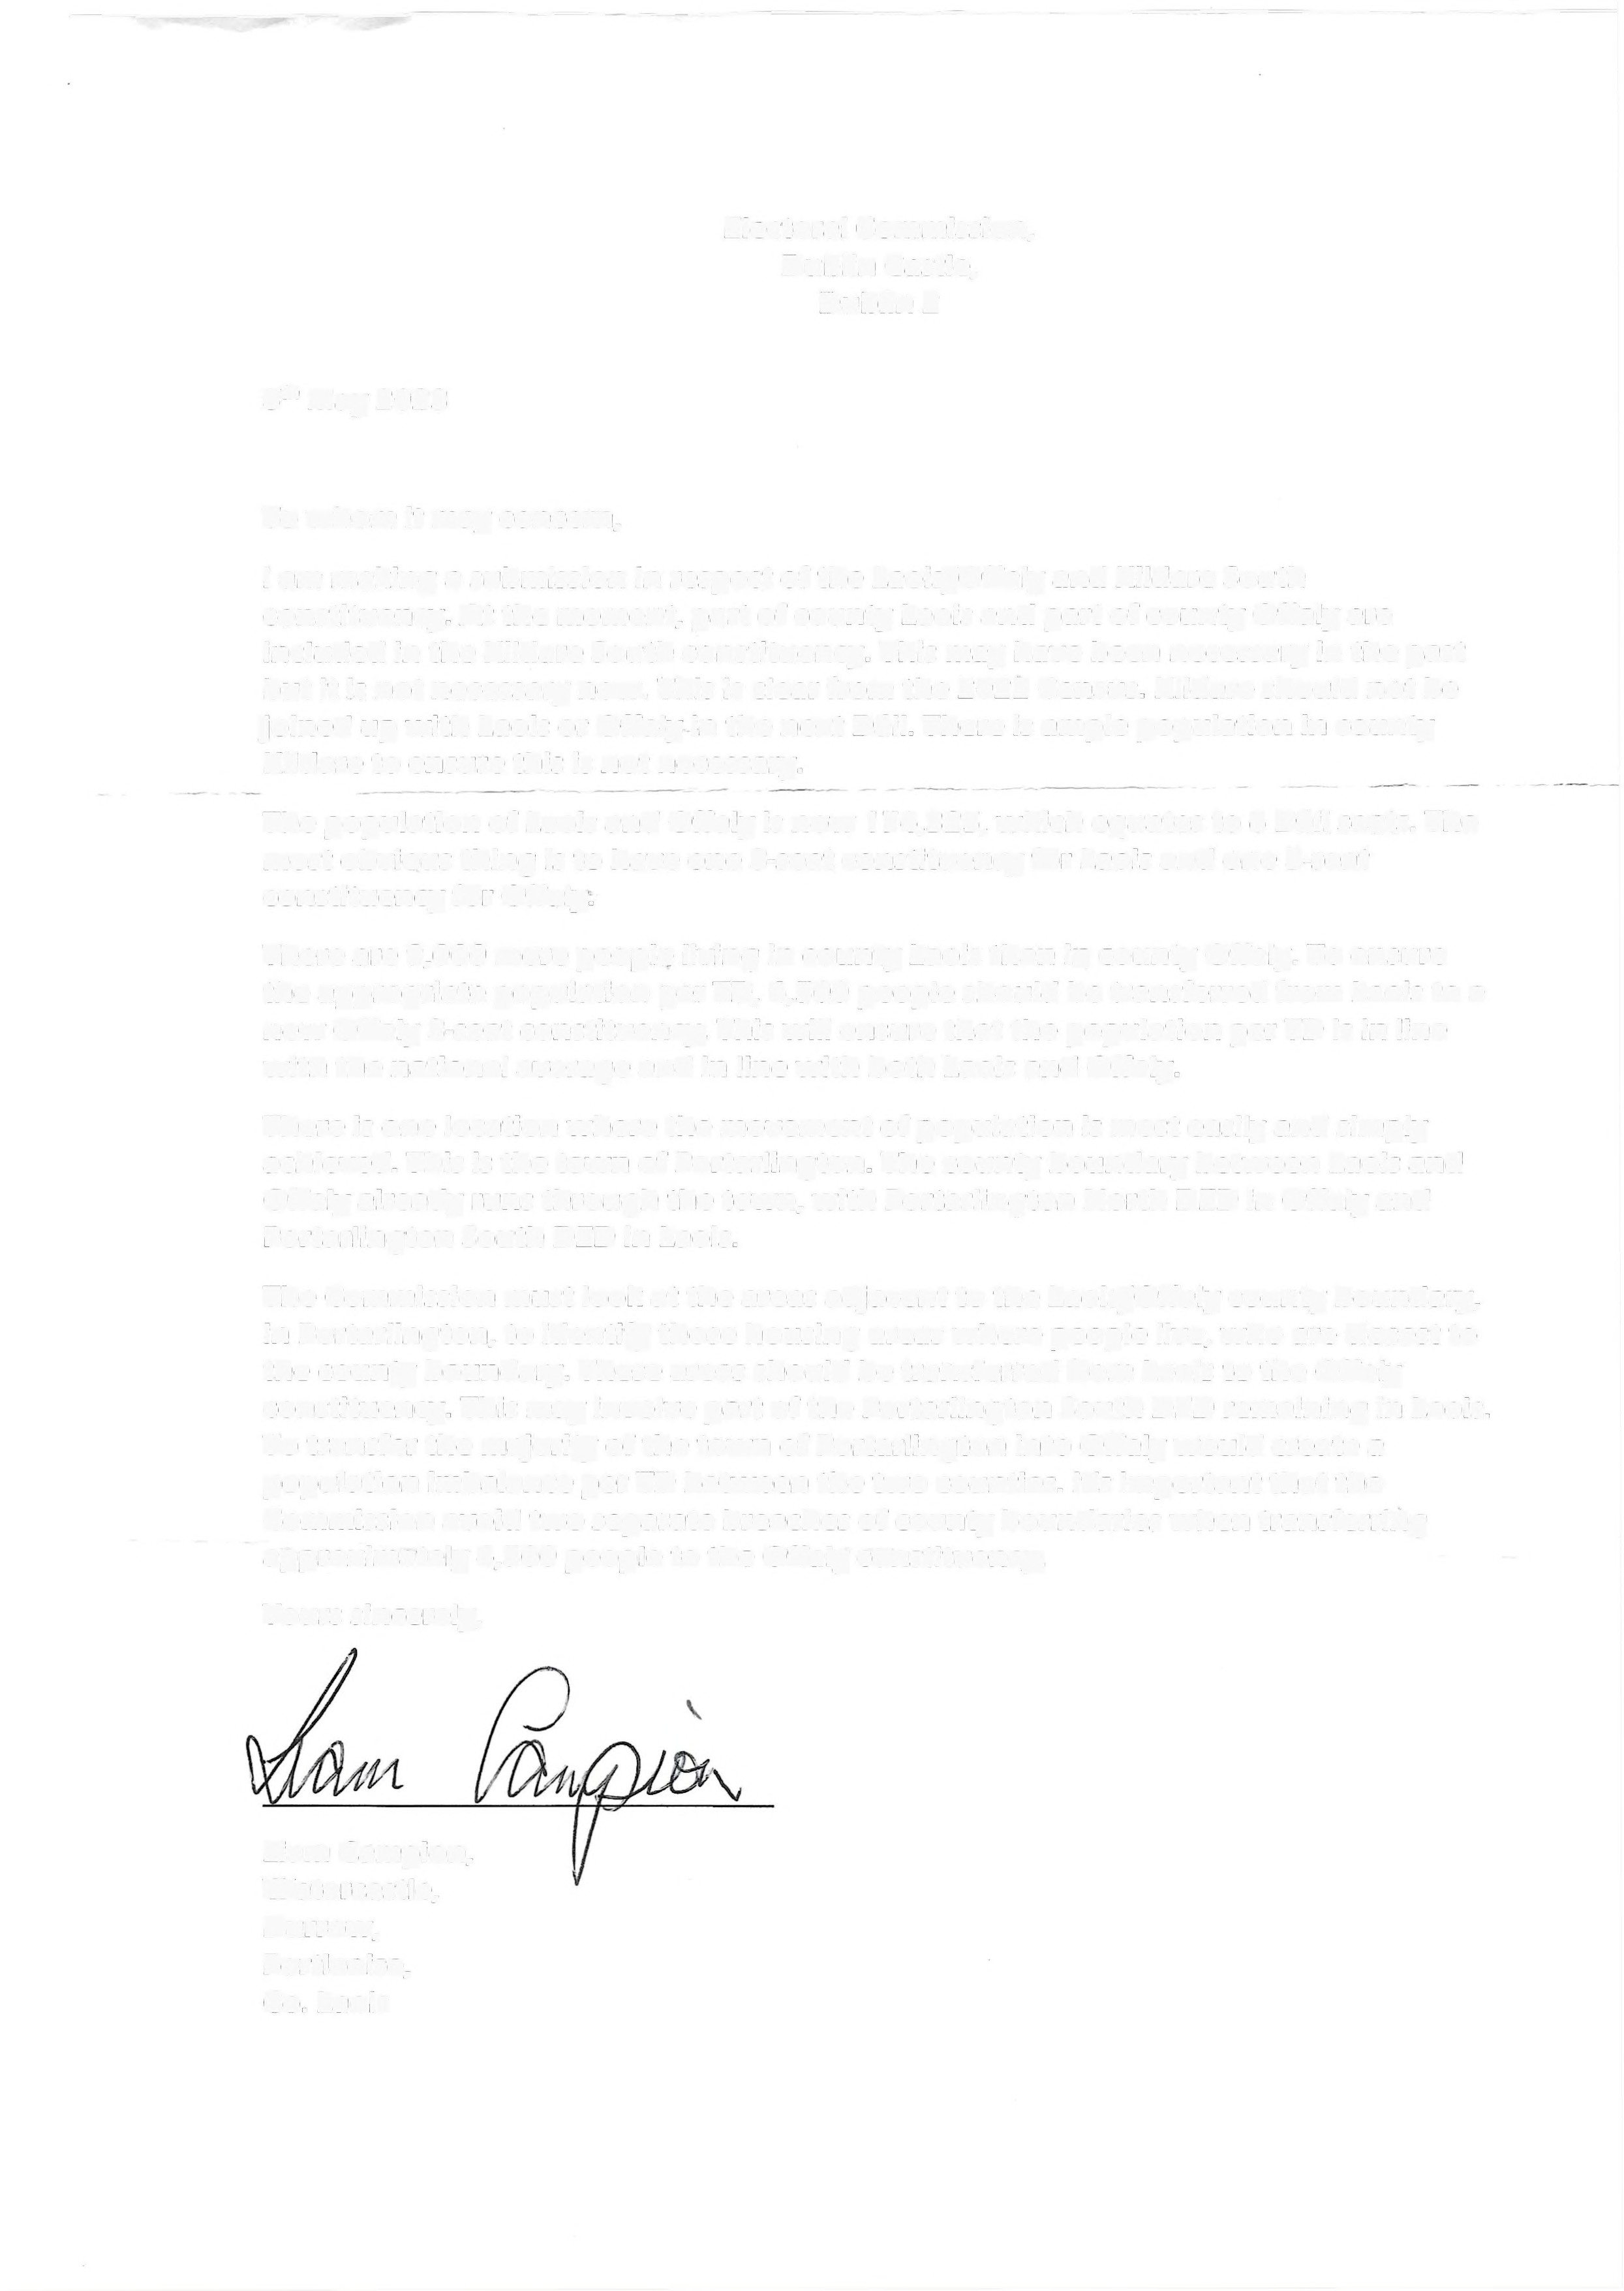-------------- --- -- ----------- ---------- ------

Electoral Commission, Dublin Castle, Dublin 2

8" May 2023

To whom it may concern,

I am making a submission in respect of the Laois/Offaly and Kildare South constituency. At the moment, part of county Laois and part of county Offaly are included in the Kildare South constituency. This may have been necessary in the past but it is not necessary now. This is clear from the 2022 Census. Kildare should not be joined up with Laois or Offaly in the next Dail. There is ample population in county Kildare to ensure this is not necessary.

The population of Laois and Offaly is now 174,325, which equates to 6 Dail seats. The most obvious thing is to have one 3-seat constituency for Laois and one 3-seat constituency for Offaly.

There are 9,000 more people living in county Laois than in county Offaly. To ensure the appropriate population per TD, 4,500 people should be transferred from Laois to a new Offaly 3-seat constituency. This will ensure that the population per TD is in line with the national average and in line with both Laois and Offaly.

There is one location where the movement of population is most easily and simply achieved. This is the town of Portarlington. The county boundary between Laois and Offaly already runs through the town, with Portarlington North OED in Offaly and Portarlington South OED in Laois.

The Commission must look at the areas adjacent to the Laois/Offaly county boundary, in Portarlington, to identify those housing areas where people live, who are closest to the county boundary. These areas should be transferred from Laois to the Offaly constituency. This may involve part of the Portarlington South OED remaining in Laois. To transfer the majority of the town of Portarlington into Offaly would create a population imbalance per TD between the two counties. It's important that the Commission avoid two separate breaches of county boundaries when transferring approximately 4,500 people to the Offaly constituency.

Yours sincerely,

Liam Campion

