DAIL CONSTITUENCY BOUNDARY PROPOSAL FOR NORTH DUBLIN and CORK COUNTY

Premis:
The 2022 Electoral Commission has been established to review the existing Dail Constituency Boundaries and to increase the number of TD’s to comply with Article 16.2.2 of the Constitution.
Scope:
To present, outline and justify Boundary Change proposals for the North Dublin and Cork County Dail Constituencies and to ensure that such proposals meet the parameters of the Constituency Boundary Commission.

Base Line Assumptions for Proposals:
Census 2022 Population: 5,123,536
Current Population per TD: 32,022 based on 160no. TD’s.
Proposed Number of TD’s for this Submission: 178no.
Proposed Population per TD based on 178no. TD’s: 28,784.
The proposed number of TD’s at 178 no. represents an increase of 18no. over the current allocation.
The increase of 18no. allows a greater degree of flexibility to the Commission in terms of balancing the constituency population.
Nominal Population per Constituency based on 178no. TD’s:
3 SEATS | 86,352
4 SEATS | 115,136
5 SEATS | 143,920

- NORTH DUBLIN
Current Constituency Population and Seat Allocation:
Constituency | Current Population | SEATS | Current Population Variance % (160 seats) | Assumed Population Variance % (178 seats)
Dublin West | 134,331 | 4 | +4.87% | +16.7%
Dublin Fingal | 170,690 | 5 | +6.61% | +18.6%
Dublin Central | 123,165 | 4 | -3.84% | +7%
Dublin North West | 90,219 | 3 | -6.09% | +4.4%
Dublin Bay North | 155,905 | 5 | -2.63% | +8.3%
 |  | 21

Proposal:
- Increase the number of Dail Seats from 21no. to 23no.
- Retain Dublin Fingal as a 5 seat constituency by transferring 5 Electoral Divisions to a new Dublin North East Constituency
- Abolish the existing Dublin Bay North Constituency to create 2no. 3 seat constituencies, Dublin North East and Dublin North Central
- Retain Dublin North West as a 3 seat constituency by transferring Electoral Divisions from Dublin Bay North and to Dublin West.
- Increase Dublin West to a 5 seat constituency by transferring Electoral Divisions from the western and northern parts of Dublin North West and the Dubber Electoral Division from Dublin Fingal.
- Retain Dublin Central as a 4 seat constituency with minor Electoral Division amendments.

Proposed Constituency Population and Seat Allocation:
Constituency | Proposed Population | Proposed SEATS | Proposed Population per Seat | Proposed Population Variance %
Dublin West | 144,343 | 5 | 28,869 | +0.2%
Dublin Fingal | 144,394 | 5 | 28,879 | +0.3%
Dublin North East | 88,024 | 3 | 29,341 | +1.9%
Dublin North Central | 88,474 | 3 | 29,491 | +2.5%
Dublin North West | 87,707 | 3 | 29,236 | +1.5%
Dublin Central | 119,833 | 4 | 29,958 | +4%
TOTAL PROPOSED SEATS |  | 23

Details:

- The transfer of Blanchardstown-Abbotstown (part containing Dunsink, Dunsogley), The Ward (part containing Cappagh) and the Dubber (including Lanesborough and Meakestown) LEA’s from Dublin North West to Dublin West.
- The transfer of Dubber, Kinsaley, Balgriffen, Portmarnock North, Portmarnock South Electoral Divisions from Dublin Fingal to retain Dublin Fingal as a 5 Seater.
- The abolishment of Dublin Bay North to create two new 3 seat constituencies: Dublin North East and Dublin North Central.
- The retention of Dublin North West as a 3 Seater gaining Kilmore A ED and Botanic A ED and losing part of Dubber ED south of the M50, and parts of Blanchardstown-Abbotstown and The Ward ED’s to Dublin West.
- The retention of Dublin Central as a 4 seater losing Botanic A ED to Dublin North West.
See Appendix A for ED Breakdown

Mapped Proposal:
Shaded Areas – Current Constituency Boundaries
Red Lines- Proposed Constituency Boundaries

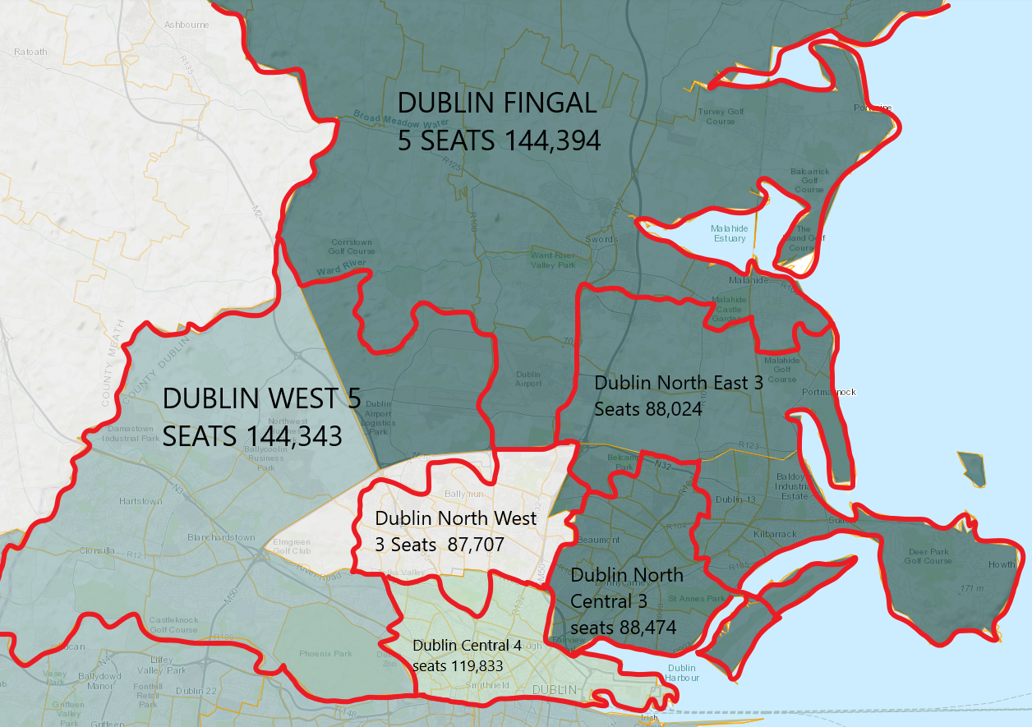
APPENDIX A
ED Transfer from Dublin North West to Dublin West
Dubber | 8,112
Blanchardstown Abbotstown(part) & The Ward (part) | 1,200

ED Transfer from Dublin Fingal to Dublin West:
Dubber (part) | 800

ED Transfer from Dublin Fingal to Dublin North East
Kinsaley | 11,542
Portmarnock North | 4,050
Portmarnock South | 4,781
Balgriffen | 5,536

ED Transfer from Dublin Bay North to Dublin North East
Baldoyle | 8,106
Sutton | 5,773
Howth | 8,439
Raheny Foxfield | 2,535
Raheny Saint Assam | 3,907
Grange D | 3,946
Grange A | 12,552
Grange B | 7,441
Grange C | 3,035
Raheny Greendale | 2,258
Grange E | 2,566
Priorswood A | 1,587

ED Transfer from Dublin Bay North to Dublin North West
Kilmore A | 3,624

ED Transfer from Dublin Central to Dublin North West
Botanic A | 3,176

- CORK COUNTY

Nominal Population per Constituency based on 178no. TD’s:
3 SEATS | 86,352
4 SEATS | 115,136
5 SEATS | 143,920

Current Constituency Population and Seat Allocation:
Constituency | Current Population | SEATS | Current Population Variance % (160 seats) | Assumed Population Variance % (178 seats)
Cork East | 130,930 | 4 | +2.22% | +13.7%
Cork North Central | 131,341 | 4 | +2.54% | +14%
Cork South Central | 130,716 | 4 | +2.05% | +13.5%
Cork North West | 96,012 | 3 | -0.66% | +11.2%
Cork South West | 92,232 | 3 | -3.99% | +6.8%
Total | 581,231 | 18

Proposal:
- Increase the number of Dail seats from 18no. seats to 20no.
- Increase Cork East to form a 5 seat constituency
- Increase Cork South Central to form a 5 seat constituency
- No change in seat allocation to Cork South West, Cork North West and Cork North Central.
Details:
- Retain Cork North Central as a 4 seat constituency, transferring 3no. ED’s to Cork East.
- Retain Cork South West as a 3 seat constituency by transferring 10no. ED’s from the Kinsale Area to Cork South Central and bringing in 17no. ED’s from Cork North West to balance the population.
- Retain Cork North West as a 3 seat constituency by transferring 17no. ED’s to Cork South West.
See Appendix B for ED Breakdown
Proposed Constituency Population and Seat Allocation:
Constituency | Proposed Population | Proposed SEATS | Proposed Population per Seat | Proposed Population Variance %
Cork East | 145,733 | 5 | 29,147 | +1.2%
Cork North Central | 116,538 | 4 | 29,135 | +0.1%
Cork South Central | 144,285 | 5 | 28,857 | +0.1%
Cork North West | 87,099 | 3 | 29,033 | +0.1%
Cork South West | 87,526 | 3 | 29,175 | +0.1%
TOTAL | 581,231 | 20

Mapped Proposal:
Shaded Areas – Current Constituency Boundaries
Red Lines- Proposed Constituency Boundaries

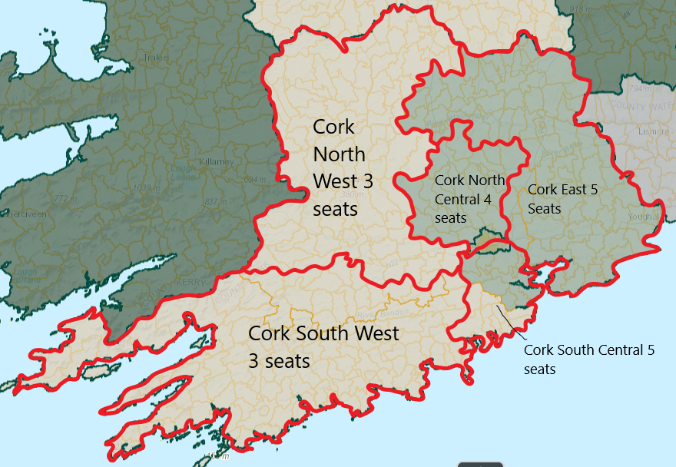

APPENDIX B

ED Transfer from Cork North Central to Cork East:
Watergrasshill | 1,925
Riverstown | 4,783
Caherlag | 8,095

ED Transfer from Cork South West to Cork South Central:
Ballymartle | 1,379
Cullan | 581
Ballyfeard | 396
Farrianbrien | 529
Ballyfoyle | 401
Nohaval | 343
Kinure | 404
Kilmanage | 1341
Kinsale Rural | 5,582
Kinsale Urban | 2,613

ED Transfer from Cork North West to Cork South West:
Ballymurphy | 998
Brinny | 659
Templemartin | 824
Murragh | 541
Teadies | 985
Bengour | 315
Castletown | 493
Kenneigh | 436
Manch | 585
Aultagh | 376
Coolmountain | 441
Garrown | 295
Beal na Gorthaigh | 203
Bealock | 280
Carrigboy | 535
Greenville | 301
Terelton | 646

ENDS.

