Maurice Glynn

Co. Carlow Boundary Review
Electoral Commission
Custom House
Dublin 1

County Carlow Submission

To Whom it may Concern

I wish to the following proposal in respect of County Carlow to the boundary review

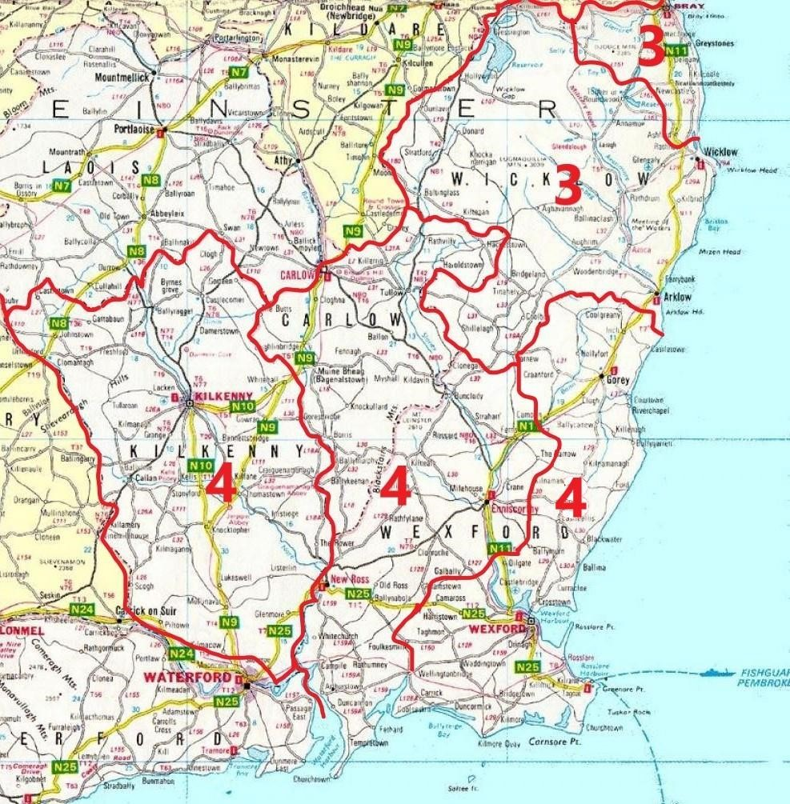

The population for the existing three 5 seat constituencies of Carlow-Kilkenny, Wexford and Wicklow is set out in the table below, with the number of deputies per 30,000 of population

County | Population | Seats
Carlow | 61931 | 2
Kilkenny | 103 685 | 3.5
Wexford | 163527 | 5.5
Wicklow | 155485 | 5.2
Total | 484638 | 16.2

However, there is a need to future proof the boundary review and please find below the number of deputies if the average ratio per Dail deputy was 27,000:1

County | Population | Seats (27k:1)
Carlow | 61931 | 2.3
Kilkenny | 103685 | 3.8
Wexford | 163527 | 6.1
Wicklow | 155485 | 5.8
Total | 484638 | 18

I propose:

- There is no need to split County Carlow between two other constituencies.
- Regrettably County Wexford must now be split into two constituencies in any circumstance
- County Carlow be combined with the Wexford municipal districts of Enniscorthy and New Ross to form a new four seat constituency
- County Kilkenny does not need to be split and can be a stand-alone four seat constituency
- County Wicklow can be split into two constituencies without the need to take territory for either new constituency from another county

Constituency | Number of TDs | Pop per deputy
Carlow/West Wexford | 4 | 28,000  (approx.)
Kilkenny | 4 | 26,000  (approx.)
Wexford East | 4 | 28,000  (approx.)
Wicklow North East | 3 | 26,000  (approx.)
Wicklow South West | 3 | 26,000  (approx.)

Thank you for reading my submission

Maurice Glynn

