Members of the Commission,
I wish you well with your deliberations. It is no easy task to make the required changes and fulfil your terms of reference. My submission relates to the Waterford Dáil Constituency. At the outset I would preface my remarks by saying it is essential that the county boundary of Waterford is not breached to bolster the neighbouring populations of Cork, Tipperary or Kilkenny.
Waterford is designated as a strategic growth centre under National spatial policy and all indicators are that this growth will continue (+9% between 2016-2022 – exclusive of growth in the Kilkenny administrative area which is earmarked for significant growth on the back of the North Quays project). The National Planning framework states that the minimum growth of population for Waterford city and suburbs to 2040 is 27,000-32,000.
I have laid out a number of options below based on the status quo and the addition of part of South Kilkenny to form a new 5 seat constituency. The latter could have the dual benefit of helping to resolve the issues with the Carlow-Kilkenny constituency which is also overpopulated for its current 5 seat Carlow-Kilkenny constituency.

Option 1 – County of Waterford (4 seats)
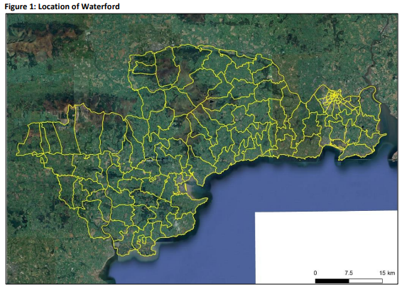
At 127,087 population, Waterford is at 5.9% variance with the 1 TD to 30,000 population ratio. In order to get below the accepted ratio, a significant area would have to be hived off to a neighbouring constituency which would disenfranchise the electors in this area. It really is not easy to take 7,087 population and its corresponding land area from Waterford without creating further knock on effects in the neighbouring constituencies.
Therefore, it would be preferable for Waterford to remain as a 4 seat constituency with its county boundary intact even if this means being at variance with the ratio i.e.no alteration required.
Option 2 – Waterford-South Kilkenny (5 seats)
Southern Regional Assembly RSES – Waterford Metropolitan Area Strategic Plan
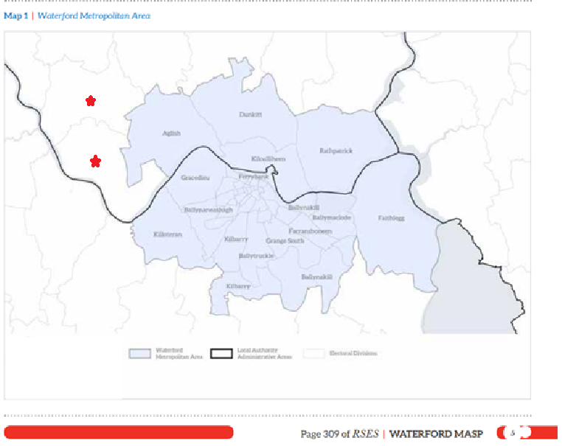
The Waterford Metropolitan Area Strategic Plan encompasses four electoral divisions within the Kilkenny administrative area namely Aglish (967), Dunkitt (988), Rathpatrick (1130) and Kilkulliheen (5,755). The combined population of the four areas is 8,840. The electoral division of Portnascully (1133) and Pollrone (1498) marked with a red star are contiguous to these 4 areas and form a natural arc around Waterford city & its environs. The inclusion of both of these two electoral divisions would bring the combined total of the six electoral divisions to 11,471.
If this is combined with the population of Waterford (127,085) it would bring the population of a potential Waterford and South Kilkenny Dáil Constituency to 138,556 which would justify a 5 seat constituency (27,711 population per TD). While this may be considered on the lower side of the TD to population ratio (depending on the final number of TD’s decided by the commission), consideration must be given to the fact Waterford experienced a 9.4% population increase in Census 2022. It is essential therefore that sufficient headroom is built into the Waterford Dail constituency figures. Waterford is designated as a strategic growth centre under National spatial policy and all indicators are that this growth will continue, with a significant portion of population growth being in the Kilkenny administrative area of the MASP. The National Planning framework states that the minimum growth of population for Waterford city and suburbs to 2040 is 27,000-32,000.
Summary
Waterford-South Kilkenny = Entire County boundary of Waterford plus Kilkenny electoral divisions of Aglish, Dunkitt, Rathpatrick, Kilkulliheen, Portnascully and Pollrone. Total population = 138,556 (27,771: 1 TD).

Option 3 – Waterford/South Kilkenny (5 seats)
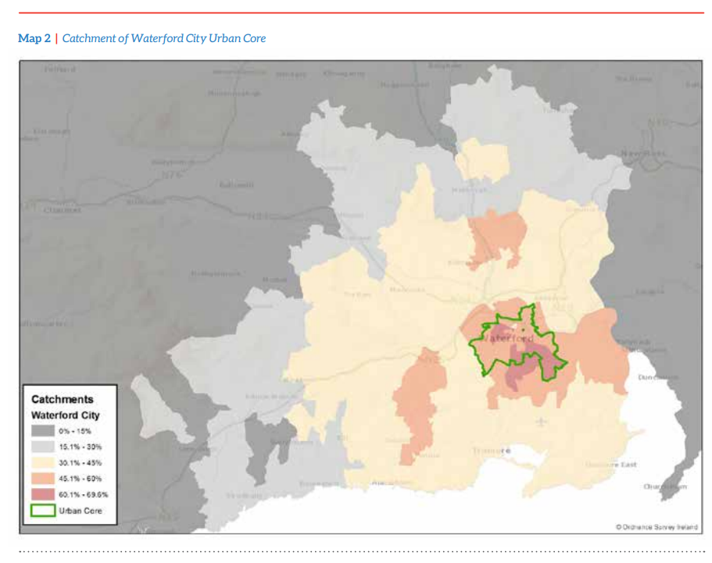
Map 2 of the Southern Regional Assembly RSES, Waterford Metropolitan Area Strategic Plan shows the wider catchment of working population to Waterford city. The areas shaded in light yellow show a catchment of between 30.1-45% which include a swathe of the Kilkenny administrative area - Ullid (1056), Kilahy (697), Ballincrea (345), Kilcolumb (610), Kilmakevoge (423) and the aforementioned Aglish (967), Dunkitt (988), Rathpatrick (1130), Portnascully (1133) and Pollrone (1498). Two electoral divisions shaded in orange - Rossinan (797) and the aforementioned Kilkulliheen (5,755) have a catchment of between 45.1%-60%. This shows a contiguous population of 15,399 within the Kilkenny administrative area that have a strong functional relationship to Waterford city. A natural connection therefore exists with Waterford city and an alignment of this area for national electoral purposes would be a natural fit.
When combined with the population of Waterford (127,085) it would bring the population of a potential Waterford and South Kilkenny Dáil Constituency to 142,484 which would comfortably justify a 5 seat constituency (28,496 population per TD), however it would not allow sufficient headroom for population growth as outlined in Option 2.
Summary
Waterford-South Kilkenny = Entire County boundary of Waterford plus Kilkenny electoral divisions of Aglish, Dunkitt, Rathpatrick, Kilkulliheen, Portnascully, Pollrone, Rossinan, Ullid, Kilahy, Ballincrea, Kilcolumb and Kilmakevoge. Total population = 142,484 (28,496: 1 TD).

Conclusion
It would appear that option 2 is the optimal configuration for the Waterford/South Kilkenny area. It would allow sufficient head room for the expected population growth in line with Project Ireland 2040. It would empower those who work in Waterford but reside in South Kilkenny to have a greater input and representation on the issues which impact their daily lives and it would assist with helping the variances at play within the existing Carlow-Kilkenny Dail constituency based on the 2022 census data.
However, should this option not be pursued, then option 1 of no alteration to the existing Waterford Dail constituency is preferable. It is more important for the county to remain intact as a homogenous unit with a higher variance, than it is to be within the 30,000:1 TD ratio.

