From: | Gerry Kelly
Sent: | Tuesday 9 May 2023 00:18
To: | ELC ConstituencyReview
Subject: | Submission

To Chair of the Electoral Commission, please find attached my submission in relation to Wicklow/Kildare. I believe the easiest way to address the issue in Wicklow is to transfer a population from Blessington into
Kildare. This would allow Wicklow to remain a 5-seater white allowing Kildare to become a 4 and 5 seater.

Regards

Gerry Kelly

-----------------------------------------------------------------

Introduction

There is a population and geographic imbalance in Wicklow due to the growth of the North Wicklow area from Blessington to Bray.

In order to retain Wicklow as a 5-seat constituency it will be necessary to transfer population to another constituency.

The fact that the town of Blessington has already grown into the County of Kildare and will expand further in the coming years the incorporation of the area in Kildare makes sense.

The business and social and economic activity in the area is also significantly co-dependent on Kildare and its neighbouring towns.

Option:

- Wicklow to transfer Blessington into Kildare. Such that Wicklow can form a 5-seat constituency.
Statistics:

Area | Population | Number of EDs
Wicklow | 155485 |  | 82
Wicklow (5 seats no Blessington) | 145470 |  | 76

Constituency | 177 | 178 | 179 | 180 | 181
Wicklow (5 seat no  Blessington) | 5.03 | 5.05 | 5.08 | 5.11 | 5.14

Notes:
- Based off the 5% variance rule the following is true
○ Valid 5 seat constituencies can form for 4.75 - 5.25

In the above table any cell highlighted green, is a configuration that can form a valid constituency within the 5% variation rule.
- Wicklow (No Blessington)

EDs: Wicklow (Excluding Blessington)
This table shows the EDs to be transferred to Kildare. The remaining EDs within Wicklow will make up our proposed Wicklow constituency.

ED_ID | ENGLISH | GAEILGE | CSOED_3409 | Electoral_Division | Population
257046 | KILBRIDE | Cill Bhríde | 15021 | Kilbride, Co.Wicklow, | 1080
257073 | TOGHER | An Tóchar | 15030 | Togher, Co.Wicklow, | 381
257054 | LACKAN | An Leacain | 15022 | Lackan, Co.Wicklow, | 839
257041 | HOLLYWOOD | Cillín  Chaoimhín | 15017 | Hollywood, Co.Wicklow, | 827
257019 | BURGAGE | An Bhuiríos | 15011 | Burgage, Co.Wicklow, | 2304
257016 | BLESSINGTON | Baile Coimín | 15010 | Blessington, Co.Wicklow, | 4584

Wicklow (Excluding Blessington)

Map 1 : EDs that make up suggestion plus LEAs
- Segments coloured blue are the EDs that would make up the proposed Wicklow 5-seater
- The red area is the part of Baltinglass local electoral area that would be transferred into Kildare

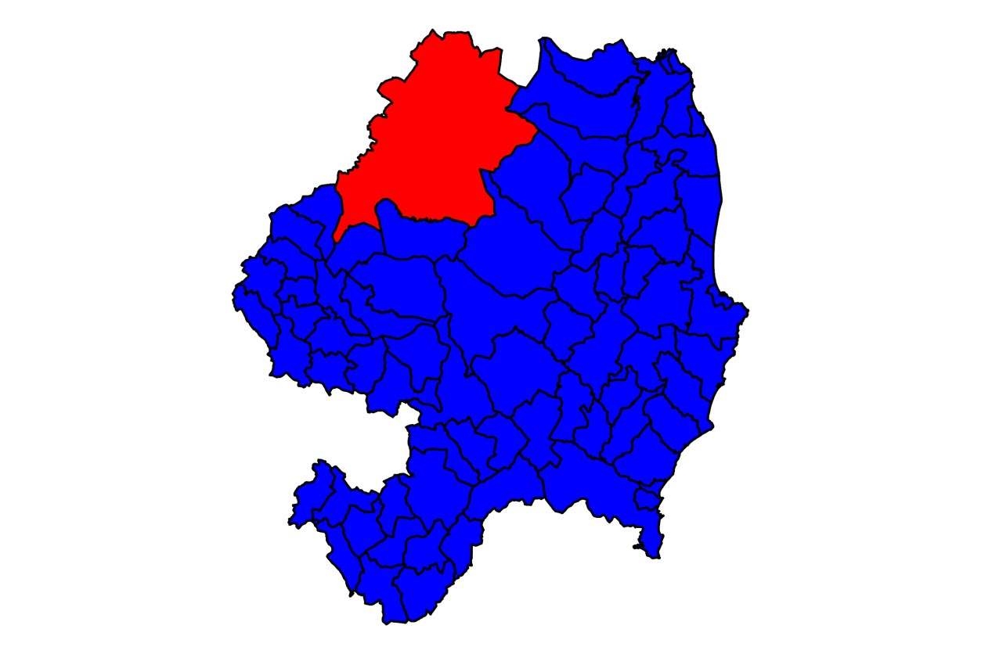

Map 2 : EDs that make up suggestion and EDs that Do not
● Segments coloured blue are the EDs that would make up the proposed Wicklow 5-seater
● The yellow EDs are the ones we suggest be transferred to Kildare.
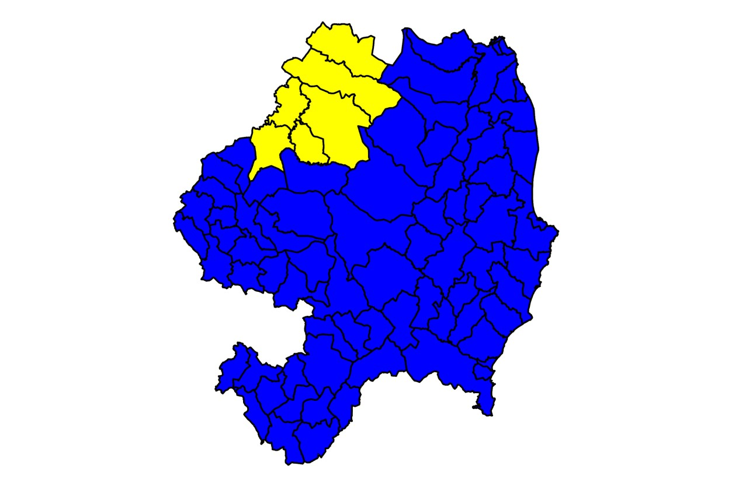

Impact On Kildare
This section outlines some brief notes about the impact of transferring Blessington into Kildare
- If we consider Kildare as a standalone county
  - Population: 246977
○ 171-174 can be split into two four seat constituencies while maintaining county boundaries
○ From 178-181 can sustain 9 seats while maintaining county boundaries.

- By transferring the Blessington region (highlighted in Yellow), Kildare can form a 5 seat and 4 seat constituency at 171-181 seat Dáil.

- Currently Kildare North and Kildare South are not able to form valid constituencies within the 5% variance
  - Except for Kildare South at 171 seats

- This submission would allow Wicklow to form a 5 seat constituency. While allowing Kildare sufficient population to divide itself such that the total number of seats sum to 9
  - 4 + 5 or 3 + 3 + 3

