Joint Submission by Dublin Mid West Fine Gael Constituency Executive
& Dublin South West Constituency Fine Gael Constituency Executive

To: constituencyreview@electoralcommission.ie

The Secretary
An Coimisiún Toghcháin, Dublin Castle,
Dublin 2

May 9th 2023

Dear Commission Secretary

The Dublin Mid West Fine Gael and Dublin South West Fine Gael Constituency Executives wish to make a joint submission regarding the reconfiguration of Dail constituencies within the South Dublin County Council administrative area.

Introduction

Our submission to the Constituency Review follows the hierarchy below:

• Dublin Region
• Four Dublin Counties
• South Dublin County Council
• District Electoral Divisions
• Neighbourhoods

Dublin Region

Although the requirement to avoid breaching of county boundaries as far as practicable does not apply between any of the two counties within the Dublin Region, given the radical and substantial revision of constituency boundaries required on foot of census 2022, the four Dublin local authorities do provide a good starting point in terms of grouping neighbourhoods that will form the basis of the new Dail constituencies post 2023.

The requirement for there to be a ratio of 30000 residents to each Dail deputy means a total of 49 deputies across the Dublin region.

Four Dublin Counties

This approximates to a breakdown of deputies by the four Dublin local authorities as follows:

Local Authority | Population 2022 | Required Number of TDs
Dublin City | 588,233 | 20
Dun Laoghaire Rathdown | 233,457 | 8
Fingal | 329,218 | 11
South Dublin | 299,793 | 10
Total | 1,450,701 | 49

SOUTH DUBLIN COUNTY COUNCIL (SDCC)

SDCC's population of 299,793 in census 2022 neatly equates neatly to the population for 10
Dail seats.

At present SDCC covers the entirety of two Dail Constituencies and part of one other:
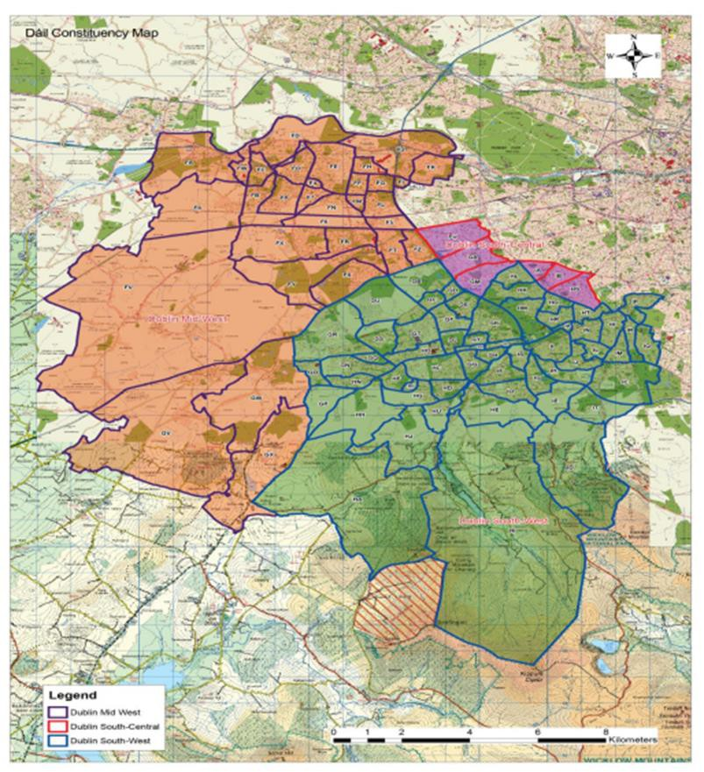

• Dublin Mid West is located entirely within SDCC and is co terminus with the local authority’s boundaries at the River Liffey (Fingal) and Counties Kildare and Wicklow to the West (coloured peach on map)
• Dublin South West is located entirely within SDCC and is co terminus with the local
authority’s boundaries at County Wicklow to the South and DLRCC to the East
(coloured green on map)
• The three electoral divisions of Templeogue Kimmage Manor, Terenure Perrystown and Terenure Cherryfield are all in the Dublin South Central constituency. (coloured purple on map)

Dublin Mid West and Dublin South West’s co terminus boundaries with SDCC have been advantageous in terms of clarity of representation and simplicity for citizens as to who their public representatives are should they wish to seek assistance or representation on behalf of their community.

The fact that census 2022 clearly shows that SDCC’s population equates the requirement for
10 Dail Deputies, this should result in the SDCC region having two 5 seat constituencies within it to ensure maximum proportionality.

At present Dublin Mid West elects 4 deputies and Dublin South West 5 deputies. To ensure maximum proportionality we submit that:

• The boundaries of the existing Dublin Mid West and South West constituencies remain largely the same with the exception of the transfer the Citywest area from Dublin South West to Dublin Mid West
• This solution will bring Dublin Mid West’s population up to the threshold for a 5 seat constituency while reducing Dublin South West’s population sufficiently to bring it back under the threshold for a 5 seat constituency
• The three electoral divisions of Templeogue Kimmage Manor, Terenure Perrystown and Terenure Cherryfield would all remain in the Dublin South Central constituency.

The above configuration would ensure proportionality and maximum continuity in representative institutions for citizens.

District Electoral Divisions

The existing District Electoral Divisions (DEDs) were drafted 40 years ago, when much of the western parts of Dublin Mid West and Dublin South West were rural with a population that is a fraction of what it is today.

The intervening 40 years has seen the extensive development of new neighbourhoods including:

• The further expansion of Tallaght to the west with substantial new estates in
Jobstown and Brookfield
• The expansion of Saggart from a rural village to a suburb connected to the surrounding neighbourhoods
• The establishment of an entirely new neighbourhood of Citywest between Jobstown and Saggart

The DEDs of Tallaght-Jobstown and Tallaght-Fettercairn each have a population of 17,957 and 11,289 respectively. Not only is the population of each DED enormous, but they do not correspond to any of the modern neighbourhood or community identities making it difficult for the Electoral Commission members find an appropriate boundary to replace the existing DMW/DSW boundary along the river Camac and N7.

To complicate matters further there are sections of the DED boundary between Tallaght- Jobstown and Tallaght-Fettercairn that no longer exist, as the lane used for the DED boundary was closed many years ago and subsequently built upon.
DEDs that form the cohesive core of Dublin South West

Rathfarnham
The following electoral divisions form the cohesive community of Rathfarnham and should be retained fully within DSW and not divided between constituencies
• Ballyboden,
• Edmondstown
• Rathfarnham-Ballyroan
• Rathfarnham-Butterfield
• Rathfarnham-Hermitage
• Rathfarnham-St. Endas
• Rathfarnham Village

Firhouse & Knocklyon
The following electoral divisions correspond to the neighbourhoods of Firhouse & Knocklyon and should be retained fully within DSW and not divided between constituencies
• Bohernabreena,
• Firhouse-Ballycullen,
• Firhouse-Knocklyon
• Firhouse Village

Tallaght
The following electoral divisions form the cohesive community of Tallaght and should be retained fully within DSW and not divided between constituencies
• Tallaght-Avonbeg
• Tallaght-Belgard
• Tallaght-Glenview
• Tallaght-Kingswood
• Tallaght-Killinardan
• Tallaght-Millbrook
• Tallaght-Oldbawn
• Tallaght-Springfield
• Tallaght-Tymon
• Tallaght-Kilnamanagh
• Tallaght-Kiltipper

Templeogue
The following electoral divisions form the cohesive community of Templeogue and should be retained fully within DSW and not divided between constituencies
• Templeogue-Limekiln,
• Templeogue-Orwell,
• Templeogue-Osprey,
• Templeogue Village,

Greenhills
The following electoral divisions form the cohesive community of Greenhills and should be retained fully within DSW and not divided between constituencies

• Terenure-St James
• Templeogue-Limekiln
The DEDs that form the cohesive core of Dublin Mid West

Clondalkin
The following electoral divisions form the cohesive community of Clondalkin and should be retained fully within DMW and not divided between constituencies
• Clondalkin-Dunawley
• Clondalkin Village
• Clondalkin-Monastery
• Clondalkin-Cappaghmore
• Clondalkin-Moorfield
• Clondalkin-Rowlagh

Four Districts: Brittas, Saggart, Rathcoole and Newcastle
The parish of the 4 Districts equate exactly to the following three electoral divisions:
• Newcastle
• Rathcoole
• Saggart

The four villages of Newcastle, Rathcoole, Saggart and Brittas make up the local community known as ‘The 4 Districts’ and all share limited services: One post-primary school, one bank, one credit union and one public park serve the 4 Districts. These villages yield representational strength and power when they come together as one community.

The 4 Districts were divided for the 2014 Local Elections which diminished the democratic mandate of the area. The 2017 Local Electoral Area Boundary Commission, in response to submissions, treated the 4 Districts as one community based on the arguments made around neighbourhood focal points, community identities and linkages and the need to facilitate effective governance and the representational role of elected members. It is
important that the 4 Districts is treated as a contiguous area to maintain its electoral integrity.

‘The 4 Districts’ have been in the Dublin Mid West since the Constituency was formed 25
years ago and should be retained fully within DMW and not divided between constituencies.

Lucan
The following electoral divisions form the cohesive community of Lucan and should be retained fully within DMW and not divided between constituencies

• Lucan-St Helens
• Lucan Heights
• Lucan Esker

Palmerstown
The following electoral divisions form the cohesive community of Palmerstown and should be retained fully within DMW and not divided between constituencies

• Palmerston Village
• Palmerston West
Conclusion: Suggested Boundary Amendment to
Dublin Mid-West & Dublin South West Constituencies

The DEDs of Tallaght-Jobstown and Tallaght-Fettercairn each have a population of 17,957 and 11,289 respectively. As previously stated, not only is the population of each DED enormous, but they do not correspond to any of the modern neighbourhood or community identities making it difficult for the Electoral Commission members find an appropriate boundary to replace the existing DMW/DSW boundary along the river Camac and N7.

To complicate matters further there are sections of the DED boundary between Tallaght- Jobstown and Tallaght-Fettercairn that no longer exist, as the lane used for the DED boundary was closed many years ago and subsequently built upon

A more effective, appropriate and identifiable means of drawing the new DMW/DSW boundaries would be to use major pieces of infrastructure. The two most prominent pieces of infrastructure in the Citywest area that would make clearly identifiable boundaries are:

• N82 Citywest Road (marked blue on the map below)
• Luas Red Line (marked red on map below).

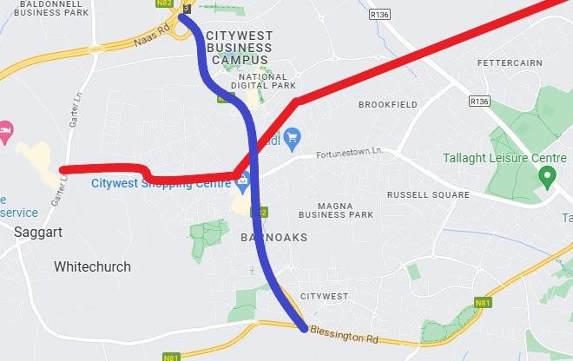

We would ask that the Electoral Commission use the above significant landmarks (or a combination thereof) as the new boundary between Dublin Mid West and Dublin South West.

We wish the Electoral Commission well in their deliberations on what will be a substantial and complicated constituency review.

Sincerely

Áine Lebioda Padraic O’Neill
Chair Chair
Fine Gael Fine Gael
Dublin Mid West Dublin South West

