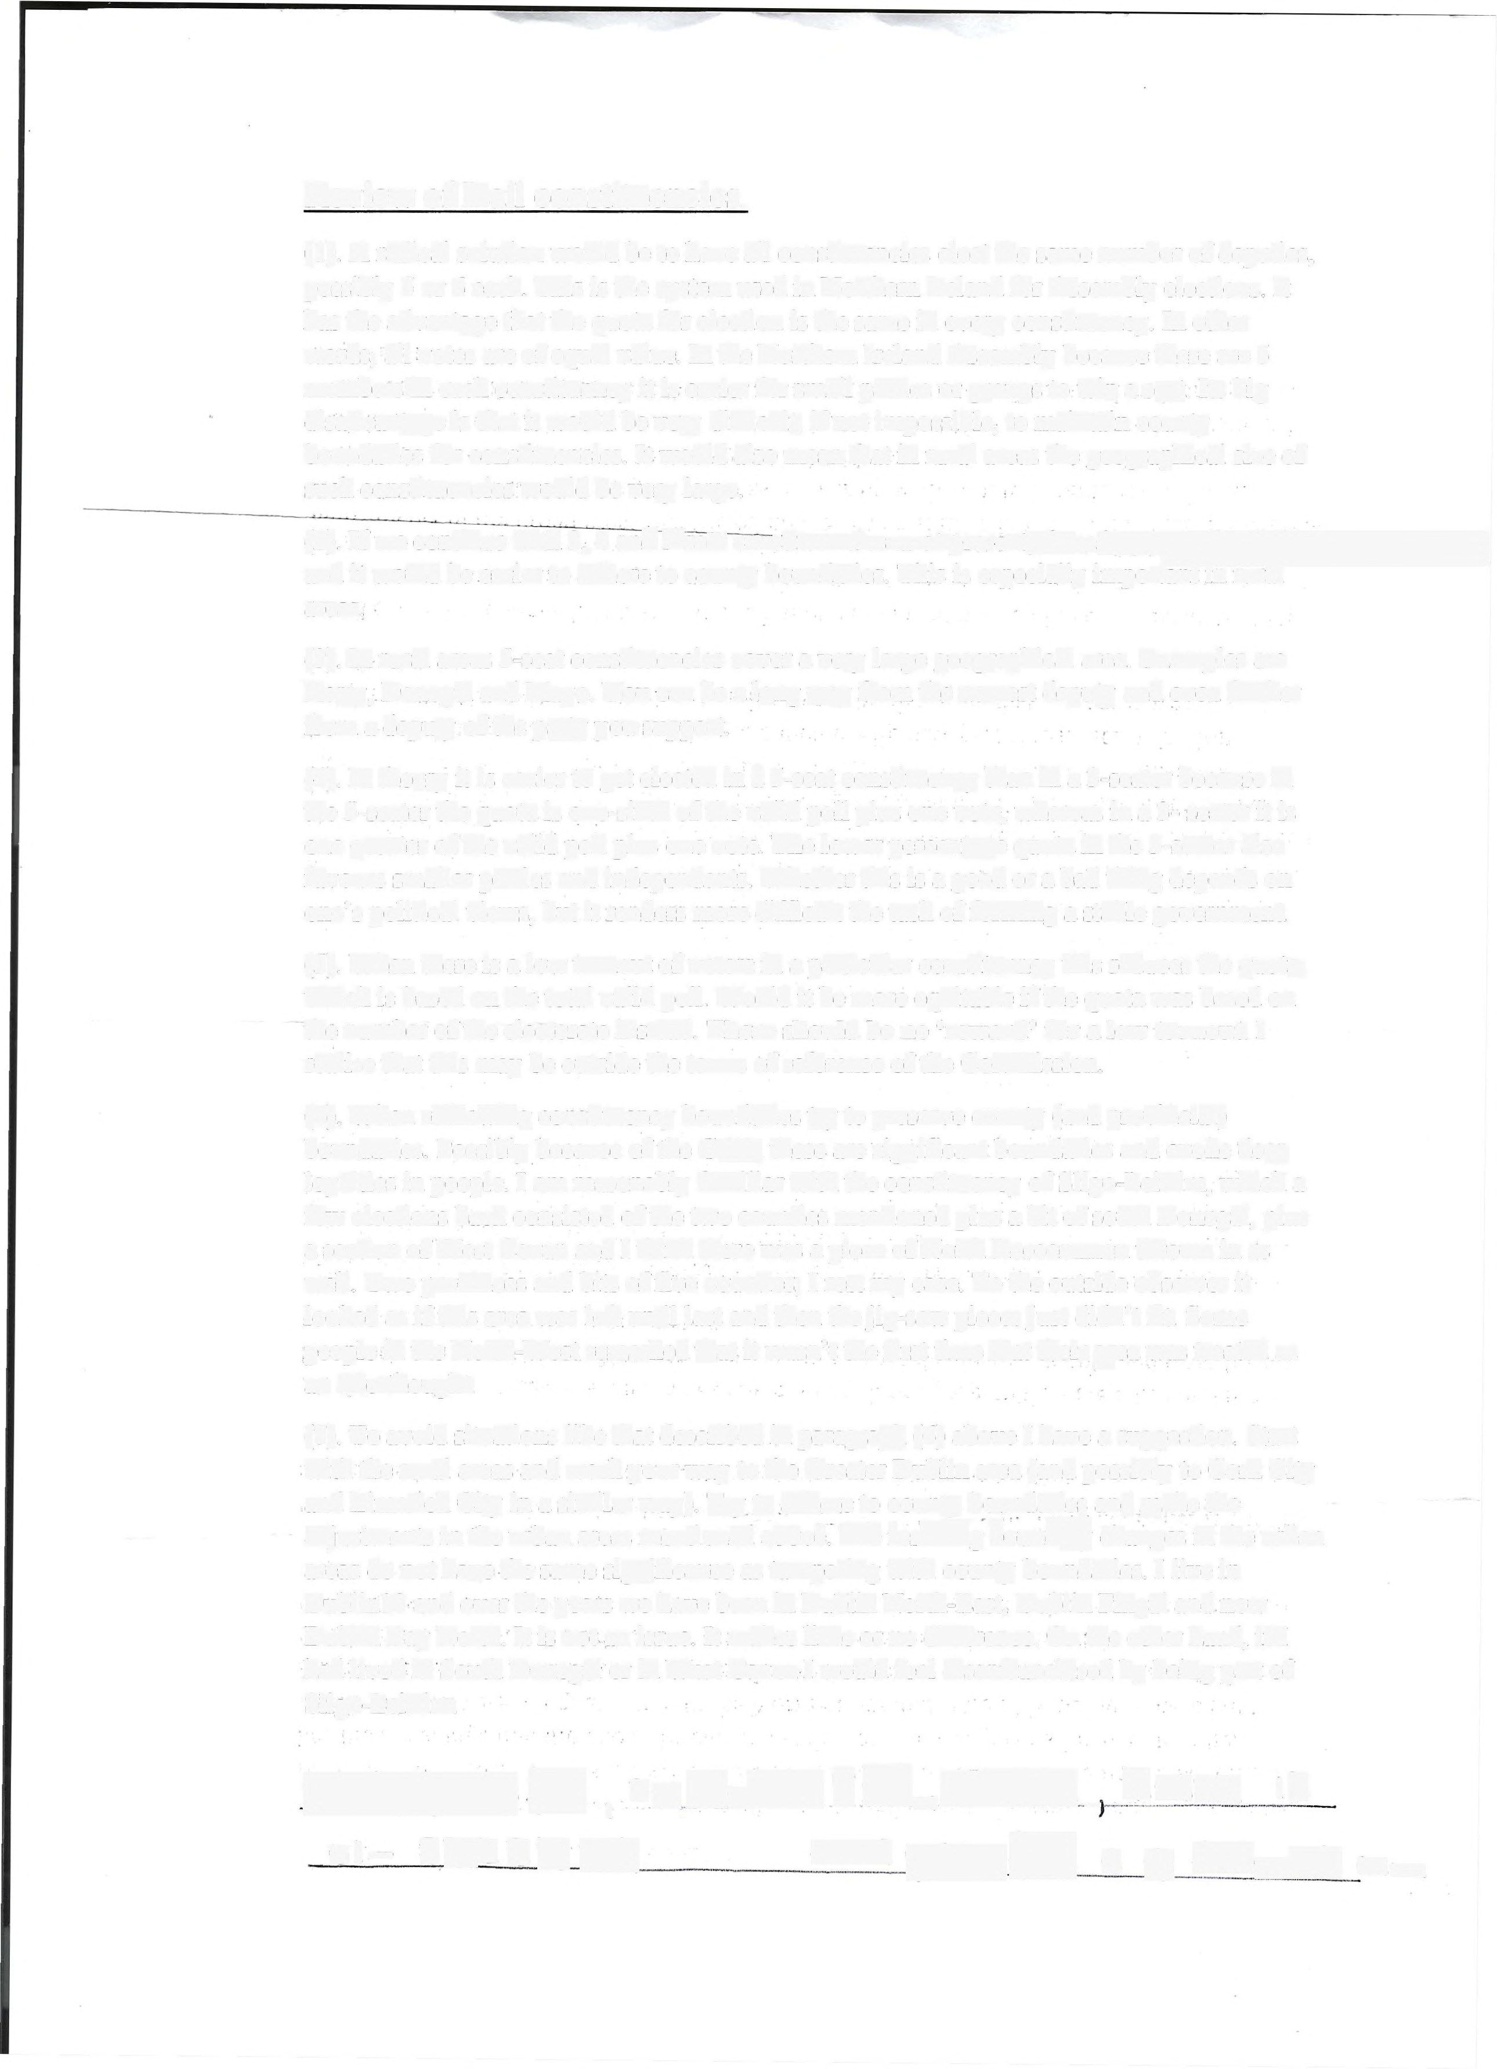Review of Dail constituencies.

(1). A radical solution would be to have all constituencies elect the same number of deputies, possibly 5 or 6 each. This is the system used in Northern Ireland for Assembly elections. It has the advantage that the quota for election is the same in every constituency. In other words, all votes are of equal value. In the Northern Ireland Assembly because there are 5 members in each constituency it is easier for small parties or groups to win a seat. Its big disadvantage is-that it would be very difficult, if not impossible, to maintain county boundaries for constituencies. It would also mean that in rural areas the geographical size of such constituencies would be very large.
(2). If we continue with 3, 4 and 5-seat constituencies as at present, there is greater flexibility
and it would be easier to adhere to county boundaries. This is especially important in rural
areas.

(3). In rural areas 5-seat constituencies cover a very large geographical area. Examples are Kerry, Donegal and Mayo. You can be a long way from the nearest deputy and even further from a deputy of the party you support.
(4). In theory it is easier to get elected in a 5-seat constituency than in a 3-seater because in the 5-seater the quota is one-sixth of the valid poll plus one vote, whereas in a 3- seater it is one quarter of the valid poll plus one vote. The lower percentage quota in the 5-seater also favours smaller parties and independents. Whether this is a good or a bad thing depends on one's political views, but it renders more difficult the task of forming a stable government.

(5). When there is a low turnout of voters in a particular constituency this reduces the quota, which is based on the total valid poll. Would it be more equitable if the quota was based on the number of the electorate instead. There should be no 'reward' for a low turnout. I realise that this may be outside the terms of reference of the Commission.

(6). When redrawing constituency boundaries try to preserve county (and provincial) boundaries. Possibly because of the GAA, these are significant boundaries and evoke deep loyalties in people. I am reasonably familiar with the constituency of Sligo-Leitrim, which a few elections back consisted of the two counties mentioned plus a bit of south Donegal, plus a section of West Cavan and I think there was a piece of North Roscommon thrown in as well. Two provinces and bits of five counties; I rest my case. To the outside observer it looked as if this area was left until last and then the jig-saw pieces just didn't fit. Some people in the North-West remarked that it wasn't the first time that their area was treated as an afterthought.

(7). To avoid situations like that described in paragraph (6) above I have a suggestion. Start with the rural areas and work your way to the Greater Dublin area (and possibly to Cork City
and Limerick City in a similar way). Try to adhere to county boundaries and make the adjustments in the urban areas mentioned above. The resulting boundary changes changes in the urban
areas do not have the same significance as tampering with county boundaries. I live in Dublin13 and over the-years we have been in Dublin North-East, Dublin Fingal and now Dublin Bay North. It is not an issue. It makes little or no difference. On the other hand, if l had lived in South Donegal or in West Cavan I would feel disenfranchised by being part of Sligo-Leitrim.

