A strong case could be made that the Electoral Commission should construct new constituencies from scratch, particularly in Dublin. I will assume, however, that the commission will base their work around existing constituencies. I am a resident of Northwood, Santry, in the constituency of Dublin North West. In 1997 I lived in what is now Dublin Central, moving in 2000 to what is now Dublin Bay North, before moving to my present home in 2004, which is in Dublin North West. I will confine my comments to these three neighbouring constituencies.

The Electoral Commission in accordance with section 56 of the Electoral Reform Act 2022 and following the publication of the 2022 Census Preliminary results is to make a report and recommendations in relation to the constituencies for the election of members to the Dáil.
The total number of members of the Dáil shall be not less than 171 and not more than 181.
I think it would be preferable that the Dail should have a total number at the higher end of this range, to minimise the changes that may be required after the next census.

Seats | Population
171 | 29962
172 | 29788
173 | 29615
174 | 29445
175 | 29277
176 | 29111
177 | 28946
178 | 28783
179 | 28623
180** | 28464
181 | 28306

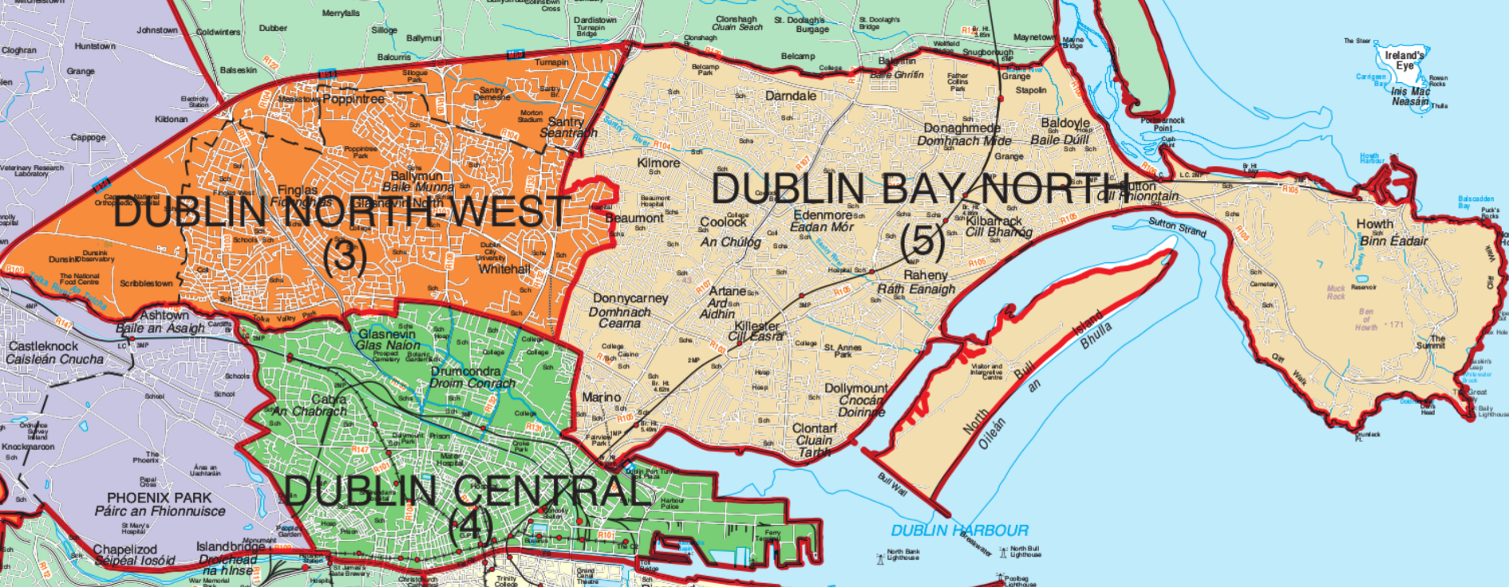

Dublin Bay North is a 5 seater, with a population of 155,905
Dublin Central is a 4 seater, with a population of of 123,165
Dublin North West is a 3 seater, with a population of 90,219

The three constituencies have a population of 369,289. This is a population of 30774 for each of the 12 seats. Adding an additional seat would give a population of 28406 for each of these 13 seats. I think it’s better to avoid 3 seaters where possible, so in my view the existing 3 seater should become a 4 seater.

Dublin Central

My proposal is to move Drumcondra C and A, and that part of Botanic A north of the Tolka, to Dublin North West. It essentially moves anything north of the Tolka from Dublin Central to Dublin North West using natural river and parkland borders. This would place all of the voters living around Old Finglas Road/Ballygall Road East in the same constituency. It also places voters in Drumcondra Village close to St. Patrick’s College in the same constituency.

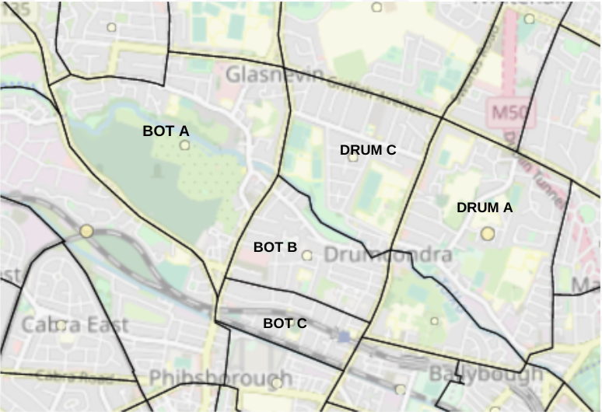
Drumcondra South A 5,912
Drumcondra South C 3,336
Total from Drumcondra 9,248
Botanic A 3,176

This would mean moving 9248 from the Drumcondra A and C wards and approx 2k of the Botanic A ward from Dublin Central to Dublin North West. This would leave Dublin Central with a population of approx 112k, or about 28k per seat. There may need to be a rearrangement of Ballot Box areas for Botanic A.

Dublin Bay North

Wards on the western side of Dublin Bay North could be moved to Dublin North West.

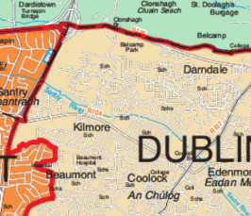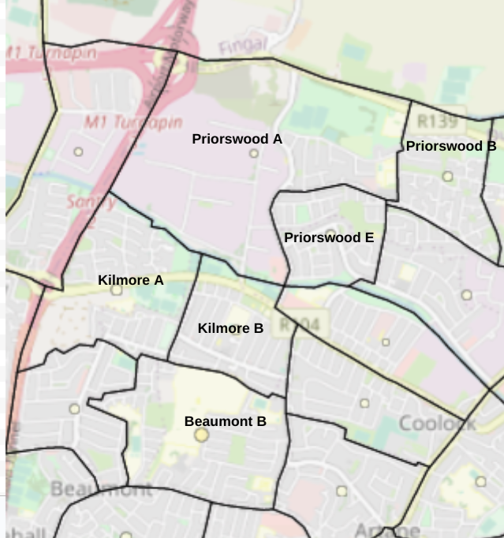

Kilmore A | 3,624
Kilmore B | 2,513
Priorswood A | 1,587
Priorswood B | 2,612
Priorswood E | 2,746
Total | 13,082

Moving these approx 13k above to Dublin North West would leave Dublin Bay North with a population of 143k approx, or 28.6k per seat.

Alternatively you could move 11k as below, leaving Dublin Bay North with a population of 145k approx, or 29k per seat

Kilmore A | 3,624
Kilmore B | 2,513
Beamont B | 5,124
Total | 11,261

Dublin North West

Adding the 13k from Dublin Bay North in the first option given above , and approx 11.2k from Dublin Central, to the existing 90219 in DNW would give a population of about 114.4k for Dublin North West, or approx 28.6k per seat for a 4 seater.

Dublin North West would have the additional areas marked below with an x (and become a four seater), if the first option given above for the adjustment of Dublin Bay North was used.

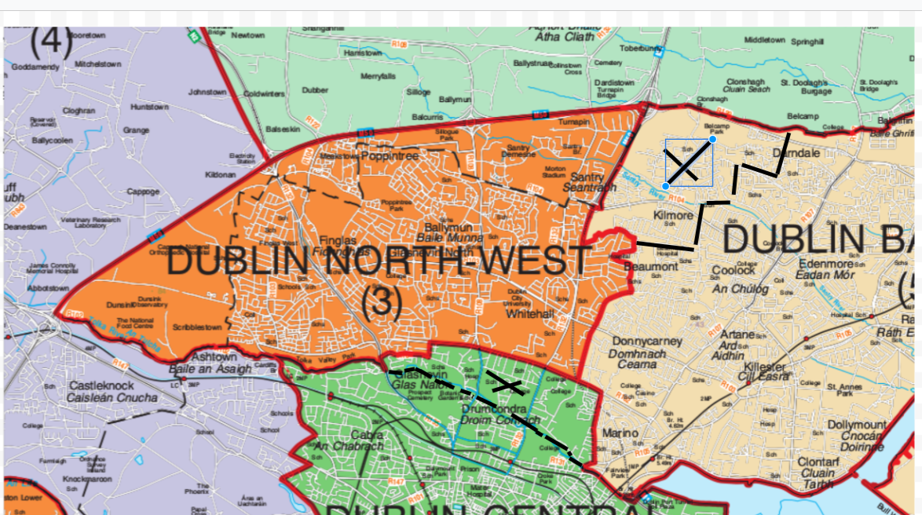

Alternative Option

An alternative option that was suggested to me is to have these constituencies reconfigured as 3 3 seaters and a 4 seater Beaumont A would be removed from Dublin North West, and Drumcondra A and C wards and perhaps some or all of Botanic A would be removed from Dublin Central. These wards would be used in the construction of two 3 seaters from Dublin Bay North. One constituency would be in the north, Howth/Raheny/Priorswood, and one in the south, Clontarf/Artane/Beaumont. It would keep Priorswood and Kilmore in the same constituency as Coolock, but I don't favour it as it leads to more 3 seaters, not less.

Other Issues

I had considered moving parts of Dublin North West (Northwood, Turnapin, Meakstown etc) to a Fingal Constituency. However it may make for sense for these areas to come under Dublin City Council control in the future. The local centres for residents in these areas are Santry and Finglas, not Swords and Blanchardstown.

It may be time to consider a referendum to fix the number of seats in the Dail (e.g. between 175 and 185 seats).

Six seat constituencies should be considered in the future, and three seaters should be avoided unless there is no other viable option.

I wish the Commission well in this review, and also in their future work in the coming years.

John Diamond

