Introduction

The General Election 2020 result in the 5 seat Constituency of Wicklow has given rise to the most significant imbalance in the fair and appropriate distribution of political representation in the Republic of Ireland. All five TD’s come from the North Wicklow Local Electoral Areas of Bray and Greystones.

Due to this imbalance, there is now no Dáil Eireann representation for a massive geographic and populated area outside of Bray / Greystones. For example, along the East Coast from outside Greystones to Enniscorthy a distance of 94km there is no representative.

This imbalance, of all five TD’s coming from the North Wicklow Local Electoral Areas of Bray and Greystones, is a direct consequence of the dramatic population growth in North Wicklow due to its geographic proximity to Dublin.

This population growth which is centred in North Wicklow (Bray, Greystones and
Blessington) has been enshrined in the population targets as laid out in the National
Planning Framework, Regional Spatial & Economic Strategy and the Wicklow County Development Plan which are provided for in Irish Law. This population imbalance in County Wicklow is therefore not a transitory occurrence but will become greater in the years ahead. As provided for in Wicklow’s adopted County Development Plan 2022 -2028, these three areas of Bray, Greystones and Blessington will account for over 49% of the projected future population growth.

This population imbalance essentially results in two distinct constituencies in County Wicklow.

North Wicklow (Bray, Greystones, Blessington) is essentially under the urban influence of Dublin and indeed its political and social-economic profile is consistent with that of a heavily urbanised Constituency such as Dublin Rathdown, Dun Laoghaire, Dublin South West or indeed Kildare North. North Wicklow has significant public transport links with Dublin through, Dart, Rail and Dublin Bus operations which all link to National Policy and schemes such as the Leap Card, Transport Strategy for the Greater Dublin Area, Natonal Fare Strategy etc. These do not operate in South Wicklow.

The Southern part of County Wicklow however is essentially similar to the rural Leinster Constituencies of Carlow/Kilkenny, Kildare South and Wexford, with large rural towns in conjunction with many villages and rural dispersed populations in a large geographic area.

The creation of a South Wicklow including part of North Wexford Constituency, made up of
62 Electoral Divisions from South Wicklow and 13-15 Electoral Divisions from north County Wexford would address the most significant imbalance in the fair and appropriate distribution of political representation in the Republic of Ireland.

These areas along the South Wicklow and North Wexford boarder comprise similar rural towns and villages of the same political and social-economic profile. The business, social and economic activities in the area are also significantly co-dependent.

I would request that the Boundary Commission therefore take into account the democratic deficit which resulted from the 2020 General Election, the growing imbalance in population trends between North and South Wicklow and the divergent socio-economic profile of each area and consider the division of the current 5 Dáil seat constituency into two distinct 3 seat constituencies of 1) North Wicklow and 2) South Wicklow including part of North Wexford.

There are a number of ways that this can be achieved which are outlined in the data below.

Proposal
Statistics
Table 1: Size of 3-seat Constituency
Table 2: Proposed North Wicklow Constituency Electoral Divisions
Table 3: Proposed South Wicklow including part of North Wexford Constituency
Electoral Divisions from County Wicklow
Table 4: Proposed South Wicklow including part of North Wexford Constituency
Electoral Divisions from County Wexford – 3 Options

Maps

Map 1: Local Election Areas of Wicklow
Map 2: Electoral Divisions that make up the proposed North Wicklow Constituency
Map 3: North Wicklow Electoral Divisions that make up the proposed Constituency
Map 4: Electoral Divisions from County Wicklow to be included in the proposed South Wicklow including part of North Wexford Constituency
Map 5: South Wicklow including part of North Wexford Constituency Electoral Divisions from County Wexford to be included - Option 1
Map 6: South Wicklow including part of North Wexford Constituency Electoral
Divisions from County Wexford to be included - Option 2
Map 7: South Wicklow including part of North Wexford Constituency Electoral Divisions from County Wexford to be included - Option 3
Map 8: Proposed Constituencies Option 1
Map 9: Proposed Constituencies Option 2
Map 10: Proposed Constituencies Option 3

Proposal
- Two 3-seat constituencies
○ North Wicklow Constituency
○ South Wicklow including part of North Wexford Constituency

- Remainder of Wexford to form a 5-seat constituency

Statistics

Area | Population | Proposed  Population | Number of EDs | Proposed  Number of  EDs
Wicklow | 155485 |  | 82
North Wicklow – 3 seat constituency | 82540 | 82540 | 20 | 20
South Wicklow – 3 seat constituency | 72945 |  | 62
Including part of north Wexford (Option 1) | 15113 | 88058 | 14 | 76
Including part of north Wexford (Option 2) | 12125 | 85070 | 13 | 75
Including part of north Wexford (Option 3) | 14537 | 87582 | 15 | 77

Proposed Constituency | Total Dáil  Seats 177 | 178 | 179 | 180 | 181
North Wicklow | 2.85 | 2.87 | 2.88 | 2.90 | 2.92
South Wicklow including part of North Wexford (Option 1) | 3.04 | 3.06 | 3.08 | 3.09 | 3.11
South Wicklow including part of North Wexford (Option 2) | 2.94 | 2.96 | 2.97 | 2.99 | 3.01
South Wicklow including part of North Wexford (Option 3) | 3.02 | 3.04 | 3.06 | 3.07 | 3.09
Wexford (Option 1) | 5.13 | 5.16 | 5.19 | 5.21 | 5.24
Wexford (Option 2) | 5.23 | 5.26 | 5.29 | 5.32 | 5.35
Wexford (Option 3) | 5.15 | 5.18 | 5.21 | 5.23 | 5.26

Notes:
- Based off the 5% variance rule the following is true
  - Valid 3 seat constituencies can form for 2.85 - 3.15
○ Valid 5 seat constituencies can form for 4.75 - 5.25
In the above table any cell highlighted green, is a configuration that can form a valid constituency within the 5% variation rule.

- For Wexford
  - Option 1 is valid for a 177-181 seat Dáil
○ Option 2 is valid for a 177 seat Dáil
○ Option 3 is valid for a 177-180 seat Dáil

Table 1
Size of 3-seat Constituency
Seats |  | People Per TD | Min Population | Max Population
 | 171 | 29962 | 85392 | 94381
 | 172 | 29788 | 84896 | 93832
 | 173 | 29616 | 84405 | 93290
 | 174 | 29446 | 83920 | 92754
 | 175 | 29277 | 83440 | 92224
 | 176 | 29111 | 82966 | 91700
 | 177 | 28947 | 82498 | 91182
 | 178 | 28784 | 82034 | 90669
 | 179 | 28623 | 81576 | 90163
 | 180 | 28464 | 81123 | 89662
 | 181 | 28307 | 80674 | 89167

Table 2
Proposed North Wicklow Constituency Electoral Divisions:
ED_ID | ENGLISH | Electoral_Division | Population
257048 | KILCOOLE | Kilcoole, Co.Wicklow, | 12083
257017 | BRAY No. 3 | Bray No., Co.Wicklow, | 6602
257059 | NEWCASTLE UPPER | Newcastle Upper, Co.Wicklow, | 4769
257020 | CALARY | Calary, Co.Wicklow, | 368
257046 | KILBRIDE | Kilbride, Co.Wicklow, | 1080
257051 | KILMACANOGE | Kilmacanoge, Co.Wicklow, | 15019
257073 | TOGHER | Togher, Co.Wicklow, | 381
257054 | LACKAN | Lackan, Co.Wicklow, | 839
257027 | DELGANY | Delgany, Co.Wicklow, | 7721
257041 | HOLLYWOOD | Hollywood, Co.Wicklow, | 827
257039 | GREYSTONES | Greystones, Co.Wicklow, | 8050
257080 | BRAY No. 1 | Bray No. , Co.Wicklow, | 1864
257081 | BRAY No. 2 | Bray No. , Co.Wicklow, | 6786
257019 | BURGAGE | Burgage, Co.Wicklow, | 2304
257058 | NEWCASTLE LOWER | Newcastle Lower, Co.Wicklow, | 2499
257002 | ALTIDORE | Altidore, Co.Wicklow, | 395
257036 | ENNISKERRY | Enniskerry, Co.Wicklow, | 3139
257082 | RATHMICHAEL (BRAY) | Rathmichael (Bray), Co.Wicklow, | 2312
257016 | BLESSINGTON | Blessington, Co.Wicklow, | 4584
257062 | POWERSCOURT | Powerscourt, Co.Wicklow, | 918

Table 3
Proposed South Wicklow including part of North Wexford Constituency: Electoral Divisions from County Wicklow

ED_ID | ENGLISH
257079 | ARKLOW No. 2 URBAN
257043 | IMAEL NORTH
257026 | CRONELEA
257052 | KILPIPE
257063 | RATH
257057 | MONEYSTOWN
257040 | HARTSTOWN
257038 | GLENEALY
257061 | OVOCA
257050 | KILLISKEY
257074 | TOGHER
257047 | KILBRIDE
257023 | COOLBALLINTAGGART
257033 | DUNLAVIN

257055 | LUGGLASS
257077 | WICKLOW RURAL
257044 | IMAEL SOUTH
257005 | AUGHRIM
257030 | DUNGANSTOWN EAST
257014 | BALLYCULLEN
257021 | CARNEW
257031 | DUNGANSTOWN SOUTH
257010 | BALLINGLEN
257071 | TINAHELY
257075 | TROOPERSTOWN
257012 | BALLYARTHUR
257078 | WICKLOW URBAN
257068 | STRATFORD
257011 | BALLINGUILE
257035 | ENNEREILLY
257008 | BALLINDERRY
257029 | DONARD
257022 | COOLATTIN
257065 | RATHDRUM
257064 | RATHDANGAN
257072 | TOBER
257070 | THE GRANGE
257037 | GLENDALOUGH
257066 | RATHSALLAGH
257028 | DONAGHMORE
257024 | COOLBOY
257007 | BALLINACOR
257004 | ARKLOW No. 1 URBAN
257053 | KNOCKRATH
257076 | TUCKMILL
257006 | BALLINACLASH
257018 | BROCKAGH
257009 | BALLINGATE
257032 | DUNGANSTOWN WEST
257015 | BALTINGLASS
257001 | AGHOWLE
257069 | TALBOTSTOWN
257025 | CRONEBANE
257042 | HUMEWOOD
257034 | EADESTOWN
257067 | SHILLELAGH
257049 | KILLINURE
257056 | MONEY
257003 | ARKLOW RURAL
257060 | OLDTOWN
257045 | KILBALLYOWEN
257013 | BALLYBEG
Total Population | 72945

Table 4
Proposed South Wicklow including part of North Wexford Constituency: Electoral Divisions from County Wexford (3 Options)

Option 1
ED_ID | ENGLISH | Electoral_Division | Population
247080 | KILRUSH | Kilrush, Co.Wexford, | 430
247077 | KILNAHUE | Kilnahue, Co.Wexford, | 483
247094 | NEWTOWNBARRY | Newtownbarry, Co.Wexford, | 2439
247089 | MOYACOMB | Moyacomb, Co.Wexford, | 466
247084 | LIMERICK | Limerick, Co.Wexford, | 1063
247020 | BALLYNESTRAGH | Ballynestragh, Co.Wexford, | 1392
247122 | WINGFIELD | Wingfield, Co.Wexford, | 1032
247040 | COURTOWN | Courtown, Co.Wexford, | 2988
247012 | BALLYELLIS | Ballyellis, Co.Wexford, | 431
247039 | COOLGREANY | Coolgreany, Co.Wexford, | 1227
247065 | KILGORMAN | Kilgorman, Co.Wexford, | 888
247088 | MONASEED | Monaseed, Co.Wexford, | 730
247009 | BALLYBEG | Ballybeg, Co.Wexford, | 630
247017 | BALLYLARKIN | Ballylarkin, Co.Wexford, | 914

Option 2
ED_ID | ENGLISH | Electoral_Division | Population
247080 | KILRUSH | Kilrush, Co.Wexford, |  | 430
247077 | KILNAHUE | Kilnahue, Co.Wexford, |  | 483
247094 | NEWTOWNBARRY | Newtownbarry, Co.Wexford, |  | 2439
247089 | MOYACOMB | Moyacomb, Co.Wexford, |  | 466
247084 | LIMERICK | Limerick, Co.Wexford, |  | 1063
247020 | BALLYNESTRAGH | Ballynestragh, Co.Wexford, |  | 1392
247122 | WINGFIELD | Wingfield, Co.Wexford, |  | 1032
247012 | BALLYELLIS | Ballyellis, Co.Wexford, |  | 431
247039 | COOLGREANY | Coolgreany, Co.Wexford, |  | 1227
247065 | KILGORMAN | Kilgorman, Co.Wexford, |  | 888
247088 | MONASEED | Monaseed, Co.Wexford, |  | 730
247009 | BALLYBEG | Ballybeg, Co.Wexford, |  | 630
247017 | BALLYLARKIN | Ballylarkin, Co.Wexford, |  | 914
Option 3
ED_ID | ENGLISH | Electoral_Division | Population
247080 | KILRUSH | Kilrush, Co.Wexford, |  | 430
247077 | KILNAHUE | Kilnahue, Co.Wexford, |  | 483
247089 | MOYACOMB | Moyacomb, Co.Wexford, |  | 466
247084 | LIMERICK | Limerick, Co.Wexford, |  | 1063
247020 | BALLYNESTRAGH | Ballynestragh, Co.Wexford, |  | 1392
247103 | ROSSMINOGE | Rossminoge, Co.Wexford, |  | 673
247122 | WINGFIELD | Wingfield, Co.Wexford, |  | 1032
247040 | COURTOWN | Courtown, Co.Wexford, |  | 2988
247012 | BALLYELLIS | Ballyellis, Co.Wexford, |  | 431
247039 | COOLGREANY | Coolgreany, Co.Wexford, |  | 1227
247065 | KILGORMAN | Kilgorman, Co.Wexford, |  | 888
247088 | MONASEED | Monaseed, Co.Wexford, |  | 730
247061 | KILCOMB | Kilcomb, Co.Wexford, |  | 1190
247009 | BALLYBEG | Ballybeg, Co.Wexford, | 630
247017 | BALLYLARKIN | Ballylarkin, Co.Wexford, | 914

Maps
Please see below the relevant maps to accompany each option:

Map 1: Local Election Areas of Wicklow

- The red areas are the Local Election Areas within Wicklow
- This map should be contrasted with Map 2 which outlines the proposed North
Wicklow Constituency, remarking that it completely contains the Bray and Greystones Local Election Areas, barely breaches Wicklow Local Election Area and takes the north of Baltinglass Local Election Area.
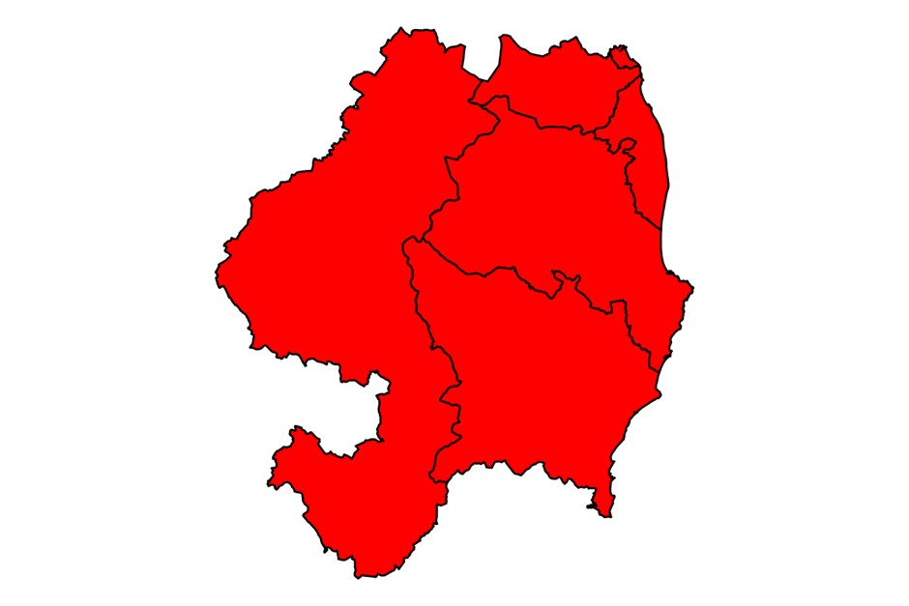

Proposed North Wicklow Constituency
Map 2: Electoral Divisions that make up the proposed North Wicklow
Constituency
- Segments coloured blue are the EDs that would make up the proposed North Wicklow Constituency (as listed in Table 2 above)

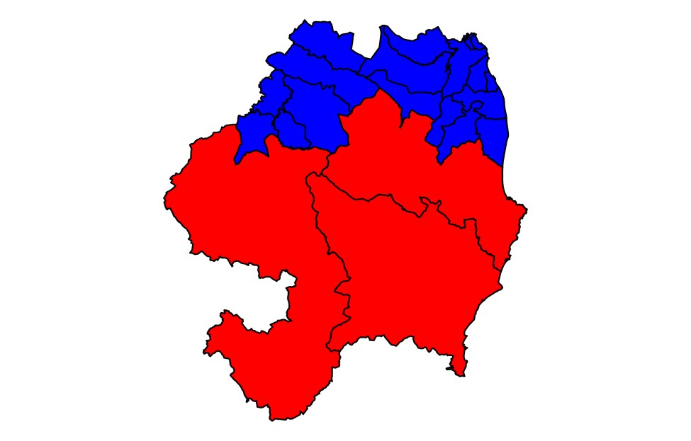
Map 3: North Wicklow (Electoral Divisions that make up the proposed Constituency) (as listed in Table 2 above)

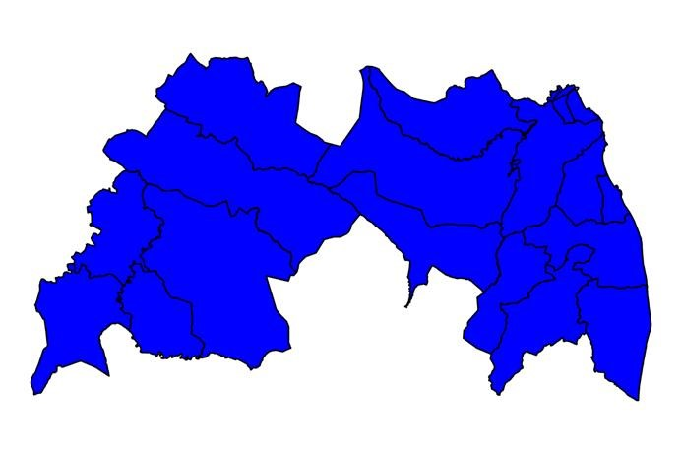

Map 4: Electoral Divisions from County Wicklow to be Included in the proposed South Wicklow including part of North Wexford Constituency

- Segments coloured yellow are the Electoral Divisions from County Wicklow that would be contained in the South Wicklow including part of North Wexford Constituency

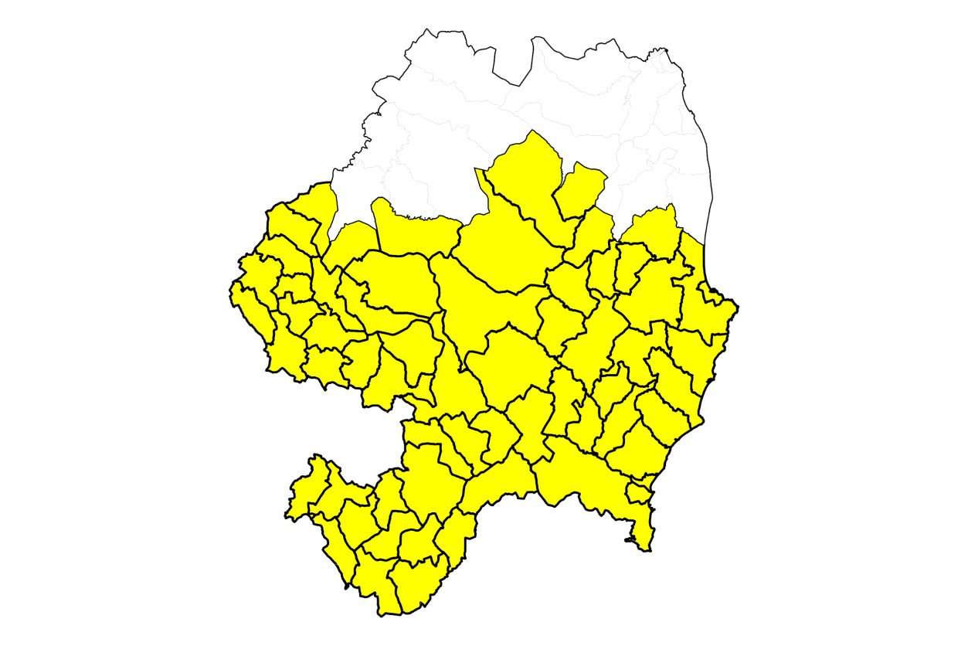

South Wicklow including parts of North Wexford Constituency

Unlike with the proposed North Wicklow Constituency, there are three options for how the South Wicklow including part of North Wexford Constituency could be configured depending on which Electoral Divisions from County Wexford are selected. The following are the three options:

Map 5: South Wicklow including part of North Wexford Constituency
Electoral Divisions from County Wexford to be included - Option 1
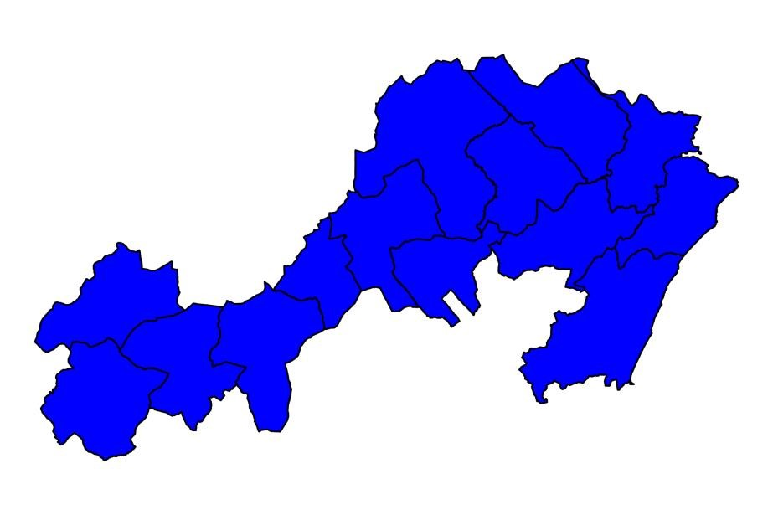

6: South Wicklow including part of North Wexford Constituency
Electoral Divisions from County Wexford to be included - Option 2
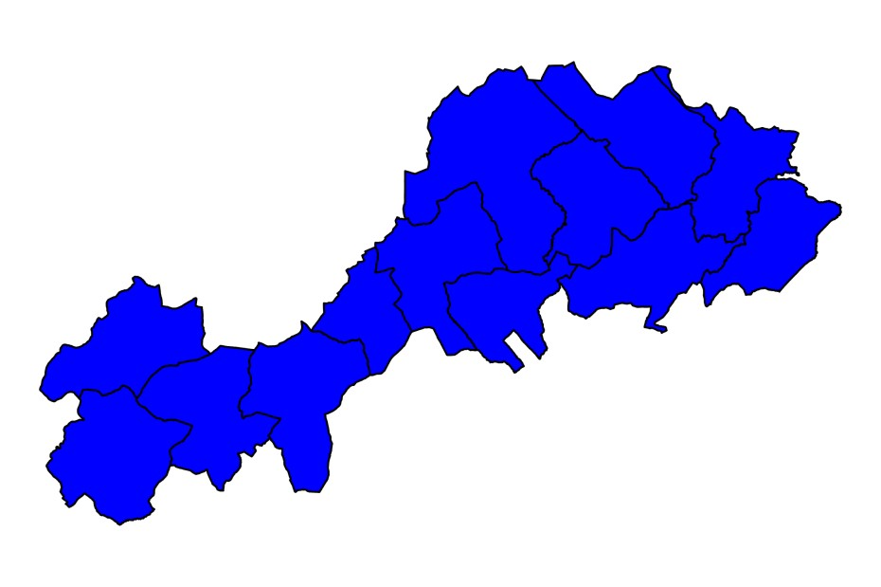

Map 7: South Wicklow including part of North Wexford Constituency Electoral Divisions from County Wexford to be included - Option 3
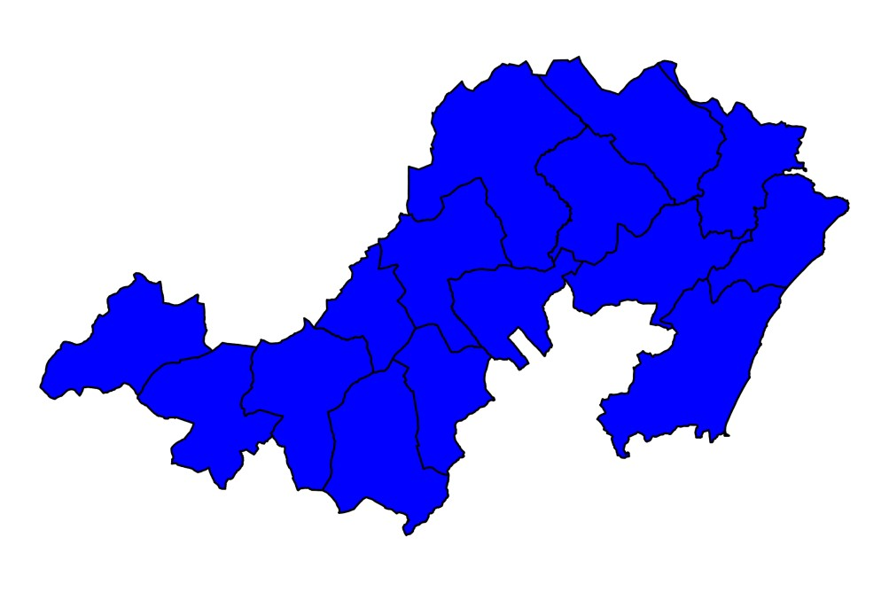

8:
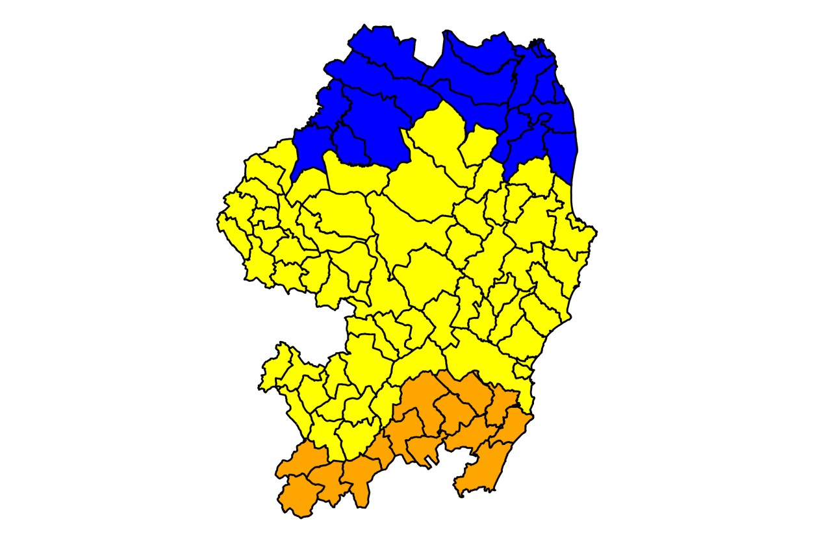
9:
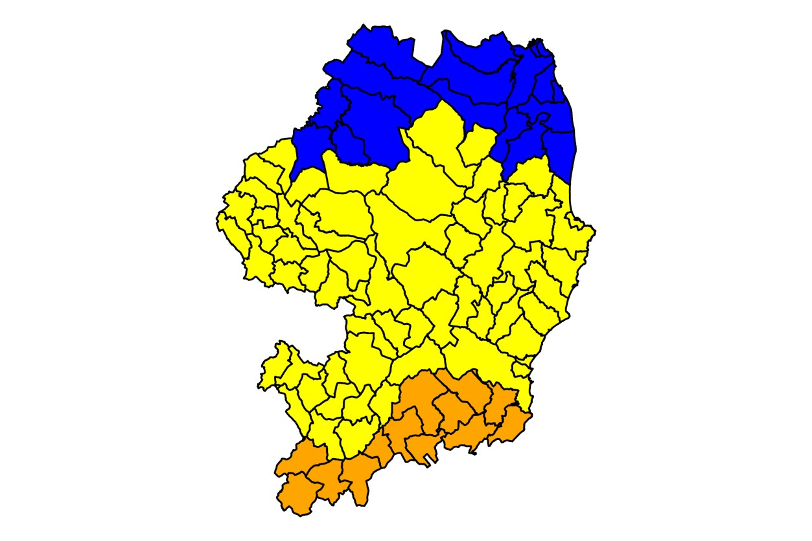

10:
