To: constituencyreview@electoralcommission.ie

The Secretary
An Coimisiún Toghcháin,
Dublin Castle,
Dublin 2

9 May 2023

Re: Dublin Region and optimum configuration of new constituencies

Dear Commission Secretary

I wish to make a submission regarding the Dublin region and the 2023 constituency boundary review on behalf of the Labour Party in Dublin South West.

Given the substantial revision of constituency boundaries required on foot of census 2022, the four Dublin local authorities provide a good starting point in terms of grouping neighbourhoods that will form the basis of the new Dáil constituencies post 2023.

The advantages of such an approach are as follows:

- ensure it is as easy as possible for citizens to understand who their public representatives are;
- ensure our neighbourhoods are cohesive communities;
- maximise the potential for consistent boundaries between new constituencies and the four Dublin local authorities;
- maximise continuity with existing constituency boundaries; and
- allow for a future proofing of constituencies to facilitate population growth in the years ahead.

The requirement for there to be a maximum ratio of 30,000 residents to each Dáil deputy means a total of at least 49 deputies are required across the Dublin region:

Local Authority | Population 2022 | Required Number of TDs
Dublin City | 588,233 | 20
Dun Laoghaire Rathdown | 233,457 | 8
Fingal | 329,218 | 11
South Dublin | 299,793 | 10
Total | 1,450,701 | 49

South Dublin County Council

Based on census 2022 South Dublin County Council’s population equates to the requirement for 10 Dáil Deputies, and this should result in the SDCC region having two 5-seat constituencies within it to ensure maximum proportionality.

At present Dublin Mid West elects four deputies and Dublin South West elects five deputies. We propose that the boundaries of the existing Dublin Mid West and Dublin South West constituencies remain largely the same with the exception of the transfer of the Citywest area from Dublin South West to Dublin Mid West.

Electoral Divisions forming the cohesive core of Dublin South West

Rathfarnham

The following electoral divisions form the cohesive community of Rathfarnham and should be retained fully within DSW and not divided between constituencies:

- Ballyboden
- Edmondstown
- Rathfarnham-Ballyroan
- Rathfarnham-Butterfield
- Rathfarnham-Hermitage
- Rathfarnham-St. Endas
- Rathfarnham Village

Firhouse & Knocklyon

The following electoral divisions correspond to the neighbourhoods of Firhouse & Knocklyon and should be retained fully within DSW and not divided between constituencies:

- Bohernabreena
- Firhouse-Ballycullen
- Firhouse-Knocklyon
- Firhouse Village

Tallaght

The following electoral divisions form the cohesive community of Tallaght and should be retained fully within DSW and not divided between constituencies:

- Tallaght-Avonbeg
- Tallaght-Belgard
- Tallaght-Glenview
- Tallaght-Kilnamanagh
- Tallaght-Killinardan
- Tallaght-Kingswood
- Tallaght-Kiltipper
- Tallaght-Millbrook
- Tallaght-Oldbawn
- Tallaght-Springfield
- Tallaght-Tymon

Templeogue

The following electoral divisions form the cohesive community of Templeogue and should be retained fully within DSW and not divided between constituencies:

- Templeogue-Limekiln
- Templeogue-Orwell
- Templeogue-Osprey
- Templeogue Village

The Citywest Neighbourhood

The electoral divisions of Tallaght-Jobstown and Tallaght-Fettercairn each have a population of 17,957 and 11,289 respectively. Not only is the population of each electoral division very large, but they do not correspond closely to any of the modern neighbourhood or community identities elsewhere, which can make it difficult to identify an appropriate boundary to replace the existing Dublin Mid West / Dublin South West boundary along the river Camac and N7.

To complicate matters further there are sections of the electoral district boundary between Tallaght- Jobstown and Tallaght-Fettercairn that no longer exist, as the lane used for this boundary was closed many years ago and subsequently built upon.

Suggested Amendment to Dublin South West / Dublin Mid West Boundary

A more effective, appropriate and identifiable means of drawing the new DSW / DMW boundaries would be to use major pieces of infrastructure. The two most prominent pieces of infrastructure in the Citywest area that would make clearly identifiable boundaries are:

- N82 Citywest Road (marked blue on the map below)
- Luas Red Line (marked red on map below).

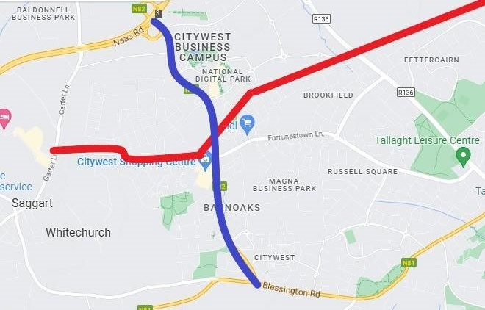

We would ask that the Electoral Commission use the above significant landmarks (or a combination thereof) as the new boundary.

Yours sincerely

Ciarán Ahern
Chair
Labour Party Dublin South West

