The Electoral Commission / An Coimisiún Toghcháin,
Dublin Castle,
Dublin 2
9th May 2023
Dear Members,
I would like to make a case for Kerry to be converted to two three-seat constituencies for the following reasons:
- . It's significant physical geographical characteristics;
  - The distances & travel times from Kerry's towns to Dáil Éireann & the distances and travel times within the county;
  - A comparison with major Dublin suburbs & major Regional towns;
  - The physical features of County Kerry
- The population of Kerry, it's likely trends & unique factors.
Distances & Time to Travel from Kerry's towns to Dáil Éireann (see Appendix 1) :
Cahersiveen.• 350 Km 4 Hours
Kenmare: 350 Km | 4 Hours
Killarney: 300 Km | 3 Hours 30 minutes
Killorglin: 310 Km | 3 Hours 37 minutes
Dingle: 340 Km | 4 Hours 7 minutes
Tralee: 294 Km | 3 Hours 20 minutes
Castleisland.• 280 Km | 3 Hours 10 minutes
Listowel: 260 Km | 3 Hours
Distances Travel Times within County Kerry (see Appendix 2):
Tarbert to Lauragh: 142 Km 2 Hours
Tarbert to Valentia: 130 Km 2 Hours
Tarbert to Slea Head: 104 Km 1 Hour 33 minutes Tarbert to Dunquin: 112 Km 1 Hour 43 minutes
Distances & Times within Dublin to Dáil Éireann see A | endix 3 :
Dalkey / Killiney: 14 Km 20 minutes
Rathcoole / Lucan / Malahide: 17 Km 22 minutes
Skerries / Balbriggan: 35 Km 35 minutes
Distances & Times from Major Regional towns to Dáil Éireann (see Appendix 4):
Kilkenny / Cavan: 125 Km 1 Hour 30 minutes Tullamore: 103 Km 1 Hour 10 minutes
Portlaoise / Carlow / Mullingar / Dundalk: 80 - 90Km 1 Hour
Navan: 55 Km 50 minutes
Physical Features:
Kerry is the fifth largest county in Ireland by area & the county's vast coastline runs to nearly 900 Km in length (see Appendix 5) Kerry is bounded by only two other counties, Cork & Limerick... and we never get tired of beating Cork. The physical features of North & South Kerry differ vastly. The South with its tourism economy, labour intensive industries, peninsula's, islets and mountains is in stark contrast to North Kerry's mainly farming economy in a more compact region and encompassing Tralee's large population.
Due to Kerry's physical and geographical location, it's well nigh on impossible for TD's to serve their constituents to the same level as other TD's in 5 Seat constituencies.
In short, for any Kerry TD to commute to and from Dáil Éireann takes 7 hours at a minimum (both ways) to reach his/her voters and then has vast tracts of the county to cover to service their electorate.
Population of Kerry:
2016 Census: 147,707 2022 Census: 155,258
2028: 165,000++
The populations of Kerry's town, according to the 2016 Census is as follows:
Traiee: 25,000+ Killarney: 15,000+
Listowel: 5,000+
The population of the nine Kerry towns was 37% of the county's total population (2016 Census).
Based on the above figures, Kerry is already nearly at the recommended number for 6 Seats. Allied to the this, the population of Kerry fluctuates more than any other county in Ireland. Since the last Census, there has been a huge Ukrainian refugee influx, which we have made very welcome, and a large percentage will likely remain in County Kerry.
Another significant cohort who are not counted in the Census are Holiday Home owners from mainly Dublin, Cork & Munster county towns who spend a considerable amount of time in Kerry during the summer and several other weekends during the year. Added to this, caravan park owners create a huge bulge in population none of which register on the county's Census returns. We surpass any other county in this regard. An example is Ballybunion near me which has 300+ Ukrainians in The Golf Hotel and 2,300 Caravan Park units in 8 / 9 Caravan Parks (that's 7,000 — 10,000 extra people in the resort when occupied). There are numerous other Caravan Parks in tourist locations throughout the county, with huge numbers not listed as Kerry residents even though they spend a considerable amount of time in Kerry.
The fact that we are the premier tourist destination in Ireland, in particular the South Kerry towns of Killarney, Kenmare & Dingle, lends itself to making a strong case for making the county; 2 X Three Seat Constituencies while retaining the counties natural physical borders in keeping with Parliamentary Constituency Review points
2.c, 2.e & 2.f.
I appeal to you & the other members of the Electoral Commission to strongly consider my points which would enable Kerry to be served by it's TD's to the same level as those in other rural Constituencies.
Appendices:
- Distances Time to Travel from Kerry's towns to Dáil Éireann:
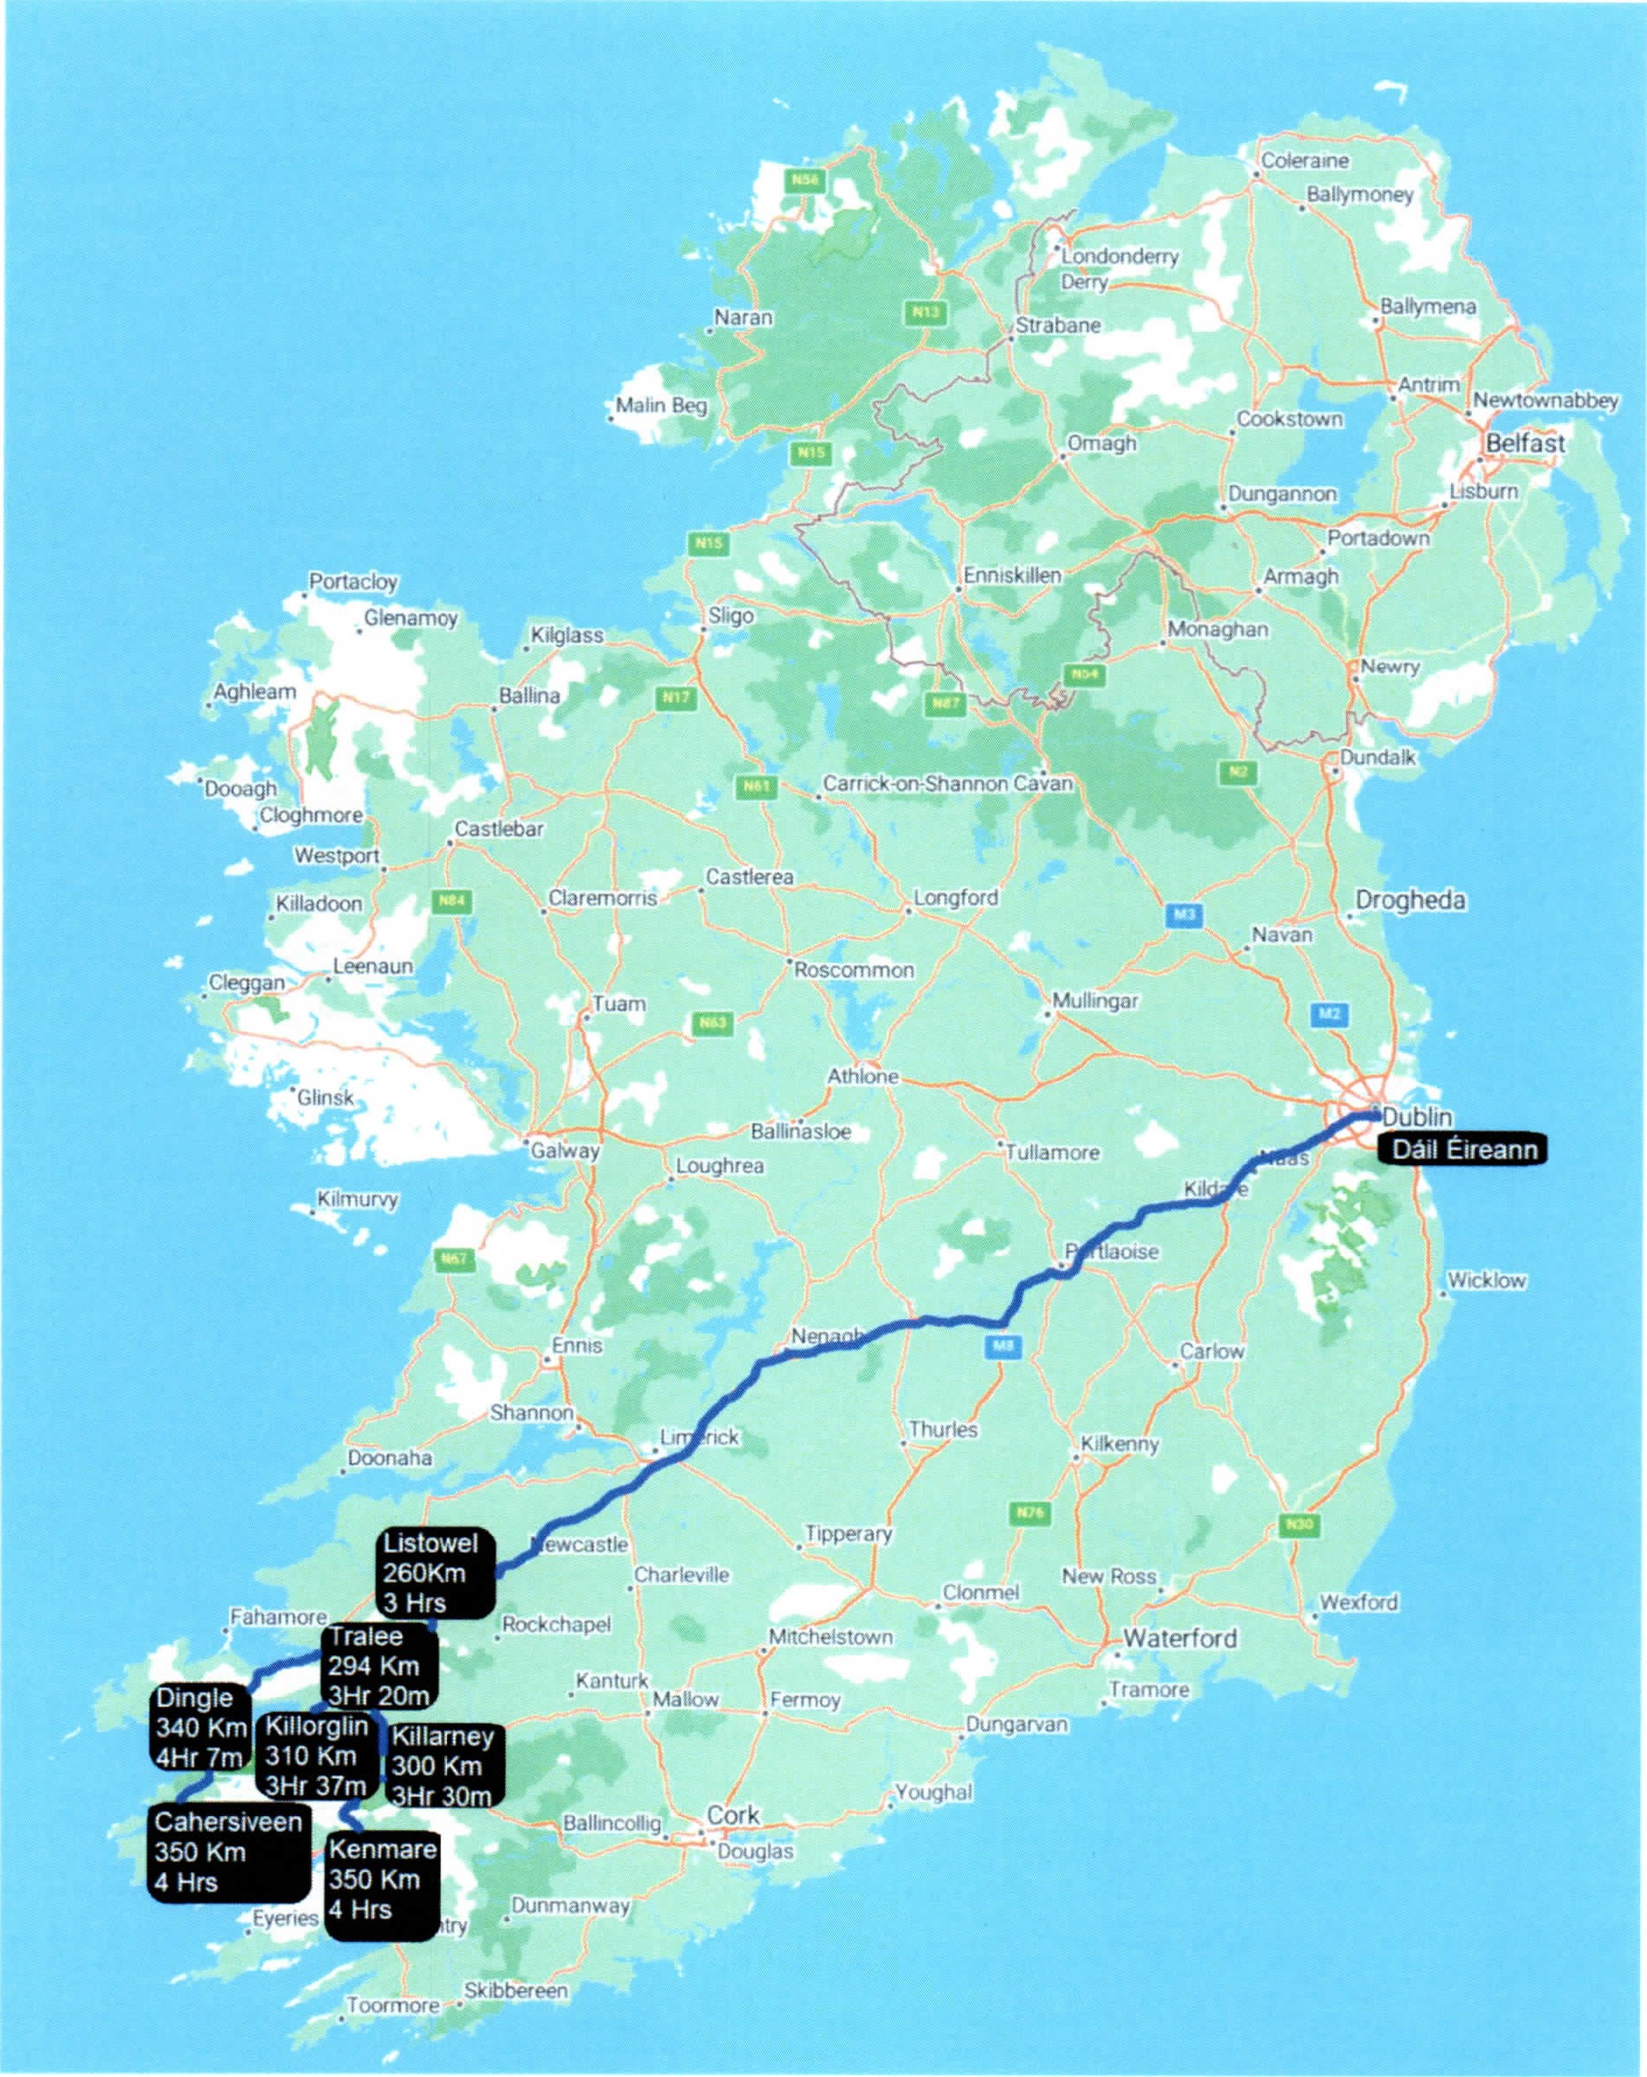

- Travel Times within County Kerry:
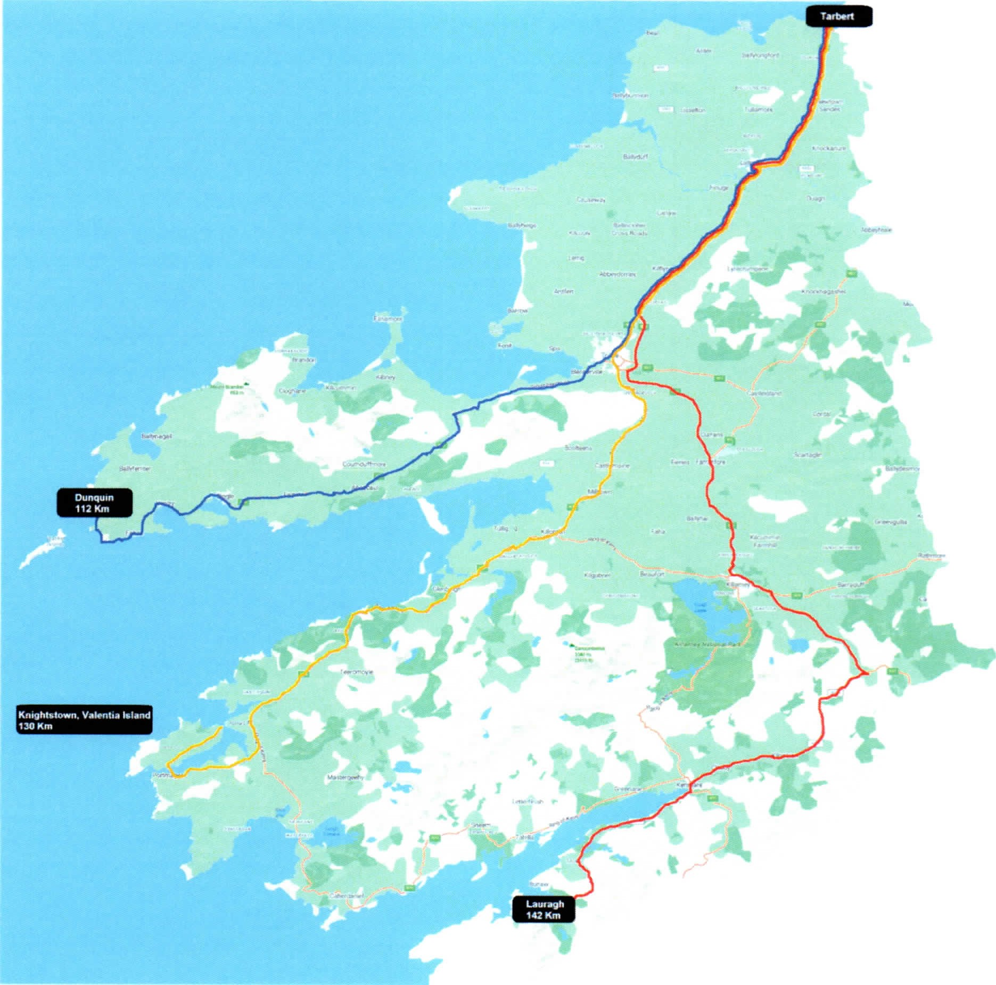
- Times within Dublin to Dáil Éireann
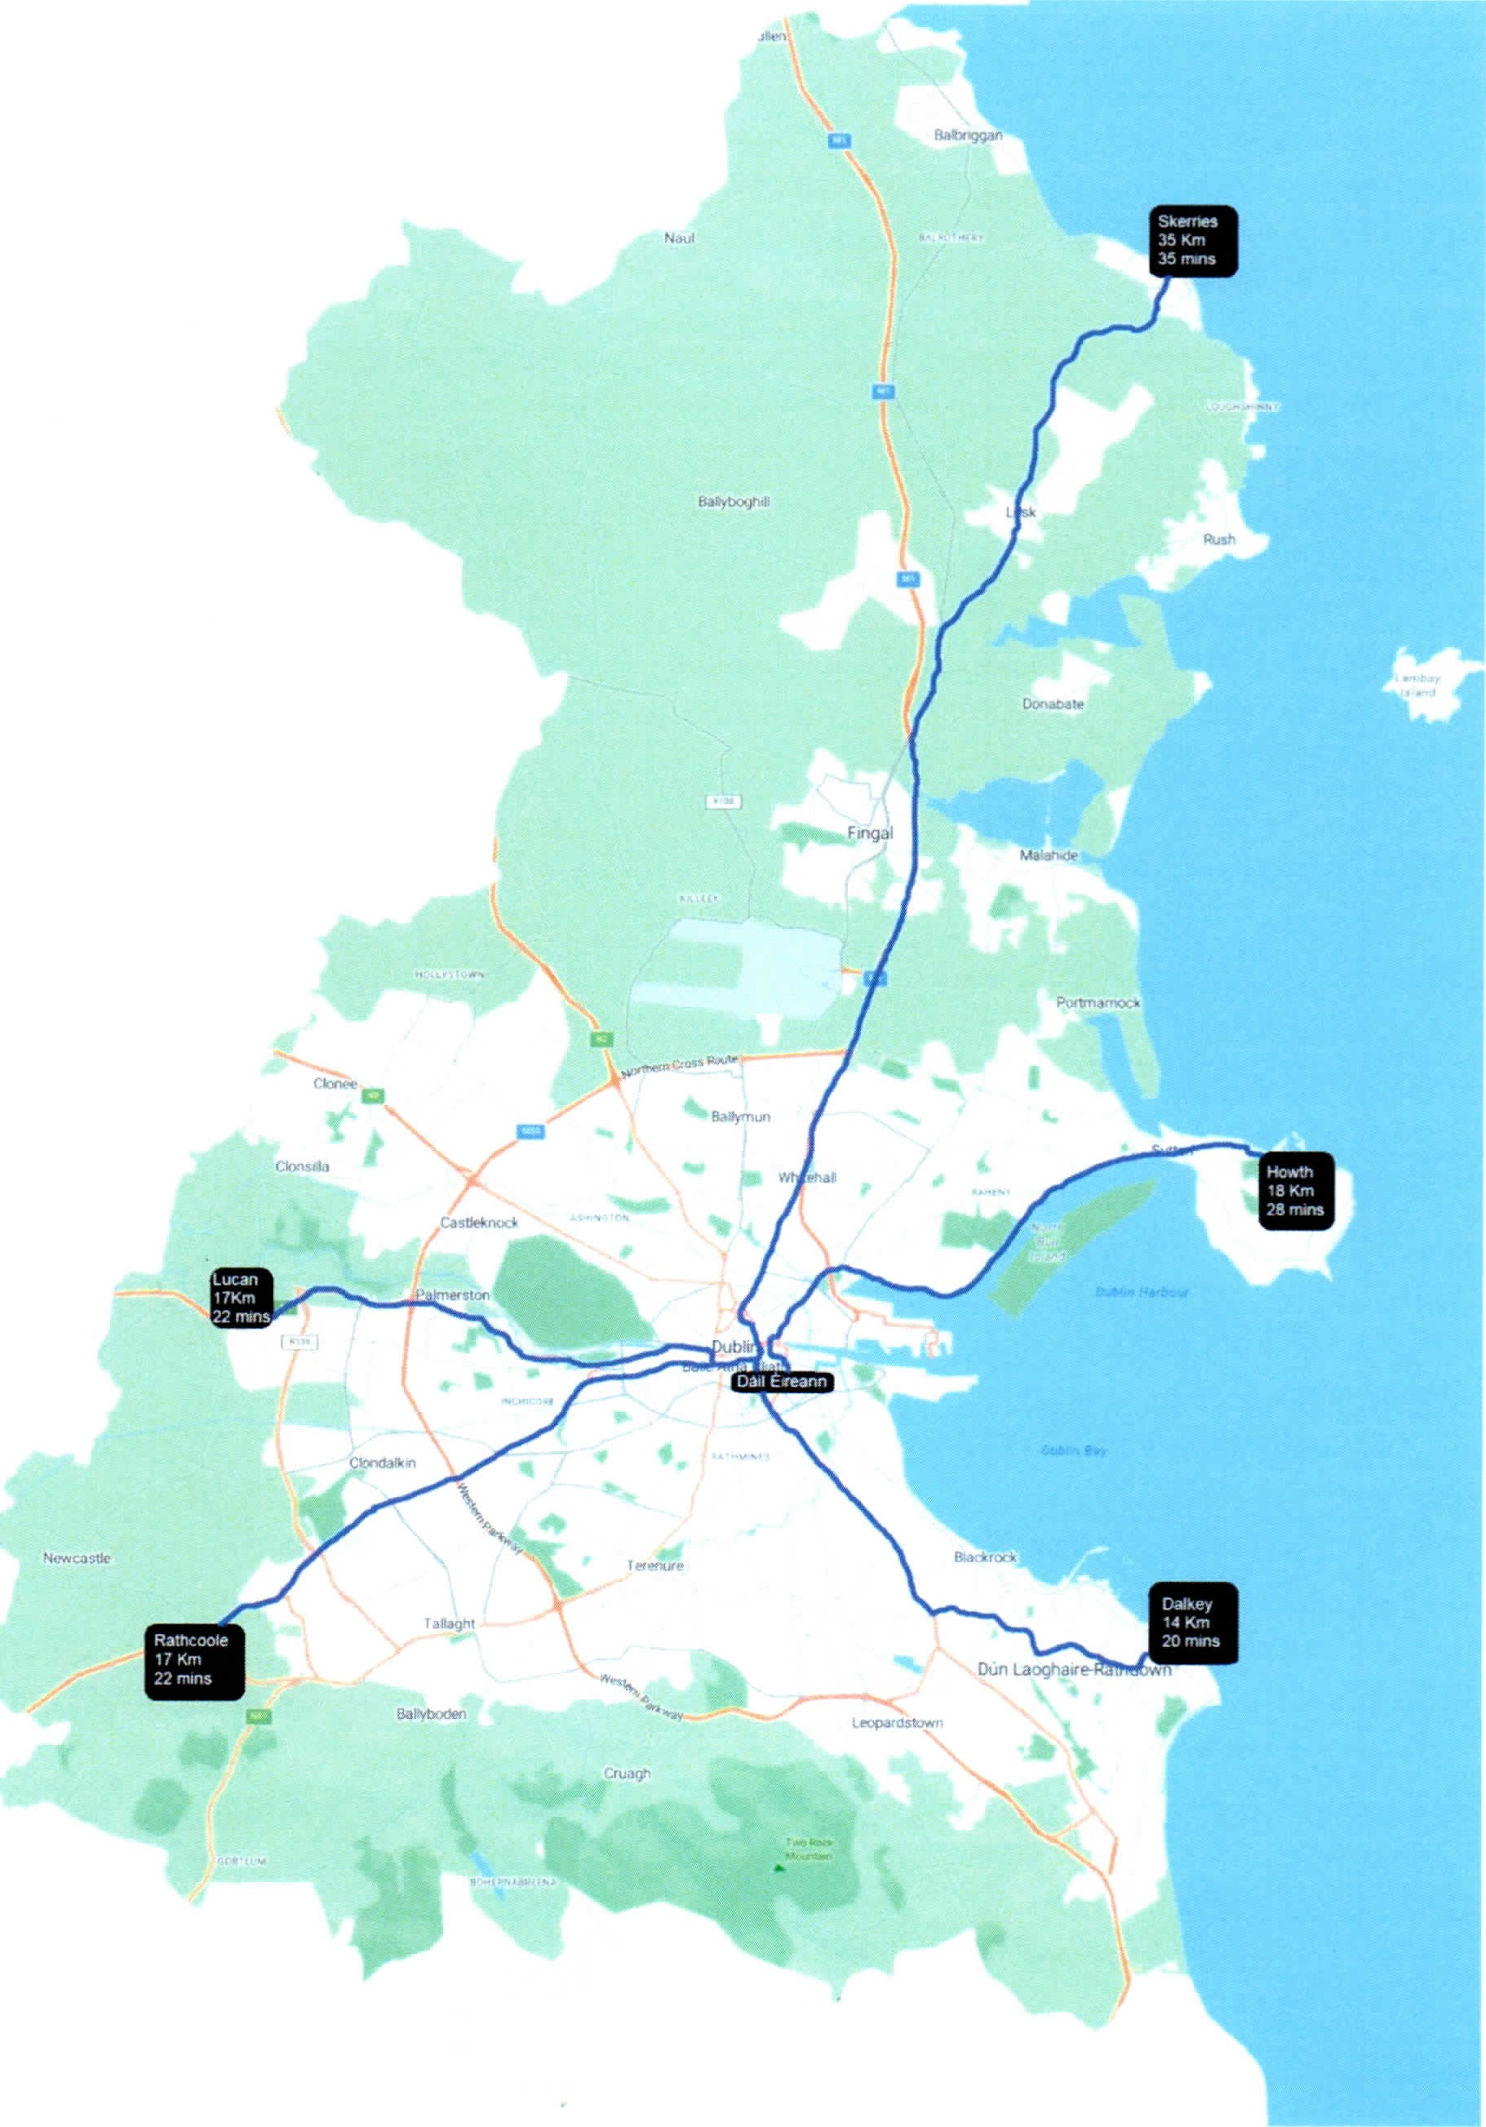
- Travel Times from Major Regional towns to Dáil Éireann
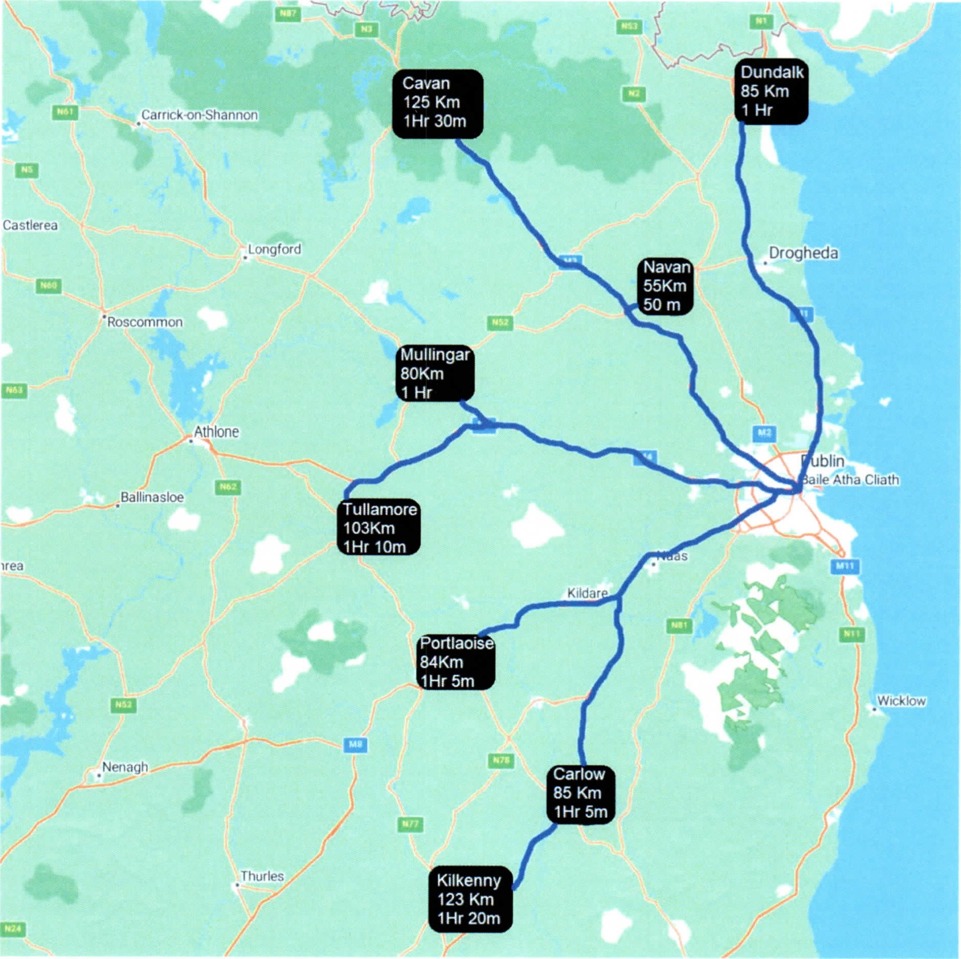

- Length of Kerry's coastline
