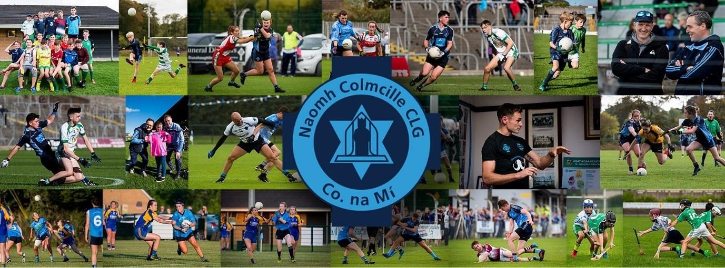

10th May 2023
constituencyreview@electoralcommission.ie

To whom it may concern,
I am writing on behalf of St Colmcilles GAA club, Bettystown to outline our views on the constituency review and particularly the challenges faced by the inclusion of part of Co. Meath in Co. Louth for electoral purposes.
Background
- St Colmcilles GAA are the largest GAA club in Bettystown Co Meath with c2,200 members made up approximately 51% male and 49% female.
- Our catchment area includes the coastal villages of Mornington, Laytown, Bettystown and Donacarney – known by Meath County Council as the LBMD settlement. This “settlement” is the 3rd largest settlement in Co Meath (after Navan and Ashbourne) with the 2016 Census noting its population at 11,872
- We have a weekly footfall of som3 5,000 people per week at our grounds and over a range of social outreach programmes (Men’s Shed. Mindfulness, Dance etc) in addition to Gaelic Football and Hurling. Our playing pitches are located at Piltown (Bettystown) and at Seafield in Laytown village.
- A recent study undertaken valuing our time at €10 an hour concluded that over €3million of volunteer hours were provided by St Colmcilles to its Community. Given our size and impact we make socially, our club is without doubt the most influential club in the region – politically, socially and economically.
- Our catchment area is wholly within the Co. Louth Electoral Boundary but administratively is under the management of Meath County Council
Comments
This mismatch between our local needs being served (excellently) by Meath County Council but our local political representation in Co Louth has caused significant difficulties and has been difficult to explain to and manage with members and our community.
A detailed study was undertaken in 2016 as to whether our area should be managed by the Louth Local authorities. This proposal was unequivocally rejected, indicating that it was generally accepted that our area is best served by the Meath authorities. However, this then gave rise to a curious position whereby our politicians should be from the Louth Constituency. This appears to make little sense, politically and culturally (for both areas) and is an inconsistency that appears to make no sense.
Louth has been traditionally dominated by 2 large urban areas, Dundalk and Drogheda. These areas have dominated political thoughts and time for over 100 years and have unique challenges that require this focus. However, these large towns have little in common with a new rapidly growing settlement such as the LBMD area which is neither a town nor a rural area. The growth of LBMD is however, consistent with that in Ashbourne, Ratoath and Dunboyne areas which are served by the Meath Electoral areas. In other words, Meath politicians have deep experience of the challenges and development needs faced by new settlements in the Dublin border regions and have successfully managed the growth in these areas. There would be a general concern in our area that given that the concentration of Louth politicians to the mid and the north of that county that the Meath areas have been neglected as there is no locally based politician with little history of and historical “allegiance” to Meath as their traditional areas.
Our club is bereft of land for recreational use and sporting infrastructure. This should be contrasted with the excellent efforts of political representatives in Meath to the development of facilities in Dunboyne, Ashbourne and Ratoath as well as the many rural areas. Many of these developments require deep concentration and effort with local authorities. An example of how inconsistent political and local authorities’ areas can negatively impact on development have been the proposed redevelopment of recreational facilities in Seafield, Laytown, Co. Meath. This area of natural beauty lends itself to the development of a community recreational and sporting hub – facilities badly needed. However, the level of preparation for and the general financing and drive of this concept would be huge. Whilst Meath County Council would be supportive of this development, there is currently little political will by either Louth politicians (who see the current electoral arrangements as temporary) and Meath politicians (as the area is within Louth for voting purposes). Accordingly, as there is no real political drive for this, this (and other local administration inaitives) fall between 2 stools
It also makes little or no sense to the people of East Meath that issues such as our Beach
Management Plan and coastal erosion challenges (which are priorities of Meath County Council) get little national airtime or hearing from political representatives as these are unique to our area rather than Louth and again, like the sporting arrangements is “falling between two stools”.
It is also fair to say that there would be significant local concerns and perhaps even distrust among parts of our community who have been born and lived in Meath all their lives, and who, prior to the last review were served by Meath politicians are looked after by Louth. The sense would be among many that Louth based politicians do not have an appreciation of the issues faced in Meath and little concern as to these. Whether this is correct or not is debatable but unfortunately it does lead to divisions.

We would call on the Commission to revisit (as a matter of urgency the electoral boundary) and to return the portion of County Meath, currently in Louth for electoral purposes to its traditional Meath constituency.
We would greatly welcome the opportunity to meet with your representatives to explore any points and to develop our concerns in greater detail. In the meantime, if you have any questions, I can be contacted at 089-4440124 or keithloughman1971@gmail.com

Is mise

Keith Loughman

Keith Loughman
Chairman
St Colmcilles GAA

