10th May, 2023

Dear Sir / Madam,

I welcome the opportunity to make this submission to the Electoral Commission’s
Constituency Review.

Firstly, I would ask that the Commission give consideration to recommending amendment of the 1997 Electoral Act and the Electoral Reform Act 2022 to allow for the creation of 6 seat constituencies on two bases:

○ Proportionality: the prohibition on 6 seat constituencies will necessitate the creation of more 3 seat constituencies, which are demonstrably less proportionate when it comes to votes-to-seat representation. This is unfair to smaller parties, minority views and is not in keeping with the spirit and intention of a proportional electoral system such as PRSTV, nor appropriate for a modern and diverse political system.
○ Diversity and gender balance: Smaller constituencies are a significant disadvantage to those currently under represented in politics and act as a barrier to entry and success to these groups. This leaves women in particular under represented and is contrary to other efforts to increase diversity and proportionality in representation amongst our public representatives.

Constituency Specific Points

In relation to Limerick City, it is unlike most Irish cities - with only Waterford being similar - in that it is located on the county boundary with suburbs extending into County Clare. While the Commission places a high importance on aligning Dáil constituencies with county boundaries, in the case of the Limerick City constituency (and Waterford) it makes less
sense to do so. The natural economic and administrative catchment of Limerick City very much includes the suburbs of Westbury and Shannon Banks as well as Ardnacrusha and Parteen (the electoral areas of Ballyglass and Cappavilla). While previously these areas were part of the Limerick City constituency, they are currently split away from it in the Clare constituency. This incoherence means that the residents of those suburbs are represented by politicians of a largely rural constituency, whose urban centre is 41 km away in Ennis, despite the fact that those residents are living in areas that are contiguous to Limerick City.

For the Midwest region to develop in the best possible way it is important that the electoral boundaries of its economic centre and largest urban area are set appropriately.
Unfortunately this is not the case at present. In other words the current set up is suppressing
the development of both Limerick City and the Midwest Region. As such I would request that the Commission consider setting a Limerick City boundary that reflects the true catchment of the metropolitan area of Limerick City and includes those suburban areas of the city that are currently in the Clare constituency.

The rationale above can reasonably justify extending the Limerick City constituency further (with an appropriate name change) such that it aligns with the boundaries of the Limerick Shannon Metropolitan Area (as set out in the Limerick Shannon MASP in the Southern Regional and Economic Spatial Strategy). Shannon Town - together with the industrial estate and the airport - and Limerick City have long been coupled economically. They are also now linked on a statutory basis from the point of view of planning, and, most recently, the
Limerick Shannon Metropolitan Area Transport Strategy (LSMATS) encompasses both areas. A single Dáil constituency to represent the area makes sense.

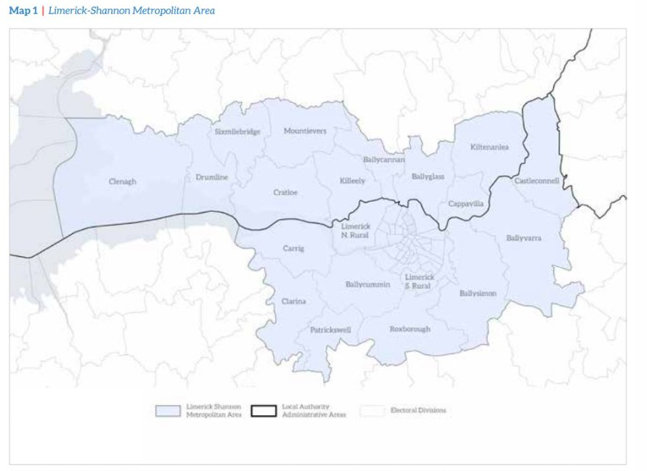

With respect to the western end of the current Limerick City constituency, electoral areas that have strong employment and education links to the City are Clarina, Patrickswell and Carrig are just outside the constituency and are currently in the Limerick County constituency. However, they are also in the Limerick Shannon Metropolitan Area.

The eastern end of the constituency currently extends into County Tipperary. As these areas of Tipperary are within the natural catchment of Limerick City, there is a rationale to maintain the boundary. However, they are not as connected to the city as the afore-mentioned
districts that are currently part of the Clare constituency. Additionally, they are not part of the
Limerick Shannon Metropolitan Area. The case to maintain the Tipperary districts with the
Limerick City constituency exists, but it is not as strong as the case to extend the constituency into Clare or, in my view, to align it with the Limerick Shannon Metropolitan Area.

Aligning the constituency with the Limerick Shannon Metropolitan Area (using preliminary
2022 census figures), the population of the larger Limerick City constituency (perhaps to be renamed as Limerick Shannon) would be 140,535. As a five-seat constituency this would have a ratio of 1 TD to 28,107. Future population growth could be accommodated by increasing the number of seats to six, as per the request made at the beginning of this submission.

Kind regards,

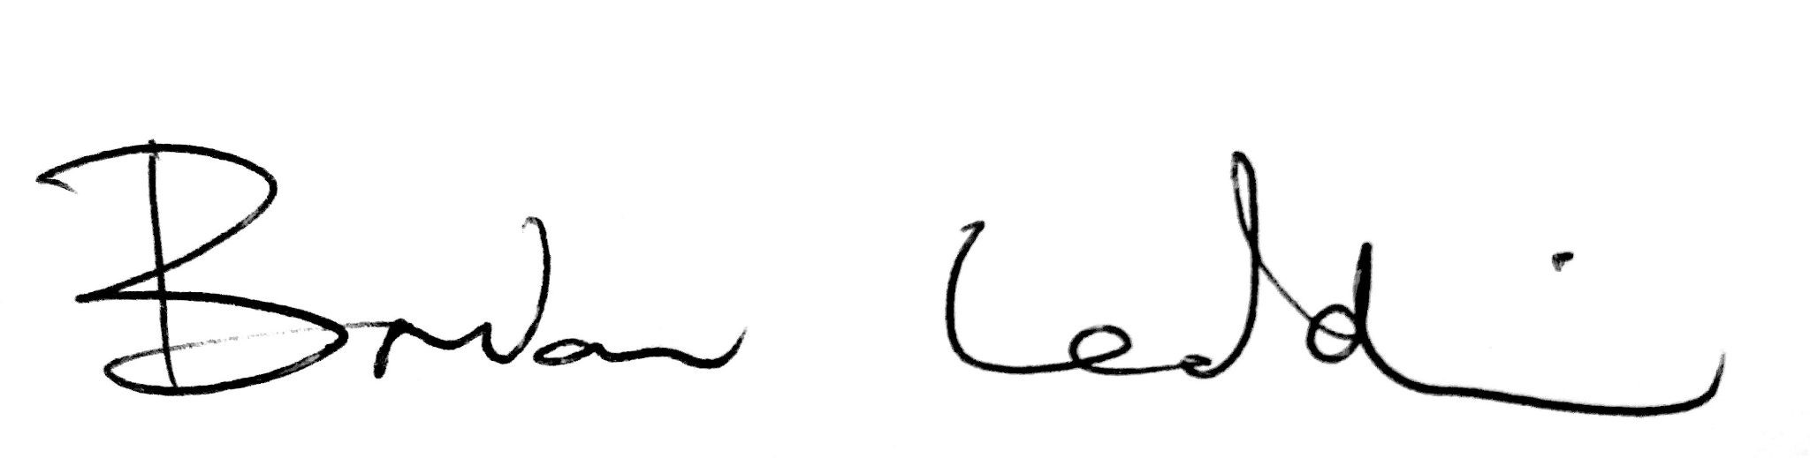

Brian Leddin TD

