Dublin South Central Constituency Labour Party – Submission to the Electoral Commission Dáil Constituency Review.

To whom it concerns,

We wish to submit to the commission that the current constituency of Dublin South Central requires the inclusion of three small contiguous areas to encompass areas within the natural boundaries of the M50 motorway to the West and the river Liffey to the North which would merit the addition of one extra TD to become a 5-seat constituency.
The current boundaries of the constituency have created issues that the commission can remedy in order to provide more effective representation for the area.
Per the commissions stated criteria, the following is observed.:

1) Article 16.2.2˚ of the Constitution
The population of the constituency now stands at 127,169 placing the number of members to each thirty thousand as required by Article 16.2.2˚ of the Constitution, at one TD per 31,792. Given that this is currently a four-seat constituency, this equates to a population of 7,168 without adequate representation. This represents a percentage of 5.64%. This is 0.64% deviance above the 5% threshold as generally observed.

2) Reference to boundaries
The constituency is currently constituted in legislation as being:
"In the city of Dublin, the electoral divisions of:
Carna, Chapelizod, Cherry-Orchard A, Cherry-Orchard C, Crumlin A, Crumlin B, Crumlin C, Crumlin D, Crumlin E, Crumlin F, Decies, Drumfinn, Inchicore A, Inchicore B, Kilmainham A, Kilmainham B, Kilmainham C, Kimmage A, Kimmage B, Kimmage D, Kimmage E, Kylemore, Merchants Quay A, Merchants Quay B, Merchants Quay C, Merchants Quay D, Merchants Quay E, Merchants Quay F, Ushers A, Ushers B, Ushers C, Ushers D, Ushers E, Ushers F, Walkinstown A, Walkinstown B, Walkinstown C; and that part of the electoral division of Phoenix Park situated south of a line drawn along Chapelizod Road, Conyngham Road and Parkgate Street;
and, in the county of South Dublin, the electoral divisions of:
Templeogue-Kimmage Manor, Terenure-Cherryfield, Terenure-Greentrees; and those parts of the electoral divisions of Clondalkin-Ballymount, Clondalkin-Monastery and Tallaght-Kilnamanagh situated east of a line drawn along the M50 Western Parkway."
These electoral divisions, and part-electoral divisions, within the constituencies western boundary cover areas of Dublin City, South Dublin County, South West Inner City LEA, Ballyfermot-Drimnagh LEA, Kimmage-Rathmines LEA and Clondalkin LEA. The constituency currently already encompasses multiple county, city, and administrative boundaries i.e., encompasses and divides LEAs and divides EDs parts of existing electoral divisions. This is necessary for contiguous areas and should not be changed.

3) Contiguous Areas, Geographic & Physical Features, Density of population
We propose that the addition of contiguous areas in the area of Cherry Orchard and Palmerstown be included in the Dublin South Central constituency. Figure 1 highlights the proposed additional area which is bounded to the north by the River Liffey, and to the west by the M50 motorway.

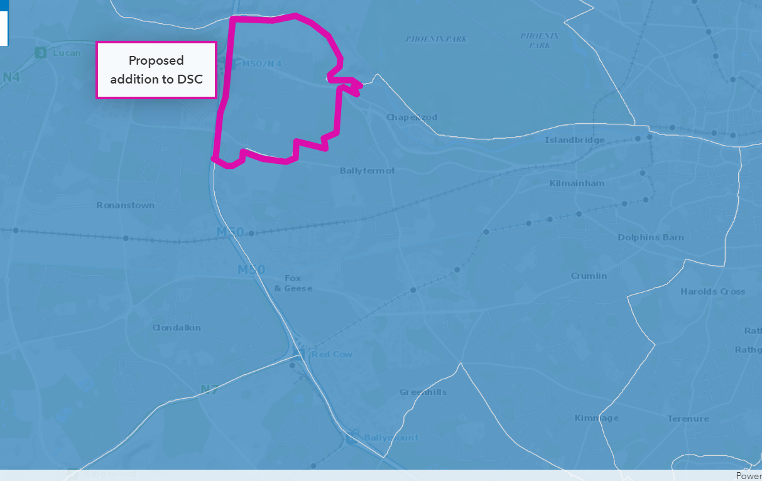
Figure 1 Suggested Parlmerstown Contiguous Area Addition to DSC - Source OSI Geohive

There are three existing electoral division boundaries within this proposed area. They are the part of Palmerstown West ED which is east of the M50, Palmerstown Village ED, and a small area of Clondalkin-Moorfield ED that is east of the M50. Figure 2 shows a suggested line dividing the current EDs to better reflect contiguous communities of the area.
Palmerstown West
2022 Census figures for Palmerstown West ED (ED03020) provides a population 7,387. Approximately two thirds of this Eds residential area is east of the M50, and one third west. The communities of Palmerstown and Quarryvale/Fonthill Rd, are two distinct population areas. This proposed change would move a population of 4924 into Dublin South Central.
Palmerstown Village ED
The Entirety of Palmerstown Village ED is a contiguous area to Ballyfermot (which is comprised mainly of the Drumfinn, Carna, Decies and Kylemore ED’s). Palmerstown Village ED has a stable population which in Census 2022 totalled 3711.
Clondalkin-Moorfield ED
The Coldcut part of the Clondalkin-Moorfield ED is very much part of the contiguous Ballyfermot and Cherry-Orchard communities and as such, ought to be part of the same constituency. This is a very small part of the ED. It might be approximated to 1/10th of the entire residential area. The Clondalkin-Moorfield ED population at the 2022 census is 7,074. It might be therefore estimated that at 1/10th of the area, the proposed change would move a population of approximately 704 into Dublin South Central.

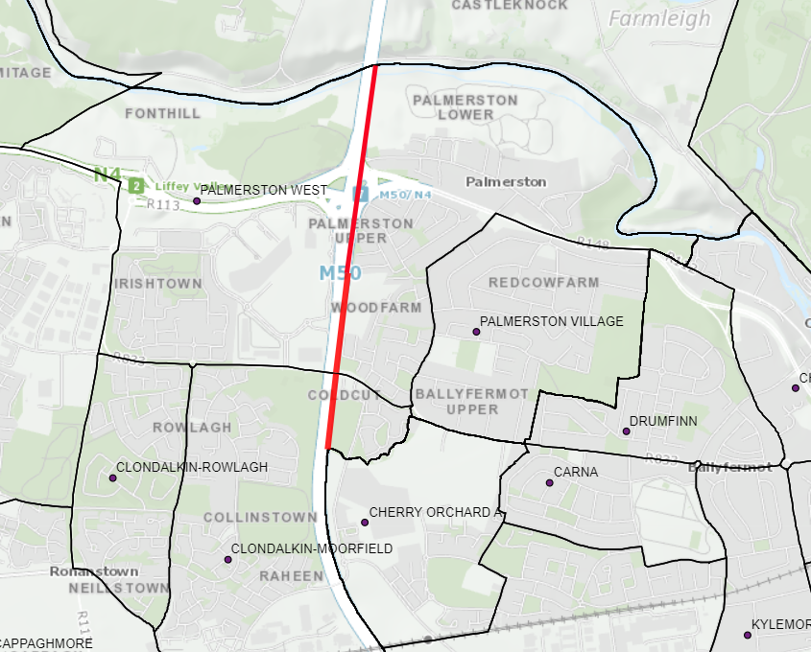
Figure 2 Palmerstown West ED & Clondalkin-Moorfield ED Red line is the M50. Source, OSI Geohive

Additional seat – change from 4 seat constituency to 5 seat.
These additional contigious areas amount to the following population additions to Dubliln South Central.
4924 + 3711+704 = 9339
The addition of 9339apx to the DSC constituency would cause the constituency to 136,508
(127,169 + 9339 = 136,508)
If provided for 5 TD’s, this would calculate as 27,301.6 per member, which is a fair and reasonable ratio within the constitutional provisions. This would also provide for projected population growth in the area over the mid-term.

Conclusion.
The Dublin South Central constituency is administratively diverse at present, and while marginally above population to representation ratios, when areas which are contiguous to the large populous areas and urban villages of the constituency are added to the current constituency boundaries, a fair, balanced, and rational national representation of the people can be achieved.

Regards,

Members of the Dublin South Central Constituency Labour Party

