Constituency Review submission
Patrick Matthews

- Overview

The stated criteria for the Electoral Commission to consider during the current constituency review process are as follows:

In relation to Dáil constituencies, the Commission is required, in observing the relevant provisions of the Constitution, to have regard to the following:

- the total number of members of the Dáil, subject to Article 16.2.2° of the Constitution, shall be not less than 171 and not more than 181;
- each constituency shall return 3, 4 or 5 members;
- the breaching of county boundaries shall be avoided as far as practicable.
- the reference to county boundaries shall be deemed not to include a reference to the boundary of a city or any boundary between any 2 of the counties of Dún Laoghaire-Rathdown, Fingal and South Dublin.
- each constituency shall be composed of contiguous areas;
- there shall be regard to geographic considerations including significant physical features and the extent of and the density of population in each constituency; and
- subject to the above matters, the Commission shall endeavour to maintain continuity in relation to the arrangement of constituencies.

The population of the Republic of Ireland as given in the preliminary report of the 2022 Census was 5,123,536, an increase of 361,671 or 7.6% over the comparable figure from 2016. This represents a figure of population/TD of between 29,962.20 (for a figure of 171 TDs) and 28,306.83 (for a figure of 181 TDs). For comparison, the equivalent population/TD figure for the constituencies delimited by the 2017 Constituency Commission was 29,761.66.

While the stated criteria allow any figure between 171 and 181 to be chosen, in practice all Constituency Commissions or constituency revisions since 1961 have decided on an even number of seats so as to reduce the possibility of tied Dáil votes, and in this submission the assumption is made that this practice will continue and so only scenarios involving even numbers of seats are considered.

The constituencies proposed by the most recent Constituency Commission allowed a maximum variance from the average population/TD figure in each direction of +5.07% (Dún Laoghaire) and -4.89% (Cavan–Monaghan). Again, the assumption is made that variances of less than 5% of the national average in each direction are required.

The third criterion in the list above states that “the breaching of county boundaries shall be avoided as far as practicable.” Complaints about such breaches have formed a major part, often close to a majority, of the submissions to each successive Constituency Commission (certainly when excluding submissions dealing with factors beyond the Commissions’ remit such as the total number of TDs or the size of constituencies) and this criterion needs to be strongly considered in any deliberations on the redrawing of boundaries.

At present, the following breaches of county boundaries exist, with the total population who live in the affected areas listed alongside:

Constituency | Population
Laois in Kildare South | 10,512
Meath in Cavan-Monaghan | 4,205
Meath in Louth | 27,912
Offaly in Kildare South | 2,568
Westmeath in Meath West | 9,418
Tipperary in Limerick City | 4,674
Galway in Roscommon-Galway | 30,717
Mayo in Galway West | 5,878
Roscommon in Sligo-Leitrim | 8,523
Donegal in Sligo-Leitrim | 9,331
Total | 113,738

This figure (113,738) can be used as a baseline to measure the effectiveness of each proposal at minimizing breaches of county boundaries.

- 172-Seat Scenario

The first scenario we will consider is one where the minimum change is made in terms of the number of extra seats; that is, an increase from 160 to 172. This produces a figure of population/TD of 29,788 (almost identical to the figure produced by the 2017 Constituency Commission) with potential variance between 31,277.4 and 28,298.6 assuming a 5% degree of tolerance.

The current set of constituencies with their current number of seats have the following characteristics under a 172-seat allocation:

Constituency | Population | Seats | Average | Variance
Limerick County | 89,479 | 3 | 29,826.33 | +0.13%
Cavan-Monaghan | 150,238 | 5 | 30,047.60 | +0.87%
Dublin North-West | 90,219 | 3 | 30,073.00 | +0.96%
Limerick City | 120,639 | 4 | 30,159.75 | +1.25%
Sligo-Leitrim | 122,760 | 4 | 30,690.00 | +3.03%
Roscommon-Galway | 92,189 | 3 | 30,729.67 | +3.16%
Cork South-West | 92,232 | 3 | 30,744.00 | +3.21%
Dublin Central | 123,165 | 4 | 30,791.25 | +3.37%
Galway West | 154,596 | 5 | 30,919.20 | +3.80%
Kerry | 155,258 | 5 | 31,051.60 | +4.24%
Wicklow | 155,485 | 5 | 31,097.00 | +4.39%
Dublin Bay North | 155,905 | 5 | 31,181.00 | +4.68%
Donegal | 156,990 | 5 | 31,398.00 | +5.40%
Kildare South | 125,703 | 4 | 31,425.75 | +5.50%
Dublin Bay South | 126,714 | 4 | 31,678.50 | +6.35%
Dublin South-West | 158,636 | 5 | 31,727.20 | +6.51%
Waterford | 127,085 | 4 | 31,771.25 | +6.66%
Dublin South Central | 127,169 | 4 | 31,792.25 | +6.73%
Clare | 127,419 | 4 | 31,854.75 | +6.94%
Cork North-West | 96,012 | 3 | 32,004.00 | +7.44%
Laois-Offaly | 161,245 | 5 | 32,249.00 | +8.26%
Galway East | 97,016 | 3 | 32,338.67 | +8.56%
Tipperary | 162,987 | 5 | 32,597.40 | +9.43%
Dublin Mid-West | 130,415 | 4 | 32,603.75 | +9.45%
Cork South-Central | 130,716 | 4 | 32,679.00 | +9.71%
Wexford | 163,527 | 5 | 32,705.40 | +9.79%
Cork East | 130,930 | 4 | 32,732.50 | +9.88%
Cork North-Central | 131,341 | 4 | 32,835.25 | +10.23%
Mayo | 131,353 | 4 | 32,838.25 | +10.24%
Meath East | 98,662 | 3 | 32,887.33 | +10.40%
Meath West | 98,935 | 3 | 32,978.33 | +10.71%
Dún Laoghaire | 132,302 | 4 | 33,075.50 | +11.04%
Carlow-Kilkenny | 165,616 | 5 | 33,123.20 | +11.20%
Longford-Westmeath | 133,056 | 4 | 33,264.00 | +11.67%
Louth | 167,012 | 5 | 33,402.40 | +12.13%
Dublin West | 134,331 | 4 | 33,582.75 | +12.74%
Kildare North | 134,354 | 4 | 33,588.50 | +12.76%
Dublin Rathdown | 101,155 | 3 | 33,718.33 | +13.19%
Dublin Fingal | 170,690 | 5 | 34,138.00 | +14.60%

We see that twelve out of thirty-nine constituencies (indicated by their variance figure having a green background) would have population/TD ratios within a 5% tolerance range of the national average, while twenty-seven (indicated by a dark orange background) are outside the range, some almost three times outside the range, and all have ratios above the national average under a 172-seat scheme. However, not all the constituencies within range could be left entirely unchanged under such a scheme, e.g., while Dublin North-West and Dublin Bay North are within the range, the neighbouring constituency of Dublin Fingal is massively above and will need to either lose population or be subdivided to meet the criteria, either of which will most likely have effects on its neighbours.

Looking at each county and its population in relation to the national population/TD average, we see the following figures:

 | Population | No. of seats |  | Population | No. of seats
LEINSTER |  |  | MUNSTER
Carlow | 61,931 | 2.08 | Clare | 127,419 | 4.28
Dublin | 1,450,701 | 48.70 | Cork | 581,231 | 19.51
North City | 346,244 | 11.62 | Kerry | 155,258 | 5.21
South City | 241,989 | 8.12 | Limerick | 205,444 | 6.90
South Dublin | 299,793 | 10.06 | Tipperary | 167,661 | 5.63
Fingal | 329,218 | 11.05 | Waterford | 127,085 | 4.27
Dún Laoghaire-Rathdown | 233,457 | 7.84 | CONNACHT
Kildare | 246,977 | 8.29 | Galway | 276,451 | 9.28
Kilkenny | 103,685 | 3.48 | Leitrim | 35,087 | 1.18
Laois | 91,657 | 3.08 | Mayo | 137,231 | 4.61
Longford | 46,634 | 1.57 | Roscommon | 69,995 | 2.35
Louth | 139,100 | 4.67 | Sligo | 69,819 | 2.34
Meath | 220,296 | 7.40 | ULSTER (part)
Offaly | 82,668 | 2.78 | Cavan | 81,201 | 2.73
Westmeath | 95,840 | 3.22 | Donegal | 166,321 | 5.58
Wexford | 163,527 | 5.49 | Monaghan | 64,832 | 2.18
Wicklow | 155,485 | 5.22

We can now proceed to look at individual counties and combinations of counties.

  - Donegal/Sligo/Leitrim

For geographical reasons, we need to begin our examination of the constituency boundaries with County Donegal. Donegal is connected to only one other county (Leitrim) in the Republic, and therefore any allocation of seats involving one county will necessarily have implications for the other.

At present, most of County Donegal constitutes a 5-seat constituency with a population of 156,990, producing a population/TD ratio of 31,398 (5.4% above the national average under a 172-seat scenario). The remainder of the county (the urban district of Bundoran, the former rural district of Ballyshannon, and the electoral division of Ballintra in the former rural district of Donegal), with a total population of 9,331, is joined with the counties of Sligo and Leitrim – and since 2017 with the northernmost part of County Roscommon – in a 4-seat Sligo–Leitrim constituency with a population of 122,760, producing a population/TD ratio of 30,690 (3.0% above the national average under a 172-seat scenario). However, this latter constituency has been subjected to severe criticism because it contains parts of four separate counties (see the submission from Deputy Marc McSharry). The pre-2017 version of Sligo–Leitrim was also heavily criticised for similar reasons (in this case it contained part of County Cavan rather than County Roscommon) and the 2017 Constituency Commission returned the Cavan portion of the constituency to Cavan–Monaghan. The portion of County Roscommon in the constituency has a population of 8,523 and removing it would leave the balance of the Sligo–Leitrim constituency with a population of 113,237 and a population/TD ratio of 28,309, very slightly under 5.0% below the national average.

Allocating six seats to County Donegal on its own, as proposed by Deputy McSharry in his submission, would produce a population/TD ratio of 27,720.17, 6.9% below the national average for a 172-seat scheme; it would require a national allocation of 176 seats or more for it to be (barely) within a 5% tolerance range. Adding territory to Donegal to bring it up to quota on lower allocations would require the annexation of territory from County Leitrim, which given the latter’s status as having the smallest population of any county, is something that has caused a high level of complaint in the past.

One solution would be to transfer the electoral divisions of Laghy, Tullynaught, Grousehall, Pettigoe and Templecarn in the former rural district of Donegal, with a total population of 2,005, from the Donegal to the Sligo–Leitrim constituency. These electoral divisions are adjacent to the part of the Donegal currently in that constituency and for the latter three the only road connection to the rest of Donegal goes through the Ballintra ED in the former Donegal rural district. This would increase the Donegal population in Sligo–Leitrim to 11,336, and it might be appropriate to recognize this, along with the reduction in the number of counties included, by renaming the constituency as Sligo–Leitrim–Donegal or Sligo–Leitrim–South Donegal.

Proposed constituency | Population | Seats | Population/TD | Variance
Donegal | 154,985 | 5 | 30,997.00 | +4.06%
Sligo–Leitrim–South Donegal | 116,242 | 4 | 29,060.50 | -2.44%

The number of residents of the Donegal constituency not in County Donegal is 0 (no change).
The number of residents of the Sligo–Leitrim–South Donegal constituency not in Counties Sligo or Leitrim is 11,336 (a decrease of 6,518).

  - Cavan/Monaghan

At present, Cavan–Monaghan is a 5-seat constituency with a population of 150,238 and a population/TD ratio of 30,047.6 (+0.9% above the national average under a 172-seat scenario). It comprises all of the counties of Cavan and Monaghan along with seven electoral divisions from the northernmost part of County Meath which were added to the constituency at the 2017 constituency review and which have a total population of 4,205.

Returning these electoral divisions to a Meath constituency would resolve this breach of county boundaries and produce a Cavan–Monaghan constituency solely from the two eponymous counties with a population of 146,033, representing a population/TD ratio of 29,206.6.
Proposed constituency | Population | Seats | Population/TD | Variance
Cavan–Monaghan | 146,033 | 5 | 29,206.60 | -1.95%

The number of residents of the Cavan–Monaghan constituency not in Counties Cavan or Monaghan is 0 (a decrease of 4,205).

  - Galway/Mayo/Roscommon

At present, the counties of Galway and Mayo and that part of County Roscommon not in the Sligo–Leitrim constituency make up four constituencies:

- a 3-seat Roscommon–Galway constituency with a population of 92,189 and a population/TD ratio of 30,729.67 (3.2% above the national average under a 172-seat scenario). It comprises a population of 61,472 in County Roscommon and 30,717 in County Galway, consisting of the urban district of Ballinasloe, the former rural district of Glennamaddy, most of the former rural districts of Ballinasloe and Mountbellew, and seven electoral divisions in the east of the former rural district of Tuam.
- a 4-seat Mayo constituency with a population of 131,353, consisting of all of County Mayo except for six electoral divisions with a total population of 5,878 in the Cong/Kilmaine/Shrule area of the former Ballinrobe rural district on the eastern shores of Loughs Mask and Corrib. Its population/TD ratio is 32,838.25 (10.2% above the national average under a 172-seat scenario).
- a 5-seat Galway West constituency with a population of 154,596, consisting of that part of County Mayo not in the Mayo constituency, the city of Galway, the former rural districts of Clifden and Oughterard, and all of the former rural district of Galway with the exception of four eastern electoral divisions which were transferred to Galway East in the 2017 review. It has a population of 148,718 in County Galway and 5,878 in Mayo and has a population/TD ratio of 30,919.2 (3.8% above the national average under a 172-seat scenario).
- A 3-seat Galway East constituency with a population of 97,016 and a population/TD ratio of 32,338.67 (8.6% above the national average under a 172-seat scenario). It comprises those parts of County Galway not in the Roscommon–Galway or Galway West constituencies.

County Mayo has a population of 137,231. Establishing it as a 5-seat constituency in its own right would give it a population/TD ratio of 27,446.2, which would be 7.9% below the national average on a 172-seat scenario and would require a 178-seat scenario for it to be within a 5% tolerance level. It would otherwise need to take territory either from Roscommon or Galway. Galway, however, has a population of 276,451 and an allocation of nine seats to the county would yield a population/TD ratio of 30,716.78, only 3.1% above the national average on a 172-seat scenario. Roscommon, even with the return of territory from Sligo–Leitrim, is entitled to a maximum of two seats and so would need to be linked with another county to form a valid constituency.

In Deputy McSharry’s submission, there is a proposal to link Roscommon with Longford to recreate the 4-seat constituency that existed between 1992 and 2007, with a population/TD ratio 2.1% below the national average under a 172-seat scenario. However, this previous constituency was negatively regarded locally because of the poor transport and social links between the two counties (most of the boundary between them lies either in Lough Ree or in the Upper Shannon, with only two land crossings at Lanesborough/Ballyleague and Cloondara/Tarmonbarry, and most transport and social links for Longford are either on a north-west/south-east axis along the N4/Dublin-Sligo railway towards Carrick-on-Shannon and Mullingar, or on a north-south axis along the N55 towards Cavan and Athlone). In addition, linking Longford with Roscommon rather than with Westmeath would breach a provincial border and also necessitate a breach of Westmeath’s border with either Meath or Offaly and cause a cascading effect elsewhere in Leinster, whereas Longford and Westmeath work well together under current figures as a 5-seat constituency in all scenarios, as we will demonstrate later.

Mayo and Roscommon have a combined population of 207,226, which produces a population/TD ratio only 0.6% below the national average under a 172-seat scenario. The only possible arrangement for this pairing is a 4-and-3 seat arrangement, with Roscommon requiring a transfer of population of around 19-20,000 from Mayo to create a 3-seat constituency.

The electoral divisions of Ballyhaunis, Ballyhowly, Bekan, Caraun, Claremorris, Course, Culnacleha, Kilcolman, Knock North, Knock South, Loughanboy, and Murneen in the former rural district of Claremorris, and the electoral divisions of Aghamore, Cloonmore, Coolnaha, Doocastle, Kilbeagh, Kilkelly, Kilmovee, Sonnagh, and Urlaur in the former rural district of Swineford, have a combined population of 20,071.

Claremorris RD |  | Swineford RD
Electoral division | Population | Electoral division | Population
Ballyhaunis | 3,495 | Aghamore | 646
Ballyhowly | 477 | Cloonmore | 440
Bekan | 773 | Coolnaha | 511
Caraun | 354 | Doocastle | 379
Claremorris | 4,709 | Kilbeagh | 1,068
Course | 446 | Kilkelly | 967
Culnacleha | 483 | Kilmovee | 658
Kilcolman | 445 | Sonnagh | 1,222
Knock North | 997 | Urlaur | 514
Knock South | 802
Loughanboy | 319
Murneen | 366
Total | 13,666 | Total | 6,405

Transferring this area from the Mayo constituency to a Roscommon-based constituency – to be called either Roscommon–Mayo or Roscommon–East Mayo – would produce:

- a 4-seat Mayo constituency with a population of 117,160 and a population/TD ratio of 29,290 (1.7% below the national average under a 172-seat scenario), and
- a 3-seat Roscommon–East Mayo constituency with a population of 90,066 and a population/TD ratio of 30,022 (0.8% above the national average under a 172-seat scenario).

A simple transfer of the part of the current Roscommon–Galway constituency located in County Galway into the now 4-seat Galway East constituency while leaving the boundary between Galway East and Galway West unchanged would produce a Galway East constituency with a population of 127,733 and a population/TD ratio of 31,933.25, 7.2% above the national average under a 172-seat scenario, so it will be necessary to transfer some electoral divisions to Galway West. The four electoral divisions of Aughrim, Belleville, Deerpark, and Stradbally in the former rural district of Galway were transferred from Galway West to Galway East by the 2017 Constituency Commission and have a combined population of 4,589.

Reversing this change would produce:

- a 4-seat Galway East constituency with a population of 123,144 and a population/TD ratio of 30,786 (3.4% above the national average under a 172-seat scenario), and
- a 5-seat Galway West constituency with a population of 153,307 and a population/TD ratio of 30,661.4 (2.9% above the national average under a 172-seat scenario).

Proposed constituency | Population | Seats | Population/TD | Variance
Galway East | 123,144 | 4 | 30,786.00 | +3.35%
Galway West | 153,307 | 5 | 30,661.40 | +2.93%
Mayo | 117,160 | 4 | 29,290.00 | -1.67%
Roscommon–East Mayo | 90,066 | 3 | 30,022.00 | +0.79%

The number of residents of the Galway East constituency not in County Galway is 0 (no change).
The number of residents of the Galway West constituency not in County Galway is 0 (a decrease of 5,878).
The number of residents of the Mayo constituency not in County Mayo is 0 (no change).
The number of residents of the Roscommon–East Mayo constituency not in County Roscommon is 20,071 (a decrease of 10,646 in comparison to the current Roscommon–Galway constituency).

  - Clare/Limerick

At present, County Clare makes up a 4-seat constituency in its own right with a population of 127,419, giving a population/TD ratio of 31,854.75, which is 6.9% above the national average under a 172-seat scenario and would require the loss of territory to bring it within a 5% tolerance level.

The city and county of Limerick are divided into two constituencies:

- a 4-seat Limerick City constituency, which includes the city of Limerick and most of the former rural district of Limerick, as well as three electoral divisions in the Newport/Birdhill area of County Tipperary with a combined population of 4,674. The population of the constituency as a whole is 120,639 (115,965 in Limerick), resulting in a population/TD ratio of 30,159.75, 1.3% above the national average under a 172-seat scenario, and
- a 3-seat Limerick County constituency, containing the balance of the county, and with a population of 89,479, giving a population/TD ratio of 29,826.33, 0.1% above the national average under a 172-seat scenario.

Removing the portion of County Tipperary in the Limerick City constituency while keeping it as a 4-seat constituency would result in a 28,991.25 population/TD figure, 2.7% below the national average and within the 5% tolerance limit under a 172-seat scenario. However, this leaves the divergence in the Clare constituency unresolved.

The Ballyglass electoral division in the former Meelick rural district of County Clare, with a population of 6,023, has formed part of Limerick city-based constituencies on a number of occasions, most recently prior to the 2017 constituency revision. The bulk of its population live in Limerick suburbia directly opposite the city. Reversing the change made in 2017 would result in a Clare constituency with a population of 121,396 and a Limerick City constituency with a population of 121,988, both within the 5% tolerance range. No change is required to the Limerick County constituency.

Proposed constituency | Population | Seats | Population/TD | Variance
Clare | 121,396 | 4 | 30,349.00 | +1.88%
Limerick City | 121,988 | 4 | 30,497.00 | +2.38%
Limerick County | 89,479 | 3 | 29,826.33 | +0.13%

The number of residents of the Clare constituency not in County Clare is 0 (no change).
The number of residents of the Limerick City constituency not in County Limerick is 6,023 (an increase of 1,349).
The number of residents of the Limerick County constituency not in County Limerick is 0 (no change).

  - Kerry

The Kerry constituency is identical with County Kerry and has a population of 155,258. With 5 seats, this results in a population/TD ratio of 31,051.6, 4.2% above the national average in a 172-seat scenario but within the 5% tolerance range. As such, no change is required under this scenario.
Proposed constituency | Population | Seats | Population/TD | Variance
Kerry | 155,258 | 5 | 31,051.60 | +4.24%

The number of residents of the Kerry constituency not in County Kerry is 0 (no change).

  - Cork

The city and county of Cork are currently divided into five constituencies, none of which include territory outside the county, and outside of which no part of the city or county lies. This configuration in terms of the names and approximate locations of the constituencies has been broadly the same since the first Constituency Commission report for the 1981 election, although the total number of seats has decreased since then from 20 to 18, with the two Cork city-based constituencies both being reduced from 5- to 4-seaters:

- Cork East, a 4-seat constituency, containing the urban districts of Cobh, Fermoy, Mallow, Midleton, and Youghal, the former rural districts of Midleton, Mitchelstown, and Youghal, most of the former rural district of Fermoy, part of the former rural district of Mallow, and the electoral divisions of Cobh Rural and Knockraha from the former rural district of Cork. This constituency has a population of 130,930, giving a population/TD ratio of 32,732.5 (9.9% above the national average in a 172-seat scenario),
- Cork North-Central, a 4-seat constituency, containing all of the pre-2014 city of Cork north of the river Lee as well as that part of the city south of the Lee but north of the Glasheen and Curraheen Roads, as well as the part of the former Cork rural district north of the Lee but not in the Cork East constituency, three electoral divisions from the former Fermoy rural district, two electoral divisions from the former Mallow rural district, and one electoral division (Gowlane) from the former Macroom rural district. This constituency has a population of 131,341, giving a population/TD ratio of 32,835.25 (10.2% above the national average in a 172-seat scenario),
- Cork North-West, a 3-seat constituency, containing Macroom urban district, the former Kanturk and Millstreet rural districts, all of the former Macroom rural district not in the Cork North-Central constituency, eleven western electoral divisions of the former Mallow rural district (mainly covering the Charleville area but also including some of the hinterland of the town of Mallow), the electoral divisions of Ballincollig and Ovens from the former rural district of Cork, and the northern parts of the former Bandon and Dunmanway rural districts. This constituency has a population of 96,012, giving a population/TD ratio of 32,004 (7.4% above the national average in a 172-seat scenario),
- Cork South-Central, a 4-seat constituency, containing that part of the pre-2014 city of Cork not in the Cork North-Central constituency, almost all of the former rural district south of the Lee not in the Cork North-Central and Cork North-West constituencies with the exception of the electoral division of Dunderrow, and four electoral divisions from the former rural district of Kinsale containing the southern part of the town of Carrigaline and its immediate environs. This constituency has a population of 130,716, giving a population/TD ratio of 32,679 (9.7% above the national average in a 172-seat scenario), and
- Cork South-West, a 3-seat constituency, containing the urban districts of Clonakilty, Kinsale, and Skibbereen, the former rural districts of Bantry, Castletownbere, Clonakilty, Skibbereen, and Skull, the majority of the former rural district of Kinsale not in the Cork South-Central constituency, the electoral division of Dunderrow from the former rural district of Cork, and the parts of the former rural districts of Bandon and Dunmanway not in the Cork North-West constituency. This constituency has a population of 92,232, giving a population/TD ratio of 30,744 (3.2% above the national average in a 172-seat scenario).

Apart from Cork South-West, all these constituencies are well outside the tolerance level under a 172-seat scenario. The city and county of Cork have a combined population of 581,231, for which an allocation of 20 seats would produce a population/TD ratio of 29,061.55, a value of 2.4% below the national average under a 172-seat scenario.

One difficulty with the task of proposing constituency boundaries is that while the expansion of the Cork city boundary has resulted in a number of electoral divisions being newly divided between the city and county – Ballincollig, Ballygarvan, Blarney, Caherlag, Carrigrohane Beg, Douglas, Inishkenny, Matehy, Monkstown Rural and Urban, Ovens, Rathcooney, Riverstown, and Whitechurch – the preliminary census figures do not separate out the portions of these electoral divisions in each local authority. We will therefore proceed on the assumption that both the city and county parts of the relevant electoral divisions will be treated as a single unit.

The Dunderrow electoral division is the only electoral division in the former Cork rural district which is in Cork South-West and has a population of 1,727. Transferring it back to Cork South-Central, from which it was removed by the 2004 Constituency Commission, reduces the population of Cork South-West to 90,505, producing a population/TD ratio of 30,168.33, a value of 1.3% above the national average in a 172-seat scenario.

In addition, transferring the electoral divisions of Bishopstown A, B, and C, and Glasheen A and B, along with the portion of the Bishopstown Rural electoral division currently in Cork North-Central (with a population of 51) to the Cork South-Central constituency, moves a total population of 11,034 from the Cork North-Central constituency and gives a total population of 143,477 for Cork South-Central. Allocating the latter constituency a fifth seat as a result gives a population/TD ratio of 28,695.4, a value of 3.7% below the national average in a 172-seat scenario.

There have been a number of calls among the submissions for the transfer of the Ballincollig electoral division from the Cork North-West constituency where it is currently located to Cork South-Central. However, with a population of 20,538, this would either produce a very poorly-shaped Cork South-Central constituency, or require the transfer of even more of Cork city south of the Lee to Cork North-Central, or both, while requiring a sizeable transfer of population into Cork North-West – presumably from the Cork East constituency – to compensate.

The Cork North-Central constituency currently contains a number of rural electoral divisions at some distance from the city itself. Transferring the electoral division of Gowlane (population 1,306), which is the only electoral division in the former rural district of Macroom not in the Cork North-West constituency, and the electoral divisions of Ballynamona and Rahan (population 1,936) in the former rural district of Mallow to the Cork East constituency, leaves Cork North-Central with a total population of 117,065. This represents a population/TD ratio of 29,266.25, a value of 1.8% below the national average in a 172-seat scenario.

The hinterland of the town of Mallow is currently divided between three constituencies – Cork East, Cork North-Central, and Cork North-West. Having removed the relevant area from Cork North-Central, the question remains as to whether to transfer the remainder of the hinterland from Cork North-West to Cork East, making the latter constituency a 5-seater, or transfer the town itself along with its eastern hinterland from Cork East to Cork North West, making that constituency a 4-seater. In order to minimize the degree of change, the first option is chosen here. This requires the transfer of the electoral divisions of Dromore and Kilshannig to the south-west of Mallow, covering the villages of Bweeng, Drommahane and Lombardstown and with a total population of 4,178, and the electoral divisions of Ardskeagh, Imphrick, Rathluirc, Springfort, and Streamhill along the N20 northward towards Charleville and the border with County Limerick and with a total population of 6,063, from Cork North-West to Cork East.

This produces:

- a 3-seat Cork North-West constituency with a population of 87,077, giving a population/TD ratio of 29,025.67, 2.6% below the national average under a 172-seat scenario, and
- a 5-seat Cork East constituency with a population of 143,107, giving a population/TD ratio of 28,621.4, 3.9% below the national average under a 172-seat scenario.

Proposed constituency | Population | Seats | Population/TD | Variance
Cork East | 143,107 | 5 | 28,621.40 | -3.92%
Cork North-Central | 117,065 | 4 | 29,266.25 | -1.75%
Cork North-West | 87,077 | 3 | 29,025.67 | -2.56%
Cork South-Central | 143,477 | 5 | 28,695.40 | -3.67%
Cork South-West | 90,505 | 3 | 30,168.33 | +1.28%

As previously mentioned, none of the Cork constituencies in either their proposed or new formats contain any population not resident in Cork city and county.

  - Tipperary/Waterford

At present, County Waterford makes up a 4-seat constituency in its own right with a population of 127,085, giving a population/TD ratio of 31,771.25, which is 6.7% above the national average under a 172-seat scenario and would require the loss of territory to bring it within a 5% tolerance level. Increasing the number of seats to 5 would require the inclusion of at least another 14,000 population from either County Tipperary or County Kilkenny given that County Cork can be allocated 20 seats without any breach of the county boundary.

County Tipperary makes up a 5-seat constituency with a population of 162,987, with the addition of the 4,674 currently in the Limerick City constituency bringing the total to 167,661. This would require the addition of at least 2,500 population from County Waterford to bring it to six seats, allowing the creation of two 3-seat constituencies. (It is slightly below the tolerance level for an allocation of six seats in its own right even under a 180-seat scenario.)

The former Tipperary North constituency prior to the 2012 Constituency Commission report comprised the former North Riding of County Tipperary along with electoral divisions from the former South Riding and from County Offaly. The population of the electoral divisions making up the former North Riding is 75,447. The population of those electoral divisions in the former South Riding which were in the Tipperary North constituency before 2016 are as follows:

Cashel RD |  | Slieveardagh RD |  | Tipperary RD
Electoral division | Population | Electoral division | Population | Electoral division | Population
Ballysheehan | 547 | Ballyphilip | 415 | Cappagh | 1,001
Clogher | 246 | Buolick | 684 | Curraheen | 289
Clonoulty East | 524 | Crohane | 290 | Donohill | 658
Clonoulty West | 710 | Farranrory | 455 | Glengar | 250
Gaile | 782 | Fennor | 563
Greystown | 427 | Kilcooly | 311
Killenaule | 1,212 | New Birmingham | 466
Nodstown | 610 | Poyntstown | 172
Total | 6,528 | Total | 3,356 | Total | 2,198

Combined with the former North Riding, this gives a total population of 86,059 for a 3-seat Tipperary North constituency, with a population/TD ratio of 28,686.33, a value of 3.7% below the national average under a 172-seat scenario.

The balance of County Tipperary has a population of 81,602. To create a 3-seat constituency within the 5% range of tolerance of the national average, it needs at least an additional 3,300 population from County Waterford, which itself needs to lose about 2,000 population to fall within the range of tolerance. The former Clonmel No. 2 rural district has formed part of previous versions of the Tipperary South constituency and has a population of 2,943, which means that a further transfer of population would be necessary.

The electoral divisions of Carrickbeg Rural, Feonagh, Glen, Mothel, and Rathgormuck in the former rural district of Carrick-on-Suir No. 2 have a combined population of 1,614, and lie adjacent to the border with County Tipperary along the river Suir. Adding these electoral divisions along with the former Clonmel No. 2 rural district to a 3-seat Tipperary South constituency produces a total population of 86,159, giving a population/TD ratio of 28,719.67, a value of 3.6% below the national average under a 172-seat scenario.

The balance of Waterford county and city less the 4,557 transferred to Tipperary South can constitute a 4-seat Waterford constituency with a population of 122,528, giving a population/TD ratio of 30,632, a value of 2.8% above the national average under a 172-seat scenario.
Proposed constituency | Population | Seats | Population/TD | Variance
Tipperary North | 86,059 | 3 | 28,686.33 | -3.70%
Tipperary South | 86,159 | 3 | 28,719.67 | -3.59%
Waterford | 122,528 | 4 | 30,632.00 | +2.83%

The number of residents of the Tipperary North constituency not in County Tipperary is 0 (no change).
The number of residents of the Tipperary South constituency not in County Tipperary is 4,557 (an increase of 4,557).
The number of residents of the Waterford constituency not in County Waterford is 0 (no change).

  - Carlow/Kilkenny/Wexford

The counties of Carlow and Kilkenny currently constitute a single 5-seat constituency with a population of 165,616, and a population/TD ratio of 33,123.2, a value of 11.2% above the national average under a 172-seat scenario.

County Wexford constitutes a 5-seat constituency in its own right and has a population of 163,527, giving a population/TD ratio of 32,705.4, a value of 9.8% above the national average under a 172-seat scenario.

The three counties combined have an allocation of 11.05 seats under a 172-seat scenario. Possible arrangements might involve:

- the transfer of territory from either County Carlow or County Kilkenny to one of two 3-seat constituencies in Wexford, preserving the balance of the Carlow–Kilkenny constituency as a 5-seat constituency, or
- the transfer of territory from Wexford to Carlow to create a 3-seat constituency which would also require population from County Kilkenny, leaving a 3-seat constituency from the balance of County Kilkenny and which would create two breaches of county boundaries and a constituency containing parts of three counties, or
- the transfer of territory from Wexford to Kilkenny to create a 3-seat constituency, with Carlow taking 28-30,000 population from the north of Kilkenny to create another 3-seat constituency. This would not involve a constituency containing parts of three counties but would still create two breaches of county boundaries.

The first of these options seems preferable in reducing the breaches of county boundaries to a minimum. Bringing a reduced Carlow–Kilkenny constituency within the range of tolerance under a 172-seat scenario would require the transfer of a minimum of 9,500 population to a Wexford constituency.

This can be done in one of two ways:

- transferring population from eastern County Carlow to a north Wexford constituency. Because of the very limited communications links over the Blackstairs mountains in the south, this would need to be in the Bunclody/Kildavin area, or
- transferring population from south-eastern County Kilkenny to a south Wexford constituency. Again, geographical factors in the form of the limited road links over the Barrow estuary would require the transfer to be in the immediate environs of New Ross.

Parts of County Wexford in the Bunclody area formed part of the Carlow–Kilkenny constituency between 1961 and 1981, so there is a precedent for a link in this area. On the other hand, Carlow is the smaller of the two counties in the Carlow–Kilkenny constituency and a breach in this direction would have a greater proportional effect on its potential representation.

Looking at the first option, the combined electoral divisions of Ballintemple, Ballon, Clonegall, Cranemore, Kilbride, Myshall, Tullowbeg, Tullow Rural, and Tullow Urban in the former rural district of Carlow have a combined population of 11,260 and have clear transport links with north Wexford along the N80 and N81. This would leave the balance of the Carlow–Kilkenny constituency with a population of 154,356 and a population/TD ratio of 30,871.2, a value of 3.6% above the national average under a 172-seat scenario.

The urban district of Enniscorthy, the former rural district of Gorey, and the former rural district of Enniscorthy with the exception of the electoral divisions of Castleboro, Clonroche, Killann, and The Leap have a combined population of 77,645. Adding to this the electoral divisions transferred from County Carlow gives a total population of 88,905 for a 3-seat Wexford North–Carlow constituency with a population/TD ratio of 29,635, a value of 0.5% below the national average under a 172-seat scenario.

The remainder of County Wexford (the borough of Wexford, the urban district of New Ross, the former rural districts of New Ross and Wexford, and the four aforementioned electoral divisions from the former rural district of Enniscorthy) can form a 3-seat Wexford South constituency with a population of 85,882 and a population/TD ratio of 28,627.33, a value of 3.9% below the national average under a 172-seat scenario.

Proposed constituency | Population | Seats | Population/TD | Variance
Carlow–Kilkenny | 154,356 | 5 | 30,871.20 | +3.64%
Wexford North–Carlow | 88,905 | 3 | 29,635.00 | -0.51%
Wexford South | 85,882 | 3 | 28,627.33 | -3.90%

The number of residents of the Carlow–Kilkenny constituency not in Counties Carlow or Kilkenny is 0 (no change).
The number of residents of the Wexford North–Carlow constituency not in County Wexford is 11,260 (an increase of 11,260).
The number of residents of the Wexford South constituency not in County Wexford is 0 (no change).

For the second option, the former rural district of Ida directly abutting New Ross has a population of only 3,201, so we will need to add further territory. The electoral divisions of Ballincrea, Dunkitt, Kilbride, Kilcolumb, Kilculliheen, Kilmakevoge, and Rathpatrick in the former rural district of Waterford No. 2 cover the south-easternmost part of County Kilkenny from Ferrybank to Glenmore and have a combined population of 9,652, making for a total of 12,853 population from Kilkenny to add to a Wexford constituency.

This would leave the remainder of the Carlow–Kilkenny constituency with a population of 152,763, giving a population/TD ratio of 30,552.6, a value of 2.6% above the national average under a 172-seat scenario.

The urban district of Enniscorthy and former rural districts of Enniscorthy and Gorey can serve as the basis for a 3-seat constituency, but with a total population of 82,000, need at least an extra 3,000 to bring them within the 5% tolerance range. The electoral divisions of Adamstown, Ballyanne, Barrack Village, Barronstown, Clonleigh, and Templeludigan in the north of the former New Ross rural district have a combined population of 3,153, and adding them to the proposed Wexford North constituency gives a population of 85,153 and a population/TD ratio of 28,384.33, a value of 4.72% below the national average under a 172-seat scenario.

The balance of County Wexford, together with the aforementioned electoral divisions from County Kilkenny, can then form a 3-seat Wexford–South Kilkenny constituency with a population of 91,227, giving a population/TD ratio of 30,409, a value of 2.1% above the national average under a 172-seat scenario.

Proposed constituency | Population | Seats | Population/TD | Variance
Carlow–Kilkenny | 152,763 | 5 | 30,552.60 | +2.57%
Wexford North | 85,153 | 3 | 28,384.33 | -4.71%
Wexford–South Kilkenny | 91,227 | 3 | 30,409.00 | +2.08%

The number of residents of the Carlow–Kilkenny constituency not in Counties Carlow or Kilkenny is 0 (no change).
The number of residents of the Wexford North constituency not in County Wexford is 0 (no change).
The number of residents of the Wexford–South Kilkenny constituency not in County Wexford is 12,853 (an increase of 12,853).

The second option is the one chosen for this exercise, despite having a slightly larger population placed outside its “home county”, given that:

- it avoids a breach of the boundary of the smaller county,
- it produces a Carlow–Kilkenny constituency which is less awkwardly-shaped.

  - Wicklow

The Wicklow constituency is identical with County Wicklow and has a population of 155,485. With 5 seats, this results in a population/TD ratio of 31,097, 4.4% above the national average in a 172-seat scenario but within the 5% tolerance range. As such, no change is required under this scenario.

Proposed constituency | Population | Seats | Population/TD | Variance
Wicklow | 155,485 | 5 | 31,097.00 | +4.39%

The number of residents of the Wicklow constituency not in County Wicklow is 0 (no change).

2.10 Kildare/Laois/Offaly

The counties of Kildare, Laois, and Offaly currently constitute three constituencies:

- Kildare North, a 4-seat constituency entirely contained within County Kildare and with a population of 134,354, giving a population/TD ratio of 33,588.5, a value of 12.8% above the national average under a 172-seat scenario,
- Kildare South, a 4-seat constituency containing a population of 112,623 from County Kildare together with one electoral division from County Offaly with a population of 2,568 and four electoral divisions from County Laois with a population of 10,512, totalling 125,703. This gives a population ratio of 31,425.75, a value of 5.5% above the national average under a 172-seat scenario, and
- Laois–Offaly, a 5-seat constituency containing the remainder of Counties Laois and Offaly with a population of 161,245, giving a population/TD ratio of 32,249, a value of 8.3% above the national average under a 172-seat scenario.

The three counties combined have an allocation of 14.14 seats under a 172-seat scenario. However, County Laois on its own, with a population of 91,657, is within range for a 3-seat constituency with a population/TD ratio of 30,552.33, a value of 2.6% above the national average under a 172-seat scenario. This would restore the situation that existed prior to the report of the 2017 Constituency Commission.

County Offaly, with a population of 82,668, would have a population/TD ratio of 27,556, a value of 7.5% below the national average, as a 3-seat constituency in its own right and would need an additional 2,500 population to bring it within range. One possible solution might be to transfer the electoral division of Portarlington South, with a population of 7,856, from County Laois, but this would leave the Laois constituency under quota requiring a further breach of county boundaries.

County Kildare, with a population of 246,977, is within range of having an allocation of eight seats by itself.

The electoral divisions of Carbury, Carrick, Drehid, Kilrainy, and Windmill Cross in the former rural district of Edenderry No. 2 currently form part of the Kildare South constituency and are adjacent to the town of Edenderry with a combined population of 4,899. Transferring them to the Offaly constituency produces a 3-seat Offaly constituency with a population of 87,567, giving a population/TD ratio of 29,189, a value of 2.0% below the national average under a 172-seat scenario.

The remainder of the existing Kildare South constituency now has a population of 107,724 and requires at least 5,500 additional population to remain within the limits of tolerance for a 4-seat constituency. The transfer of the electoral divisions of Clane, Downings, and Timahoe North in the former rural district of Naas from the Kildare North constituency produces two constituencies with almost equal populations: Kildare North with a population of 121,037 and Kildare South with a population of 121,041.

Proposed constituency | Population | Seats | Population/TD | Variance
Kildare North | 121,037 | 4 | 30,259.25 | +1.58%
Kildare South | 121,041 | 4 | 30,260.25 | +1.59%
Laois | 91,657 | 3 | 30,552.33 | +2.57%
Offaly | 87,567 | 3 | 29,189.00 | -2.01%

The number of residents of the Kildare North constituency not in County Kildare is 0 (no change).
The number of residents of the Kildare South constituency not in County Kildare is 0 (a decrease of 13,080).
The number of residents of the Laois constituency not in County Laois is 0 (no change).
The number of residents of the Offaly constituency not in County Offaly is 4,899 (an increase of 4,899).
2.11 Longford/Westmeath

At present, the constituency of Longford–Westmeath is a 4-seat constituency comprising all of County Longford and all of County Westmeath except for the former rural district of Delvin, which forms part of the constituency of Meath West. With two brief intervals (1938-48 and 1992-2007) the two counties have formed a single constituency since the Second Dáil and there are strong social and communications links between them. The current constituency has a population of 133,056, giving a population/TD ratio of 33,256 for 4 seats, a value 11.7% above the national average under a 172-seat scenario. However, the addition of the 9,418 Westmeath population currently in Meath West produces a total of 142,474, which if treated as a 5-seat constituency, produces a population/TD ratio of 28,494.8, a value of 4.3% below the national average under a 172-seat scenario.

Proposed constituency | Population | Seats | Population/TD | Variance
Longford–Westmeath | 142,474 | 5 | 28,494.80 | -4.34%

The number of residents of the Longford–Westmeath constituency not in Counties Longford or Westmeath is 0 (no change).

2.12 Louth/Meath
At present, County Louth, together with the electoral divisions of Julianstown and St. Mary’s in the former rural district of Meath in County Meath, constitutes the 5-seat Louth constituency, which has a population of 167,012, giving a population/TD ratio of 33,302.4, a value 12.1% above the national average under a 172-seat scenario. County Louth by itself has a population of 139,100 and would require an additional 2,500 population to bring it within the tolerance level of 5% of the national average. The electoral division of St. Mary’s has undergone rapid growth since the last census and largely consists of the southern suburbs of Drogheda, with some of the electoral division having already been transferred to County Louth in the 1990s. Retaining it in the Louth constituency while transferring Julianstown to Meath East produces a Louth constituency with a population of 155,538, giving a population/TD ratio of 31,107.6, a value of 4.4% above the national average under a 172-seat scenario.

County Meath, excluding the two electoral divisions mentioned above and those electoral divisions currently in the Cavan–Monaghan constituency, is divided into two constituencies:

- Meath East, a 3-seat constituency entirely located within County Meath, with a population of 98,662, giving a population/TD ratio of 32,887.33, a value of 10.4% above the national average under a 172-seat scenario, and
- Meath West, a 3-seat constituency containing the remainder of County Meath along with the former Delvin rural district from County Westmeath, with a population of 98,935, giving a population/TD ratio of 32,978.33, a value of 10.7% above the national average under a 172-seat scenario.

Removing the former Delvin rural district from Meath West and adding the Julianstown electoral division to Meath East along with the six electoral divisions removed from the Cavan–Monaghan constituency, produces population figures of 114,341 for Meath East and 89,517 for Meath West. Adding an additional seat to Meath East to make it a 4-seat constituency and calculating the population/TD ratios for the constituencies now gives us figures of 28,525.25 and 29,839 respectively, both within the 5% tolerance level from the national average.

While population figures at a level below that of electoral divisions are not yet publicly available, it might be worthwhile considering the subdivision of the St. Mary’s electoral division to bring both the Louth and Meath East constituencies closer to the national average population/TD ratio under this scenario.

Proposed constituency | Population | Seats | Population/TD | Variance
Louth | 155,538 | 5 | 31,107.60 | +4.43%
Meath East | 114,341 | 4 | 28,525.25 | -4.04%
Meath West | 89,517 | 3 | 29,839.00 | +0.17%

The number of residents of the Louth constituency not in County Louth is 16,438 (a decrease of 11,474).
The number of residents of the Meath East constituency not in County Meath is 0 (no change).
The number of residents of the Meath West constituency not in County Meath is 0 (a decrease of 9,418).

2.13 Dublin

The city and former administrative county of Dublin (officially referred to as the Greater Dublin Area) has a total population of 1,450,701 and an entitlement to 48.70 seats under a 172-seat scenario. The eleven constituencies currently in the Greater Dublin Area were allocated 45 seats by the 2017 Constituency Commission, which indicates that an additional four seats can be allocated.

While the criteria state that “the reference to county boundaries shall be deemed not to include a reference to the boundary of a city or any boundary between any 2 of the counties of Dún Laoghaire-Rathdown, Fingal and South Dublin”, it may be useful to consider the administrative counties, alone or in combination, as the basis for constituency delimitation.

2.13.1 Dún Laoghaire-Rathdown

The administrative county of Dún Laoghaire-Rathdown has a population of 233,457, which if allocated eight seats under a 172-seat scenario would produce a population/TD ratio of 29,182.13, a value 2.0% below the national average. The county is currently divided into two constituencies with a total of seven seats:

- Dublin Rathdown, a 3-seat constituency covering the west of the county broadly defined by a line along the N11, Leopardstown Road, and M50 as far as Junction 15 at Carrickmines before travelling west and south to the border with County Wicklow, and which has a population of 101,155, giving a population/TD ratio of 33,718.33, a value of 13.2% above the national average under a 172-seat scenario, and
- Dún Laoghaire, a 4-seat constituency covering the remainder of the county with a population of 132,302, giving a population/TD ratio of 33,075.5, a value of 11.0% above the national average under a 172-seat scenario.

The transfer to Dublin Rathdown of the electoral divisions of Foxrock-Carrickmines, Foxrock-Torquay, Stillorgan-Leopardstown, and the part of Glencullen east of the M50 and currently in the Dún Laoghaire constituency allows for the N11 to form the border between the two constituencies for most of its length. This transfer produces a Dublin Rathdown constituency with a population of 113,520, giving a population/TD ratio of 28,380, a value of 4.7% below the national average under a 172-seat scenario, and a Dún Laoghaire constituency with a population of 119,937, giving a population/TD ratio of 29,984.25, a value of 0.7% above the national average under a 172-seat scenario. The additional transfer of the Cabinteely-Loughlinstown electoral division would have brought the divergence between the two constituencies closer but would have created an arbitrary border within the new developments at Cherrywood and so is avoided.

Proposed constituency | Population | Seats | Population/TD | Variance
Dublin Rathdown | 113,520 | 4 | 28,380.00 | -4.73%
Dún Laoghaire | 119,937 | 4 | 29,984.25 | +0.66%

2.13.2 South Dublin

The administrative county of South Dublin has a population of 299,793, which if allocated ten seats under a 172-seat scenario would produce a population/TD ratio of 29,979.3, a value 0.6% above the national average. The county is currently divided between three constituencies:

- Dublin Mid-West, a 4-seat constituency covering Clondalkin, Lucan, Newcastle and Rathcoole whose boundary is largely marked by the M50 and the M7 as far as Junction 3 at Citywest before travelling southward towards the border with County Wicklow, and which has a population of 130,415,
- Dublin South West, a 5-seat constituency covering Tallaght, Firhouse, Rathfarnham and those parts of Greenhills and Templeogue on the western side of a line drawn through St. Peter’s Road, Greentrees Road and Templeville Road, and which has a population of 158,636, and
- Dublin South-Central, most of which is within the Dublin city boundary, but which contains parts of the electoral divisions of Clondalkin-Monastery, Clondalkin-Ballymount, and Tallaght-Kilnamanagh within the M50 (these areas are mainly occupied by business parks and industrial estates and have a combined population of 640), and the entire electoral divisions of Templeogue-Kimmage Manor, Terenure-Cherryfield, and Terenure-Greentrees with a combined population of 10,102.

Dublin Mid-West would need to gain about 14,000 population to reach the minimum threshold for a 5-seat constituency under the 172-seat scenario, with Dublin South-West needing to lose approximately 2,500 population to fall under the maximum threshold, in both cases assuming that the area currently in Dublin South-Central remains unchanged.

However, if we consider the administrative county as a single unit, there is the opportunity to recast the two constituencies as 5-seaters covering the entire county and following road lines as boundaries between them. This would involve:

- the transfer of the electoral divisions of Rathcoole and Saggart, south of the N7, with a combined population of 12,838, from Dublin Mid-West to Dublin South-West,
- the transfer of those parts of the electoral divisions of Clondalkin-Monastery, Clondalkin-Ballymount, and Tallaght-Kilnamanagh within the M50, with a combined population of 640, from Dublin South-Central to Dublin Mid-West, reunifying these electoral divisions,
- the transfer of the electoral divisions of Terenure-Cherryfield and Terenure-Greentrees, with a combined population of 5,151, from Dublin South-Central to Dublin Mid-West,
- the transfer of the electoral division of Templeogue-Kimmage Manor, with a population of 4,951, from Dublin South-Central to Dublin South-West,
- the transfer of those parts of the electoral divisions of Clondalkin-Ballymount and Tallaght-Kilnamanagh outside the M50, with a total population of 6,054, from Dublin South-West to Dublin Mid-West, and
- the transfer of the electoral divisions of Tallaght-Glenview, Tallaght-Kingswood, Tallaght-Tymon, Templeogue-Limekiln, Templeogue-Osprey, and Terenure-St. James, with a combined population of 19,716, from Dublin South-West to Dublin Mid-West.

This would produce two 5-seat constituencies separated by a line going along the N7 eastward from the border with County Kildare to the junction with Belgard Road, southward along Belgard Road to its junction with the N81, eastward along the N81 and the Tallaght Road to the Spawell Roundabout, and then northward along Wellington Lane, Wellington Road, and Whitehall Road until it meets the Dublin city boundary.

Dublin Mid-West (to the north of the line) would have a population of 149,138, giving a population/TD ratio of 29,827.6, a value 0.1% above the national average under a 172-seat scenario. Dublin South-West (to the south of the line) would have a population of 150,655, giving a population/TD ratio of 30,131, a value 1.2% above the national average under a 172-seat scenario.

Proposed constituency | Population | Seats | Population/TD | Variance
Dublin Mid-West | 149,138 | 5 | 29,827.60 | +0.13%
Dublin South-West | 150,655 | 5 | 30,131.00 | +1.15%

Using the city/county boundary as a constituency dividing line would eliminate the situation where those voters living in the Dublin South-Central portions of the split electoral divisions currently vote at different polling stations for local/European and Dáil elections.

2.13.3 Dublin City (South of the Liffey)

That part of Dublin City south of the Liffey is currently divided between two 4-seat constituencies:

- Dublin Bay South, delimited by a western boundary running along Winetavern Street, Nicholas Street, Patrick Street, New Street South, Clanbrassil Street, the Grand Canal, Clogher Road, Sundrive Road, and Fortfield Road to the city boundary, with a population of 126,714, giving a population/TD ratio of 31,678.5, a value 6.3% above the national average under a 172-seat scenario, and
- Dublin South-Central, covering the remainder of Dublin City south of the Liffey, as well as the six whole and partial electoral divisions in South Dublin County, that part of the electoral division of Chapelizod north of the Liffey, and that part of the electoral division of Phoenix Park south of the southern wall of the park (with a population of 1,152). This area has a population of 127,169, but removing the electoral divisions forming part of South Dublin County, which have a combined population of 10,752, leaves a population of 116,417, giving a population/TD ratio of 29,104.25, a value of 2.3% below the national average under a 172-seat scenario.

Although the modified Dublin South-Central constituency is within the valid range for a 4-seat constituency under a 172-seat scenario, in order to bring the Dublin Bay South constituency within the 5% tolerance range, we can transfer the electoral division of Kimmage C, with a population of 3,540, from Dublin Bay South to Dublin South-Central.

Proposed constituency | Population | Seats | Population/TD | Variance
Dublin Bay South | 123,174 | 4 | 30,793.50 | +3.38%
Dublin South-Central | 119,967 | 4 | 29,991.75 | +0.68%

2.13.4 Fingal and Dublin City (North of the Liffey)

With 26 out of 49 seats in Dublin allocated to the areas south of the Liffey, 23 seats remain to be allocated to the area north of the Liffey, comprising the administrative county of Fingal and that part of Dublin City north of the river (excluding those parts of the Chapelizod and Phoenix Park electoral divisions in the Dublin South Central constituency).

Fingal by itself has a population of 329,218, corresponding to a population/TD ratio of 29,928.91 if it were allocated 11 seats in its own right, a value of 0.5% above the national average under a 172-seat scenario. If Dublin City north of the Liffey, with a population of 345,092 were to be allocated the remaining 12 seats, it would have a population/TD ratio of 28,757.67, a value 3.5% below the national average under a 172-seat scenario.

However, the disposition of the administrative county and electoral division boundaries in Fingal – particularly those in the Howth/Baldoyle area – makes it difficult to draw boundaries for 3-seat constituencies without either arbitrarily dividing the town of Swords or producing extremely poorly-shaped constituencies, or both. A “Fingal North” constituency comprising Kilsallaghan and Donabate electoral divisions on either side of Swords town, along with all the electoral divisions northward towards the Meath border, would still require territory from the town itself to reach the minimum tolerance level under the 172-seat scenario.

At present the area of Dublin north of the Liffey is divided into five constituencies, one entirely contained within the Dublin City boundary, one entirely contained within the Fingal boundary, and three which combine parts of both the city and Fingal. These are:

- Dublin Central, a 4-seat constituency entirely contained within Dublin City with a population of 123,165, giving a population/TD ratio of 30,791.25, a value of 3.4% above the national average under a 172-seat scenario,
- Dublin Fingal, a 5-seat constituency entirely contained within Fingal but with a number of electoral divisions divided between itself and Dublin North-West along the line of the M50, namely Airport, Dubber, and Turnapin, where in all cases the majority of the population live within the M50. It has a population of 170,690, giving a population/TD ratio of 34,138, a value 14.6% above the national average under a 172-seat scenario,
- Dublin Bay North, a 5-seat constituency which contains the north-eastern part of the city, with a population of 133,657, along with the electoral divisions of Baldoyle, Howth, and Sutton, with a population of 22,248, in Fingal, making a total of 155,905. This gives a population/TD ratio of 31,181, a value of 4.7% above the national average under a 172-seat scenario,
- Dublin West, a 4-seat constituency containing most of the southern part of Fingal lying west of the N2, with the exception of those parts of the electoral divisions of Blanchardstown-Abbotstown and The Ward lying within the M50, which form part of Dublin North-West and have a combined population of 2,255 (for both these electoral divisions, the majority of the population live outside the M50), along with the electoral divisions of Ashtown A and B, and that part of the electoral division of Phoenix Park not in the Dublin South-Central constituency, with a combined population of 15,123. Along with the population of 119,208 living in the Fingal part of the constituency, this produces a total population of 134,331, giving a population/TD ratio of 33,582.75, a value of 12.7% above the national average under a 172-seat scenario, and
- Dublin North-West, a 3-seat constituency containing the north-western part of the city, with a population of 73,147, along with the parts of the five previously mentioned Fingal electoral divisions within the M50 with a total population of 17,072, giving a total population of 90,219 and a population/TD ratio of 30,073, a value of 1.0% above the national average under a 172-seat scenario.

While the mainly city-based constituencies are all within the 5% tolerance range of the national average population/TD ratio, the large discrepancies in the two mainly Fingal-based constituencies will require cascading effects elsewhere. Unfortunately the precise breakdown of population within those electoral divisions divided between constituencies is not publicly available and it is not possible to disaggregate it by a process of elimination as might be done elsewhere, so these proposals will assume that electoral divisions will remain undivided.

As mentioned earlier, it is not possible to divide the existing Dublin Fingal constituency into two 3-seaters without dividing the town of Swords, which was the subject of immense controversy when last done. Instead, if the entire electoral divisions of Kilsallaghan, Dubber, Airport, Turnapin, Balgriffin, Portmarnock North, and Portmarnock South are removed from Dublin Fingal, this leaves a “trimmed” 5-seat constituency containing all of the town of Swords and the electoral divisions to the north of Swords with a total population of 152,109 and a population/TD ratio of 30,421.8, a value of 2.1% above the national average under a 172-seat scenario.

Transferring the entire electoral divisions of Kilsallaghan and Dubber to Dublin West from Dublin Fingal and/or Dublin North-West allows for a 5-seat Dublin West constituency with a total population of 147,825, giving a population/TD ratio of 29,565, a value of 0.7% below the national average under a 172-seat scenario.

The Drumcondra South A electoral division, with a population of 5,912, can be removed from Dublin Central to give a 4-seat constituency with a population of 117,273 and a population/TD ratio of 29,318.25, a value of 1.6% below the national average under a 172-seat scenario.

Dublin North-West is the only 3-seat constituency on the north side of Dublin. Taking its population within the city limits with a population of 73,147, and adding to it the electoral divisions of Beaumont B and C, Kilmore A, B, C, and D, and Priorswood A, B, C, D, and E previously in Dublin Bay North, as well as the whole of the electoral divisions of Airport and Turnapin, gives it a boundary along the Malahide Road from its intersection with Skelly’s Lane to the city boundary and an additional population of 40,412 and a total population of 113,469, giving it as a 4-seat constituency a population/TD ratio of 28,367.25, a value of 4.8% below the national average under a 172-seat scenario.

The remainder of Dublin Bay North, with the addition of Drumcondra South A from Dublin Central, the whole of the Balgriffin, Portmarnock North, and Portmarnock South electoral divisions from Dublin Fingal produces a population of 143,654, giving a population/TD ratio of 28,730.8, a value of 3.6% below the national average under a 172-seat scenario.

Proposed constituency | Population | Seats | Population/TD | Variance
Dublin Bay North | 143,564 | 5 | 28,730.80 | -3.55%
Dublin Central | 117,273 | 4 | 29,318.25 | -1.58%
Dublin Fingal | 152,109 | 5 | 30,421.80 | +2.13%
Dublin North-West | 113,469 | 4 | 28,367.25 | -4.77%
Dublin West | 147,825 | 5 | 29,565.00 | -0.75%

Summary

A total of 42 constituencies are proposed, with the subdivision of three constituencies (Laois–Offaly, Tipperary, and Wexford), the reorientation of one constituency (Roscommon–East Mayo in place of Roscommon–Galway), and the renaming of a fifth constituency (Sligo–Leitrim to Sligo–Leitrim–South Donegal). The continuity of all other constituencies remains, although most will have modified boundaries and/or additional seats. Three constituencies (Kerry, Limerick County, and Wicklow) remain entirely unchanged and five others (Clare, Cork South-West, Dublin Bay South, Dublin Central, and Louth) see the removal of only a single electoral division.

Proposed constituency | Population | Seats | Population/TD | Variance
Dublin North-West | 113,469 | 4 | 28,367.25 | -4.77%
Dublin Rathdown | 113,520 | 4 | 28,380.00 | -4.73%
Wexford North | 85,153 | 3 | 28,384.33 | -4.71%
Longford–Westmeath | 142,474 | 5 | 28,494.80 | -4.34%
Meath East | 114,341 | 4 | 28,525.25 | -4.04%
Cork East | 143,107 | 5 | 28,621.40 | -3.92%
Tipperary North | 86,059 | 3 | 28,686.33 | -3.70%
Cork South-Central | 143,477 | 5 | 28,695.40 | -3.67%
Tipperary South | 86,159 | 3 | 28,719.67 | -3.59%
Dublin Bay North | 143,564 | 5 | 28,730.80 | -3.55%
Cork North-West | 87,077 | 3 | 29,025.67 | -2.56%
Sligo–Leitrim–South Donegal | 116,242 | 4 | 29,060.50 | -2.44%
Offaly | 87,567 | 3 | 29,189.00 | -2.01%
Cavan–Monaghan | 146,033 | 5 | 29,206.60 | -1.95%
Cork North-Central | 117,065 | 4 | 29,266.25 | -1.75%
Mayo | 117,160 | 4 | 29,290.00 | -1.67%
Dublin Central | 117,273 | 4 | 29,318.25 | -1.58%
Dublin West | 147,825 | 5 | 29,565.00 | -0.75%
Limerick County | 89,479 | 3 | 29,826.33 | +0.13%
Dublin Mid-West | 149,138 | 5 | 29,827.60 | +0.13%
Meath West | 89,517 | 3 | 29,839.00 | +0.17%
Dún Laoghaire | 119,937 | 4 | 29,984.25 | +0.66%
Dublin South-Central | 119,967 | 4 | 29,991.75 | +0.68%
Roscommon–East Mayo | 90,066 | 3 | 30,022.00 | +0.79%
Dublin South-West | 150,655 | 5 | 30,131.00 | +1.15%
Cork South-West | 90,505 | 3 | 30,168.33 | +1.28%
Kildare North | 121,037 | 4 | 30,259.25 | +1.58%
Kildare South | 121,041 | 4 | 30,260.25 | +1.59%
Clare | 121,396 | 4 | 30,349.00 | +1.88%
Wexford–South Kilkenny | 91,227 | 3 | 30,409.00 | +2.08%
Dublin Fingal | 152,109 | 5 | 30,421.80 | +2.13%
Limerick City | 121,988 | 4 | 30,497.00 | +2.38%
Laois | 91,657 | 3 | 30,552.33 | +2.57%
Carlow–Kilkenny | 152,763 | 5 | 30,552.60 | +2.57%
Waterford | 122,528 | 4 | 30,632.00 | +2.83%
Galway West | 153,307 | 5 | 30,661.40 | +2.93%
Galway East | 123,144 | 4 | 30,786.00 | +3.35%
Dublin Bay South | 123,174 | 4 | 30,793.50 | +3.38%
Donegal | 154,985 | 5 | 30,997.00 | +4.06%
Kerry | 155,258 | 5 | 31,051.60 | +4.24%
Wicklow | 155,485 | 5 | 31,097.00 | +4.39%
Louth | 155,538 | 5 | 31,107.60 | +4.43%

All 42 constituencies are within the 5% tolerance level of the national average with the largest variances on each side being +4.4% and -4.8%. There are 15 5-seat constituencies, 16 4-seat constituencies, and 11 3-seat constituencies.

The following breaches of county boundaries exist, with the total population who live in the affected areas listed alongside:

Constituency | Population
Donegal in Sligo–Leitrim–South Donegal | 11,336
Mayo in Roscommon–East Mayo | 20,071
Clare in Limerick City | 6,023
Waterford in Tipperary South | 4,557
Kilkenny in Wexford–South Kilkenny | 12,853
Kildare in Offaly | 4,899
Meath in Louth | 16,438
Total | 76,177

This figure of 76,177 represents a reduction of 37,561 on the current total. Increasing the tolerance range to beyond 5% would in addition allow at least some of these breaches to be removed.
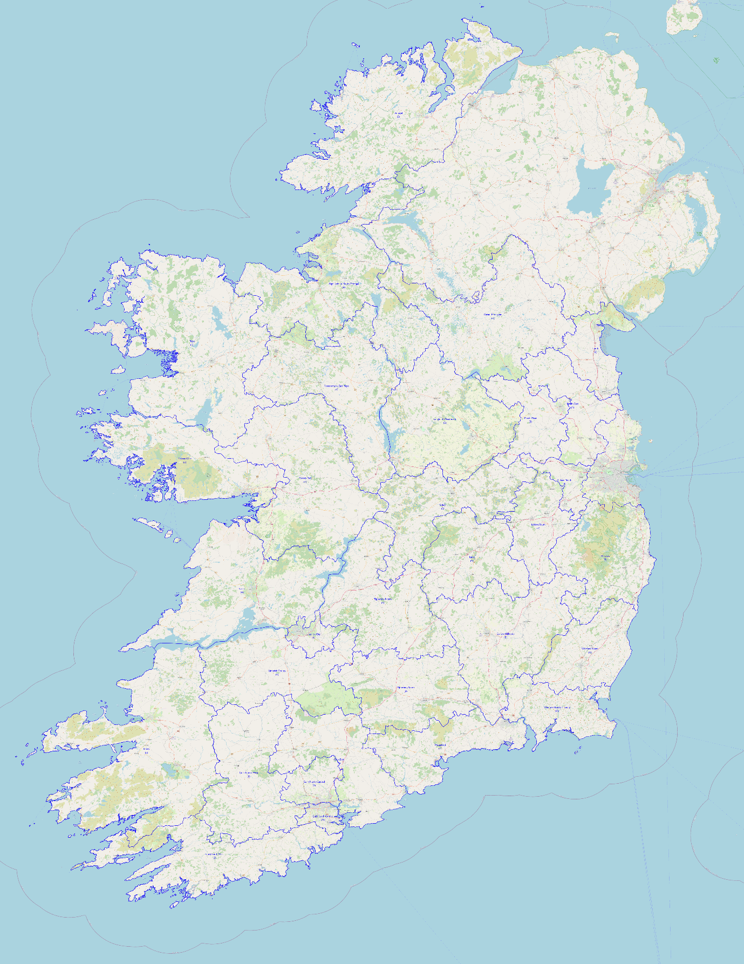

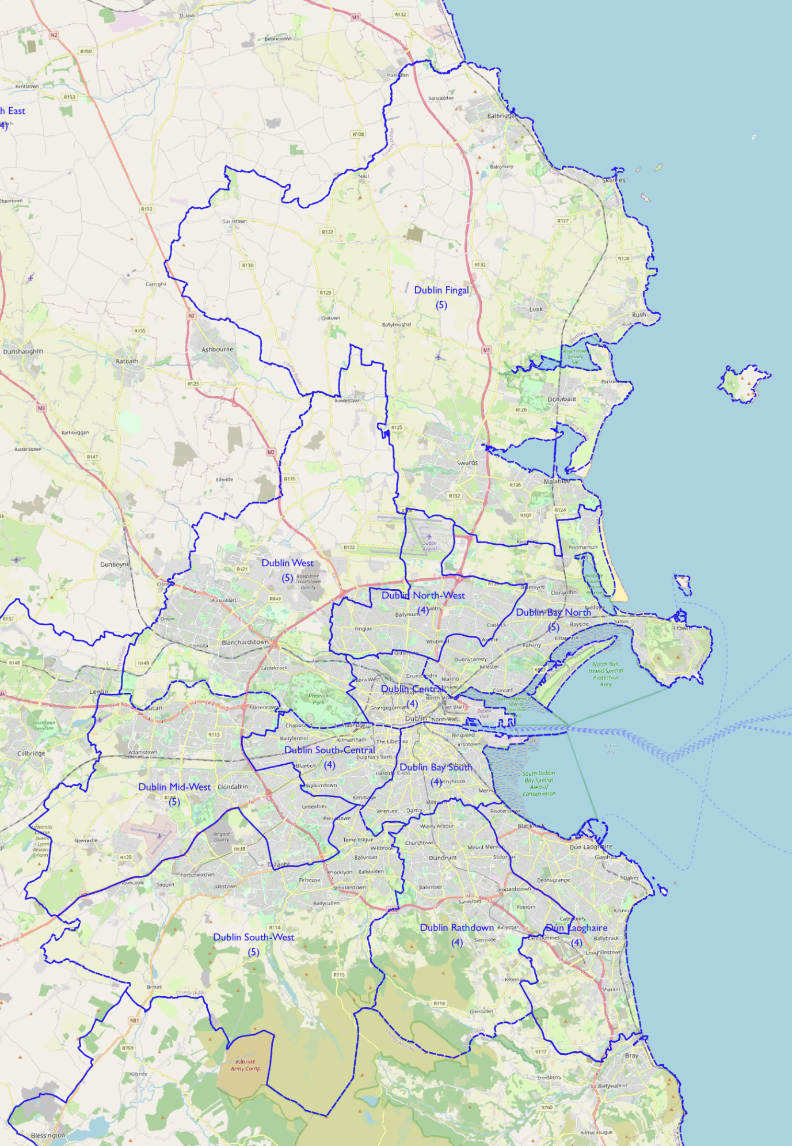

- 174-Seat Scenario

Increasing the number of seats from 172 to 174 produces a figure of population/TD of 29,445.6 with potential variance between 30,917.9 and 27,973.3 assuming a 5% degree of tolerance.

The set of constituencies produced under the 172-seat allocation in the last section have the following characteristics under a 174-seat allocation:

Proposed constituency | Population | Seats | Population/TD | Variance
Dublin North-West | 113,469 | 4 | 28,367.25 | -3.66%
Dublin Rathdown | 113,520 | 4 | 28,380.00 | -3.62%
Wexford North | 85,153 | 3 | 28,384.33 | -3.60%
Longford–Westmeath | 142,474 | 5 | 28,494.80 | -3.23%
Meath East | 114,341 | 4 | 28,525.25 | -2.92%
Cork East | 143,107 | 5 | 28,621.40 | -2.80%
Tipperary North | 86,059 | 3 | 28,686.33 | -2.58%
Cork South-Central | 143,477 | 5 | 28,695.40 | -2.55%
Tipperary South | 86,159 | 3 | 28,719.67 | -2.47%
Dublin Bay North | 143,564 | 5 | 28,730.80 | -2.43%
Cork North-West | 87,077 | 3 | 29,025.67 | -1.43%
Sligo–Leitrim–South Donegal | 116,242 | 4 | 29,060.50 | -1.31%
Offaly | 87,567 | 3 | 29,189.00 | -0.87%
Cavan–Monaghan | 146,033 | 5 | 29,206.60 | -0.81%
Cork North-Central | 117,065 | 4 | 29,266.25 | -0.61%
Mayo | 117,160 | 4 | 29,290.00 | -0.53%
Dublin Central | 117,273 | 4 | 29,318.25 | -0.45%
Dublin West | 147,825 | 5 | 29,565.00 | +0.41%
Limerick County | 89,479 | 3 | 29,826.33 | +1.30%
Dublin Mid-West | 149,138 | 5 | 29,827.60 | +1.30%
Meath West | 89,517 | 3 | 29,839.00 | +1.34%
Dún Laoghaire | 119,937 | 4 | 29,984.25 | +1.83%
Dublin South-Central | 119,967 | 4 | 29,991.75 | +1.85%
Roscommon–East Mayo | 90,066 | 3 | 30,022.00 | +1.96%
Dublin South-West | 150,655 | 5 | 30,131.00 | +2.33%
Cork South-West | 90,505 | 3 | 30,168.33 | +2.45%
Kildare North | 121,037 | 4 | 30,259.25 | +2.76%
Kildare South | 121,041 | 4 | 30,260.25 | +2.77%
Clare | 121,396 | 4 | 30,349.00 | +3.07%
Wexford–South Kilkenny | 91,227 | 3 | 30,409.00 | +3.27%
Dublin Fingal | 152,109 | 5 | 30,421.80 | +3.32%
Limerick City | 121,988 | 4 | 30,497.00 | +3.57%
Laois | 91,657 | 3 | 30,552.33 | +3.76%
Carlow–Kilkenny | 152,763 | 5 | 30,552.60 | +3.76%
Waterford | 122,528 | 4 | 30,632.00 | +4.03%
Galway West | 153,307 | 5 | 30,661.40 | +4.13%
Galway East | 123,144 | 4 | 30,786.00 | +4.55%
Dublin Bay South | 123,174 | 4 | 30,793.50 | +4.58%
Donegal | 154,985 | 5 | 30,997.00 | +5.27%
Kerry | 154,396 | 5 | 31,051.60 | +5.45%
Wicklow | 155,485 | 5 | 31,097.00 | +5.61%
Louth | 155,538 | 5 | 31,107.60 | +5.64%

We see here that four of the proposed constituencies under the last iteration – Donegal, Kerry, Wicklow, and Louth – now have population/TD ratios that are beyond the 5% tolerance level and therefore require change.

Looking at each county and its population in relation to the national population/TD average, we see the following figures:

 | Population | No. of seats |  | Population | No. of seats
LEINSTER |  |  | MUNSTER
Carlow | 61,931 | 2.10 | Clare | 127,419 | 4.33
Dublin | 1,450,701 | 49.27 | Cork | 581,231 | 19.74
North City | 346,244 | 11.76 | Kerry | 155,258 | 5.27
South City | 241,989 | 8.22 | Limerick | 205,444 | 6.98
South Dublin | 299,793 | 10.18 | Tipperary | 167,661 | 5.69
Fingal | 329,218 | 11.18 | Waterford | 127,085 | 4.32
Dún Laoghaire-Rathdown | 233,457 | 7.93 | CONNACHT
Kildare | 246,977 | 8.39 | Galway | 276,451 | 9.39
Kilkenny | 103,685 | 3.52 | Leitrim | 35,087 | 1.19
Laois | 91,657 | 3.11 | Mayo | 137,231 | 4.66
Longford | 46,634 | 1.58 | Roscommon | 69,995 | 2.38
Louth | 139,100 | 4.72 | Sligo | 69,819 | 2.37
Meath | 220,296 | 7.48 | ULSTER (part)
Offaly | 82,668 | 2.81 | Cavan | 81,201 | 2.76
Westmeath | 95,840 | 3.25 | Donegal | 166,321 | 5.65
Wexford | 163,527 | 5.55 | Monaghan | 64,832 | 2.20
Wicklow | 155,485 | 5.28

We can now proceed to look at individual counties and combinations of counties, in particular those where change is required in comparison with the 172-seat scenario.

  - Donegal/Sligo/Leitrim

County Donegal, with a population of 166,321, is still marginally below the tolerance level for a sixth seat (by under 1,000) and so would still require territory from County Leitrim to create two 3-seat constituencies. Instead, we must for the moment consider further transfer of territory from the Donegal constituency created in the last scenario and now itself above the tolerance level in a 174-seat scenario to the Sligo–Leitrim–South Donegal constituency.

The electoral division of Donegal, covering the town of Donegal itself, has a population of 4,133, and transferring it to the Sligo–Leitrim–South Donegal constituency produces the following outcome:

Proposed constituency | Population | Seats | Population/TD | Variance
Donegal | 150,852 | 5 | 30,170.40 | +2.46%
Sligo–Leitrim–South Donegal | 120,375 | 4 | 30,093.75 | +2.20%

The number of residents of the Sligo–Leitrim–South Donegal constituency not in Counties Sligo or Leitrim is 15,469 (a decrease of 2,335 in comparison with the current constituency).

  - Cavan/Monaghan

The Cavan–Monaghan constituency from the 172-seat scenario remains within the 5% tolerance range under the 174-seat scenario so no modification is required.

Proposed constituency | Population | Seats | Population/TD | Variance
Cavan–Monaghan | 146,033 | 5 | 29,206.60 | -0.81%

The number of residents of the Cavan–Monaghan constituency not in Counties Cavan or Monaghan is 0 (a decrease of 4,205).

  - Galway/Mayo/Roscommon

County Mayo, with a population of 137,231, is just under 3,000 below the tolerance level of 5% in order for it to be a constituency in its own right under the 174-seat scenario. County Roscommon, with a population of 69,995, would need an extra 14,000 population under a 174-seat scenario to form the basis for a 3-seat constituency. County Galway, on the other hand, with a population of 276,451, could afford to lose territory with a population of almost 25,000 and still be entitled to 9 seats under a 174-seat scenario, although the geography and population distribution of the area around Galway city and Lough Corrib may present difficulties when realigning the constituency boundaries within the county.

The electoral divisions of Ballaghaderreen and Edmondstown in the north-west of County Roscommon have a combined population of 3,687 and formed part of County Mayo until the Local Government Act of 1898 and still have very strong bonds of identity with County Mayo. Adding them to County Mayo allows us to create a 5-seat constituency with a population of 140,918, giving a population/TD ratio of 28,183.6, a value of 4.3% below the national average under a 174-seat scenario.

The remainder of County Roscommon, with a population of 66,308, now needs an additional 17,700 population from County Galway to form a 3-seat constituency. The former rural districts of Glennamaddy and Mountbellew have a combined population of 15,199 so further territorial transfers are required. The electoral divisions of Addergoole, Carrownagur, Clonbern, Cloonkeen, Dunmore North and South, and Toberadosh in the former rural district of Tuam currently form part of the Roscommon–Galway constituency and have a combined population of 3,764. Adding these areas to the remainder of Roscommon allows us to create a 3-seat constituency with a population of 85,271, giving a population/TD ratio of 28,423.67, a value of 3.5% below the national average under a 174-seat scenario.

The remainder of the Galway East constituency created under the 172-seat scenario has a population of 104,181 and will need an additional 8,000 population to reach the tolerance level for a 4-seat constituency under the 174-seat scenario. The constituency of Galway West can shed approximately 13,000 population and still remain within the tolerance level. The four electoral divisions of Aughrim, Belleville, Deerpark, and Stradbally in the current Galway East constituency, with a combined population of 4,589, can be transferred back to Galway East under the 174-seat scenario from the 172-seat Galway West and need to be joined by the electoral divisions of Ballynacourty and Clarinbridge, also in the former rural district of Galway and with a combined population of 5,366, leaving the Galway West constituency with only those electoral divisions east of the Corrib which form – wholly or in part – part of the Gaeltacht.

These changes produce the following constituencies under this scenario:

Proposed constituency | Population | Seats | Population/TD | Variance
Galway East | 114,136 | 4 | 28,534.00 | -3.10%
Galway West | 143,352 | 5 | 28,670.40 | -2.63%
Mayo | 140,918 | 5 | 28,183.60 | -4.29%
Roscommon–North Galway | 85,271 | 3 | 28,423.67 | -3.47%

The number of residents of the Galway East constituency not in County Galway is 0 (no change).
The number of residents of the Galway West constituency not in County Galway is 0 (a decrease of 5,878).
The number of residents of the Mayo constituency not in County Mayo is 3,687 (an increase of 3,687).
The number of residents of the Roscommon–North Galway constituency not in County Roscommon is 18,963 (a decrease of 11,335 in comparison to the current Roscommon–Galway constituency).

  - Clare/Kerry/Limerick

The Kerry constituency, with a population of 155,258, is above the tolerance level for a 5-seat constituency under the 174-seat scenario and needs to lose at least 750 population to bring it within a 5% tolerance level. The electoral divisions of Leitrim, Tarbert, and Tarmon in the former rural district of Listowel are adjacent to Glin in County Limerick and have a combined population of 1,795. Transferring them to the Limerick County constituency, itself within the tolerance level under the 174-seat scenario, allows both constituencies to remain within the tolerance level. No change is required to either the Clare or Limerick City constituencies from the 172-seat scenario.

This produces the following constituencies:

Proposed constituency | Population | Seats | Population/TD | Variance
Clare | 121,396 | 4 | 30,349.00 | +3.07%
Kerry | 153,463 | 5 | 30,692.60 | +4.23%
Limerick City | 121,988 | 4 | 30,497.00 | +3.57%
Limerick County | 91,276 | 3 | 30,425.33 | +3.33%

The number of residents of the Limerick City constituency not in County Limerick is 6,023 (an increase of 1,349).
The number of residents of the Limerick County constituency not in County Limerick is 1,795 (an increase of 1,795).

  - Cork

All five Cork constituencies from the 172-seat scenario remain comfortably within the tolerance level under the 174-seat scenario so no modifications are required.

Proposed constituency | Population | Seats | Population/TD | Variance
Cork East | 143,107 | 5 | 28,621.40 | -2.80%
Cork North-Central | 117,065 | 4 | 29,266.25 | -0.61%
Cork North-West | 87,077 | 3 | 29,025.67 | -1.43%
Cork South-Central | 143,477 | 5 | 28,695.40 | -2.55%
Cork South-West | 90,505 | 3 | 30,168.33 | +2.45%

  - Carlow/Kilkenny/Tipperary/Waterford/Wexford

Of the constituencies in this region from the 172-seat scenario, only one – Wicklow – has a population/TD ratio outside the limit of tolerance under the 174-seat scenario. However, the modifications required to bring it within the acceptable range will have consequences for other constituencies in the region, so we will view them as a larger whole.

The Tipperary North constituency from the 172-seat scenario can be left unmodified. For the Tipperary South constituency, the part of the constituency in County Tipperary has a population of 81,602, and adding the former Clonmel No. 2 rural district from County Waterford with a population of 2,943, brings its total population to 84,545, which gives a population/TD ratio of 28,181.67, a value of 4.3% below the national average under the 174-seat scenario.

This allows the five electoral divisions of from the former rural district of Carrick-on-Suir No. 2 with a combined population of 1,614 to be returned to the Waterford constituency, increasing its population to 124,142. This gives a population/TD ratio of 31,035.5, which is 5.4% above the national average under the 174-seat scenario.

However, Wicklow and Wexford have a combined seat allocation of 10.83 under the 174-seat scenario, which allows them to be paired with a total of 11 seats, but means that the part of County Kilkenny in the proposed Wexford–South Kilkenny constituency under the 172-seat scenario now has to be accommodated elsewhere. The Waterford constituency would require a further 16,000 population to be allocated 5 seats, whereas County Kilkenny on its own has a population of 103,685, which would need to lose approximately 11,000 population to be of appropriate size for a 3-seat constituency, and in combination with County Carlow has a total population of 165,616, which would also need to lose in excess of 11,000 population to fall within the limits under the 174-seat scenario.

The former rural district of Waterford No. 2 in County Kilkenny has a total population of 16,352, to give a total population of 140,494. This produces a population/TD ratio of 28,098.8, a value 4.6% below the national average under the 174-seat scenario for a 5-seat constituency.

The remainder of County Kilkenny and County Carlow can form a 5-seat constituency with a total population of 149,264, giving a population/TD ratio of 29,852.8, a value 1.4% above the national average for the 174-seat scenario.

Turning to Counties Wexford and Wicklow, County Wicklow, with a population of 155,485, needs to lose at least 1,000 population to be within the 5% tolerance level for the 174-seat scenario. County Wexford, with a population of 163,527, needs an additional 4,500 population to form two 3-seat constituencies under the 174-seat scenario.

Earlier, when discussing a potential cross-border linkage between Counties Wexford and Carlow, a Wexford South constituency was proposed consisting of the borough of Wexford, the urban district of New Ross, the former rural districts of New Ross and Wexford, and the electoral divisions of Castleboro, Clonroche, Killann, and The Leap from the former rural district of Enniscorthy with a population of 85,882. Omitting the electoral division of The Leap, which is in the county electoral area of Enniscorthy rather than New Ross, reduces the population of the proposed constituency to 84,861, giving a population/TD ratio of 28,287, a value of 3.9% below the national average under the 174-seat scenario.

The remainder of County Wexford (the urban district of Enniscorthy, the former rural district of Gorey, and the balance of the former rural district of Enniscorthy) has a population of 78,666 and requires between 5,300 and 14,000 population from County Wicklow to come within the tolerance limit under the 174-seat scenario. The town of Arklow and its environs have good communications links with north Wexford but are oversized for this purpose. The former rural district of Shillelagh has more limited communications links, principally through Carnew, but has a population of 8,518. Transferring its southern part (less the electoral divisions of Ballinglen, Ballybeg, Coolballintaggart, and Kilballyowen) with a population of 7,137 to the Wexford North constituency produces figures for both constituencies within the limits of tolerance under the 174-seat scenario.

Proposed constituency | Population | Seats | Population/TD | Variance
Carlow–Kilkenny | 149,264 | 5 | 29,852.80 | +1.38%
Tipperary North | 86,059 | 3 | 28,686.33 | -2.58%
Tipperary South | 84,545 | 3 | 28,181.67 | -4.29%
Waterford–South Kilkenny | 140,494 | 5 | 28,098.80 | -4.57%
Wexford North | 85,803 | 3 | 28,601.00 | -2.87%
Wexford South | 84,861 | 3 | 28,287.00 | -3.93%
Wicklow | 148.348 | 5 | 29,669.60 | +0.76%

The number of residents of the Tipperary South constituency not in County Tipperary is 2,943 (an increase of 2,943).
The number of residents of the Waterford–South Kilkenny constituency not in County Waterford is 16,352 (an increase of 16,352).
The number of residents of the Wexford North constituency not in County Wexford is 7,137 (an increase of 7,137).

3.7 Kildare/Laois/Offaly

The four constituencies from the 172-seat scenario in this region remain within the tolerance level under the 174-seat scenario so no modifications are required.

Proposed constituency | Population | Seats | Population/TD | Variance
Kildare North | 121,037 | 4 | 30,259.25 | +2.76%
Kildare South | 121,041 | 4 | 30,260.25 | +2.77%
Laois | 91,657 | 3 | 30,552.33 | +3.76%
Offaly | 87,567 | 3 | 29,189.00 | -0.87%

The number of residents of the Kildare South constituency not in County Kildare is 0 (a decrease of 13,080).
The number of residents of the Offaly constituency not in County Offaly is 4,899 (an increase of 4,899).

3.8 Longford/Westmeath

The Longford–Westmeath constituency from the 172-seat scenario remains within the 5% tolerance range under the 174-seat scenario so no modification is required.

Proposed constituency | Population | Seats | Population/TD | Variance
Longford–Westmeath | 142,474 | 5 | 28,494.80 | -3.23%

3.9 Louth/Meath
County Louth, with a population of 139,100, still requires an additional 800 population to bring it within the tolerance range at the lower level under the 174-seat scenario, but retaining the St. Mary’s electoral division from County Meath in the constituency leaves it above the higher level of the tolerance range. Adding all of the St. Mary’s electoral division to Meath East gives it a population of 130,779 and a population/TD ratio of 32,694.75, a value 11.0% above the national average. To bring it within range it needs to lose more than 7,000 population. Meanwhile, Meath West, with a population/TD ratio of 1.3% above the national average, can only gain 3,500 while remaining within tolerance levels.

One means of resolving this dilemma is to add territory to Louth from elsewhere in County Meath. The former rural district of Ardee No. 2 has a population of 3,380, and adding the electoral division of Mellifont in the former rural district of Meath increases the population that can be transferred to Louth to 3,952. This now reduces the population of our proposed Meath East to 126,827, some 3,300 above the upper limit for a 4-seater.

At this point, it may well be worth considering reconfiguring the two Meath constituencies by transferring the remaining electoral divisions in Meath East north of the Boyne to Meath West and either making the resulting north Meath constituency a 4-seater or transferring territory in the south of the county in the opposite direction to compensate.

The total population of:

- the urban district of Kells,
- the electoral divisions of Ardagh, Carrickleck, Cruicetown, Kells Rural, Kilmainham, Maperath, Moybolgue, Moynalty, Newcastle, Newtown, Nobber, Posseckstown, Staholmog, and Trohanny in the former rural district of Kells, and
- the electoral divisions of Castletown, Domhnach Phádraig, Rathkenny, Slane, and Stackallan in the former rural district of Navan,

is 20,655.

Transferring this population from Meath East to Meath West produces populations for the two constituencies of 106,172 and 110,172 respectively. If the purpose of the realignment is to produce two constituencies on a ‘north-south’ basis, then a compensating transfer in the south-west of the county seems appropriate.

The transfer can consist of:

- the electoral division of Kilmessan in the former rural district of Dunshaughlin, and
- the electoral divisions of Ardnamullan, Ballyboggan, Castlejordan, Castlerickard, Gallow, Galtrim, Hill of Down, Innfield, Killyon, Rahinstown, Rathmolyon, and Summerhill in the former rural district of Trim,

with a total population of 17,514.

This produces the following constituencies:

Proposed constituency | Population | Seats | Population/TD | Variance
Louth | 143,052 | 5 | 28,610.40 | -2.84%
Meath North | 92,658 | 3 | 30,886.00 | +4.89%
Meath South | 123,686 | 4 | 30,921.25 | +5.01%

The number of residents of the Louth constituency not in County Louth is 3,952 (a decrease of 23,960).
The number of residents of the Meath North constituency not in County Meath is 0 (a decrease of 9,418).

3.10 Dublin

Dublin has an entitlement to 49.27 seats under a 174-seat scenario. The eleven constituencies from the 172-seat scenario have a total of 49 seats and all have population/TD ratios within the 5% tolerance level of the national average under the 174-seat scenario. No modification is therefore required.

Proposed constituency | Population | Seats | Population/TD | Variance
Dublin Bay North | 143,564 | 5 | 28,730.80 | -2.43%
Dublin Bay South | 123,174 | 4 | 30,793.50 | +4.58%
Dublin Central | 117,273 | 4 | 29,318.25 | -0.45%
Dublin Fingal | 152,109 | 5 | 30,421.80 | +3.32%
Dublin Mid-West | 149,138 | 5 | 29,827.60 | +1.30%
Dublin North-West | 113,469 | 4 | 28,367.25 | -3.66%
Dublin Rathdown | 113,520 | 4 | 28,380.00 | -3.62%
Dublin South-Central | 119,967 | 4 | 29,991.75 | +1.85%
Dublin South-West | 150,655 | 5 | 30,131.00 | +2.33%
Dublin West | 147,825 | 5 | 29,565.00 | +0.41%
Dún Laoghaire | 119,937 | 4 | 29,984.25 | +1.83%

Summary

A total of 42 constituencies are proposed under this scenario.

Proposed constituency | Population | Seats | Population/TD | Variance
Waterford–South Kilkenny | 140,494 | 5 | 28,098.80 | -4.57%
Mayo | 140,918 | 5 | 28,183.60 | -4.29%
Tipperary South | 84,545 | 3 | 28,181.67 | -4.29%
Wexford South | 84,861 | 3 | 28,287.00 | -3.93%
Dublin North-West | 113,469 | 4 | 28,367.25 | -3.66%
Dublin Rathdown | 113,520 | 4 | 28,380.00 | -3.62%
Roscommon–North Galway | 85,271 | 3 | 28,423.67 | -3.47%
Longford–Westmeath | 142,474 | 5 | 28,494.80 | -3.23%
Galway East | 114,136 | 4 | 28,534.00 | -3.10%
Wexford North | 85,803 | 3 | 28,601.00 | -2.87%
Louth | 143,052 | 5 | 28,610.40 | -2.84%
Cork East | 143,107 | 5 | 28,621.40 | -2.80%
Galway West | 143,352 | 5 | 28,670.40 | -2.63%
Tipperary North | 86,059 | 3 | 28,686.33 | -2.58%
Cork South-Central | 143,477 | 5 | 28,695.40 | -2.55%
Dublin Bay North | 143,564 | 5 | 28,730.80 | -2.43%
Cork North-West | 87,077 | 3 | 29,025.67 | -1.43%
Offaly | 87,567 | 3 | 29,189.00 | -0.87%
Cavan–Monaghan | 146,033 | 5 | 29,206.60 | -0.81%
Cork North-Central | 117,065 | 4 | 29,266.25 | -0.61%
Dublin Central | 117,273 | 4 | 29,318.25 | -0.45%
Dublin West | 147,825 | 5 | 29,565.00 | +0.41%
Wicklow | 148.348 | 5 | 29,669.60 | +0.76%
Dublin Mid-West | 149,138 | 5 | 29,827.60 | +1.30%
Carlow–Kilkenny | 149,264 | 5 | 29,852.80 | +1.38%
Dún Laoghaire | 119,937 | 4 | 29,984.25 | +1.83%
Dublin South-Central | 119,967 | 4 | 29,991.75 | +1.85%
Sligo–Leitrim–South Donegal | 120,375 | 4 | 30,093.75 | +2.20%
Dublin South-West | 150,655 | 5 | 30,131.00 | +2.33%
Cork South-West | 90,505 | 3 | 30,168.33 | +2.45%
Donegal | 150,852 | 5 | 30,170.40 | +2.46%
Kildare North | 121,037 | 4 | 30,259.25 | +2.76%
Kildare South | 121,041 | 4 | 30,260.25 | +2.77%
Clare | 121,396 | 4 | 30,349.00 | +3.07%
Dublin Fingal | 152,109 | 5 | 30,421.80 | +3.32%
Limerick County | 91,276 | 3 | 30,425.33 | +3.33%
Limerick City | 121,988 | 4 | 30,497.00 | +3.57%
Laois | 91,657 | 3 | 30,552.33 | +3.76%
Kerry | 153,463 | 5 | 30,692.60 | +4.23%
Dublin Bay South | 123,174 | 4 | 30,793.50 | +4.58%
Meath North | 92,658 | 3 | 30,886.00 | +4.89%
Meath South | 123,686 | 4 | 30,921.25 | +5.01%

All but one of the 42 constituencies are within the 5% tolerance level of the national average (and the exception is only marginally beyond it) with the largest variances on each side being +5.0% and -4.6%. There are 17 5-seat constituencies, 14 4-seat constituencies, and 11 3-seat constituencies.

The following breaches of county boundaries exist, with the total population who live in the affected areas listed alongside:

Constituency | Population
Donegal in Sligo–Leitrim–South Donegal | 15,469
Roscommon in Mayo | 3,687
Galway in Roscommon–North Galway | 18,963
Clare in Limerick City | 6,023
Kerry in Limerick County | 1,795
Waterford in Tipperary South | 2,943
Kilkenny in Waterford–South Kilkenny | 16,352
Wicklow in Wexford North | 7,137
Kildare in Offaly | 4,899
Meath in Louth | 3,952
Total | 81,220

This figure of 81,220 represents a reduction of 32,518 on the current total (although the number of breaches has risen to 10 in comparison with 7 under the 172-seat scenario). Increasing the tolerance range to beyond 5% would in addition allow at least some of these breaches to be removed.
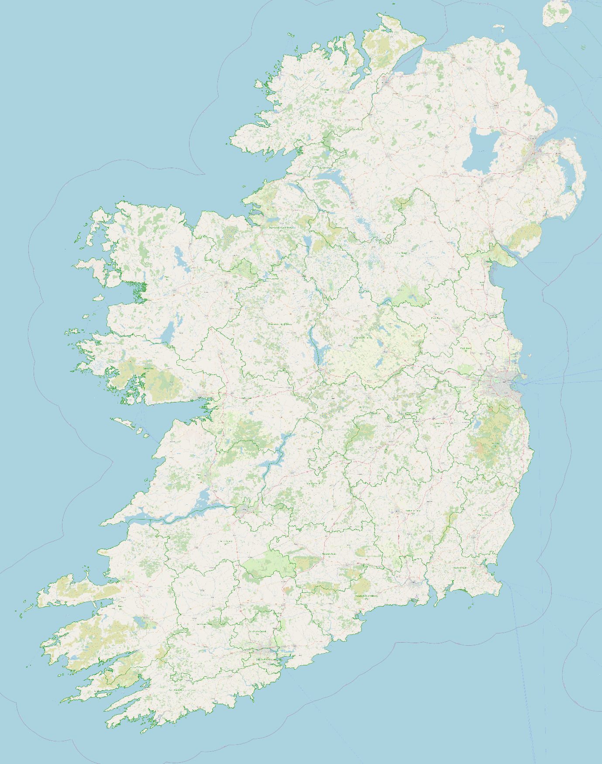

- 176-Seat Scenario

Increasing the number of seats from 174 to 176 produces a figure of population/TD of 29,111 with potential variance between 30,566.6 and 27,655.5 assuming a 5% degree of tolerance.

The set of constituencies produced under the 174-seat allocation in the last section have the following characteristics under a 176-seat allocation:

Proposed constituency | Population | Seats | Population/TD | Variance
Waterford–South Kilkenny | 140,494 | 5 | 28,098.80 | -3.48%
Mayo | 140,918 | 5 | 28,183.60 | -3.19%
Tipperary South | 84,545 | 3 | 28,181.67 | -3.19%
Wexford South | 84,861 | 3 | 28,287.00 | -2.83%
Dublin North-West | 113,469 | 4 | 28,367.25 | -2.55%
Dublin Rathdown | 113,520 | 4 | 28,380.00 | -2.51%
Roscommon–North Galway | 85,271 | 3 | 28,423.67 | -2.36%
Longford–Westmeath | 142,474 | 5 | 28,494.80 | -2.12%
Galway East | 114,136 | 4 | 28,534.00 | -1.98%
Wexford North | 85,803 | 3 | 28,601.00 | -1.75%
Louth | 143,052 | 5 | 28,610.40 | -1.72%
Cork East | 143,107 | 5 | 28,621.40 | -1.68%
Galway West | 143,352 | 5 | 28,670.40 | -1.51%
Tipperary North | 86,059 | 3 | 28,686.33 | -1.46%
Cork South-Central | 143,477 | 5 | 28,695.40 | -1.43%
Dublin Bay North | 143,564 | 5 | 28,730.80 | -1.31%
Cork North-West | 87,077 | 3 | 29,025.67 | -0.29%
Offaly | 87,567 | 3 | 29,189.00 | +0.27%
Cavan–Monaghan | 146,033 | 5 | 29,206.60 | +0.33%
Cork North-Central | 117,065 | 4 | 29,266.25 | +0.53%
Dublin Central | 117,273 | 4 | 29,318.25 | +0.69%
Dublin West | 147,825 | 5 | 29,565.00 | +1.56%
Wicklow | 148.348 | 5 | 29,669.60 | +1.92%
Dublin Mid-West | 149,138 | 5 | 29,827.60 | +2.46%
Carlow–Kilkenny | 149,264 | 5 | 29,852.80 | +2.55%
Dún Laoghaire | 119,937 | 4 | 29,984.25 | +3.00%
Dublin South-Central | 119,967 | 4 | 29,991.75 | +3.03%
Sligo–Leitrim–South Donegal | 120,375 | 4 | 30,093.75 | +3.38%
Dublin South-West | 150,655 | 5 | 30,131.00 | +3.50%
Cork South-West | 90,505 | 3 | 30,168.33 | +3.63%
Donegal | 150,852 | 5 | 30,170.40 | +3.64%
Kildare North | 121,037 | 4 | 30,259.25 | +3.94%
Kildare South | 121,041 | 4 | 30,260.25 | +3.95%
Clare | 121,396 | 4 | 30,349.00 | +4.25%
Dublin Fingal | 152,109 | 5 | 30,421.80 | +4.50%
Limerick County | 91,276 | 3 | 30,425.33 | +4.51%
Limerick City | 121,988 | 4 | 30,497.00 | +4.76%
Laois | 91,657 | 3 | 30,552.33 | +4.95%
Kerry | 153,463 | 5 | 30,692.60 | +5.43%
Dublin Bay South | 123,174 | 4 | 30,793.50 | +5.78%
Meath North | 92,658 | 3 | 30,886.00 | +6.10%
Meath South | 123,686 | 4 | 30,921.25 | +6.22%

We see here that four of the proposed constituencies under the last iteration – Kerry, Dublin Bay South, Meath North, and Meath South – now have population/TD ratios that are beyond the 5% tolerance level and therefore require change.

Looking at each county and its population in relation to the national population/TD average, we see the following figures:

 | Population | No. of seats |  | Population | No. of seats
LEINSTER |  |  | MUNSTER
Carlow | 61,931 | 2.13 | Clare | 127,419 | 4.38
Dublin | 1,450,701 | 49.83 | Cork | 581,231 | 19.97
North City | 346,244 | 11.89 | Kerry | 155,258 | 5.33
South City | 241,989 | 8.32 | Limerick | 205,444 | 7.06
South Dublin | 299,793 | 10.30 | Tipperary | 167,661 | 5.76
Fingal | 329,218 | 11.31 | Waterford | 127,085 | 4.37
Dún Laoghaire-Rathdown | 233,457 | 8.02 | CONNACHT
Kildare | 246,977 | 8.48 | Galway | 276,451 | 9.50
Kilkenny | 103,685 | 3.56 | Leitrim | 35,087 | 1.21
Laois | 91,657 | 3.15 | Mayo | 137,231 | 4.71
Longford | 46,634 | 1.60 | Roscommon | 69,995 | 2.40
Louth | 139,100 | 4.78 | Sligo | 69,819 | 2.40
Meath | 220,296 | 7.57 | ULSTER (part)
Offaly | 82,668 | 2.84 | Cavan | 81,201 | 2.79
Westmeath | 95,840 | 3.29 | Donegal | 166,321 | 5.71
Wexford | 163,527 | 5.62 | Monaghan | 64,832 | 2.23
Wicklow | 155,485 | 5.34

We can now proceed to look at individual counties and combinations of counties, in particular those where change is required in comparison with the 174-seat scenario.

  - Donegal/Sligo/Leitrim/Galway/Mayo/Roscommon

All the constituencies proposed under the 174-seat scenario are within the tolerance levels for the population/TD ratio under a 176-seat scenario.

County Donegal, with a population of 166,321 is now very marginally above the minimum threshold for six seats in its own right. County Mayo, with a population of 137,231, remains under the minimum threshold for five seats in its own right. Leitrim, Roscommon and Sligo together have the numbers required for two 3-seat constituencies but doing so, and compensating the Mayo constituency with territory from Galway East, would still leave an excess of population in County Galway for nine seats, even at the highest threshold value, and this would mean an overall increase in the total population displaced from their home county given that one of the two constituencies in the Leitrim/Roscommon/Sligo block would have to breach a county boundary. For the moment, no change to the constituencies proposed under the 174-seat scenario will be made for the 176-seat scenario.

Proposed constituency | Population | Seats | Population/TD | Variance
Donegal | 150,852 | 5 | 30,170.40 | +3.64%
Galway East | 114,136 | 4 | 28,534.00 | -1.98%
Galway West | 143,352 | 5 | 28,670.40 | -1.51%
Mayo | 140,918 | 5 | 28,183.60 | -3.19%
Roscommon–North Galway | 85,271 | 3 | 28,423.67 | -2.36%
Sligo–Leitrim–South Donegal | 120,375 | 4 | 30,093.75 | +3.38%

The number of residents of the Galway West constituency not in County Galway is 0 (a decrease of 5,878).
The number of residents of the Mayo constituency not in County Mayo is 3,687 (an increase of 3,687).
The number of residents of the Roscommon–North Galway constituency not in County Roscommon is 18,963 (a decrease of 11,335 in comparison to the current Roscommon–Galway constituency).
The number of residents of the Sligo–Leitrim–South Donegal constituency not in Counties Sligo or Leitrim is 15,469 (a decrease of 2,335 in comparison with the current constituency).

  - Cavan/Monaghan

The Cavan–Monaghan constituency from the 174-seat scenario remains within the 5% tolerance range under the 176-seat scenario so no modification is required.

Proposed constituency | Population | Seats | Population/TD | Variance
Cavan–Monaghan | 146,033 | 5 | 29,206.60 | +0.33%

The number of residents of the Cavan–Monaghan constituency not in Counties Cavan or Monaghan is 0 (a decrease of 4,205).

  - Clare/Kerry/Kilkenny/Limerick/Tipperary/Waterford

The Kerry constituency proposed under the 174-seat scenario, with a population of 153,463, is now above the tolerance level for a 5-seat constituency under the 176-seat scenario. County Kerry would need to gain 10,700 population, presumably from County Limerick to bring it within the minimum threshold level for two 3-seat constituencies. Alternatively, the removal of a further 700 population would bring it back within the upper tolerance level for a 5-seat constituency under the 176-seat scenario.
At this point, the Clare, Limerick City, and Limerick County constituencies proposed under the 174-seat scenario all have population/TD ratios above the national average – by 4.3%, 4.5%, and 4.8% respectively.

The Cappavilla electoral division in the former rural district of Limerick No. 2 in County Clare covers an area adjacent to the Limerick City constituency, including part of the University of Limerick campus, and has a population of 1,106. Transferring this area to Limerick City would produce a Clare constituency with a population of 120,290, giving a population/TD ratio of 30,072.5, a value 3.3% above the national average under a 176-seat scenario.

Adding this area to the proposed Limerick City constituency produces a population of 123,092, which is now above the 5% maximum threshold under the 176-seat scenario. We need to transfer territory to Limerick County to bring it back within the tolerance level. The electoral division of Ballybricken in the former rural district of Limerick has a population of 1,671, and transferring it to Limerick County leaves the proposed Limerick City constituency with a population of 121,421, giving a population/TD ratio of 30,355.25, a value 4.3% above the national average under a 176-seat scenario.

In Kerry, the electoral divisions of Carrig and Lislaughtin (covering Ballylongford) and Newtownsandes (covering Moyvane) have a combined population of 2,044. Transferring them to the Limerick County constituency gives the proposed Kerry constituency a population of 151,419. This produces a population/TD ratio of 30,283.8, a value 4.0% above the national average under a 176-seat scenario.

The consequence of these transfers to Limerick County is that this proposed constituency now has a population of 94,991, a figure over 3,000 above the maximum population for a 3-seat constituency under the 176-seat scenario. This excess population must be transferred elsewhere.

The obvious solution lies to the east in County Tipperary. Both Tipperary-based constituencies proposed under the 174-seat scenario have population/TD ratios under the national average for the 176-seat scenario. In the case of the Tipperary South constituency, the population/TD ratio is more than 3% below the national average, even including population from County Waterford.

The Waterford–South Kilkenny constituency proposed under the 174-seat scenario has a population/TD ratio 3.5% below the national average under the 176-seat scenario. Restoring the Clonmel No. 2 former rural district and thereby removing the breach of the Waterford/Tipperary county boundary produces a constituency with a population of 143,437, giving a population/TD ratio of 28,687.4, a value 1.5% below the national average under a 176-seat scenario. No change is required to the Carlow–Kilkenny constituency proposed under the 174-seat scenario.

This transfer leaves the proposed Tipperary South constituency with a population of 81,602, a figure 1,400 below the minimum population for a 3-seat constituency under the 176-seat scenario. The former rural district of Mitchelstown No. 2 in County Limerick has a total population of 3,383, and adding the electoral divisions of Glenbrohane and Knocklong from the former Kilmallock rural district brings the total population up to 4,759.

Making this final transfer gives us a Limerick County constituency with a population of 90,232 and a population/TD ratio of 30,077.33, a value 3.3% above the national average under a 176-seat scenario, and a Tipperary South constituency with a population of 86,361 and a population/TD ratio of 28,787, a value 1.1% below the national average under a 176-seat scenario.

This produces the following constituencies:

Proposed constituency | Population | Seats | Population/TD | Variance
Carlow–Kilkenny | 149,264 | 5 | 29,852.80 | +2.55%
Clare | 120,290 | 4 | 30,072.50 | +3.30%
Kerry | 151,419 | 5 | 30,283.80 | +4.03%
Limerick City | 121,421 | 4 | 30,355.25 | +4.27%
Limerick County | 90,232 | 3 | 30,077.33 | +3.32%
Tipperary North | 86,059 | 3 | 28,686.33 | -1.46%
Tipperary South | 86,361 | 3 | 28,787.00 | -1.11%
Waterford–South Kilkenny | 143,437 | 5 | 28,687.40 | -1.45%

The number of residents of the Limerick City constituency not in County Limerick is 7,129 (an increase of 2,455).
The number of residents of the Limerick County constituency not in County Limerick is 3,839 (an increase of 3,839).
The number of residents of the Tipperary South constituency not in County Tipperary is 4,759 (an increase of 4,759).
The number of residents of the Waterford–South Kilkenny constituency not in County Waterford is 16,352 (an increase of 16,352).

  - Cork

All five Cork constituencies from the 174-seat scenario remain within the tolerance level under the 176-seat scenario so no modifications are required.

Proposed constituency | Population | Seats | Population/TD | Variance
Cork East | 143,107 | 5 | 28,621.40 | -1.68%
Cork North-Central | 117,065 | 4 | 29,266.25 | +0.53%
Cork North-West | 87,077 | 3 | 29,025.67 | -0.29%
Cork South-Central | 143,477 | 5 | 28,695.40 | -1.43%
Cork South-West | 90,505 | 3 | 30,168.33 | +3.63%

  - Wexford/Wicklow

The three constituencies covering Counties Wexford and Wicklow from the 174-seat scenario remain within the tolerance level under the 176-seat scenario so no modifications are required.

Proposed constituency | Population | Seats | Population/TD | Variance
Wexford North | 85,803 | 3 | 28,601.00 | -1.75%
Wexford South | 84,861 | 3 | 28,287.00 | -2.83%
Wicklow | 148.348 | 5 | 29,669.60 | +1.92%

The number of residents of the Wexford North constituency not in County Wexford is 7,137 (an increase of 7,137).

  - Kildare/Laois/Louth/Meath/Offaly

Of the constituencies proposed under the 174-seat scenario, two – Meath North and Meath South – are over the maximum tolerance level under a 176-seat scenario and will need to be modified.
County Louth, with a population of 139,100, is now of sufficient size to constitute a 5-seat constituency in its own right with a population/TD ratio of 27,820, a value 4.4% below the national average under a 176-seat scenario.

The population of 3,952 from County Meath previously in the proposed Louth constituency now needs to be added to the Meath North constituency (all of it is north of the River Boyne which can function as a natural boundary between the two Meath constituencies downstream from Navan). While this transfer resolves the breach in the Louth/Meath county boundary, it increases the population of Meath North to 96,038, more than 4,200 above the maximum threshold for a 3-seat constituency under the 176-seat scenario.

The counties of Laois and Offaly have a combined allocation of 5.99 seats under the 176-seat scenario, removing entirely the need for Offaly to take any territory from County Kildare. This population of 4,899 can be returned to the proposed Kildare South constituency (of which it currently forms part) to give a total population of 125,940, some 3,700 above the maximum threshold for a 4-seat constituency under the 176-seat scenario.

County Offaly has a population of 82,668 and would need an additional 400 population to reach the minimum threshold for a 3-seat constituency under the 176-seat scenario. Laois has a population of 91,657 and, in contrast, is now only 42 below the maximum threshold for a 3-seat constituency. The obvious solution is to unite the town of Portarlington, split between the two counties but currently in the Kildare South constituency, by transferring the electoral division of Portarlington South with a population of 7,856 to the Offaly constituency. (One unfortunate side-effect of this transfer is that it splits the village of Killenard and it might be worth considering leaving the townland of Tirhogar, covering this area, out of the transfer – in the 2016 Census it had a population of 493.)

This transfer now produces an Offaly constituency with a population of 90,524, giving a population/TD ratio of 30,174.67, a value 3.7% above the national average under a 176-seat scenario, and a Laois constituency with a population of 83,801, giving a population/TD ratio of 27,933.67, a value 4.0% below the national average under a 176-seat scenario.

We are now left with County Meath, with a total population of 220,296 and an entitlement to 7.57 seats under the 176-seat scenario, and County Kildare, with a total population of 246,977 and an entitlement to 8.48 seats under the 176-seat scenario. Allocating each county eight seats on their own would produce a population/TD ratio of 27,537 for Meath, a value 5.4% below the national average under a 176-seat scenario, and a ratio of 30,872.13 for Kildare, a value 6.0% above the national average, so a breach of the county boundary is required here. Meath requires a minimum of 1,000 population to reach the minimum threshold for eight seats while Kildare requires losing about 2,500 population to reach the maximum threshold for eight seats. The appropriate measure in this case seems to be to award an eighth seat to County Meath and transfer population from County Kildare to make up the numbers.

The electoral divisions of Ballynadrumny, Cadamstown, and Dunfierth in the former rural district of Edenderry No. 2 are adjacent to Enfield and are traversed by the M4. They have a combined population of 2,924. In addition, transferring the five electoral divisions previously in the Offaly constituency under the 174-seat scenario gives a total population of 7,823. Performing this transfer leaves the proposed Kildare North with a population of 118,113, giving a population/TD ratio of 29,528.25, a value 1.4% above the national average under a 176-seat scenario, and the proposed Kildare South unchanged from the 174-seat scenario with a population of 121,041, giving a population/TD ratio of 30,260.25, a value 3.9% above the national average under a 176-seat scenario.

These cumulative transfers leave Meath South with a population of 131,509 and requiring an additional 6,800 population to bring it to the minimum threshold for a 5-seat constituency under the 176-seat scenario. The transfer of the urban district of Trim along with the electoral divisions of Kilcooly, Laracor, and Trim Rural in the former rural district of Trim from Meath North to Meath South, with a combined population of 11,679, produce a 5-seat Meath South constituency – representing the Dublin suburban and commuting areas of the county – with a total population of 143,188 and a population/TD ratio of 28,637.6, 1.6% below the national average under a 176-seat scenario, and a 3-seat Meath North – representing the more rural areas of the county – with a population of 84,931 and a population/TD ratio of 28,310.33, a value 2.8% below the national average for a 176-seat scenario.

Proposed constituency | Population | Seats | Population/TD | Variance
Kildare North | 118,113 | 4 | 29,528.25 | +1.43%
Kildare South | 121,041 | 4 | 30,260.25 | +3.95%
Laois | 83,801 | 3 | 27,933.67 | -4.04%
Louth | 139,100 | 5 | 27,820.00 | -4.43%
Meath North | 84,931 | 3 | 28,310.33 | -2.75%
Meath South | 143,188 | 5 | 28,637.60 | -1.63%
Offaly | 90,524 | 3 | 30,174.67 | +3.65%

The number of residents of the Kildare South constituency not in County Kildare is 0 (a decrease of 13,080).
The number of residents of the Louth constituency not in County Louth is 0 (a decrease of 27,912).
The number of residents of the Meath North constituency not in County Meath is 0 (a decrease of 9,418).
The number of residents of the Meath South constituency not in County Meath is 7,823 (a increase of 7,823).
The number of residents of the Offaly constituency not in County Offaly is 7,856 (an increase of 7,856).

  - Longford/Westmeath

The Longford–Westmeath constituency from the 174-seat scenario remains within the 5% tolerance range under the 176-seat scenario so no modification is required.

Proposed constituency | Population | Seats | Population/TD | Variance
Longford–Westmeath | 142,474 | 5 | 28,494.80 | -2.12%

  - Dublin

Dublin has an entitlement to 49.83 seats under a 176-seat scenario. The eleven constituencies from the 174-seat scenario have a total of 49 seats and all except Dublin Bay South have population/TD ratios within the 5% tolerance level of the national average under the 176-seat scenario. We need to look at where the additional seat could be allocated.

Dún Laoghaire-Rathdown has an entitlement to 8.02 seats under the 176-seat scenario and both constituencies are within the tolerance limits. No change is required.

Proposed constituency | Population | Seats | Population/TD | Variance
Dublin Rathdown | 113,520 | 4 | 28,380.00 | -2.51%
Dún Laoghaire | 119,937 | 4 | 29,984.25 | +3.00%

Dublin City north of the Liffey has an entitlement to 11.89 seats and Fingal has an entitlement to 11.31 seats making a total of 23.2 seats and it currently is allocated 23 seats so no change in the overall number of seats is needed. Individually, the variance in population/TD ratio ranges from -2.6% for Dublin North-West through to +4.5% for Dublin Fingal, with the other values being -1.3% for Dublin Bay North, +0.7% for Dublin Central, and +1.6% for Dublin West.

We earlier mentioned the possibility of a 3-seat constituency based in the area of Fingal north of Swords. The combined population of these electoral divisions is 82,752, which gives a population/TD average of 27,584, 5.3% below the national average, so it is not yet possible to create such a constituency without splitting the town of Swords. For the moment, we propose no change to the constituencies north of the Liffey.

Proposed constituency | Population | Seats | Population/TD | Variance
Dublin Bay North | 143,564 | 5 | 28,730.80 | -1.31%
Dublin Central | 117,273 | 4 | 29,318.25 | +0.69%
Dublin Fingal | 152,109 | 5 | 30,421.80 | +4.50%
Dublin North-West | 113,469 | 4 | 28,367.25 | -2.55%
Dublin West | 147,825 | 5 | 29,565.00 | +1.56%

This leaves South Dublin, with an entitlement to 10.30 seats, and Dublin City south of the Liffey, with an entitlement to 8.32, making a total of 18.62. The most obvious constituency to look at first is Dublin Bay South which, with a population of 123,174, needs to lose at least 900 population to be below the maximum threshold for a 4-seat constituency under the 176-seat scenario. Removing the four electoral divisions of Terenure A, B, C, and D, with a combined population of 10,333, which were transferred to the constituency by the 2012 Constituency Commission reduces the population to 112,841, giving a population/TD ratio of 28,210.25, a value 3.1% below the national average under a 176-seat scenario. Given the reversal of the changes made by the 2012 Constituency Commission which it cited as the reason to change the name of the constituency to Dublin Bay South, it may be appropriate to now restore the former constituency name of Dublin South-East.

Transferring these electoral divisions to Dublin South-Central gives that constituency a total population of 130,300, some 8,000 below the minimum threshold for a 5-seat constituency under a 176-seat scenario. The population/TD ratios for the proposed Dublin Mid-West and Dublin South-West constituencies under the 174-seat scenario are 2.5% and 3.5% above the national average respectively so both can afford to lose some population to the proposed Dublin South-Central. The electoral division of Templeogue-Kimmage Manor with a population of 4,951 can be transferred from the proposed Dublin South-West and the electoral divisions of Terenure-Cherryfield and Terenure-Greentrees with a combined population of 5,151 can be transferred from the proposed Dublin Mid-West (all are currently in Dublin South-Central).

This leaves us with three 5-seat constituencies:

- a Dublin South-Central constituency with a population of 140,402, giving a population/TD ratio of 28,080.4, a value of 3.5% below the national average under a 176-seat scenario,
- a Dublin Mid-West constituency with a population of 143,987, giving a population/TD ratio of 28,797.4, a value of 1.1% below the national average under a 176-seat scenario, and
- a Dublin South-West constituency with a population of 145,704, giving a population/TD ratio of 29,140.8, a value of 0.1% above the national average for a 176-seat scenario.

Proposed constituencies:

Proposed constituency | Population | Seats | Population/TD | Variance
Dublin Mid-West | 143,987 | 5 | 28,797.40 | -1.08%
Dublin South-Central | 140,402 | 5 | 28,080.40 | -3.54%
Dublin South-East | 112,841 | 4 | 28,210.25 | -3.09%
Dublin South-West | 145,704 | 5 | 29,140.80 | +0.10%

Summary

A total of 42 constituencies are proposed under this scenario.

Proposed constituency | Population | Seats | Population/TD | Variance
Louth | 139,100 | 5 | 27,820.00 | -4.43%
Laois | 83,801 | 3 | 27,933.67 | -4.04%
Dublin South-Central | 140,402 | 5 | 28,080.40 | -3.54%
Mayo | 140,918 | 5 | 28,183.60 | -3.19%
Dublin South-East | 112,841 | 4 | 28,210.25 | -3.09%
Wexford South | 84,861 | 3 | 28,287.00 | -2.83%
Meath North | 84,931 | 3 | 28,310.33 | -2.75%
Dublin North-West | 113,469 | 4 | 28,367.25 | -2.55%
Dublin Rathdown | 113,520 | 4 | 28,380.00 | -2.51%
Roscommon–North Galway | 85,271 | 3 | 28,423.67 | -2.36%
Longford–Westmeath | 142,474 | 5 | 28,494.80 | -2.12%
Galway East | 114,136 | 4 | 28,534.00 | -1.98%
Wexford North | 85,803 | 3 | 28,601.00 | -1.75%
Cork East | 143,107 | 5 | 28,621.40 | -1.68%
Meath South | 143,188 | 5 | 28,637.60 | -1.63%
Galway West | 143,352 | 5 | 28,670.40 | -1.51%
Tipperary North | 86,059 | 3 | 28,686.33 | -1.46%
Waterford–South Kilkenny | 143,437 | 5 | 28,687.40 | -1.45%
Cork South-Central | 143,477 | 5 | 28,695.40 | -1.43%
Dublin Bay North | 143,564 | 5 | 28,730.80 | -1.31%
Tipperary South | 86,361 | 3 | 28,787.00 | -1.11%
Dublin Mid-West | 143,987 | 5 | 28,797.40 | -1.08%
Cork North-West | 87,077 | 3 | 29,025.67 | -0.29%
Dublin South-West | 145,704 | 5 | 29,140.80 | +0.10%
Cavan–Monaghan | 146,033 | 5 | 29,206.60 | +0.33%
Cork North-Central | 117,065 | 4 | 29,266.25 | +0.53%
Dublin Central | 117,273 | 4 | 29,318.25 | +0.69%
Kildare North | 118,113 | 4 | 29,528.25 | +1.43%
Dublin West | 147,825 | 5 | 29,565.00 | +1.56%
Wicklow | 148.348 | 5 | 29,669.60 | +1.92%
Carlow–Kilkenny | 149,264 | 5 | 29,852.80 | +2.55%
Dún Laoghaire | 119,937 | 4 | 29,984.25 | +3.00%
Clare | 120,290 | 4 | 30,072.50 | +3.30%
Limerick County | 90,232 | 3 | 30,077.33 | +3.32%
Sligo–Leitrim–South Donegal | 120,375 | 4 | 30,093.75 | +3.38%
Cork South-West | 90,505 | 3 | 30,168.33 | +3.63%
Donegal | 150,852 | 5 | 30,170.40 | +3.64%
Offaly | 90,524 | 3 | 30,174.67 | +3.65%
Kildare South | 121,041 | 4 | 30,260.25 | +3.95%
Kerry | 151,419 | 5 | 30,283.80 | +4.03%
Limerick City | 121,421 | 4 | 30,355.25 | +4.27%
Dublin Fingal | 152,109 | 5 | 30,421.80 | +4.50%
All 42 constituencies are within the 5% tolerance level of the national average with the largest variances on each side being +4.5% and -4.4%. There are 19 5-seat constituencies, 12 4-seat constituencies, and 11 3-seat constituencies.

The following breaches of county boundaries exist, with the total population who live in the affected areas listed alongside:

Constituency | Population
Donegal in Sligo–Leitrim–South Donegal | 15,469
Roscommon in Mayo | 3,687
Galway in Roscommon–North Galway | 18,963
Clare in Limerick City | 7,129
Kerry in Limerick County | 3,839
Limerick in Tipperary South | 4,759
Kilkenny in Waterford–South Kilkenny | 16,352
Wicklow in Wexford North | 7,137
Laois in Offaly | 7,856
Kildare in Meath South | 7,823
Total | 93,014

This figure of 93,014 represents a reduction of 20,724 on the current total (although the number of breaches has risen to 10 in comparison with 7 under the 172-seat scenario). Increasing the tolerance range to beyond 5% would in addition allow at least some of these breaches to be removed.
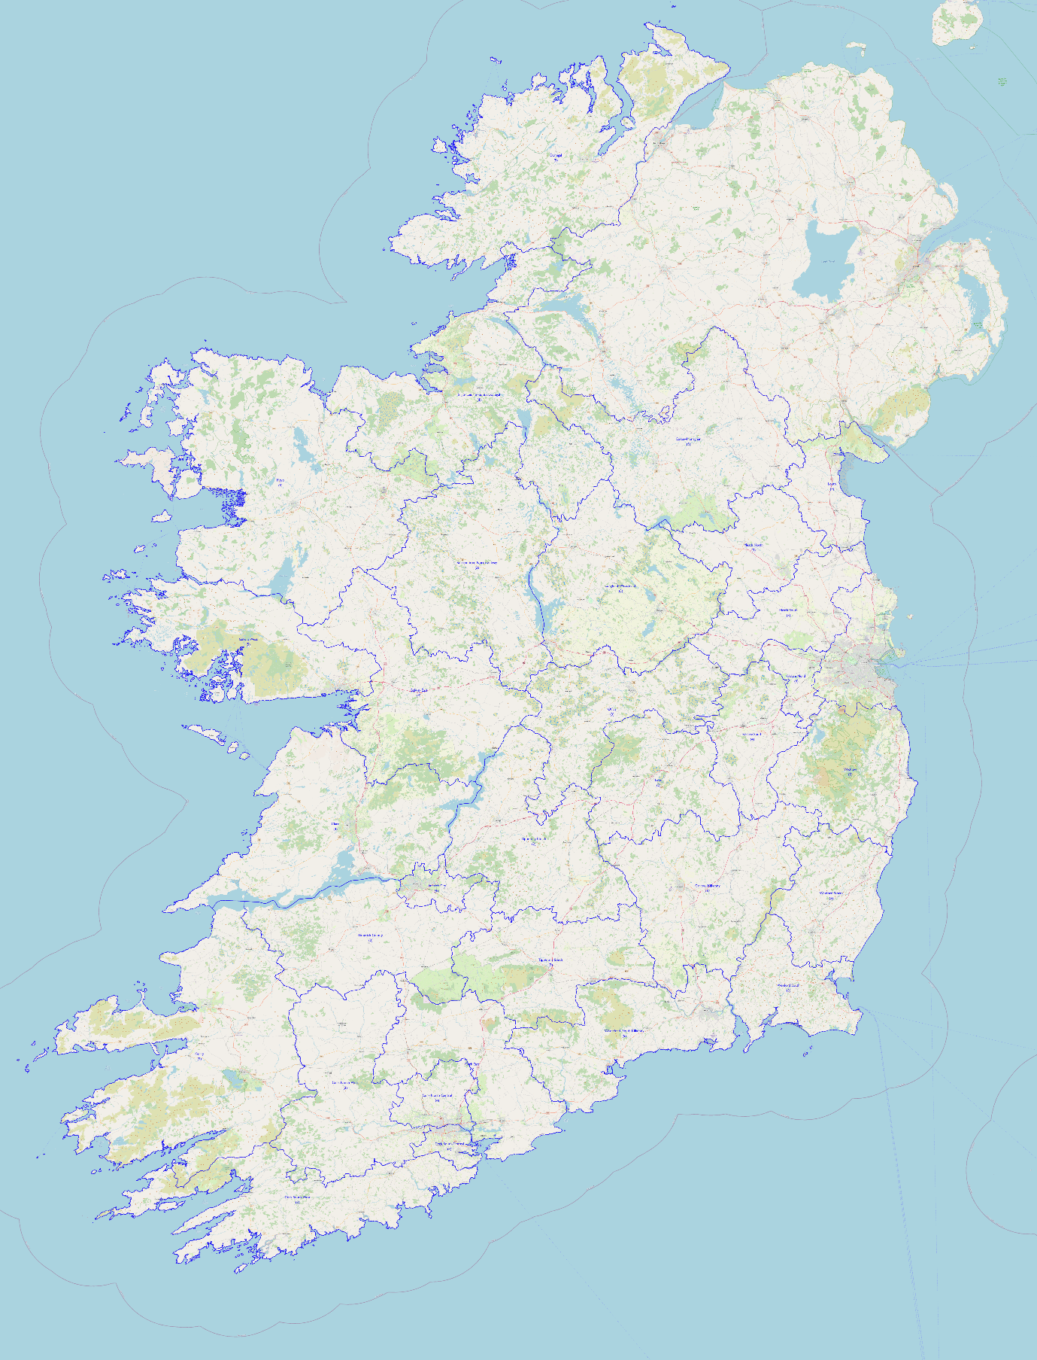

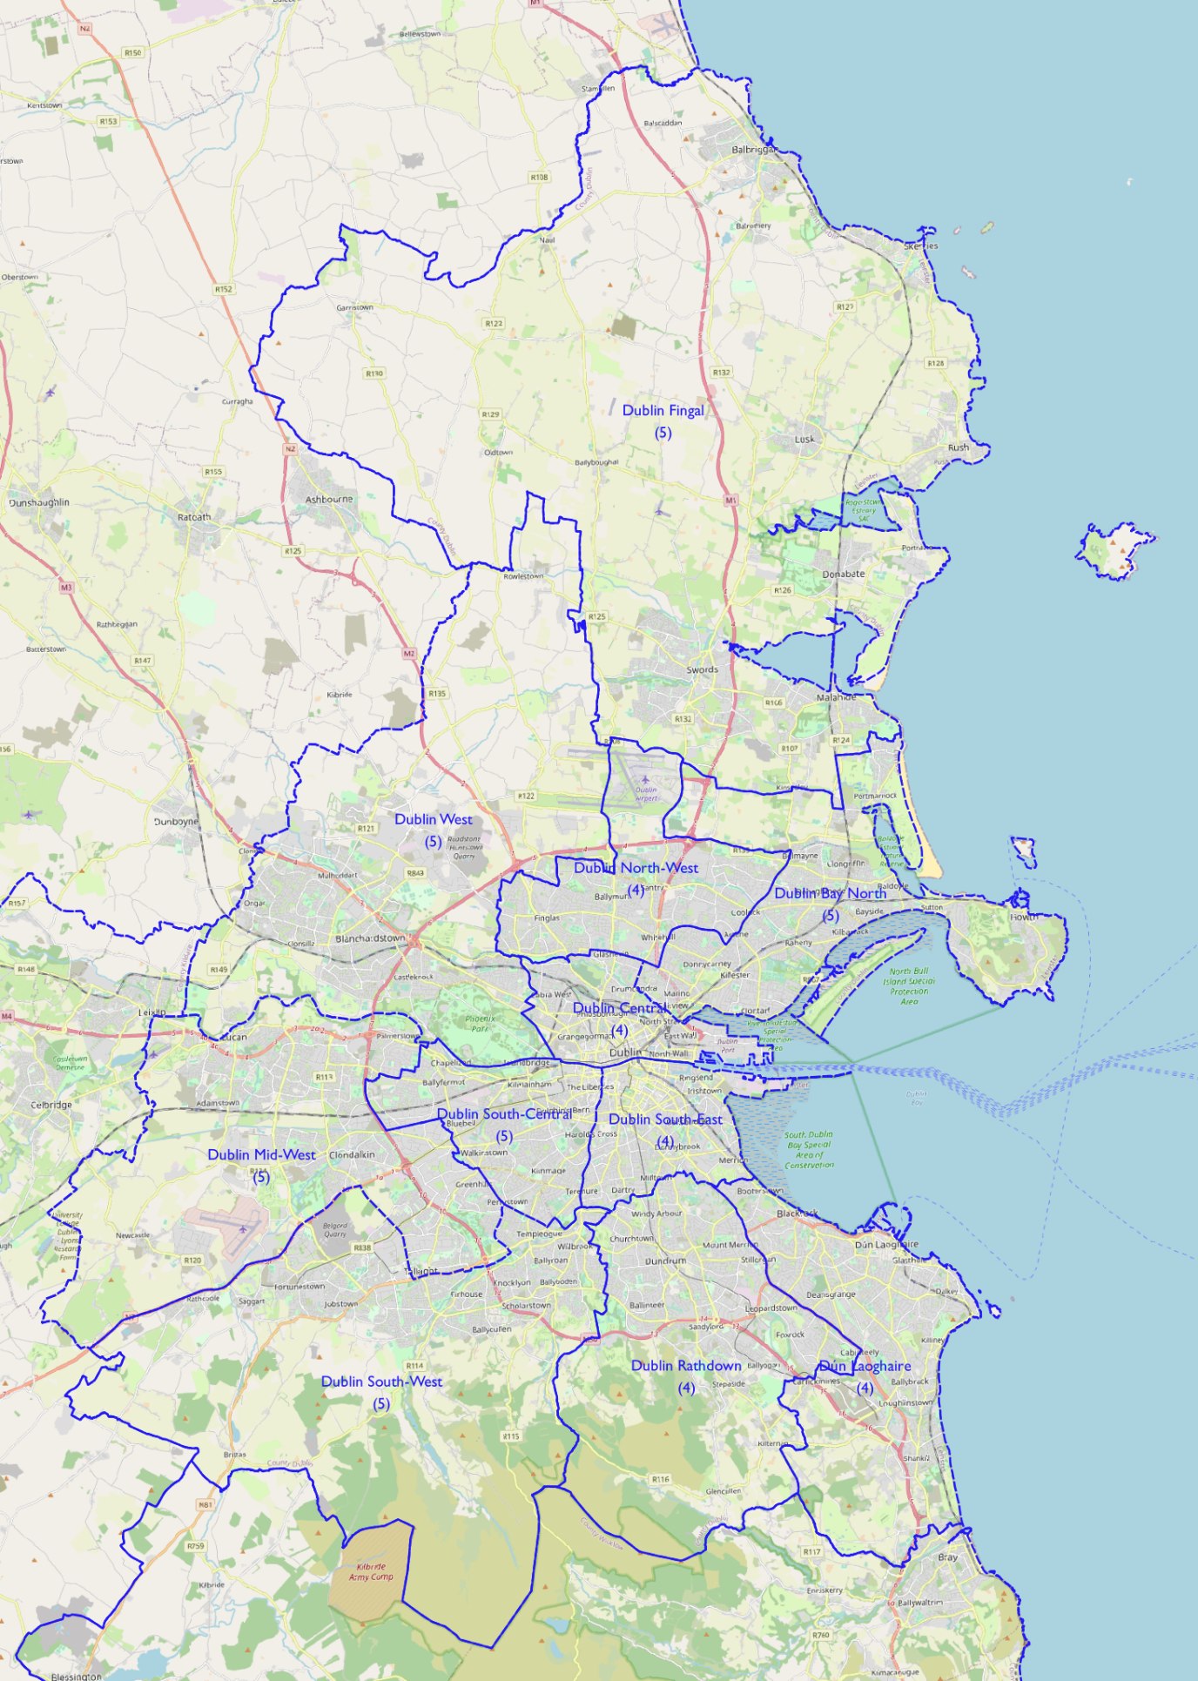

- 178-Seat Scenario

Increasing the number of seats from 176 to 178 produces a figure of population/TD of 28,783.9 with potential variance between 30,223.1 and 27,344.7 assuming a 5% degree of tolerance.

The set of constituencies produced under the 176-seat allocation in the last section have the following characteristics under a 178-seat allocation:

Proposed constituency | Population | Seats | Population/TD | Variance
Louth | 139,100 | 5 | 27,820.00 | -3.35%
Laois | 83,801 | 3 | 27,933.67 | -2.95%
Dublin South-Central | 140,402 | 5 | 28,080.40 | -2.44%
Mayo | 140,918 | 5 | 28,183.60 | -2.09%
Dublin South-East | 112,841 | 4 | 28,210.25 | -1.99%
Wexford South | 84,861 | 3 | 28,287.00 | -1.73%
Meath North | 84,952 | 3 | 28,310.33 | -1.65%
Dublin North-West | 113,469 | 4 | 28,367.25 | -1.45%
Dublin Rathdown | 113,520 | 4 | 28,380.00 | -1.40%
Roscommon–North Galway | 85,271 | 3 | 28,423.67 | -1.25%
Longford–Westmeath | 142,474 | 5 | 28,494.80 | -1.00%
Galway East | 114,136 | 4 | 28,534.00 | -0.87%
Wexford North | 85,803 | 3 | 28,601.00 | -0.64%
Cork East | 143,107 | 5 | 28,621.40 | -0.56%
Meath South | 143,188 | 5 | 28,637.60 | -0.51%
Galway West | 143,352 | 5 | 28,670.40 | -0.39%
Tipperary North | 86,059 | 3 | 28,686.33 | -0.34%
Waterford–South Kilkenny | 143,437 | 5 | 28,687.40 | -0.34%
Cork South-Central | 143,477 | 5 | 28,695.40 | -0.31%
Dublin Bay North | 143,564 | 5 | 28,730.80 | -0.18%
Tipperary South | 86,361 | 3 | 28,787.00 | +0.01%
Dublin Mid-West | 143,987 | 5 | 28,797.40 | +0.05%
Cork North-West | 87,077 | 3 | 29,025.67 | +0.84%
Dublin South-West | 145,704 | 5 | 29,140.80 | +1.24%
Cavan–Monaghan | 146,033 | 5 | 29,206.60 | +1.47%
Cork North-Central | 117,065 | 4 | 29,266.25 | +1.68%
Dublin Central | 117,273 | 4 | 29,318.25 | +1.84%
Kildare North | 118,113 | 4 | 29,528.25 | +2.59%
Dublin West | 147,825 | 5 | 29,565.00 | +2.71%
Wicklow | 148.348 | 5 | 29,669.60 | +3.08%
Carlow–Kilkenny | 149,264 | 5 | 29,852.80 | +3.71%
Dún Laoghaire | 119,937 | 4 | 29,984.25 | +4.17%
Clare | 120,290 | 4 | 30,072.50 | +4.48%
Limerick County | 90,232 | 3 | 30,077.33 | +4.49%
Sligo–Leitrim–South Donegal | 120,375 | 4 | 30,093.75 | +4.55%
Cork South-West | 90,505 | 3 | 30,168.33 | +4.81%
Donegal | 150,852 | 5 | 30,170.40 | +4.82%
Offaly | 90,524 | 3 | 30,174.67 | +4.83%
Kildare South | 121,041 | 4 | 30,260.25 | +5.13%
Kerry | 151,419 | 5 | 30,283.80 | +5.21%
Limerick City | 121,421 | 4 | 30,355.25 | +5.46%
Dublin Fingal | 152,109 | 5 | 30,421.80 | +5.69%

We see here that four of the proposed constituencies under the last iteration – Kildare South, Kerry, Limerick City, and Dublin Fingal – now have population/TD ratios that are beyond the 5% tolerance level and therefore require change.

Looking at each county and its population in relation to the national population/TD average, we see the following figures:

 | Population | No. of seats |  | Population | No. of seats
LEINSTER |  |  | MUNSTER
Carlow | 61,931 | 2.15 | Clare | 127,419 | 4.43
Dublin | 1,450,701 | 50.40 | Cork | 581,231 | 20.19
North City | 346,244 | 12.02 | Kerry | 155,258 | 5.39
South City | 241,989 | 8.41 | Limerick | 205,444 | 7.14
South Dublin | 299,793 | 10.42 | Tipperary | 167,661 | 5.82
Fingal | 329,218 | 11.44 | Waterford | 127,085 | 4.42
Dún Laoghaire-Rathdown | 233,457 | 8.11 | CONNACHT
Kildare | 246,977 | 8.58 | Galway | 276,451 | 9.60
Kilkenny | 103,685 | 3.60 | Leitrim | 35,087 | 1.22
Laois | 91,657 | 3.18 | Mayo | 137,231 | 4.77
Longford | 46,634 | 1.62 | Roscommon | 69,995 | 2.43
Louth | 139,100 | 4.83 | Sligo | 69,819 | 2.43
Meath | 220,296 | 7.65 | ULSTER (part)
Offaly | 82,668 | 2.87 | Cavan | 81,201 | 2.82
Westmeath | 95,840 | 3.33 | Donegal | 166,321 | 5.78
Wexford | 163,527 | 5.68 | Monaghan | 64,832 | 2.25
Wicklow | 155,485 | 5.40

We can now proceed to look at individual counties and combinations of counties, in particular those where change is required in comparison with the 176-seat scenario.

  - Clare/Donegal/Sligo/Leitrim/Galway/Mayo/Roscommon

County Donegal, with a population of 166,321 is now just over 2,000 above the minimum threshold for six seats in its own right.

The 2007 Constituency Commission, the last to recommend six seats for Donegal, defined:

- a Donegal North-East constituency comprising the urban districts of Buncrana and Letterkenny, and the former rural districts of Inishowen, Letterkenny, and Milford, and
- a Donegal South-West constituency comprising the remainder of the county, namely the urban district of Bundoran and the former rural districts of Ballyshannon, Donegal, Dunfanaghy, Glenties, and Stranorlar.

However, while this would create a Donegal North-East constituency with a population of 86,792 and a population/TD ratio of 28,930.67, a value only 0.1% above the national average under a 178-seat scenario, the resultant Donegal South-West constituency only has a population of 79,529, well below the lower threshold for a 3-seat constituency under the 178-seat scenario. There needs to be a transfer of approximately 2,500 population to the latter constituency from the former for both constituencies to be acceptable.

The narrow link between the Inishowen peninsula and the Letterkenny/Milford area due to Lough Swilly means that it is more practical to perform this transfer along the western border between the two constituencies, more particularly along the coastal part given the limited connections further inland. The electoral divisions of Carraig Airt, Creamhghort, Glen, and Ros Goill are separated by Mulroy Bay on the east from Fanad and have a combined population of 2,644. Transferring them to Donegal South-West from Donegal North-East produces two constituencies with populations of 82,173 and 84,148, both within the thresholds for 3-seat constituencies under the 178-seat scenario, albeit very narrowly so in the case of Donegal South-West.

Proposed constituency | Population | Seats | Population/TD | Variance
Donegal North-East | 84,148 | 3 | 28,049.33 | -2.45%
Donegal South-West | 82,173 | 3 | 27,391.00 | -4.84%

County Mayo, with a population of 137,231, is now just above the threshold for five seats in its own right and can return the 3,687 population of Ballaghaderreen and its environs to Roscommon, resolving that breach of the county boundary.

Proposed constituency | Population | Seats | Population/TD | Variance
Mayo | 137,231 | 5 | 27,446.20 | -4.65%

The counties of Leitrim, Roscommon and Sligo together have the numbers required for two 3-seat constituencies. The remainder of the Sligo–Leitrim–South Donegal constituency proposed under the 176-seat scenario has a population of 104,906, more than 14,000 above the maximum threshold for a 3-seat constituency under the 178-seat scenario. County Roscommon would need to take approximately 12,000 population to reach the minimum threshold under the 178-seat scenario.

In the past, County Leitrim has been divided between Counties Roscommon and Sligo and while this is mathematically straightforward, it has produced enormous popular disapproval given Leitrim’s small size and its sense of disenfranchisement when divided between other counties. The last two Constituency Commissions both recognized this problem and kept Leitrim intact, although at the cost of creating unwieldy constituencies combining parts of four different counties. We will therefore look at ways of transferring territory from County Sligo to Roscommon in a way that will produce two 3-seat constituencies within the thresholds for a 178-seat scenario.

The former rural districts of Boyle No. 2 and Tobercurry have a combined population of 14,773. However there are poor communication links between them and the northern part of the latter area forms part of the hinterland of Sligo borough. It is therefore proposed to retain the electoral divisions of Annagh, Coolaney, and Temple in the north of the former Tobercurry rural district with the north Sligo-based constituency, but transfer the electoral divisions of Ballymote, Bricklieve, and Lakeview in the former Sligo rural district to the Roscommon/south Sligo-based constituency to improve communications links. This produces a Roscommon–South Sligo constituency with a population of 85,576 and a population/TD ratio of 28,525.33, a value 0.9% below the national average under a 178-seat scenario, and a Leitrim–North Sligo constituency with a population of 89,325 and a population/TD ratio of 29,775, a value 3.4% above the national average under a 178-seat scenario.

Proposed constituency | Population | Seats | Population/TD | Variance
Leitrim–North Sligo | 89,325 | 3 | 29,775.00 | +3.44%
Roscommon–South Sligo | 85,576 | 3 | 28,525.33 | -0.90%

The number of residents of the proposed Leitrim–North Sligo constituency not in Counties Sligo or Leitrim is 0 (a decrease of 17,804 in comparison with the current constituency).
The number of residents of the proposed Roscommon–South Sligo constituency not in County Roscommon is 15,581 (a decrease of 15,136 in comparison to the current Roscommon–Galway constituency).

The transfer of the electoral divisions in County Galway previously in the proposed Roscommon–North Galway constituency increases the Galway East constituency’s population to 133,099, more than 12,000 above the maximum threshold for a 4-seat constituency under a 178-seat scenario but just under 3,800 below the minimum threshold for a 5-seat constituency. One possibility would be to transfer population from Galway West, which is within the limits for a 5-seat constituency to create two 5-seat constituencies entirely within County Galway. However, the neighbouring County Clare has an entitlement to 4.43 seats and the proposed Clare constituency is close to the upper limit for a 4-seat constituency despite having transferred over 7,000 population to Limerick City, itself now over the maximum threshold for a 4-seat constituency under a 178-seat scenario. Combined with County Galway’s entitlement to 9.60 seats these would combine to allow an allocation of 14 seats to the two counties and would allow breaches of county boundaries in Limerick and Tipperary to be eliminated, although a cross-border constituency would also breach a provincial boundary.

The transfer of:

- the former rural district of Ballyvaghan,
- the electoral divisions of Ayle, Boherglass, Caherhurley, Cahermurphy, Cappaghabaun, Cloonusker, Coolreagh, Corlea, Derrynagittagh, Drummaan, Feakle, Inishcaltra North and South, Mountshannon, Ogonnelloe, and Scariff in the former rural district of Scariff, and
- the electoral divisions of Caher, Glendree, Killanena, and Loughea in the former rural district of Tulla,

to Galway East, with a total population of 10,211, produces a 4-seat Clare constituency with a total population of 117,208, giving a population/TD ratio of 29,302, a value 1.8% above the national average under a 178-seat scenario, and a 5-seat Galway East–North Clare constituency with a population of 143,310, giving a population/TD ratio of 28,662, a value 0.4% below the national average under a 178-seat scenario. No change is required to the proposed Galway West constituency.
Proposed constituency | Population | Seats | Population/TD | Variance
Clare | 117,208 | 4 | 29,302.00 | +1.80%
Galway East–North Clare | 143,310 | 5 | 28,662.00 | -0.42%
Galway West | 143,352 | 5 | 28,670.40 | -0.39%

The number of residents of the Galway East–North Clare constituency not in County Galway is 10,211 (an increase of 10,211).
The number of residents of the Galway West constituency not in County Galway is 0 (a decrease of 5,878).

  - Cavan/Monaghan

The Cavan–Monaghan constituency from the 176-seat scenario remains within the 5% tolerance range under the 178-seat scenario so no modification is required.

Proposed constituency | Population | Seats | Population/TD | Variance
Cavan–Monaghan | 146,033 | 5 | 29,206.60 | +1.47%

The number of residents of the Cavan–Monaghan constituency not in Counties Cavan or Monaghan is 0 (a decrease of 4,205).

  - Cork/Kerry/Limerick/Tipperary

The removal of the electoral divisions from County Clare previously in the proposed Limerick City constituency leaves the population of that constituency as 114,292, and returning the electoral division of Ballybricken transferred to the Limerick County constituency in the 176-seat scenario increases that population to 115,963, giving a population/TD ratio of 28,990.75, a value of 0.7% above the national average under a 178-seat scenario.

County Limerick as a whole has an entitlement to 7.14 seats, with the areas not in the proposed Limerick City constituency having a population of 89,481, giving a 3-seat Limerick County a population/TD ratio of 29,827, a value of 3.6% above the national average under a 178-seat scenario.

County Tipperary, with a population of 167,661, now has sufficient population for 2 3-seat constituencies entirely contained within its boundaries. The previously proposed Tipperary South constituency has a population of 81,602 once the electoral divisions in County Limerick have been removed, leaving it some 500 short of the minimum threshold for a 3-seat constituency under a 178-seat scenario. The four electoral divisions of Cappagh, Curraheen, Donohill, and Glengar in the former rural district of Tipperary have a combined population of 2,198 and transferring them from the proposed Tipperary North to Tipperary South produces a Tipperary North constituency with a total population of 83,861, giving a population/TD ratio of 27,953.67, a value 2.9% below the national average under a 178-seat scenario, and a Tipperary South constituency with a total population of 83,800, giving a population/TD ratio of 27,933.33, a value 3.0% below the national average under a 178-seat scenario.

This leaves us with the question of County Kerry, which has a population of 155,258 and an entitlement to 5.39 seats, and which would need an additional 9,000 population to form two 3-seat constituencies. The only remaining county with which it could be paired is County Cork, which has an entitlement to 20.19 seats, making 25.58 in total. Four of the five Cork constituencies are well within the tolerance range for the 178-seat scenario but Cork South-West is close to the limit at 4.9% above the average so it is there we will look for additions to our proposed Kerry constituencies.

The former rural district of Castletown, covering the western part of the Béara peninsula, has a population of 4,497. Further east, the electoral divisions of Ahil, Bantry Rural and Urban, Douce, Glengarriff, Kealkill, Kilcaskan, Mealagh, and Whiddy in the former rural district of Bantry have a combined population of 8,063, making 12,560 in total to be added to Kerry-based constituencies.

This transfer reduces the population of the proposed Cork South-West constituency to 77,945, just over 4,000 population short of the minimum threshold for a 3-seat constituency. To alleviate this, we can transfer from the proposed Cork North-West constituency the electoral divisions of Aultagh, Castletown, Coolmountain, Garrown, Kinneigh, and Manch in the former rural district of Dunmanway, with a total population of 2,626, and the electoral divisions of Bengour, Murragh, and Teadies, with a total population of 1,841.

This produces a Cork North-West constituency with a population of 82,610, giving a population/TD ratio of 27,536.67, a value of 4.3% below the national average under a 178-seat scenario, and a Cork South-West constituency with a population of 82,412, giving a population/TD ratio of 27,470.67, a value of 4.6% below the national average under a 178-seat scenario.

The parts of the Kerry North–West Limerick constituency proposed by the 2007 Constituency Commission within County Kerry were:

- the urban districts of Listowel and Tralee,
- the former rural district of Listowel, and
- the electoral divisions of Abbeydorney, Arabela, Ardfert, Ballyegan, Ballyheige, Ballynahaglish, Ballynorig, Ballyseedy, Banna, Blennerville, Brosna, Clogherbrien, Crinny,
Doon, Gneeves, Kerryhead, Kilflyn, Killahan, Kilmurry, Knocknagashel, Lackabaun, Mount Eagle, Nohaval, O’Brennan, Ratass, Tralee Rural, and Tubrid in the former rural district of Tralee.

These areas have a current population of 70,343. Adding the electoral divisions of Baurtregaum, Castleisland, Kilgobban, and Knockglass in the former rural district of Tralee, and the whole of the former rural district of Dingle, increases the population to 84,751, giving a population/TD ratio of 28,250.33, a value of 0.2% below the national average under a 178-seat scenario.

The remainder of County Kerry, along with the electoral divisions previously mentioned in the rural districts of Bantry and Castletown, can form a Kerry South–West Cork constituency with a population of 83,067, giving a population/TD ratio of 27,689, a value of 3.8% below the national average under a 178-seat scenario.

The constituencies of Cork East, Cork North-Central, and Cork South-Central remain unchanged under this scenario.

Proposed constituency | Population | Seats | Population/TD | Variance
Cork East | 143,107 | 5 | 28,621.40 | -0.56%
Cork North-Central | 117,065 | 4 | 29,266.25 | +1.68%
Cork North-West | 82,610 | 3 | 27,536.67 | -4.33%
Cork South-Central | 143,477 | 5 | 28,695.40 | -0.31%
Cork South-West | 82,412 | 3 | 27,470.67 | -4.57%
Kerry North | 84,751 | 3 | 28,250.33 | -1.85%
Kerry South–West Cork | 83,067 | 3 | 27,689.00 | -3.80%
Limerick City | 115,963 | 4 | 28,990.75 | +0.72%
Limerick County | 89,481 | 3 | 29,827.00 | +3.62%
Tipperary North | 83,861 | 3 | 27,953.67 | -2.88%
Tipperary South | 83,800 | 3 | 27,933.33 | -2.96%

The number of residents of the Kerry South–West Cork constituency not in County Kerry is 12,560 (an increase of 12,560).
The number of residents of the Limerick City constituency not in County Limerick is 0 (an increase of 4,674).

  - Carlow/Kilkenny/Waterford

The two constituencies covering Counties Carlow, Kilkenny, and Waterford from the 176-seat scenario remain within the tolerance level under the 178-seat scenario, so no modifications are required.

Proposed constituency | Population | Seats | Population/TD | Variance
Carlow–Kilkenny | 149,264 | 5 | 29,852.80 | +3.71%
Waterford–South Kilkenny | 143,437 | 5 | 28,687.40 | -0.34%

The number of residents of the Waterford–South Kilkenny constituency not in County Waterford is 16,352 (an increase of 16,352).

  - Wexford/Wicklow

The three constituencies covering Counties Wexford and Wicklow from the 174-seat scenario remain within the tolerance level under the 176-seat scenario so no modifications are required.

Proposed constituency | Population | Seats | Population/TD | Variance
Wexford North | 85,803 | 3 | 28,601.00 | -0.64%
Wexford South | 84,861 | 3 | 28,287.00 | -1.73%
Wicklow | 148.348 | 5 | 29,669.60 | +3.08%

The number of residents of the Wexford North constituency not in County Wexford is 7,137 (an increase of 7,137).

  - Kildare/Meath

The Kildare South constituency proposed under the 176-seat scenario is marginally above the tolerance level under the 178-seat scenario. The other three constituencies remain within the tolerance level. Transferring the Timahoe North electoral division to the proposed Kildare North constituency (of which it currently forms a part) would allow both constituencies to remain within the acceptable margins for 4-seat constituencies under the 178-seat scenario.

Proposed constituency | Population | Seats | Population/TD | Variance
Kildare North | 119,343 | 4 | 29,835.75 | +3.65%
Kildare South | 119,811 | 4 | 29,952.75 | +4.06%
Meath North | 84,931 | 3 | 28,310.33 | -1.65%
Meath South | 143,188 | 5 | 28,637.60 | -0.51%

The number of residents of the Kildare South constituency not in County Kildare is 0 (a decrease of 13,080).

  - Laois/Offaly

The two constituencies covering Counties Laois and Offaly from the 176-seat scenario remain within the tolerance level under the 178-seat scenario, so no modifications are required.

Proposed constituency | Population | Seats | Population/TD | Variance
Laois | 83,801 | 3 | 27,933.67 | -2.95%
Offaly | 90,524 | 3 | 30,174.67 | +4.83%

The number of residents of the Offaly constituency not in County Offaly is 7,856 (an increase of 7,856).

  - Longford/Westmeath

The Longford–Westmeath constituency from the 176-seat scenario remains within the 5% tolerance range under the 178-seat scenario so no modification is required.

Proposed constituency | Population | Seats | Population/TD | Variance
Longford–Westmeath | 142,474 | 5 | 28,494.80 | -1.00%

  - Louth

The Louth constituency from the 176-seat scenario remains within the tolerance range under the 178-seat scenario so no modificiation is required.

Proposed constituency | Population | Seats | Population/TD | Variance
Louth | 139,100 | 5 | 27,820.00 | -3.35%

The number of residents of the Louth constituency not in County Louth is 0 (a decrease of 27,912).

5.10 Dublin

Dublin has an entitlement to 50.40 seats under a 178-seat scenario. The eleven constituencies from the 174-seat scenario have a total of 50 seats and all except Dublin Fingal have population/TD ratios within the 5% tolerance level of the national average under the 178-seat scenario.

The six constituencies south of the Liffey are all within the tolerance limits. No change is required.

Proposed constituency | Population | Seats | Population/TD | Variance
Dublin Mid-West | 143,987 | 5 | 28,797.40 | +0.05%
Dublin Rathdown | 113,520 | 4 | 28,380.00 | -1.40%
Dublin South-Central | 140,402 | 5 | 28,080.40 | -2.44%
Dublin South-East | 112,841 | 4 | 28,210.25 | -1.99%
Dublin South-West | 145,704 | 5 | 29,140.80 | +1.24%
Dún Laoghaire | 119,937 | 4 | 29,984.25 | +4.17%

Looking at the north Fingal-based 3-seat constituency previously referred to in the document, the numbers now support the establishment of such a constituency containing the electoral divisions of Balbriggan Rural and Urban, Balscadden, Ballyboghil, Clonmethan, Donabate, Garristown, Hollywood, Kilsallaghan (in the previously proposed Dublin West), Lusk, Rush, Skerries. The combined population of these electoral divisions is 82,752, which gives a population/TD average of 27,584, a value 4.1% below the national average under a 178-seat scenario. The remainder of the previously proposed Dublin Fingal constituency, consisting of the towns of Swords and Malahide and territory to their south, has a population of 71,784. Adding the electoral divisions of Balgriffin and Portmarnock North and South, previously in the proposed Dublin Bay North but in the current Dublin Fingal constituency, brings the population of this Fingal South constituency to 86,121, giving a population/TD ratio of 28,707, a value 0.3% below the national average under a 178-seat scenario.

We now need to adjust the boundaries of the four remaining constituencies north of the Liffey to take account of the creation of this additional constituency and its side-effects. Removing the Kilsallaghan electoral division from Dublin West leaves it with a population of 145,398. We can add the Cabra West D electoral division from Dublin Central, with a population of 2,795, to move its population to 148,193, giving a population/TD ratio of 29,638.6, a value of 3.0% above the national average under a 178-seat scenario. We can replace Cabra West D with Drumcondra South A, previously transferred from the existing Dublin Central to the proposed Dublin Bay North, to leave our Dublin Central constituency with a population of 120,370, giving a population/TD ratio of 30,092.5, a value of 4.6% above the national average under a 178-seat scenario. The remainder of the proposed Dublin Bay North constituency has a population of 123,405 and needs to lose territory to Dublin North-West to be within the tolerance levels for a 4-seat constituency. The transfer of Beaumont D and F, with a combined population of 5,968, leaves the Dublin Bay North constituency with a population of 117,437, giving a population/TD ratio of 29,359.25, a value of 2.0% above the national average under a 178-seat scenario, and the Dublin North-West constituency with a population of 119,437, giving a population of 29.829.25, a value of 3.7% above the national average under a 178-seat scenario.

Proposed constituency | Population | Seats | Population/TD | Variance
Dublin Bay North | 117,437 | 4 | 29,359.25 | -2.00%
Dublin Central | 120,370 | 4 | 30,092.50 | +4.55%
Dublin North-West | 119,437 | 4 | 29,859.25 | +3.74%
Dublin West | 148,193 | 5 | 29,565.00 | +1.56%
Fingal North | 82,752 | 3 | 30,421.80 | -4.17%
Fingal South | 86,121 | 3 | 28,707.00 | -0.27%

Summary

A total of 45 constituencies are proposed under this scenario.

Proposed constituency | Population | Seats | Population/TD | Variance
Donegal South-West | 82,173 | 3 | 27,391.00 | -4.84%
Mayo | 137,231 | 5 | 27,446.20 | -4.65%
Cork South-West | 82,412 | 3 | 27,470.67 | -4.57%
Cork North-West | 82,610 | 3 | 27,536.67 | -4.33%
Fingal North | 82,752 | 3 | 30,421.80 | -4.17%
Kerry South–West Cork | 83,067 | 3 | 27,689.00 | -3.80%
Louth | 139,100 | 5 | 27,820.00 | -3.35%
Tipperary South | 83,800 | 3 | 27,933.33 | -2.96%
Laois | 83,801 | 3 | 27,933.67 | -2.95%
Tipperary North | 83,861 | 3 | 27,953.67 | -2.88%
Donegal North-East | 84,148 | 3 | 28,049.33 | -2.45%
Dublin South-Central | 140,402 | 5 | 28,080.40 | -2.44%
Dublin Bay North | 117,437 | 4 | 29,359.25 | -2.00%
Dublin South-East | 112,841 | 4 | 28,210.25 | -1.99%
Kerry North | 84,751 | 3 | 28,250.33 | -1.85%
Wexford South | 84,861 | 3 | 28,287.00 | -1.73%
Meath North | 84,931 | 3 | 28,310.33 | -1.65%
Dublin Rathdown | 113,520 | 4 | 28,380.00 | -1.40%
Longford–Westmeath | 142,474 | 5 | 28,494.80 | -1.00%
Roscommon–South Sligo | 85,576 | 3 | 28,525.33 | -0.90%
Wexford North | 85,803 | 3 | 28,601.00 | -0.64%
Cork East | 143,107 | 5 | 28,621.40 | -0.56%
Meath South | 143,188 | 5 | 28,637.60 | -0.51%
Galway East–North Clare | 143,310 | 5 | 28,662.00 | -0.42%
Galway West | 143,352 | 5 | 28,670.40 | -0.39%
Waterford–South Kilkenny | 143,437 | 5 | 28,687.40 | -0.34%
Cork South-Central | 143,477 | 5 | 28,695.40 | -0.31%
Fingal South | 86,121 | 3 | 28,707.00 | -0.27%
Dublin Mid-West | 143,987 | 5 | 28,797.40 | +0.05%
Limerick City | 115,963 | 4 | 28,990.75 | +0.72%
Dublin South-West | 145,704 | 5 | 29,140.80 | +1.24%
Cavan–Monaghan | 146,033 | 5 | 29,206.60 | +1.47%
Dublin West | 148,193 | 5 | 29,565.00 | +1.56%
Cork North-Central | 117,065 | 4 | 29,266.25 | +1.68%
Clare | 117,208 | 4 | 29,302.00 | +1.80%
Wicklow | 148.348 | 5 | 29,669.60 | +3.08%
Leitrim–North Sligo | 89,325 | 3 | 29,775.00 | +3.44%
Limerick County | 89,481 | 3 | 29,827.00 | +3.62%
Kildare North | 119,343 | 4 | 29,835.75 | +3.65%
Carlow–Kilkenny | 149,264 | 5 | 29,852.80 | +3.71%
Dublin North-West | 119,437 | 4 | 29,859.25 | +3.74%
Kildare South | 119,811 | 4 | 29,952.75 | +4.06%
Dún Laoghaire | 119,937 | 4 | 29,984.25 | +4.17%
Dublin Central | 120,370 | 4 | 30,092.50 | +4.55%
Offaly | 90,524 | 3 | 30,174.67 | +4.83%

All 45 constituencies are within the 5% tolerance level of the national average with the largest variances on each side being +4.8% and -4.8%. There are 16 5-seat constituencies, 11 4-seat constituencies, and 18 3-seat constituencies.

The following breaches of county boundaries exist, with the total population who live in the affected areas listed alongside:

Constituency | Population
Sligo in Roscommon–South Sligo | 15,581
Clare in Galway East–North Clare | 10,211
Cork in Kerry South–West Cork | 12,560
Kilkenny in Waterford–South Kilkenny | 16,352
Wicklow in Wexford North | 7,137
Laois in Offaly | 7,856
Kildare in Meath South | 7,823
Total | 77,520

This figure of 77,520 represents a reduction of 36,218 on the current total with the number of breaches of county boundaries reduced to 7. Increasing the tolerance range to beyond 5% would in addition allow at least some of these breaches to be removed.

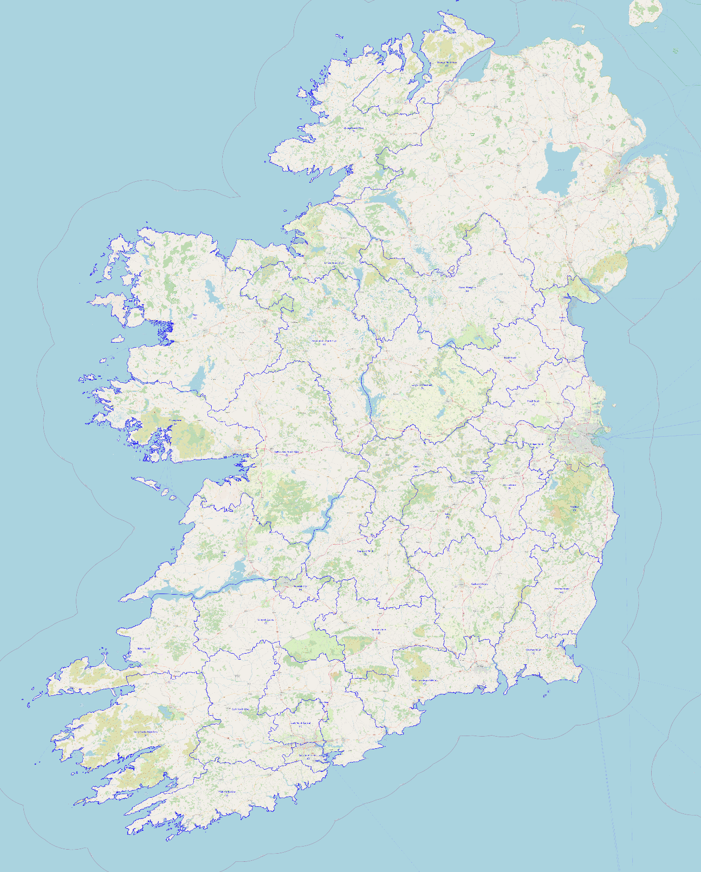

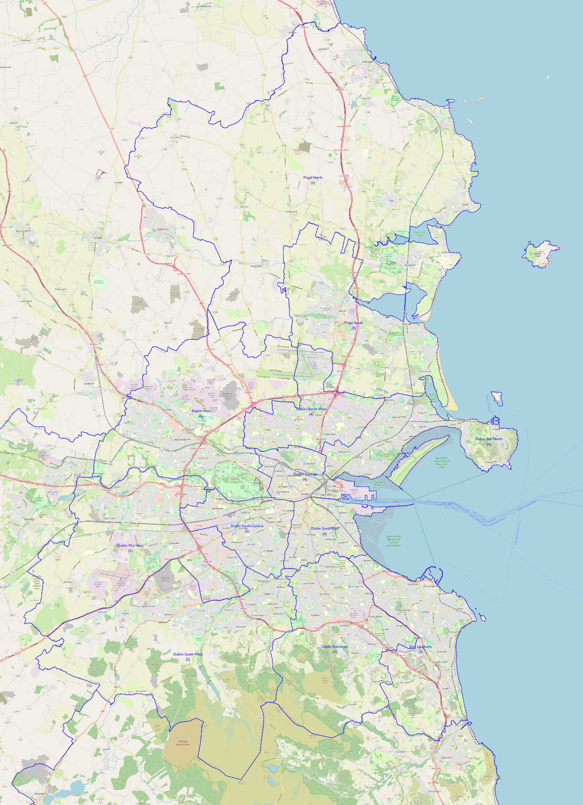

- Conclusions

This document may be viewed as a “scoping exercise” investigating possible configurations for constituencies meeting the criteria laid out in the opening section and operating under the following assumptions:

- maintaining a relatively narrow band of variance from the national average – 5% in either direction. Previous Constituency Commissions have operated on broader bands of up to 7.5%
- minimizing breaches of county boundaries and splitting urban settlements wherever possible. A large proportion of the submissions to this and to previous commissions have always focussed on these aspects of constituency delimitation; much more so than concerns about strict numerical equality between constituencies. The sense of county identity is still very strong in this country, even in urban areas.
- where there is a choice between splitting a smaller and splitting a larger county (e.g. Carlow vs. Kilkenny in the 172-seat scenario, Leitrim vs. Sligo in the 178-seat scenario) choosing the larger because of the detrimental effects.
- where constituencies do need to contain parts of more than one county, minimizing the number of counties involved to two, with the exception of the Donegal/Sligo/Leitrim three-county combination where geography and history combine to limit the possible combinations involving County Donegal.

There has been speculation about increasing the number of seats sharply to the top of the permitted range. I am not convinced that this is a good idea, both for political reasons – the perception of politicians providing the maximum number of positions for themselves among the general public – and, much more importantly for practical reasons.

There is no guarantee that, given the rate of population increase over the last intercensal period and national plans for population growth, that 180 seats would be enough to accommodate an increased population after the 2027 Census. Even if the population limit is not breached, the next constituency review process would then run the risk of “taking back” extra seats that had been allocated to counties or regions in this constituency review process, not because of population decline in those regions, but because population had increased there at a lower rate than in the state as a whole. There is much to be said for the principle of providing resources (in this case, Dáil seats) as they are immediately needed rather than making assumptions that may not be borne out.

I wish you well in your new roles and the process ahead. I would echo the comments made by Dr. Adrian Kavanagh of Maynooth University in his submission about the desirability of issuing initial proposals for public perusal rather than “launching the finished product” although I realize that this is much more complicated than it sounds given the time that elapses between the initial and final Census results and the consequent delays there might be in issuing a set of recommendations as a result.

I enclose a set of shapefiles with the proposed boundaries for the various scenarios. All boundary data is courtesy of Ordnance Survey Ireland’s Open Data. All maps are courtesy of OpenStreetMap contributors.

Yours faithfully,

Patrick Matthews.

