Submission to the Electoral Commission on Constituency Boundary Review
I wish to make the following submission regarding the current boundary review as it pertains to the Dublin North-West Constituency, the Dublin Bay North Constituency, and the Dublin Central Constituency.
The Electoral Commission has stated that in order to comply with Article 16.2.2° of the constitution the number of TDs will need to be increased. Section 57(2)(a) of the Electoral Reform Act 2022 provides that the total number of members of Dáil Éireann, subject to Article 16.2.2° of the Constitution, shall be not less than 171 and not more than 181
The 2022 Census Preliminary Results show an overall increase in population in the order of 361,671, mostly in the Dublin region. With most population growth in the Dublin region, it would be suggestible to increase Public Representation in the Dublin Region.
This submission will examine public representation in the North Dublin City area. The constituencies we will look at are Dublin North-West, Dublin Central, and Dublin Bay North.
As has been put forward by the Labour Party submission, the number of 3-Seat Constituencies should be reduced to allow for greater democratic representation. I would advocate that the Dublin North-West Constituency should have the amount of Dáil seats increased from 3 seat to 4 seats.
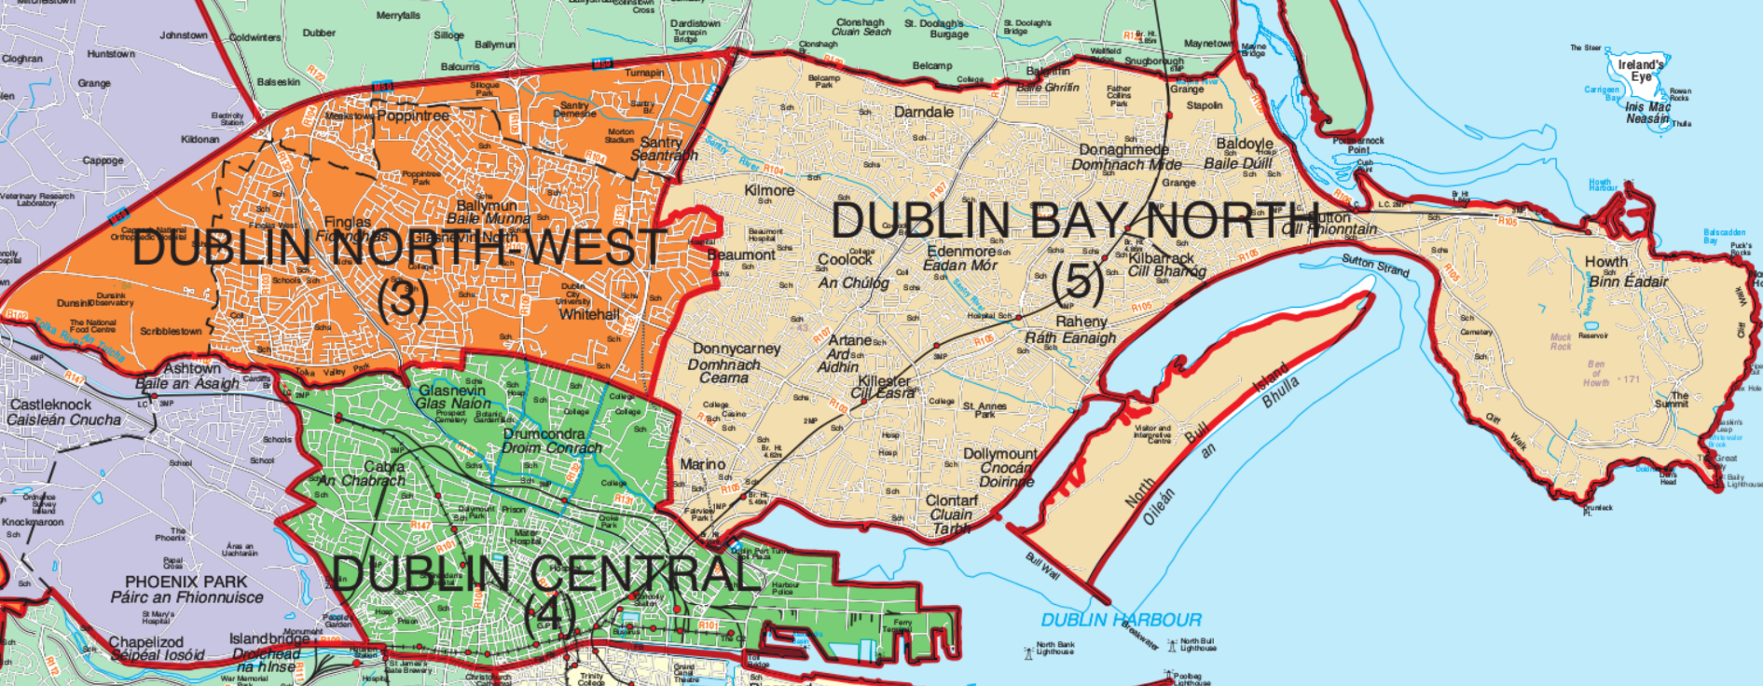

According to 2022 Census Preliminary Data:
- Dublin Bay North has 5 Dáil seats, with a population of 155,905. The population per TD is 31,181.
- Dublin Central has 4 Dáil seats, with a population of 123,165. The population per TD is 30,791.
- Dublin North-West has 3 Dáil seats, with a population of 90,219. The population per TD is 30,073.
The three constituencies have a population of 369,289.
Each of these three constituencies are beyond the ideal 30,000 population per TD but there is scope to examine how moving certain areas from Dublin Central and Dublin Bay North to the Dublin North-West Constituency can allow a more even spread between constituencies while respecting contiguous and geographical boundaries.
Dublin Central/Dublin North-West Boundaries
The boundaries between the Dublin Central and Dublin North-West Constituencies rests with the Whitehall and Ballygall/Drumcondra Electoral Divisions. We are proposing that from the Dublin Central Constituency, the Drumcondra South A, Drumcondra South C and part of the Botanic A Electoral Divisions would move to the Dublin North-West Constituency. The idea behind this is to essentially move anything north of the Tolka River from Dublin Central to Dublin North-West.
There are contiguous, geographical and population reasons for this proposal. The Tolka River is a defining natural and geographical boundary between these areas and the communities of these Electoral Divisions share a lot with the communities of Glasnevin, Whitehall and Santry. Parts of the Drumcondra area were previously part of the Dublin North-West Constituency.
On a population level, this proposal would move approximately 11,248 from the Dublin Central Constituency to the Dublin North-West Constituency.
Drumcondra South A has a population of 5,912.
Drumcondra South C has a population of 3,336.
And the area of Botanic A that is being proposed has an approximate population of 2,000.
This would reduce the population of Dublin Central to approximately 111,917 and a population per TD of 27,979.

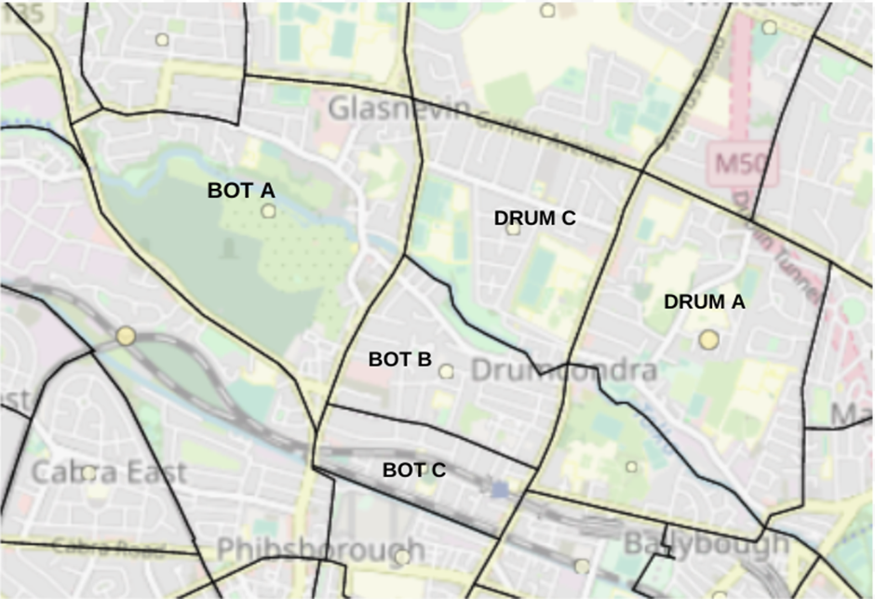
Dublin Bay North/Dublin North-West Boundaries
The boundary between the Dublin Bay North and Dublin North-West Constituencies is considerably long but retreats unusually just north of the Beaumont A Electoral Division. The Constituency boundary includes Beaumont A but does not include areas of Kilmore or Priorswood which are neighbouring communities of Whitehall, Santry and Northwood. We are proposing that the boundary should capture more of this area as those communities have more in common with neighbouring Dublin North-West areas than they do with Dublin Bay North areas.
The populations of each of these Electoral Divisions is displayed in the table below.
Kilmore A | 3,624
Kilmore B | 2,513
Priorswood A | 1,587
Priorswood B | 2,612
Priorswood E | 2,746
Total | 13,082

This would reduce the population of Dublin Bay North to approximately 142,823 and a population per TD of 28,564.
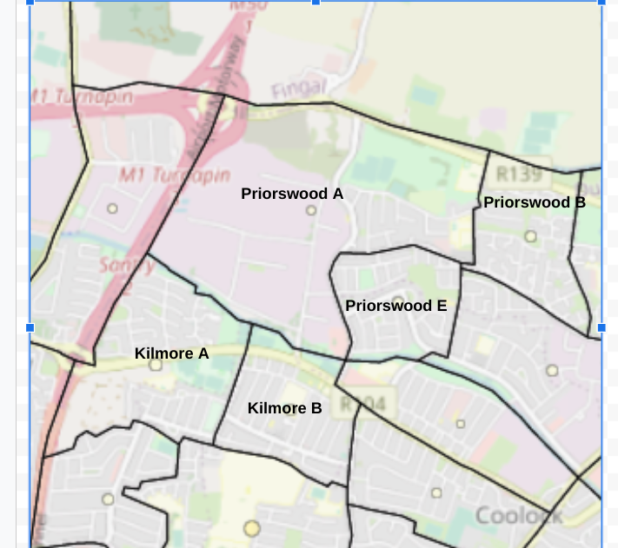

Dublin North-West
The below image highlights how Dublin North-West would look with the proposed changes. This would collate communities in the areas that have a shared and collective identity in the Dublin North-West area.
The proposals would add approximately 24,330 to the population of Dublin North-West and would increases the population to 114,549.
As I have mentioned before, and what the Labour Party submission notes,the number of 3-Seat Constituencies should be reduced to allow for greater democratic representation. At 3 seats this would have a population per TD 38,183 which is why we are proposing that one Dáil seat is added to the Dublin North-West Constituency to create 4 seats. This would then create a population per TD of 28,637.
The population across the three North Dublin City Constituencies would look as follows.
Constituency | Population | Dáil Seats | Population per TD
Dublin North-West | 114,549 | 4 | 28,637
Dublin Bay North | 142,823 | 5 | 28,564
Dublin Central | 111,917 | 4 | 27,979

This would more evenly spread the populations of the three North Dublin City Constituencies as well as improve public representation across the constituencies.
