BOUNDARY COMMISSION SUGGESTIONS

From D.J.Moore

Besides my proposal on Kildare North, I would like to make some suggestions as to how minimal changes could be made to other constituencies in line with the guidelines issued.

These are meant to be only suggestions to help give overall shape to regions and not to supersede the knowledge of local submitters.
CARLOW, KILKENNY and SOUTH KILDARE (9 seats)

I feel these areas should be treated together, but while I have done draft maps I am reluctant to make a suggestion due to the complex issues involved. A further complicating factor is the geographical position of both Carlow and Kilkenny in their respective counties.

Note : When I’m talking about South Kildare here, I’m talking about the parts that I’m not recommending go into Kildare North (the DEDs of Ballymore, Carrick, Carbury, Donore, Drehid, Killashee, Kilmeague North, Kilpatrick, Kilrainy, Lullymore, Robertstown, Timahoe South and Windmill Cross) as well as the parts of Kildare South that were in Laois and Offaly.

The table below gives the population details of the three areas :

AREA | POPULATIONS | SEATS @ 178 | SEATS @ 180
Carlow | 61,931 | 2.15 | 2.18
South Kildare | 97,883 | 3.40 | 3.44
Kilkenny | 103,685 | 3.60 | 3.64
Total | 263,499 | 9.15 | 9.26

I think the two possible options are :

• A three seat Kildare South, a three seat Carlow with portions of North and/or East
Kilkenny and South Kildare, and a three seat Kilkenny.
• A four seat Kilkenny taking in rural south Carlow, and a five seat Carlow-Kildare
South.

The one point I would make is that serious consideration be given to uniting the Graigue Rural DED in Laois with Carlow and Graiguecullen – if the numbers permit. The Carlow-Laois border runs right through the town of Graiguecullen and many estates in the town find themselves not just in another county but another constituency. This should be rectified if possible.
CAVAN-MONAGHAN (5 seats)

The constituency of Cavan-Monaghan currently encompasses seven DEDs in North-West Meath. As the counties of Cavan and Monaghan currently have a population of 146,033 between them – equivalent to 5.07 seats in a 178 seat Dáil, and 5.13 seats in a 180 seat Dáil, I would strongly suggest that Cavan and Monaghan form a standalone Cavan-Monaghan constituency again.

The variance from the national average is 1.4% above in 178 a seat Dáil, and 2.6% above in a
180 seat Dáil.

I would suggest that the seven DEDs in Meath can go into an expanded Meath West constituency.

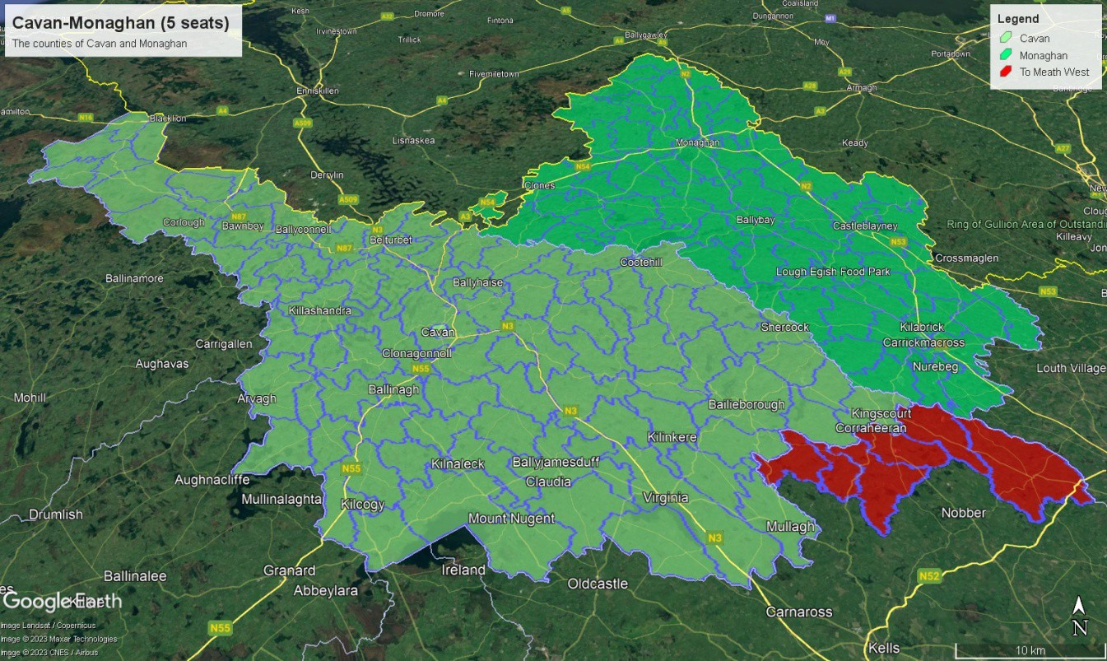
DUBLIN BAY NORTH (5 seats)

Currently Waterford has a population of 155,905 as of Census 2021, equivalent to 5.42 seats (in a 178 seat Dáil) or 5.48 seats (in a 180 seat Dáil). This means it is marginally closer to a five than a five-seater than two three-seaters – certainly at the 178 seat option.

My suggestion here is that three District Electoral Divisions - Clontarf West C, D and E – be moved from Dublin Bay North into Dublin Central. These DEDs contain Fairview, Marino and a part of West Clontarf. The movement of these areas – along with movements from Dublin West will facilitate Dublin Central becoming a five seater again. The total population of
those three DEDs is 9,566.

I did consider the Grace Park DED but it seems most of the population is on the north side of the area with the south side being dominated by an educational campus, leading to a lack of continuity.

In addition, I would suggest moving the small Beaumont A DED (population 2,664) back into Dublin Bay North from Dublin North-West which would mean that the Beaumont DEDs are reunited in the one constituency and also allows Dublin North-West to remain within the permitted bounds of variation in both a 178 seat Dail (+0.5%) and a 180 seat Dail (+1.6%).

The total population of the new Dublin Bay North would be 149,003, 3.5% above the national Population:Representative ratio in a 178 seat Dail and 4.7% above in a 180 seat one.

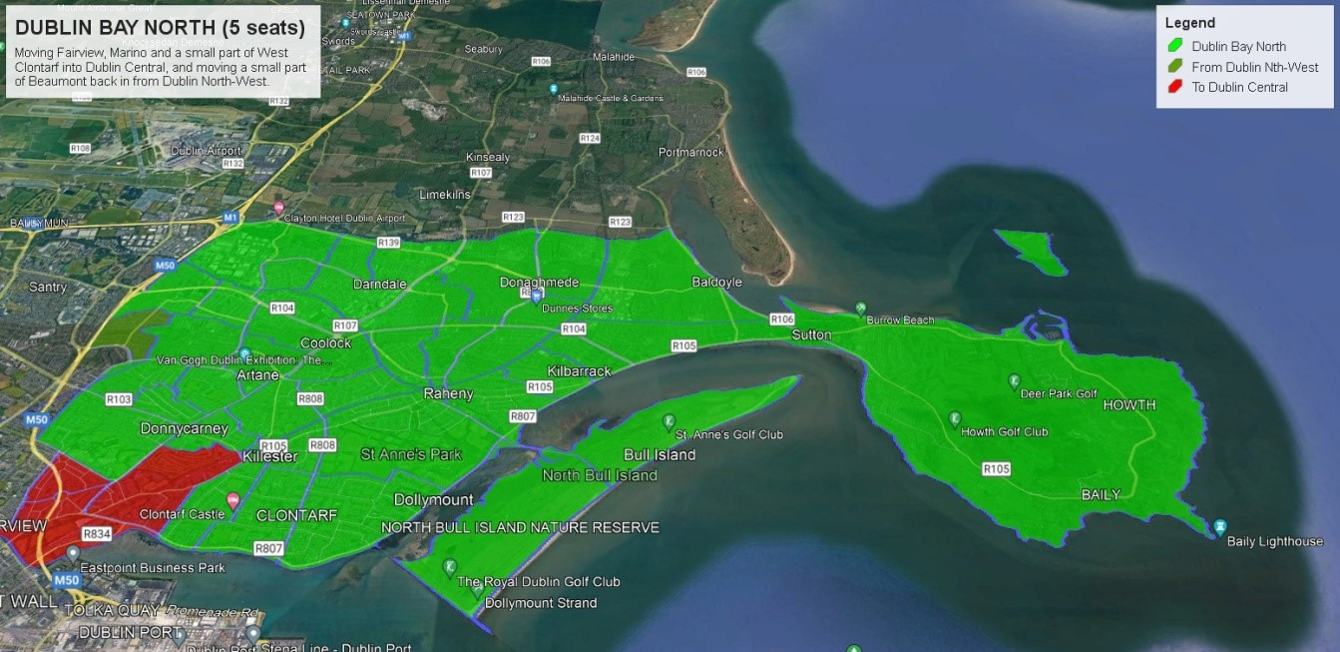
DUBLIN CENTRAL (5 seats)

Currently Dublin Central has a population of 123,165 as of Census 2021, equivalent to 4.28 seats (in a 178 seat Dáil) or 4.33 seats (in a 180 seat Dáil). This means it is marginally closer to a four-seater – but both Dublin West on its western flank and Dublin Bay North on its eastern flank are also over-subscribed population-wise.

Accordingly, I’m suggesting that Ashtown A, Ashtown B and the northern side of Phoenix Park (population c.13,600 – see caveat below) be moved back into Dublin Central from Dublin West as well as Clontarf West C, D and E from Dublin Bay North (population 9,566).

Caveat : I’m not certain what the population is the North-side of the Phoenix Park, but it seems most of the population lies in housing on the southern fringe of the park – there
were 240 people registered to vote in St. Mary’s Hospital in 2020, so with an educated guess the population on the North side is probably around 350.

This would give a total population of approximately 146,500 which would 1.8% above the
National population ratio in a 178 seat Dail and 3.0% above in a 180 seat Dail.

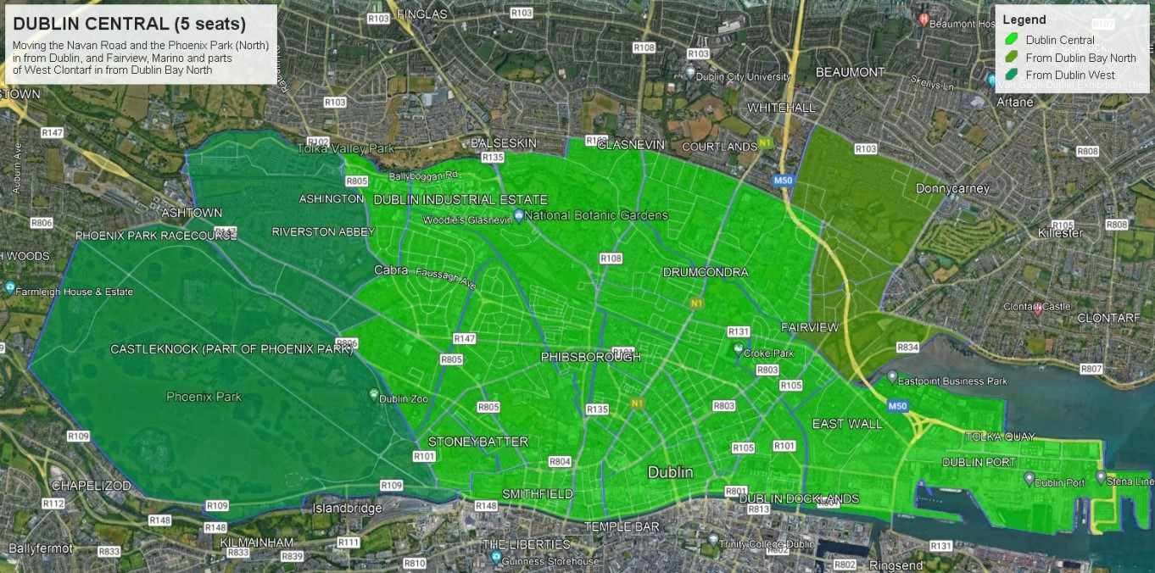
DUBLIN FINGAL NORTH (3 seats) and DUBLIN FINGAL NORTH (3 seats)

Currently Dublin Fingal has a population of 170,690 as of Census 2021, equivalent to 5.93 seats (in a 178 seat Dáil) or 7.00 seats (in a 180 seat Dáil). In other words, it can be split into two three-seaters.

The easiest way to do this is probably on a North-South basic wuth Balbriggan and Rush- Lusk Electoral Areas, along with the Kilsallaghan DED from the Swords LEA making up Fingal North, and the rest of Swords LEA and Malahide-Portmarnock LEA making up Fingal South.

The large population size of many of the DEDs in the Fingal area does make it difficult to come up with constituency configurations for the area without splitting DEDs – hence the slightly ungainly addition of Kilsallaghan to Fingal North.

Fingal North would have a population of 82,752 which would be 4.2% below the national representation average in a 178 seat Dail and 3.0% below in a 180 seat Dáil.

Fingal South would have a population of 87,938 which would be 1.8% above the national representation average in a 178 seat Dail and 3.0% above in a 180 seat Dáil.

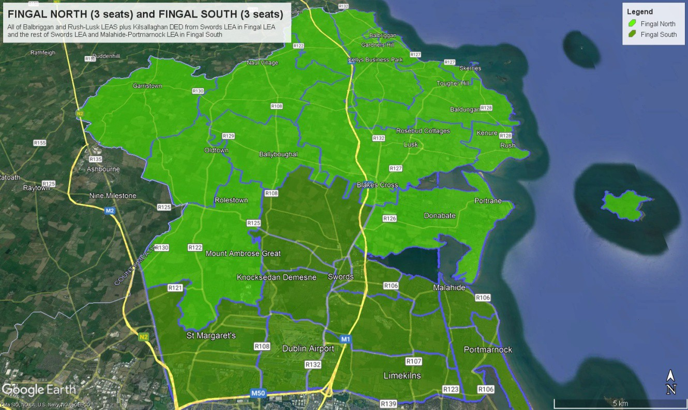
LONGFORD-WESTMEATH (5 seats)

The constituency of Longford-Westmeath currently encompasses the whole of the counties of Longford and Westmeath save a portion of east Westmeath which currently forms part of the Meath West constituency.

As the counties of Longford and Westmeath currently have a population of 142,114
between them – equivalent to 4.95 seats in a 178 seat Dáil, and 5.01 seats in a 180 seat Dái - I would strongly suggest that Longford and Roscommon form a standalone Longford- Westmeath constituency again.

The variance from the national average is 1.0% below in 178 a seat Dáil, and 0.2% above in a
180 seat Dáil.

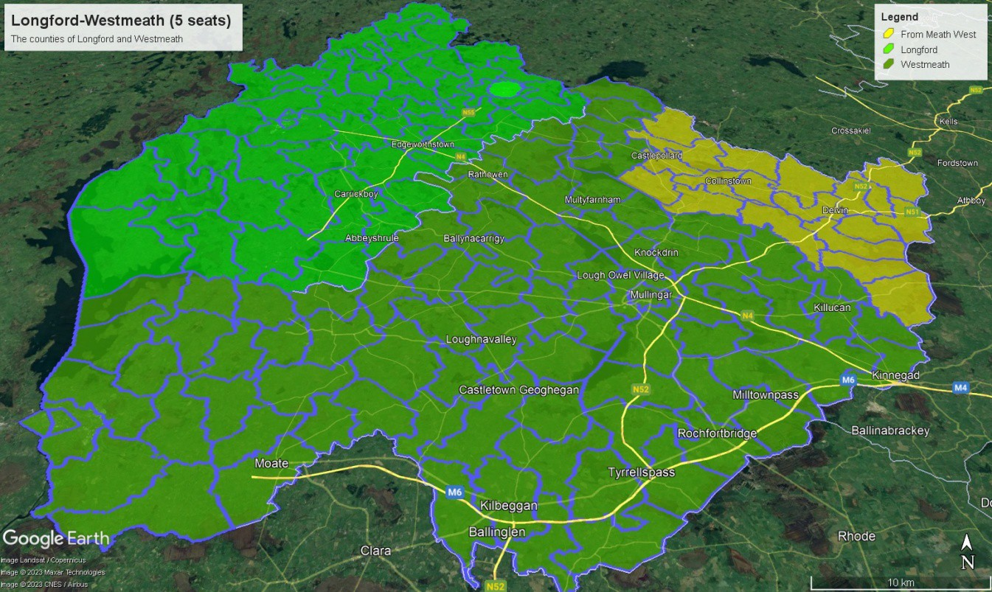
LAOIS (3 seats) and OFFALY (3 seats)

Currently Laois has a population of 91,657 as of Census 2021, equivalent to 3.18 seats (in a
178 seat Dáil) or 3.22 seats (in a 180 seat Dáil). Offaly has a population of 82,668 as of
Census 2021, equivalent to 2.87 seats (in a 178 seat Dáil) or 2.90 seats (in a 180 seat Dáil).

Offaly is currently within the permitted bounds of variation for being a three seat standalone constituency, but Laois cannot.

This can be easily solved as the town of Portarlington actually lies on both sides of the Laois- Offaly border. Moving South Portarlington DED (population 7,856) into Offaly gives the would bring both constituencies within the permitted bounds of variation in a 178 seat Dail at least.

The Laois constituency would have a population of 81,051 which entail a negative variation of 3.1% in a 178 seat Dáil and 1.5% in a 180 seat Dáil.

The Offaly constituency would have a population of 90,524 which entail a positive variation of 4.8% in a 178 seat Dáil and 6.0% in a 180 seat Dáil. Admittedly this wouldn’t work in the latter scenario, but it could be compensated for by the exchange of a small DED.

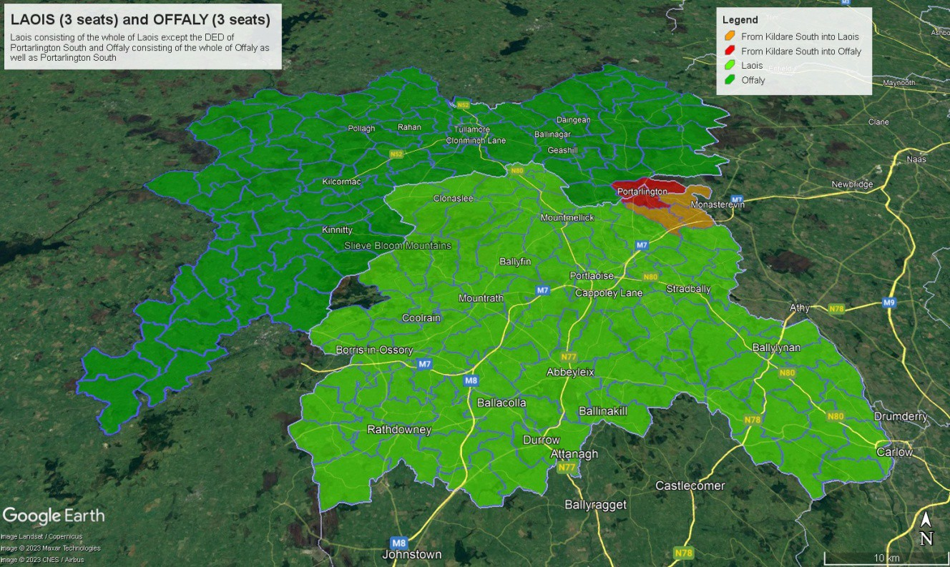
WATERFORD (4 seats)

Currently Waterford has a population of 127,085 as of Census 2021, equivalent to 4.42 seats (in a 178 seat Dáil) or 4.46 seats (in a 180 seat Dáil). This means it is closer to a four seater than a five-seater.

Accordingly I would like to suggest moving the northern part of Lismore into Tipperary
(which would facilitate two three-seat constituencies in that county)

The DEDs involved are : All DEDs in Lismore except Kilcockan, Kilwatermoy East, Kilwatermoy
West, Tallow and Templemichael

This would see a population transfer of 8,649 leaving the new Waterford Constituency with a population of 118,436 – which in a 178 seat Dáil would be 2.9% above the national average ratio of Population:Representative and in a 180 seat Dáil 4.0% above.

The Knockmealdown mountains run across the Tipperary-Waterford border in this area, but Tipperary and the area to be moved in Waterford are connected by two regional roads – the R668 which runs from Cahir to Lismore in the west and the R671 which runs from Clonmel
to the east side of the area, as well as several smaller roads that run across the mountains.

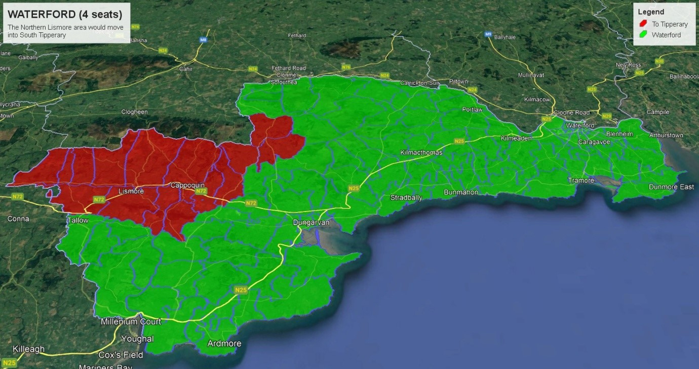

One thing I would strongly counsel against is the idea of moving part of South Kilkenny into the Waterford constituency. While there is some merit in the Ferrybank suburbs in Kilculliheen DED being moved, firstly this breaches a provincial boundary and secondly – as pointed out above – less movement of population is required to make Waterford a four- seater than to make it a five-seater. Also, given that Carlow and Kilkenny in a 178 seat Dail would have enough population for 5.75 seats (just about enough to form two three-seaters, it would require a large movement of population (at least 14,000) to make a five-seat
Carlow-Kilkenny viable.
By my calculations, getting Carlow-Kilkenny viable as a five-seater in both a 178 seat and a
180 seat Dail would require the movement of large tracts of rural areas in South Kilkenny. The following DEDs – at a minimum – would be required : Aglish, Ballincrea, Dunkitt, Farnoge, Kilbride, Kilcolumb, Kilculliheen, Kilmakevoge, Pollrone, Portnascully, Rathpatrick, Rossinan, Shanbogh, Tubbrid and Ullid. This would lead to a population of 16,419 being transferred.

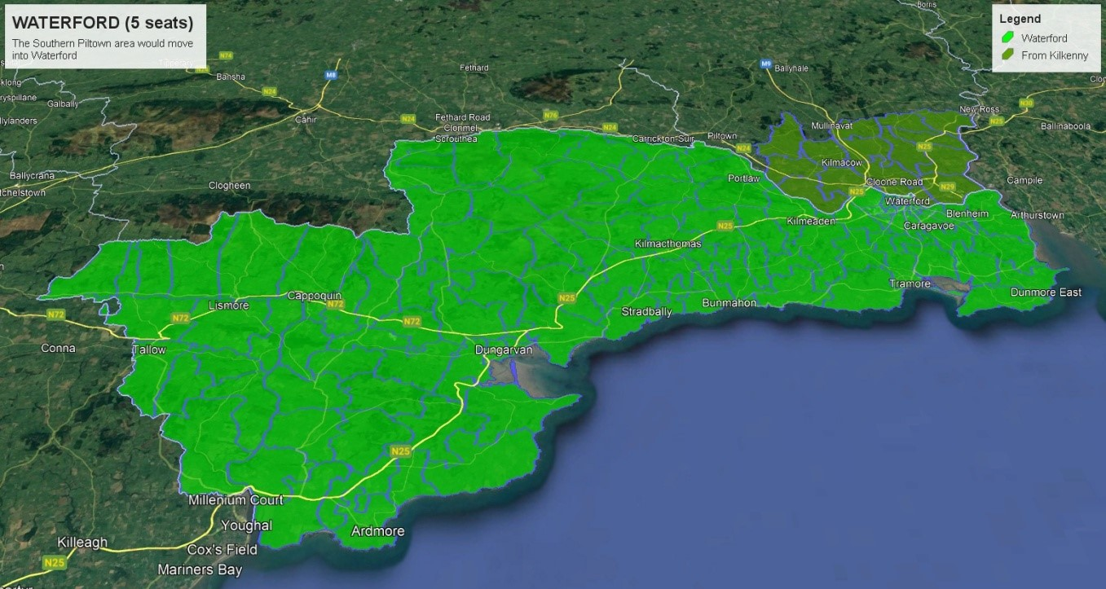

I would strongly suggest that the four seat option with transfer to Tipperary be considered, given that it doesn’t breach a provincial boundary and much less population will find themselves moved to a different constituency.

