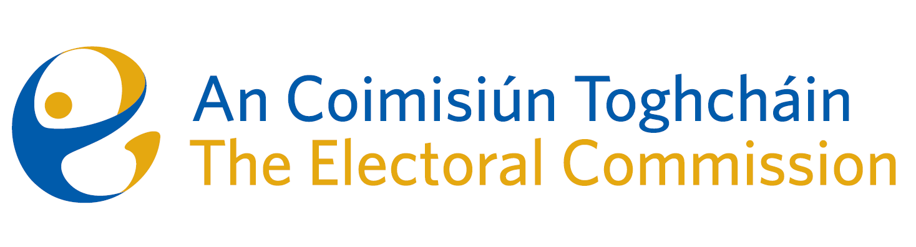
Meeting of An Coimisiún Toghcháin (ACT), The Electoral Commission.

Held in the Office of the Ombudsman, 6 Earlsfort Terrace, 8.00am – 18th May 2023

In attendance:
Coimisiún Members: Justice Marie Baker (Chairperson)*, Alex Attwood (AA), John Curran (JC), Ger Deering (GD)*, Maura Quinn (MQ), Peter Finnegan (PF), and Prof. Caroline Fennell (CF)*.

An Coimisiún Executive: Art O’Leary (AOL), Tim Carey (TC), Mary Clare O’Sullivan, Karen Kehily, Andrea Jones, Ian Stuart–Mills (ISM) and Aodha Molloy (AM)*.

* Justice Marie Baker, Ger Deering, Prof. Caroline Fennell and Aodha Molloy attended remotely on Zoom
------------------------------------
- Welcome
The Chairperson welcomed members.

The minutes from the previous meeting were approved.

- Conflict of Interest
No conflict of interest was declared

- Briefing on the National Democracy Study
Commission members were provided with a briefing on the development of a National Democracy Study which included reflection on a diverse range of considered objectives and the suggested next steps.

- Constituency Review
Commission members continued their consideration of the review of constituencies for Dáil Éireann and the European Parliament.

- AOB
The Commission further considered correspondence from the Department of Justice as part of the public consultation on the role of Sheriffs. The Commission members agreed a response which will be circulated to the Department of Justice in the coming days.

The Commission members were provided with the 2024 European Parliamentary Election schedule, which are to be held on the 6th to the 9th of June 2024.

Dates of the next meetings are 1st June, 15th June and 29th June.

__________________
Ms. Justice Marie Baker (signed)
Chairperson

