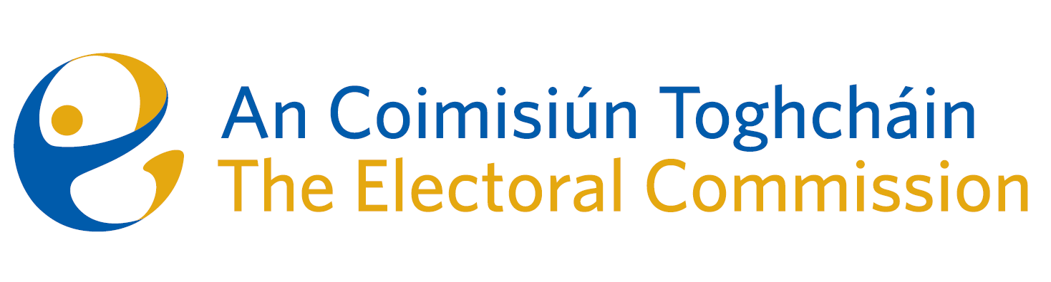
Meeting of An Coimisiún Toghcháin (ACT), The Electoral Commission.

Held in the Radisson Blu Hotel, Golden Lane, Dublin 8 - 8.00am – 1st June 2023

In attendance:
Maura Quinn (Deputising as Chairperson), Alex Attwood (AA), John Curran (JC), Ger Deering (GD), Peter Finnegan (PF), and Prof. Caroline Fennell (CF)*.

An Coimisiún Executive: Art O’Leary (AOL), Tim Carey (TC), Ian Stuart–Mills (ISM) and Aodha Molloy (AM)*, Karen Kehily, Emer Grenville, Andrea Jones, Emma O’Donoghue, Dionne O’Mahony, Michele Hillenbrand, Muireann Ní Thuairisg, Seamus Byrne and Frank Daly

* Prof. Caroline Fennell and Aodha Molly attended remotely on Zoom

Apologies: Justice Marie Baker (Chairperson)

------------------------------------
- Appointment of temporary Chairperson

In the unavoidable absence of Judge Baker, Ms. Maura Quinn was appointed as Chairperson for this meeting.

The Chairperson welcomed members.

The minutes from the previous meeting were approved.

- Conflict of Interest

No conflict of interest was declared.

- HR and Financial Briefing
Commission members received a briefing on the Human Resources priorities of the Commission which included an update on recruitment to date and next phase, learning and development and wellness of staff.

A financial overview and report of 2023 expenditure was also provided to the Commission.

- Constituency Review
Commission members continued their consideration of the review of constituencies for Dáil Éireann and the European Parliament.

- AOB

- The Commission were asked to consider dates in September for Returning Officer training.

- Dates of the next meetings are 15th June and 29th June.

__________________
Ms. Maura Quinn (signed)
Chairperson

