Michael Leahy, Co. Clare.

To the Board members of the Electoral Commission in respect of the review of boundaries to Dáil Elections.

Dear Board Members,
Further to my submission by e-mail to you sent on 1st March, I have looked at the terms of reference issued by the government and I now wish to update my submission as follows, particularly as the government has set an upper limit of 181 Dáil seats, representing an average population per TD of 28,307.

I wish to make representation in respect of the proposed constituency boundary review for the upcoming Dáil election in respect of County Clare.
The commission will note that as of the 2016 census, Clare had a population of 118,817 persons and had four Dáil representatives, giving a proportion of 29,704 persons per TD, or very close to the maximum of 30,000 / TD permitted by the Constitution.
The population of Clare has now increased, as per the preliminary census results for 2022, to a population of 127,419. If the number of representatives was to remain at four this would represent a population or TD of 31,855 persons, well outside the maximum set by the constitution. If the number of representatives was increased to 5 TDs this would give a proportion of 25,484 persons per TD or just over the median point between the maximum (30,000) and the minimum (20,000) persons per representative. The case therefore for increasing the representation for the Clare constituency to 5 TDs seems to be overwhelming. Increasing representation to 5 would be likely to ensure that it would remain at this level for at least the next two elections, as it is unlikely that there would be a further increase of 25,000 persons, thus triggering another revision, for the next 15 years or so.
Clare is a very geographically distinct County being bordered on the South and West by the sea, on the east by the River Shannon and Lough Derg, and to the north by the Burren hills. The only area where there is not a distinct geographical boundary is the area around Gort/ South Galway.
Most Clare people would be very much of the opinion that the constituency should remain as a single entity and that the only matter to be decided is the level of representation. As pointed out above, the argument for increasing representation to 5 TDs for Dáil elections is very strong.
I note that the terms of reference for the commission is that county boundaries should generally be observed for constituencies. I note also however that the government has placed an upper limit of 181 TDs for the next Dáil. Given the current national population of 5,123,536, this equates to a population per TD of 28,307, and for this reason it may be difficult for the commission to achieve the constituency revisions required without breaching some county boundaries.

Given the limit of 181 TDs, the commission may feel that the population of the Clare constituency may need to be increased if it becomes a five seat constituency to some 140,000 persons, (ie 5x28,000) and that the constituency may need to extend outside of the county boundary. As indicated above, the area of Gort/south Galway is very much the hinterland of Clare with parts of south Galway being within the Burren and with the town of Gort being only 18 miles from Ennis and regarding it as its nearest service centre.
As stated above, if the constituency is kept to the county boundaries of Clare with a population 127,419, this would give a population per TD of 25,484 if a five-seat constituency. The commission may feel that the constituency should therefore increase its population by approximately 14,111 to reach the median population figure of 28,307 to ensure that the figure of 181 TDs is not exceeded.
Adding the following DEDs, which are at present part of the Galway East constituency, would increase the population of the Clare constituency by 13,474, which would bring the population to 140,891 giving a population per TD of 28,178.

DEDs within Galway East which could be brought into an enlarged Clare constituency with their populations in brackets- Source -preliminary results of the 2022 census.

Doorus (899), Kinvarra (1,586) Killiny (497), Beagh 799), Ardmullivan (719), Gort (3,139), Kiltartan ( 861), Cahermore (633), Skehanagh (534), Ardrahan (613), Castletaylor (689), Killeeenvarra (906), Drumacoo (1,564)

The locations of these DEDs are indicated in the below map.

Drumacoo Ardrahan

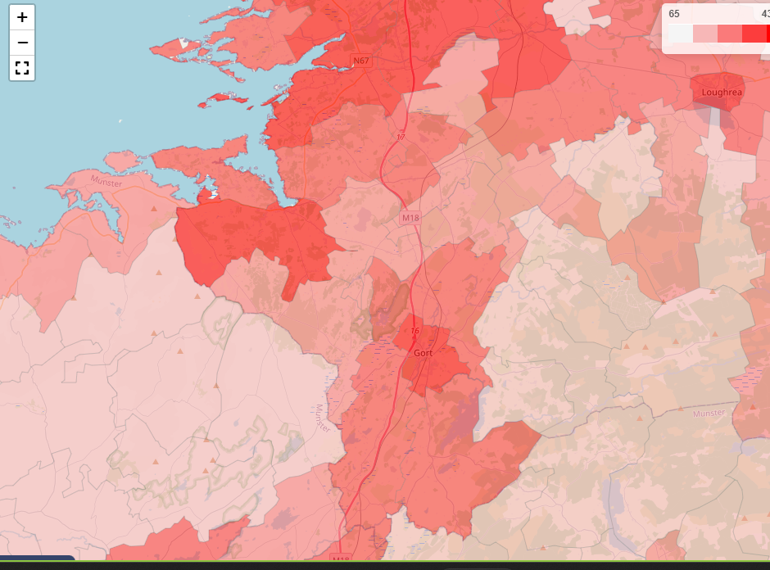

Existing Clare Constituency Existing Galway East Constituency.

Deleting Drumacoo and Ardrahan still brings the total increase to 11,297 bringing the population of the constituency to 138,716 or 27,743 per TD.

If this latter proposal were adopted the Galway East constituency would retain a population of 85,719 (97,016 present population minus 11,297) and would remain a 3-seat constituency with a population per TD of 28,573. Alternatively, if the larger figure (13,474) were brought into the Clare constituency, the population of East Galway would reduce to 83,542. While this would enable it to remain a three seat constituency, it would also enable it to take the 4,595 excess persons from the Galway West constituency while not further breaching the Galway county boundary, thus keeping both Galway constituencies below the 30,000 person population limit and retaining Galway east as a three seater and Galway West as a five seater.
In this scenario Galway West would have a population of just under 30,000 per TD and Galway East would have a total population of 88,137 giving a population per TD of 29,379 if remaining a three-seat constituency.

While my preference would be for Clare to be a five seat constituency without going outside its boundaries, the above proposal indicates how the issues in three constituencies could be resolved with minimum county boundary breaches and by the addition of a single TD over the three constituencies.

I would be obliged if you could acknowledge receipt of this submission and also if you could give an indication of when the boundary changes are likely to be decided.

Yours sincerely,

Michael Leahy,
10th March 2023

