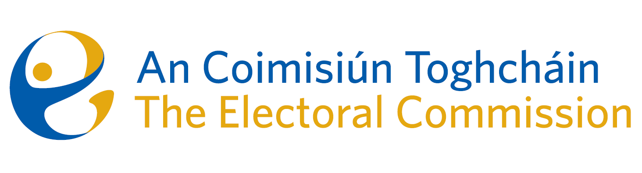
Agenda
Meeting 11, 8.00am 6th July 2023
Pearse Suite – Radisson Blu Hotel, Golden Lane, Dublin 8

- Minutes of the previous meeting
- Conflicts of Interest
- Pilot National Election and Democracy Study (Dr. Theresa Reidy, UCC)
- Draft legislative proposal regarding Mayoral Plebiscites

- Constituency Review and draft research paper
- Work Programme update
- AOB

