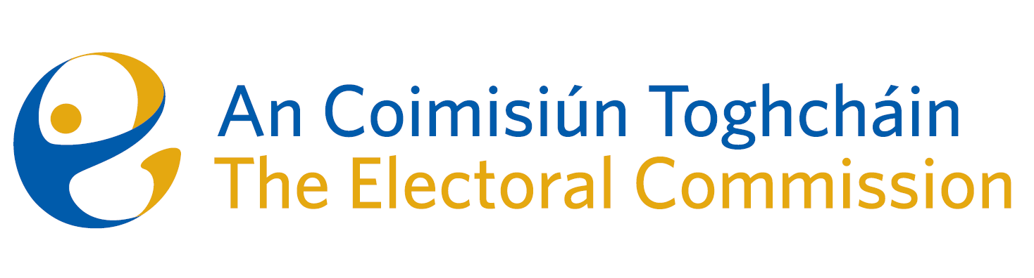
Meeting of An Coimisiún Toghcháin (ACT), The Electoral Commission.

Held in OPW, 1 Georges Quay, 8.00am – 15th June 2023

In attendance:
Justice Marie Baker (Chairperson), Maura Quinn (MQ), Alex Attwood (AA), John Curran (JC), Ger Deering (GD), Peter Finnegan (PF), and Prof. Caroline Fennell (CF)*.

An Coimisiún Executive: Art O’Leary (AOL), Tim Carey (TC), Brian Dawson (BD), Ian Stuart–Mills (ISM), Aodha Molloy (AM)*, Karen Kehily and Andrea Jones.

* Justice Marie Baker (Chairperson), Prof. Caroline Fennell, Tim Carey and Aodha Molly attended remotely on Zoom

------------------------------------
- Welcome

The Chairperson welcomed members.

The minutes from the previous meeting were approved.

- Conflict of Interest

No conflict of interest was declared.

- Referendum Information Campaign
Commission members considered a number of proposals for the information campaign for the Autumn Referendums and will return to the matter as soon the timeline becomes clear.

- Constituency Review
Commission members continued their consideration of the review of constituencies for Dáil Éireann and the European Parliament.

- AOB

- Dates of the next meetings are 6th July and 20th July.

- Update on the forthcoming decision of the EU Parliament on the apportionment of European Parliament seats assigned to Ireland.

__________________
Ms. Justice Marie Baker (signed)
Chairperson

