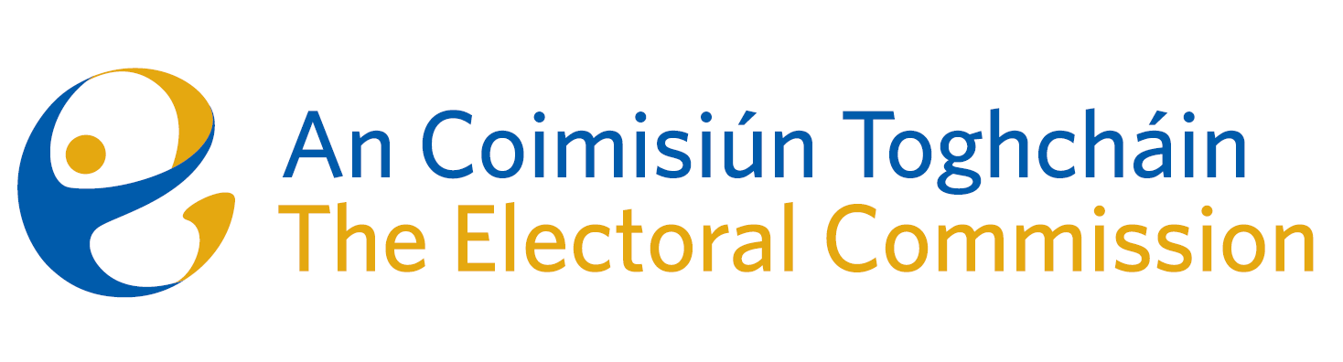
Meeting of An Coimisiún Toghcháin (ACT), The Electoral Commission.

Held in Radisson Blu Hotel, 8.00am – 6th July 2023

In attendance:
Justice Marie Baker (Chairperson), Maura Quinn (MQ), Alex Attwood (AA)*, John Curran (JC), Ger Deering (GD), Peter Finnegan (PF), and Prof. Caroline Fennell (CF)|*.

An Coimisiún Executive: Art O’Leary (AOL), Tim Carey (TC), Brian Dawson (BD), Ian Stuart–Mills (ISM), Aodha Molloy (AM)*, Mary Clare O’Sullivan (MCOS) and Andrea Jones.

Guest Speaker: Dr. Theresa Reidy, senior lecturer in the Department of Government and Politics, University College Cork

* Alex Attwood, Caroline Fennell and Aodha Molloy attended remotely on Zoom

------------------------------------
- Welcome
The Chairperson welcomed members.

The minutes from the previous meeting were approved.

- Conflict of Interest
No conflict of interest was declared.

- National Election and Democracy Study
Dr. Theresa Reidy made a presentation to Commission members on researching electoral behaviour in Ireland, including a proposal for a pilot programme for the Autumn referendums.
- Mayoral Plebiscites
The Commission was provided with an update on the progression of the Local Government (Mayor of Limerick) Bill 2023 which is expected to be published by the end of the summer parliamentary session.
The Commission made a number of suggestions in relation to any possible role associated with the future holding of mayoral plebiscites.

- Constituency Review
Commission members continued their consideration of the review of constituencies for Dáil Éireann and the European Parliament.

- Work Programme update
The Commission received an update on the status of the Referendum proposed to take place during November.

- AOB
- Date of the next meeting is 20th July.

__________________
Ms. Justice Marie Baker (signed)
Chairperson

