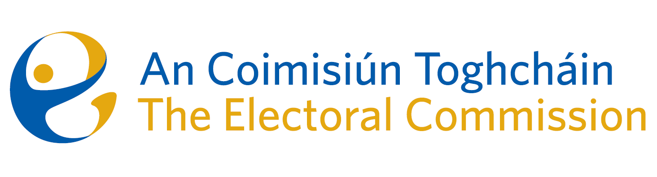
Agenda
Meeting 12, 10.30am 20th July 2023
Sky Suite – Radisson Blu Hotel, Golden Lane, Dublin 8

- Minutes of the previous meeting
- Conflicts of Interest
- Constituency Review:
  - Dáil Éireann;
  - European Parliament;
  - Other recommendations.
- Communications campaign for Constituency Review Report Launch
- Pilot National Election and Democracy Study Governance Programme
- ACT Budget 2024 and Estimates
- Audit and Risk Committee membership proposal
- An Coimisiún membership
- An Coimisiún Statement of Strategy – initial discussion
- AOB
- Proposed dates for Returning Officer training – 14th or 21st September;
- Date for next meeting – proposed to hold on same day as Returning Officer training;
- Work Programme for remainder of the year.

