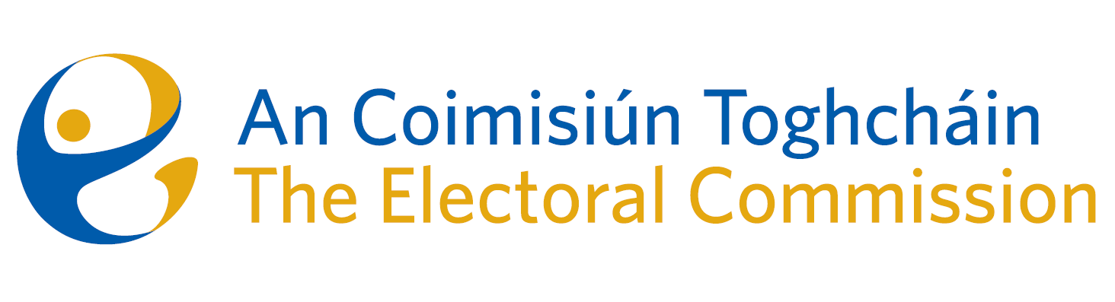
Agenda
Meeting #14, 10.30am 14th September 2023
Venue – Parlour Suite, The Richmond Education and Event Centre

- Minutes of the previous meeting
- Conflicts of Interest
- Presentation on the modernisation of the electoral register: Ms. Petra Woods (Dept. of Housing, Local Government & Heritage) and Ms. Deirdre Ní Raghallaigh (Dublin City Council).
- Dáil Constituency Review: developments and updates
- European Parliament Constituency Review
- Research Programme
- Gender Equality and other referendums
- Work programme to year-end
- AOB

- Date for next meeting – 5th October

LUNCH

- Training on the PR/STV system of voting and counting (with all ACT staff).

