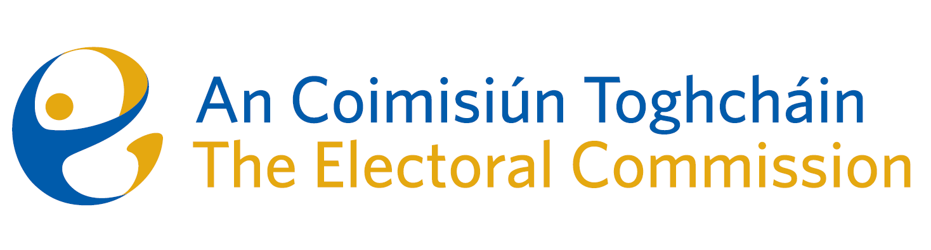
Meeting of An Coimisiún Toghcháin (ACT), The Electoral Commission.

Held in the Richmond Event Centre, 10.30am – 14th September 2023

In attendance:
Justice Marie Baker (Chairperson), Maura Quinn (MQ), Alex Attwood (AA), John Curran (JC), Ger Deering (GD), Peter Finnegan* (PF), and Prof. Caroline Fennell* (CF).

An Coimisiún Executive: Art O’Leary (AOL), Tim Carey (TC), Mary Clare O’Sullivan (MCOS), Karen Kehily (KK) Brian Dawson (BD), and Andrea Jones

Guest speakers: Petra Woods (Department of Housing, Planning and Local Government) and Deirdre Ní Rathaillaigh (Dublin City Council)

*Peter Finnegan and Caroline Fennell attended the meeting remotely

------------------------------------
- Welcome
The Chairperson welcomed members.

The minutes from the previous meeting were approved.

- Conflict of Interest
During a segment discussion of an agenda item, one Commission members notified the Chair of the possibility of a perceived conflict of interest. In the presence of the Commission member, the Commission:

- Agreed there was a possibility of a perceived conflict of interest.
- The Commission member recused themselves while this discussion segment was discussed and resolved.

- Presentation on the modernisation of the electoral register
Senior officials from the Dept. of Housing, Local Government and Heritage and Dublin City Councils made a presentation to Commission members on the LGERS (Local Government Electoral Registration System) project.

The Commission were updated with an overview and progress to date of the project, which is to develop a shared database for all local authorities.

The Commission members agreed further discussion and engagement would be required on the matter and will return to it at a future meeting.

- Updates following the Dáil Constituency Review
The Commission received an update following the launch of the Constituency Review Report on the 30th of August.

- European Parliament Constituency Review
The Commission received an update on the upcoming European Parliament Constituency Review. The European Parliament voted on Wednesday 13th September to add 15 new seats to the European legislative body, with one additional seat allocated to Ireland. Ireland will now have 14 seats in total to fill in the next European election in June 2024.

As soon as the ratification procedure has been completed, the Minister for Housing, Local Government & Heritage will write to An Coimisiún Toghcháin with an instruction to conduct a further review of European Parliament constituencies.

- Research Programme
Commission members were provided with an overview of the development of an ACT Research Programme and will return to the subject at the next meeting.

- Gender Equality and other Referendums
The Commission further considered the proposed Gender Equality and other Referendums and the proposed voting date during November. The CEO will meet with the Taoiseach in the coming weeks.

- Work programme to year-end
A work programme for the Commission was set out and discussed by the Commission members.

- AOB
- Date of next meeting will be held on Thursday 5th October @ 8.00am

__________________
Ms. Justice Marie Baker (signed)
Chairperson

