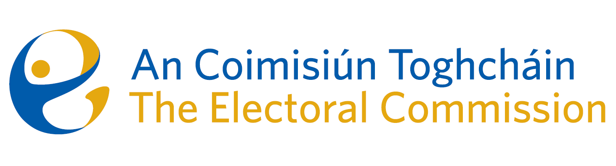
Agenda
Meeting #15, 8.00am 5th October 2023
Venue – The Richmond Centre (Education Suite)

- Minutes of the previous meeting
- Conflicts of Interest
- Gender Equality Referendum – information campaign presentation
- European Parliament Constituency Review
- Draft Research Strategy
- AOB
- Strategic planning and development session – facilitated by Gary Joyce

- Date for next meeting – 9th November 2023

