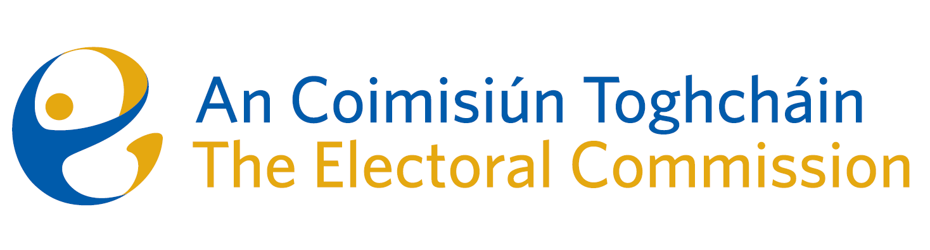
Meeting of An Coimisiún Toghcháin (ACT), The Electoral Commission.

Held in the Richmond Event Centre, 8.00am – 5th October 2023

In attendance:
Justice Marie Baker (Chairperson), Maura Quinn* (MQ), Alex Attwood (AA), John Curran (JC), Ger Deering (GD), Peter Finnegan (PF), and Prof. Caroline Fennell (CF).

An Coimisiún Executive: Art O’Leary (AOL), Tim Carey (TC), Mary Clare O’Sullivan (MCOS), Karen Kehily (KK) Brian Dawson (BD, agenda item 3), Ian Stuart Mills (ISM, agenda item 4) and Andrea Jones (secretariat)

*Maura Quinn attended the meeting remotely

------------------------------------
- Welcome
The Chairperson welcomed members.

The minutes from the previous meeting were approved.

- Conflict of Interest
No conflict of interest was declared.

- Gender Equality Referendum

The Commission was provided with an update on the proposed Gender Equality Referendum announced by the Government in March 2023. The desired 14-16 week timeline to carry out the statutory functions (to promote public awareness of the referendum, preparing a general explanation of the subject matter of the proposal for the referendum concerned, and encourage the public to vote) was noted by the Commission members.

- European Parliament Constituency Review
The decision of the European Council to allocate an additional seat in the European Parliament to Ireland was ratified by MEP’s on the 24th September. On the 27th of September, the Minister for Housing, Local Government and Heritage wrote to the Chairperson of ACT to direct the Commission to conduct a further review of Ireland’s European Parliament constituencies.

ACT invited public submissions by the 29th of October in relation to matters which should be considered in reporting on European Parliament constituencies. The matter will be further discussed at the next Commission meeting.

- Draft Research Programme
The ACT draft research programme was discussed by the Commission members and will be finalised in the coming weeks before submission of the programme to the Houses of the Oireachtas and for wider public consultation.

- AOB
- Date of next meeting Thursday 9th November 2023

Following the meeting, the members met for a half-day facilitated discussion on ACT organisational strategy.

__________________
Ms. Justice Marie Baker (signed)
Chairperson

