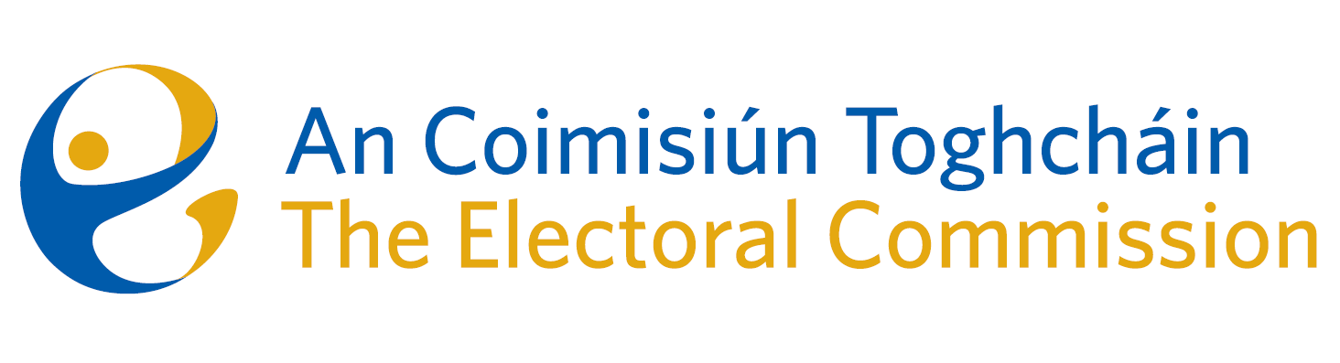
Agenda
Meeting #17, 8.00am 9th November 2023
Venue – OPW Offices, 1 Georges Quay, 3rd Floor, Liffey Room

- Minutes of the previous meeting

- Conflicts of Interest

- Online misinformation and disinformation patterns in Ireland and EU & impacts for elections (Presentation by Dr. Eileen Culloty, DCU)

- European Parliament Constituency Review

- Presentation on the Electoral Register Project

- Referendums
- Critical path timeline
- Research groups output

- Draft Statement of Strategy

- ACT Audit & Risk Committee (ARC) – Introduction of Chairperson to the Commission

- 2024 Work Programme & schedule of meetings

- AOB

- Date for next meeting – 7th December 2023

