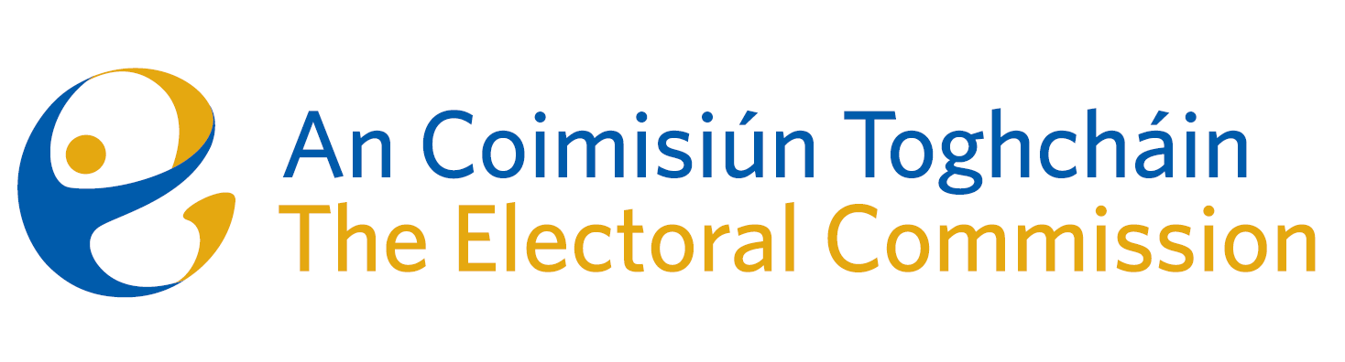
Meeting of An Coimisiún Toghcháin (ACT), The Electoral Commission.

Held in OPW, 1 Georges Quay, 8.00am – 9th November 2023

In attendance:
Justice Marie Baker (Chairperson), Maura Quinn(MQ), Alex Attwood* (AA), John Curran (JC), Ger Deering (GD), Peter Finnegan (PF), and Prof. Caroline Fennell* (CF).

An Coimisiún Executive: Art O’Leary (AOL), Tim Carey (TC), Mary Clare O’Sullivan (MCOS), Karen Kehily (KK) Aoife O’Sullivan (AOS, agenda item 3 & 5), Ian Stuart Mills (ISM, agenda item 4), Aodha Molloy (AM, agenda item 4) and Andrea Jones (secretariat)

*Caroline Fennell and Alex Attwood attended the meeting remotely

------------------------------------
- Welcome
The Chairperson welcomed members.

The minutes from the previous meeting were approved.

- Conflict of Interest
No conflict of interest was declared.

- Online misinformation and disinformation patterns in Ireland and EU & impacts for elections (Presentation by Dr. Eileen Culloty, DCU)
Dr. Eileen Culloty (DCU) presented the Commission members with an overview of the focus of the European Digital Media Observatory (EDMO), the EU Code of Practise on Disinformation and the approach of relevant stakeholders in tackling disinformation.

- European Parliament Constituency Review
The invitation by ACT for public submissions in relation to matters which should be considered in reporting on European Parliament constituencies closed on the 29th of October. The matter was further discussed by the Commission members and the ACT European Parliament Constituency Review report will be finalised in the coming weeks.

- Presentation on the Electoral Register Oversight Project
The Commission were provided with an overview and progress to date of the electoral register oversight project, and the work to date with registration authorities. The next steps and future plans for the project were also outlined to the Commission.

- Introduction of Audit & Risk (ARC) Chairperson to the Commission
Mr. Cyril Maybury was introduced to the Commission as the chairperson of the ACT Audit & Risk Committee. The ARC chairperson provided the Commission with an overview of the responsibilities of the Committee and the supporting role the Committee will offer to the Commission. The Commission members welcomed the Chairperson to the role.

- Referendum update
The Commission was provided with an update on the proposed Referendums announced by the Government earlier this year, and the yet-to-be-decided polling date. The work to date and critical timelines for ACT to carry out its statutory functions in relation to a Referendum were noted by the Commission.

- Statement of Strategy
The Commission noted the development of the statement of strategy and agreed to consider it further at the next meeting.

- Commission Work programme 2024
A draft work programme and schedule of meetings to take place during 2024 were discussed by the Commission and it was agreed to consider a revised version at the next meeting.

AOB
- Development of a policy on post-electoral event reviews;
- Establishment of the Research Advisory Group (chaired by Prof. Caroline Fennell) and the NEDS Management Board, both of which to support the draft Research Programme which will be launched on Friday 10th November; and
- Announcement of the registration of a new political party on Friday 10th November;
- Date of next meeting Thursday 7th December 2023

__________________

Ms. Justice Marie Baker (signed)
Chairperson

