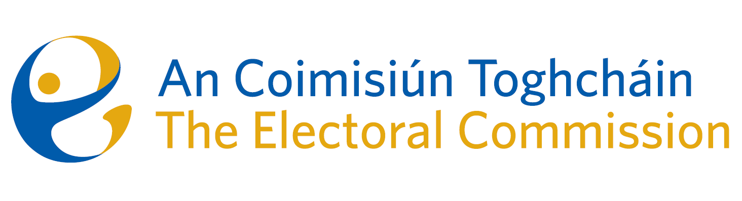
Agenda
Meeting #20, 8.30am 13th December 2023 (2 hours)
Venue – Radisson Blu Hotel

- Conflicts of Interest
- Thirty-ninth amendment of the Constitution (The Family) Bill 2023, and the fortieth amendment of the Constitution (Care) Bill 2023 (Eileen Barrington and Raymond Byrne).
- Referendum Update

- AOB
Date for next meeting – to be confirmed

