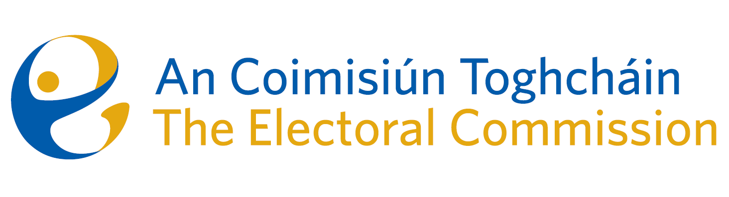
Agenda
Meeting #21, 8.00am 18th January 2024 (2 hours)
Venue – ACT Boardroom – Dublin Castle

- Conflicts of Interest
- Thirty-ninth amendment of the Constitution (The Family) Bill 2023, and the fortieth amendment of the Constitution (Care) Bill 2023
- AOB
Date for next meeting – to be confirmed

