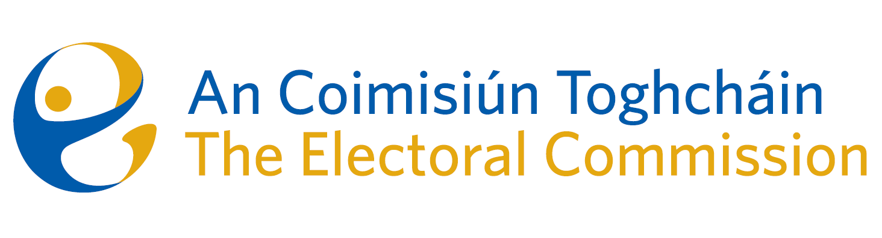
Draft Agenda
Meeting #22, 5.30pm 22nd January 2024 (2 hours)
Venue – Zoom Meeting

- Conflicts of Interest
- Thirty-ninth amendment of the Constitution (The Family) Bill 2023, and the fortieth amendment of the Constitution (Care) Bill 2023
- AOB
Date for next meeting – to be confirmed

