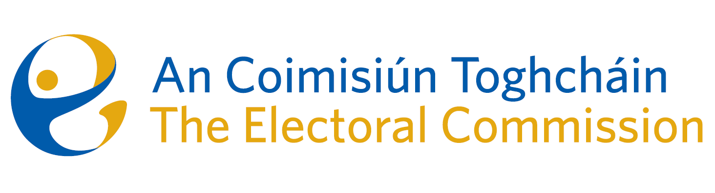
Agenda
Meeting #19, 8.00am 7th December 2023 (2 hours 15 mins)
Venue – Radisson Blu Hotel

- Minutes of the previous meeting (2 minutes)
- Conflicts of Interest (2 minutes)
- Presentation by Richard Browne (Director of the National Cyber Security Centre) (30 minutes)
- Referendum Update (25 minutes)

- Active Participation (a.k.a. the Education programme) (20 mins)
- Post electoral reviews (20 mins)
- Electoral Register Update (20 mins)
- Draft Statement of Strategy (15 mins)
- An Coimisiún Toghcháin Draft Terms of Reference (to note)
- AOB
Date for next meeting – (provisionally) 13 December, 2023 at 8.30 a.m.

