


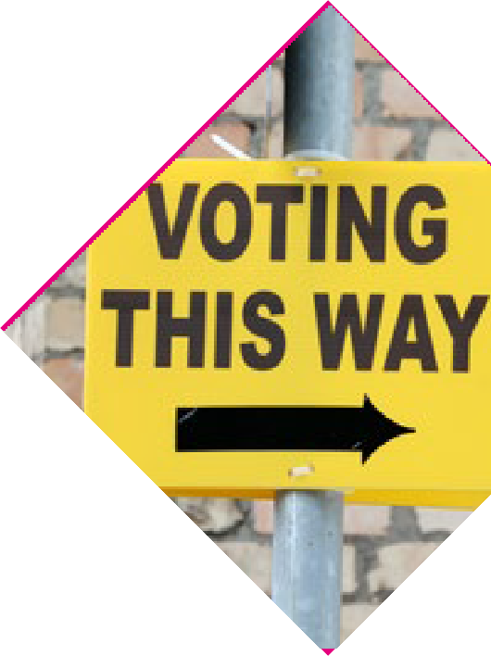

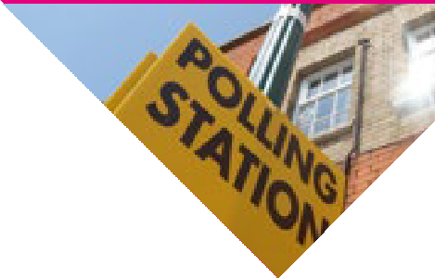




MARCH
FRIDAY
8

Referendums on Family and Care
Your independent guide


This Easy-to-Read was co-produced with Easy-to-Read users by Inclusion Ireland


Find us online electoralcommission.ie/ referendums


Introduction
By Judge Marie Baker Chairperson of the Electoral Commission.



On Friday 8th March 2024 there will be 2 (two) referendums.


A referendum is when Irish Citizens are asked to vote about changes to the Constitution. Our Constitution can only be changed by Irish Citizens in a referendum.

You have 2 (two) separate votes.

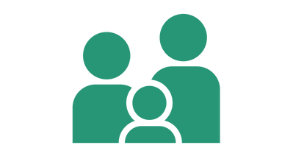


- Do you think that our Constitution should be changed so that it talks about, not only the family based on marriage but also the family based on other lasting relationships?
- Do you think that how our
Constitution talks about the life of women and duties of mothers in the home should be taken out. Instead, it would talk about care by family members to each other?


Your vote is your voice.

Learn as much as you can from places you trust and make up your own mind.

The Electoral Commission of Ireland is a group of people who provide correct and clear information about elections and referendums in Ireland.


The law says that we must give you easy to understand information so that you will know how to vote and what an election or referendum is about.


You might come across information about the referendums in different places such as social media. This information might not be true.


When you see this information you should ask yourself?
How do I know if this is true? Who is telling me this?
Why are they telling me this? How can I find out if it is correct? Do I need to think about this some more?

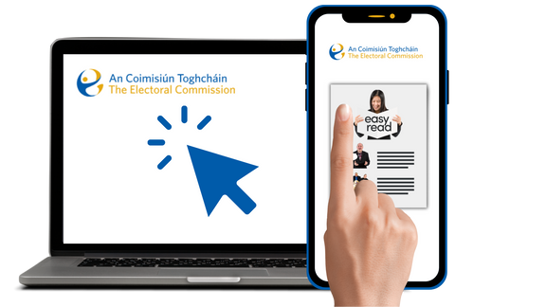
You can download this information booklet at www.electoralcommission.ie/ referendums

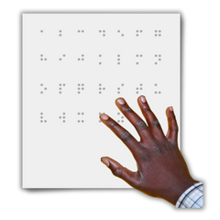
It is available in lots of different formats such as Irish Sign Language, Braille and on CD.

The Referendums will be held on Friday 8th March 2024.
This is also called Polling Day.



Polling Stations will be open from 7am in the morning until 10pm at night.

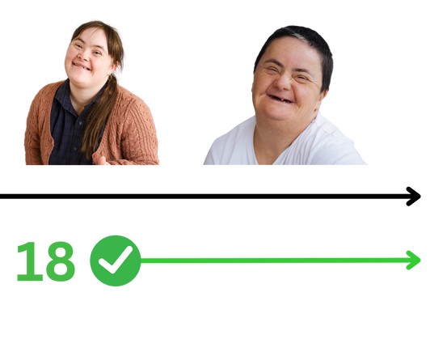
To vote in a referendum you must be:

age 18 years or older. an Irish citizen. registered to vote.

Voter Checklist



Look on www.checktheregister.ie to make sure that your details are right on the register.
www.checktheregister.com


Learn about the referendum questions.


Watch for your polling card to arrive in the post.


Make your plan to vote on the day. You might want a person you trust to support you to get there.

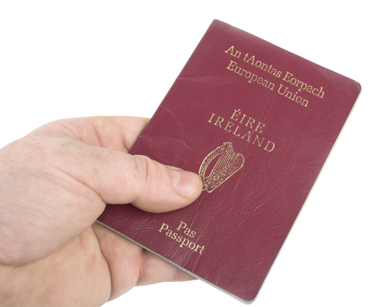
Bring photo ID with you to the polling station on 8th March.

The Family Amendment

This Ballot Paper will be white.

This amendment concerns Article 41 of the Constitution which talks about the family.


Article 41 of the Constitution talks about the important place that the family based on marriage has in Irish society and how it must be protected.

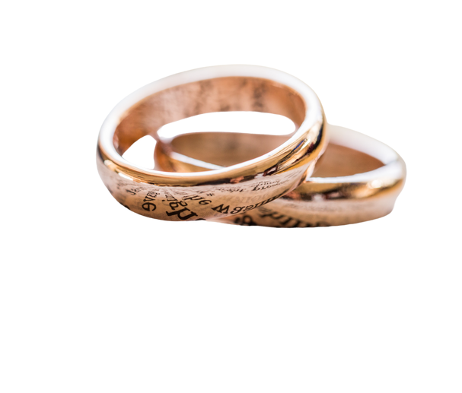
It refers to families based on marriage.


This referendum asks if you think that changes should be made to Article 41 of the Constitution to include in it not only the family based on marriage, but also the family based on other lasting relationships.


YES


NO
If you want to change Article 41 of the Constitution to include not only the family based on marriage but also the family based on other lasting relationships then vote YES.

If you want Article 41 of the Constitution to stay the same and continue to include the family based on marriage then vote NO.

The Care Amendment


This Ballot Paper will be green.

This amendment is about asking if the way the Constitution talks about the life of women and duties of mothers in the home should be taken out.

Instead, the Constitution would talk about care by family members to each other.

Article 41 of the Constitution says that the life of women in the home is an important support to Ireland.




YES

NO
It also says that mothers should not have to go out to work for money reasons if this would remove them from their duties in the home.

This referendum asks if what’s in Article 41 about women and mothers should be taken out of the Constitution, and that instead a new Article 42B should be put in that would talk about how the care given by family members to each other is an important support to Ireland.

If you want the Constitution to change so that it talks about how the care given by family members to each other is an important support to Ireland then vote YES.

If you want the Constitution to stay the same and to continue to talk about how the life of women and duties of mothers in the home is an important support to Ireland then vote NO.

Voting on the day
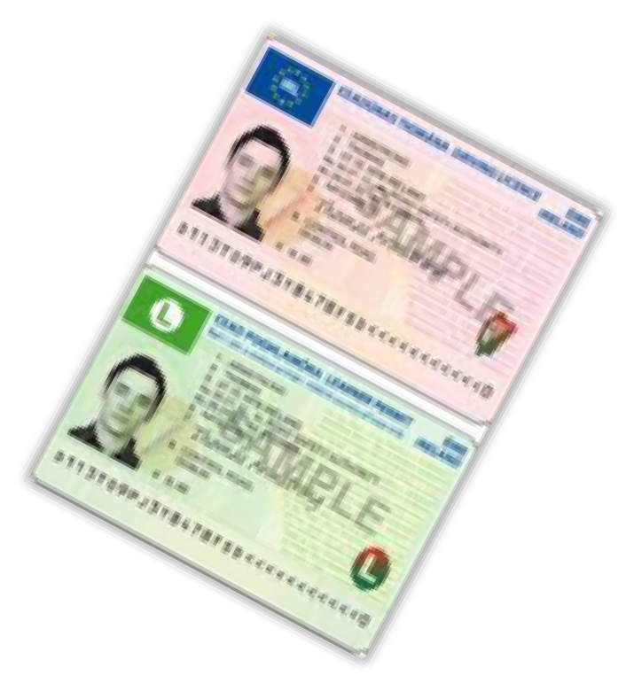
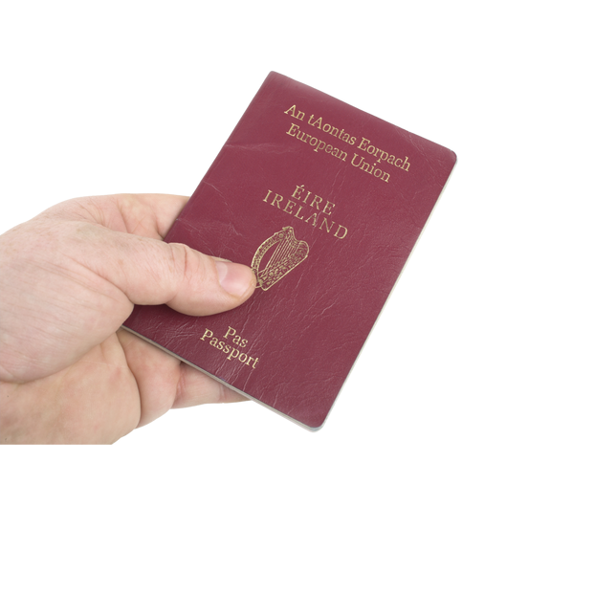
If you can vote in the referendums you should get a polling card in the post.

If you do not get one then you can still vote by bringing ID with you.

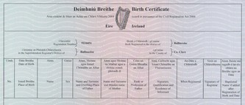
All voters should bring ID in case they are asked for it.

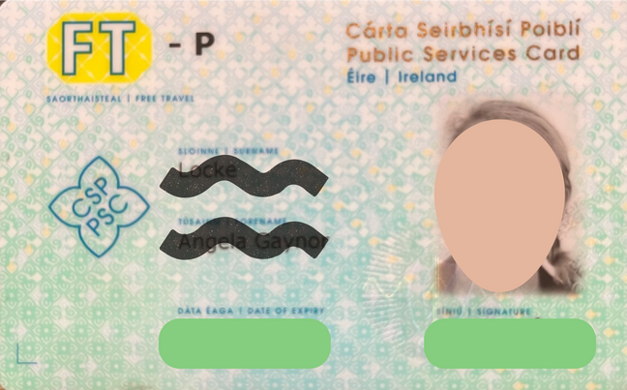
This could include: passport drivers licence student ID
Public Services Card


If you bring something that does not have your address on it then you should bring another document which has your address on it. This will help to show that you are voting in the right polling station.


You will be given a Ballot Paper when you arrive at the polling station.

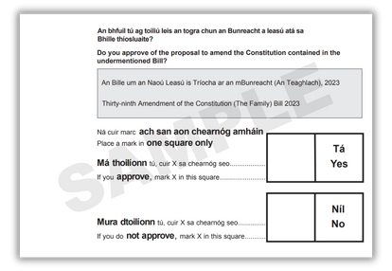
This is what the Family Amendment Ballot Paper will look like.

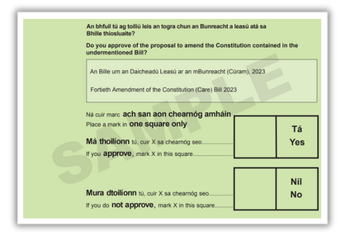
This is what the Care Amendment Ballot Paper will look like.

You vote by marking an X in the YES box or by marking an X in the NO box on your Ballot Paper.

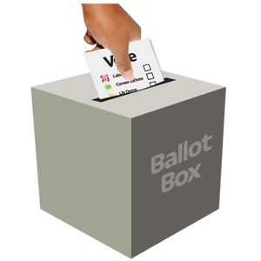
You can then put your Ballot Paper in the Ballot Box.

For more information:

Postal address:
An Coimisiún Toghcháin, Dublin Castle, Dublin 2
D02 X8X8

Email: referendumqs@electoralcommission.ie

Website: www.electoralcommission.ie/referendums




@ElecCommIRL

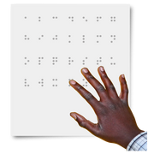

Accessibility
This booklet is available in Braille, on CD and in large text format through Vision Ireland.

An Irish Sign Language version is available at www.electoralcommission.ie/referendums and www.irishdeafsociety.ie and www.chime.ie


This Easy-to-Read was co- produced with Easy-to-Read users by Inclusion Ireland



