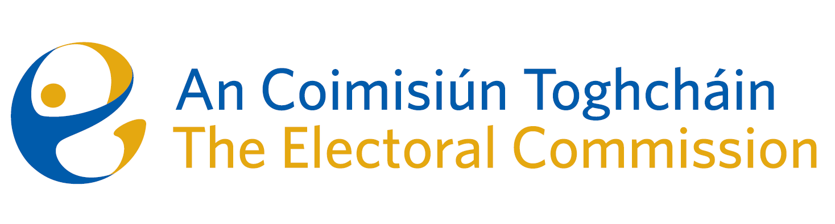
Meeting of An Coimisiún Toghcháin (ACT), The Electoral Commission.

Held in the ACT Boardroom, Dublin Castle, 8.00am – 18th January 2024

In attendance:
Justice Marie Baker (Chairperson), Maura Quinn(MQ), Alex Attwood (AA), John Curran (JC), Ger Deering (GD), Peter Finnegan (PF) and Prof. Caroline Fennell (CF)*.

An Coimisiún Executive: Art O’Leary (AOL), Tim Carey (TC), Mary Clare O’Sullivan (MCOS), Karen Kehily (KK), Brian Dawson (BD) Annmarie Power (AMP), and Andrea Jones (secretariat)

*Prof. C Fennell attended the meeting remotely
------------------------------------
- Welcome
The Chairperson welcomed members.

- Conflict of Interest
No conflicts of interest were declared.

- Legal overview and perspective of proposed amendments to the Constitution
Eileen Barrington SC and Raymond Byrne BL discussed with the Commission members a draft text of the information booklet for the proposed thirty-ninth amendment of the Constitution (The Family) Bill 2023, and the fortieth amendment of the Constitution (Care) Bill 2023. The referendums will be held on 8 March 2024.
The Bills propose for two amendments to the Constitution which will:
- amend Article 41 of the Constitution to provide for a wider concept of Family; and
- delete Article 41.2 of the Constitution to remove text on the role of women in the home, and insert a new Article 42B to recognise family care.

The Commission agreed to reflect on the text of the booklet and revert with suggested amendments.

AOB
- Date of next meeting 22nd January 2024

__________________

Ms. Justice Marie Baker (signed)
Chairperson

