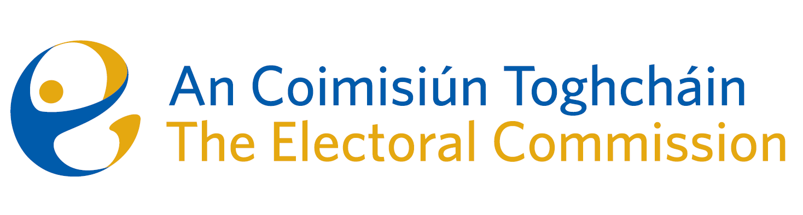
Meeting of An Coimisiún Toghcháin (ACT), The Electoral Commission.

Held via Zoom, 5.30pm – 22nd January 2024

In attendance:
Justice Marie Baker (Chairperson), Maura Quinn(MQ), Alex Attwood (AA), John Curran (JC), Ger Deering (GD), Peter Finnegan (PF) and Prof. Caroline Fennell (CF).

An Coimisiún Executive: Art O’Leary (AOL), Tim Carey (TC), Mary Clare O’Sullivan (MCOS), Karen Kehily (KK), Brian Dawson (BD) Annmarie Power (AMP), and Andrea Jones (secretariat)

------------------------------------
- Welcome
The Chairperson welcomed members.

- Conflict of Interest
No conflict of interest was declared.

- Legal overview and perspective of proposed amendments to the Constitution
The Commission gave continued consideration to the proposed thirty-ninth amendment of the Constitution (The Family) Bill 2023, and the fortieth amendment of the Constitution (Care) Bill 2023. The referendums for both amendments will be held on 8 March 2024.
Eileen Barrington SC and Raymond Byrne BL provided the Commission members with a legal overview on the recent judgment by the Supreme Court in the O’Meara case and associated issues in relation to the proposed amendments to the Constitution. The Commission agreed to reflect further on the content of the information booklet.

AOB
- Date of next meeting - 15 February 2024

__________________

Ms. Justice Marie Baker (signed)
Chairperson

