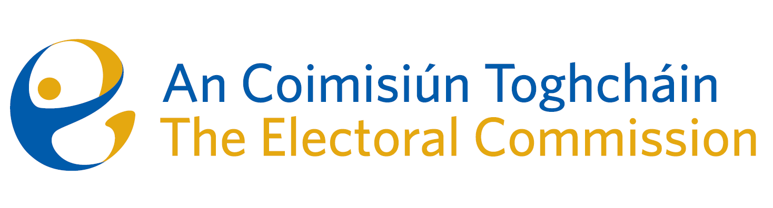
Zoom Meetings of An Coimisiún Toghcháin (ACT), The Electoral Commission.

Held at 5.30pm on Thursday 13th July and 9.30am on Friday 14th July

In attendance Thursday 13th July:

Justice Marie Baker (Chairperson), Maura Quinn, Ger Deering, Peter Finnegan, and Prof. Caroline Fennell.

An Coimisiún Executive: Art O’Leary, Tim Carey, Brian Dawson, Ian Stuart–Mills, Aodha Molloy, Karen Kehily and Andrea Jones.

In attendance Friday 14th July:

Justice Marie Baker (Chairperson), Alex Attwood and John Curran

An Coimisiún Executive: Art O’Leary, Tim Carey, Brian Dawson, Ian Stuart–Mills, Aodha Molloy, Muireann Ní Thuairisg and Andrea Jones.

Constituency Review

Commission members continued their consideration of the review of constituencies for Dáil Éireann and the European Parliament.

------------------------------------

