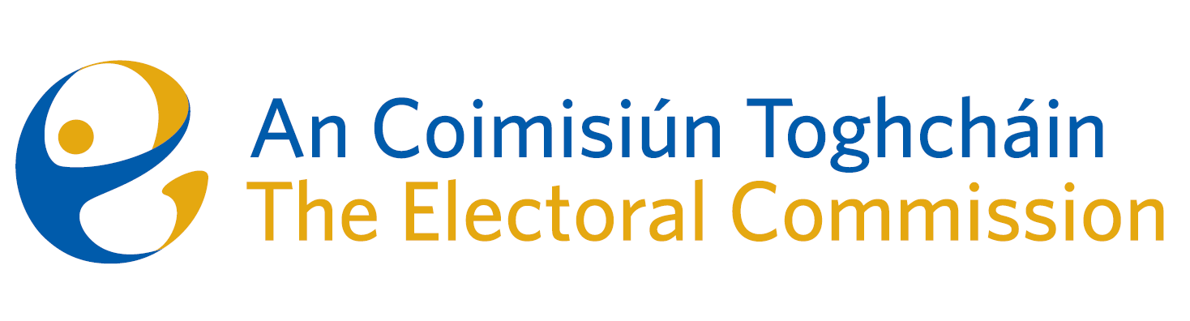
Draft Minutes - Incorporeal Meeting of An Coimisiún Toghcháin (ACT), The Electoral Commission.

Conducted via email from Thursday 16th November to Friday 17th November

Note from Art O’Leary to the Commission: Justice Marie Baker (Chairperson), Maura Quinn, Alex Attwood, John Curran, Ger Deering, Peter Finnegan, and Prof. Caroline Fennell.

An Coimisiún Executive: Tim Carey, Karen Kehily, Mary Clare O’Sullivan and Andrea Jones.

Constituency Review Report - Description of the constituency of Cork South Central

Following a correspondence from the Department of Housing, Local Government and Heritage, Commission members were asked to consider the correction of a typographical error on page 128 of the An Coimisiún Toghcháin Constituency Review Report, published on the 30th of August 2023.
The error must be corrected by way of a Report Stage amendment, to insert the words “and the constituency of Cork North-West” to the description of the constituency of Cork South-Central. This correction will require the agreement of An Coimisiún to change the report, before the Chair of the Commission writes to the Minister for Housing, Local Government and Heritage to clarify the situation.
Commission members gave the amendment consideration and unanimously agreed to the correction.

------------------------------------

